Fundraising Manager
28hrs/4 days a week - £39,000 pa pro rata (£48,750 full-time equivalent)

Reporting to: Head of Fundraising and Communications
Location: Wimbledon London SW19 with occasional UK travel. The office is just a few minutes’ walk from Wimbledon mainline and underground stations. (Hybrid option up to 2 day p/w working from home).

The Royal Medical Benevolent Fund has been helping doctors, medical students and their families through hardship for almost 190 years. We are looking for an experienced relationship fundraiser to take ownership of our growing mid-value donor programme and help shape the future of supporter engagement at the charity.
This is an opportunity to build meaningful relationships with committed supporters, develop innovative stewardship strategies and contribute to a fundraising programme that has a direct and lasting impact on the lives of doctors within the medical profession.
Joining a friendly and collaborative team, you'll enjoy a high degree of autonomy, excellent benefits including a 15% employer pension contribution, flexible working arrangements and genuine opportunities for professional development.

About the role
We are looking for an experienced senior fundraiser to join our small and friendly fundraising and communications team. The Fundraising Manager is primarily responsible for developing, managing and growing the charity's mid-value donor programme. The role will steward and upgrade a defined portfolio of supporters, delivering excellent supporter experiences that increase donor retention, engagement and income. In addition, the post holder will support on individual giving, legacy fundraising and developing and stewarding a small portfolio of corporate partnerships.
Join a well-established, financially secure charity where people genuinely enjoy working together to make a difference. We pride ourselves on our friendly, collaborative culture, where everyone's contribution is valued and supported. As an organisation, we are committed to helping our employees develop and grow.

The team structure

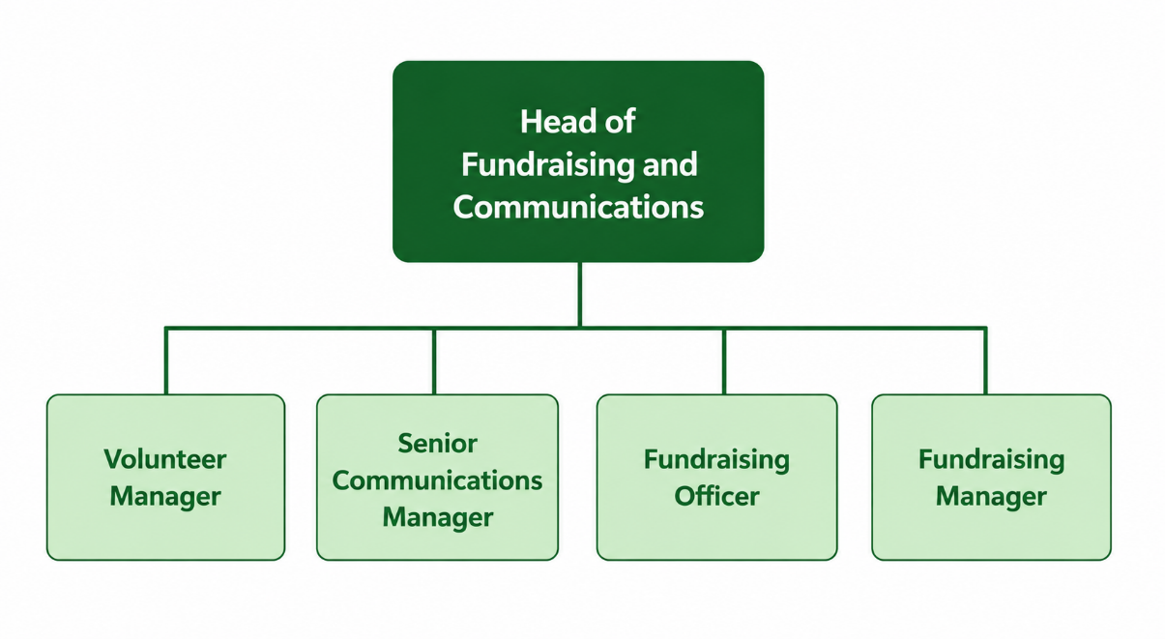

About RMBF
The Royal Medical Benevolent Fund (RMBF) supports doctors, medical students, and their families, providing vital financial, practical, and emotional support when illness, disability, bereavement, or other life-changing circumstances create hardship. The RMBF helps hundreds of doctors each year, ensuring that those who have dedicated their lives to caring for others have somewhere to turn when they need help most.
For fundraisers, the RMBF is a fantastic cause to work for. We deliver tangible, life-changing assistance that enables beneficiaries to regain stability and, in many cases, return to medicine. We have a long history, a strong reputation, and deep roots within the medical community. We also have a loyal and engaged supporter base, with the majority of our donors coming from the profession.

Key Responsibilities

- Manage and develop a portfolio of mid-value supporters, delivering tailored stewardship, personalised communications, meetings, events and digital engagement that demonstrate impact, strengthen relationships and enhance the supporter experience.

- Design and implement segmented donor journeys and cultivation strategies that move supporters from mass fundraising communications to more personalised engagement, identifying opportunities to increase giving through appeals and special funding opportunities.

- Use donor insight, data analysis and supporter behaviour to monitor engagement and retention, reducing attrition, increasing lifetime value, and identifying supporters with the potential to upgrade their giving and progress towards major donor status.

- Develop, manage, and grow a small portfolio of corporate supporters, identifying and securing new fundraising opportunities including sponsorship, employee fundraising, and cause-related marketing initiatives.

- Manage the legacy giving programme, overseeing legacy administration and delivering targeted marketing and stewardship activities to raise awareness, generate enquiries and encourage supporters to leave a gift in their Will.

- Ensure all fundraising activity complies with relevant legislation, data protection requirements, fundraising regulations and organisational policies.

- Maintain accurate supporter records and activity tracking within the CRM system.

Personal Specification

- A proven track record in fundraising

- Ability to think strategically to identify potential donors, prioritise efforts and develop effective fundraising strategies. This includes analysing data, assessing donor potential and adapting approaches based on feedback and results.

- Excellent interpersonal skills with the ability to build and maintain donor relationships and understand donor motivations and interests.

- Excellent written skills with an ability to craft compelling and personalised proposals, with a meticulous attention to detail.

- Confident and comfortable making telephone calls and meeting donors in person as a key part of relationship building and stewardship.

- Strong collaborative skills as a team player, whilst also able to work autonomously initiating and driving tasks as a self-starter.

- Experience using CRM systems and supporter data to drive fundraising performance.

- An understanding of the challenges facing doctors and medical students, including mental health and workplace pressures would be desirable.

Additional Information
- Occasional UK travel maybe required for donor meetings, events and conferences.
- Occasional evening or weekend work may be required (time off in lieu provided)

Package
The remuneration package includes:
- Generous pension scheme with 15% employer contributions and 5% employee contributions with salary sacrifice option
- Death in service benefit
- Flexible working arrangements
- 25 days paid holiday in first year, increasing in stages to 30.5 days after four years’ service, plus an additional 3 days paid leave between Christmas and New Year

- Employee assistance programme

- Dental insurance

Interview Process
- Shortlisted candidates will be invited to a first-round online interview, scheduled for Wednesday 8th July
- Successful candidates will progress to an in-person second-stage interview.

