
Job Description
JOB TITLE: Fundraising Manager
LOCATION: Petty Pool, Pool Lane, Sandiway, Cheshire, CW8 2DR
REPORTS TO: Head of Marketing & Fundraising
SALARY: £33,277.26- £36,785.65 per annum (Grade 5)
HOURS: 35 Hours per week - Monday to Friday – 52 week contract
DBS: Enhanced check required.

Fundraising Manager
Purpose of the Role
The Fundraising Manager will be responsible for developing and delivering a successful fundraising strategy to secure income from a range of sources. This includes individual giving, legacies and alumni giving, major donors, community fundraising, corporate partnerships, trusts and foundations, and digital campaigns.
This proactive role combines strategic planning, relationship development and income generation, working closely with the marketing team to secure sustainable funding for the charity, and to achieve funding for our £13 million capital appeal project, Project Learn Hive.
The postholder will also manage a Grants & Fundraising Officer, ensuring effective fundraising through trusts, foundations, and grants across the organisation, (Petty Pool, Autism Practical Support and The Ground Up Project). They will work closely with colleagues across marketing, communications, operations, and governance to build strong relationships with supporters, donors, alumni, executors, and solicitors.
The role will ensure Petty Pool maximises fundraising income while honouring donor intentions and maintaining the highest professional and ethical standards.
Key Responsibilities
1. Individual and Corporate Engagement & Stewardship
- Build and maintain positive relationships with prospective and current donors, supporters and families.
- Develop a pipeline of corporate partners, locally and regionally, to raise funds, attract volunteers, and build long term mutually beneficial relationships with organisations.
- Provide tailored stewardship to ensure donors feel valued and connected to Petty Pool’s mission, and maximise lifetime value of donors.
- Represent Petty Pool at fundraising events, supporter meetings, and sector networking opportunities.
2. Legacy Fundraising & Marketing
- Develop and deliver strategies for legacy giving, major donors, alumni engagement, and in-memory donations.
- Work with marketing & communications team to create compelling legacy campaigns, events, and supporter journeys, across digital, print, and face-to-face channels.
- Ensure consistent, sensitive, and inspiring messaging to drive income and engagement.
- Lead the administration of legacy and high-value fundraising cases, working with solicitors, executors, alumni, and families to ensure income is received efficiently and ethically.
- Maintain accurate records of income and pipelines for legacies, major donors, and alumni engagement, ensuring timely reporting and forecasting.
- Plan and run cultivation events, for high net worth donors and individuals and influential stakeholders, resulting in gifts or partnerships.
- Protect the charity’s interests in estates, liaising with external advisors where necessary.

3. Data & Reporting
- Use the CRM system to track supporter interactions, pledges, donations, and income across all relevant income streams.
- Produce regular reports on performance and projections for the Executive Team and Trustees.
- Contribute to organisational KPIs, strategic planning, and monitoring through accurate and timely data.

4. Cross-Organisational Contribution
- Line-manage the Grants & Fundraising Officer, providing guidance, oversight, and support to deliver on income targets.
- Support cross-organisational events and activities to embed fundraising across the charity’s culture.

Person Specification
Essential Skills & Experience
- Proven experience in fundraising strategy, as well as legacy fundraising, gifts in wills, major gifts fundraising or related fundraising discipline.
- Strong relationship management and communication skills, with empathy and sensitivity when dealing with families and supporters.
- Experience using CRM systems to manage supporter journeys and income pipelines.
- Strong organisational skills with the ability to manage multiple priorities and deadlines.
- Excellent written and verbal communication skills, with attention to detail.

Desirable Skills & Experience
- Experience within the charity, education, or public sector.
- Understanding of legacy giving and donor stewardship best practice.
- Familiarity with fundraising marketing techniques and campaign delivery.
- Awareness of fundraising regulation and governance requirements.

Key Attributes
- Compassionate, supporter-focused, and respectful.
- A proactive, solution-focused approach to challenges.
- A team player who collaborates across departments.
- Committed to equality, diversity, and inclusion.
- Enthusiastic about Petty Pool’s mission and able to inspire others.

Our Trust is committed to safeguarding and promoting the welfare of our children and young people and expects all staff and volunteers to share this commitment.

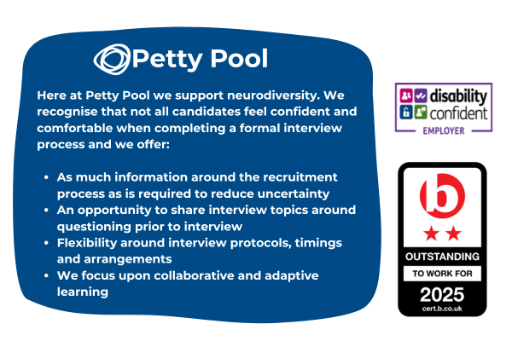
Petty Pool is an equal-opportunity employer. We are committed to equality of opportunity for all staff and applications from individuals are encouraged regardless of age, disability, sex, gender reassignment, sexual orientation, pregnancy and maternity, race, religion or belief and marriage and civil partnerships.

