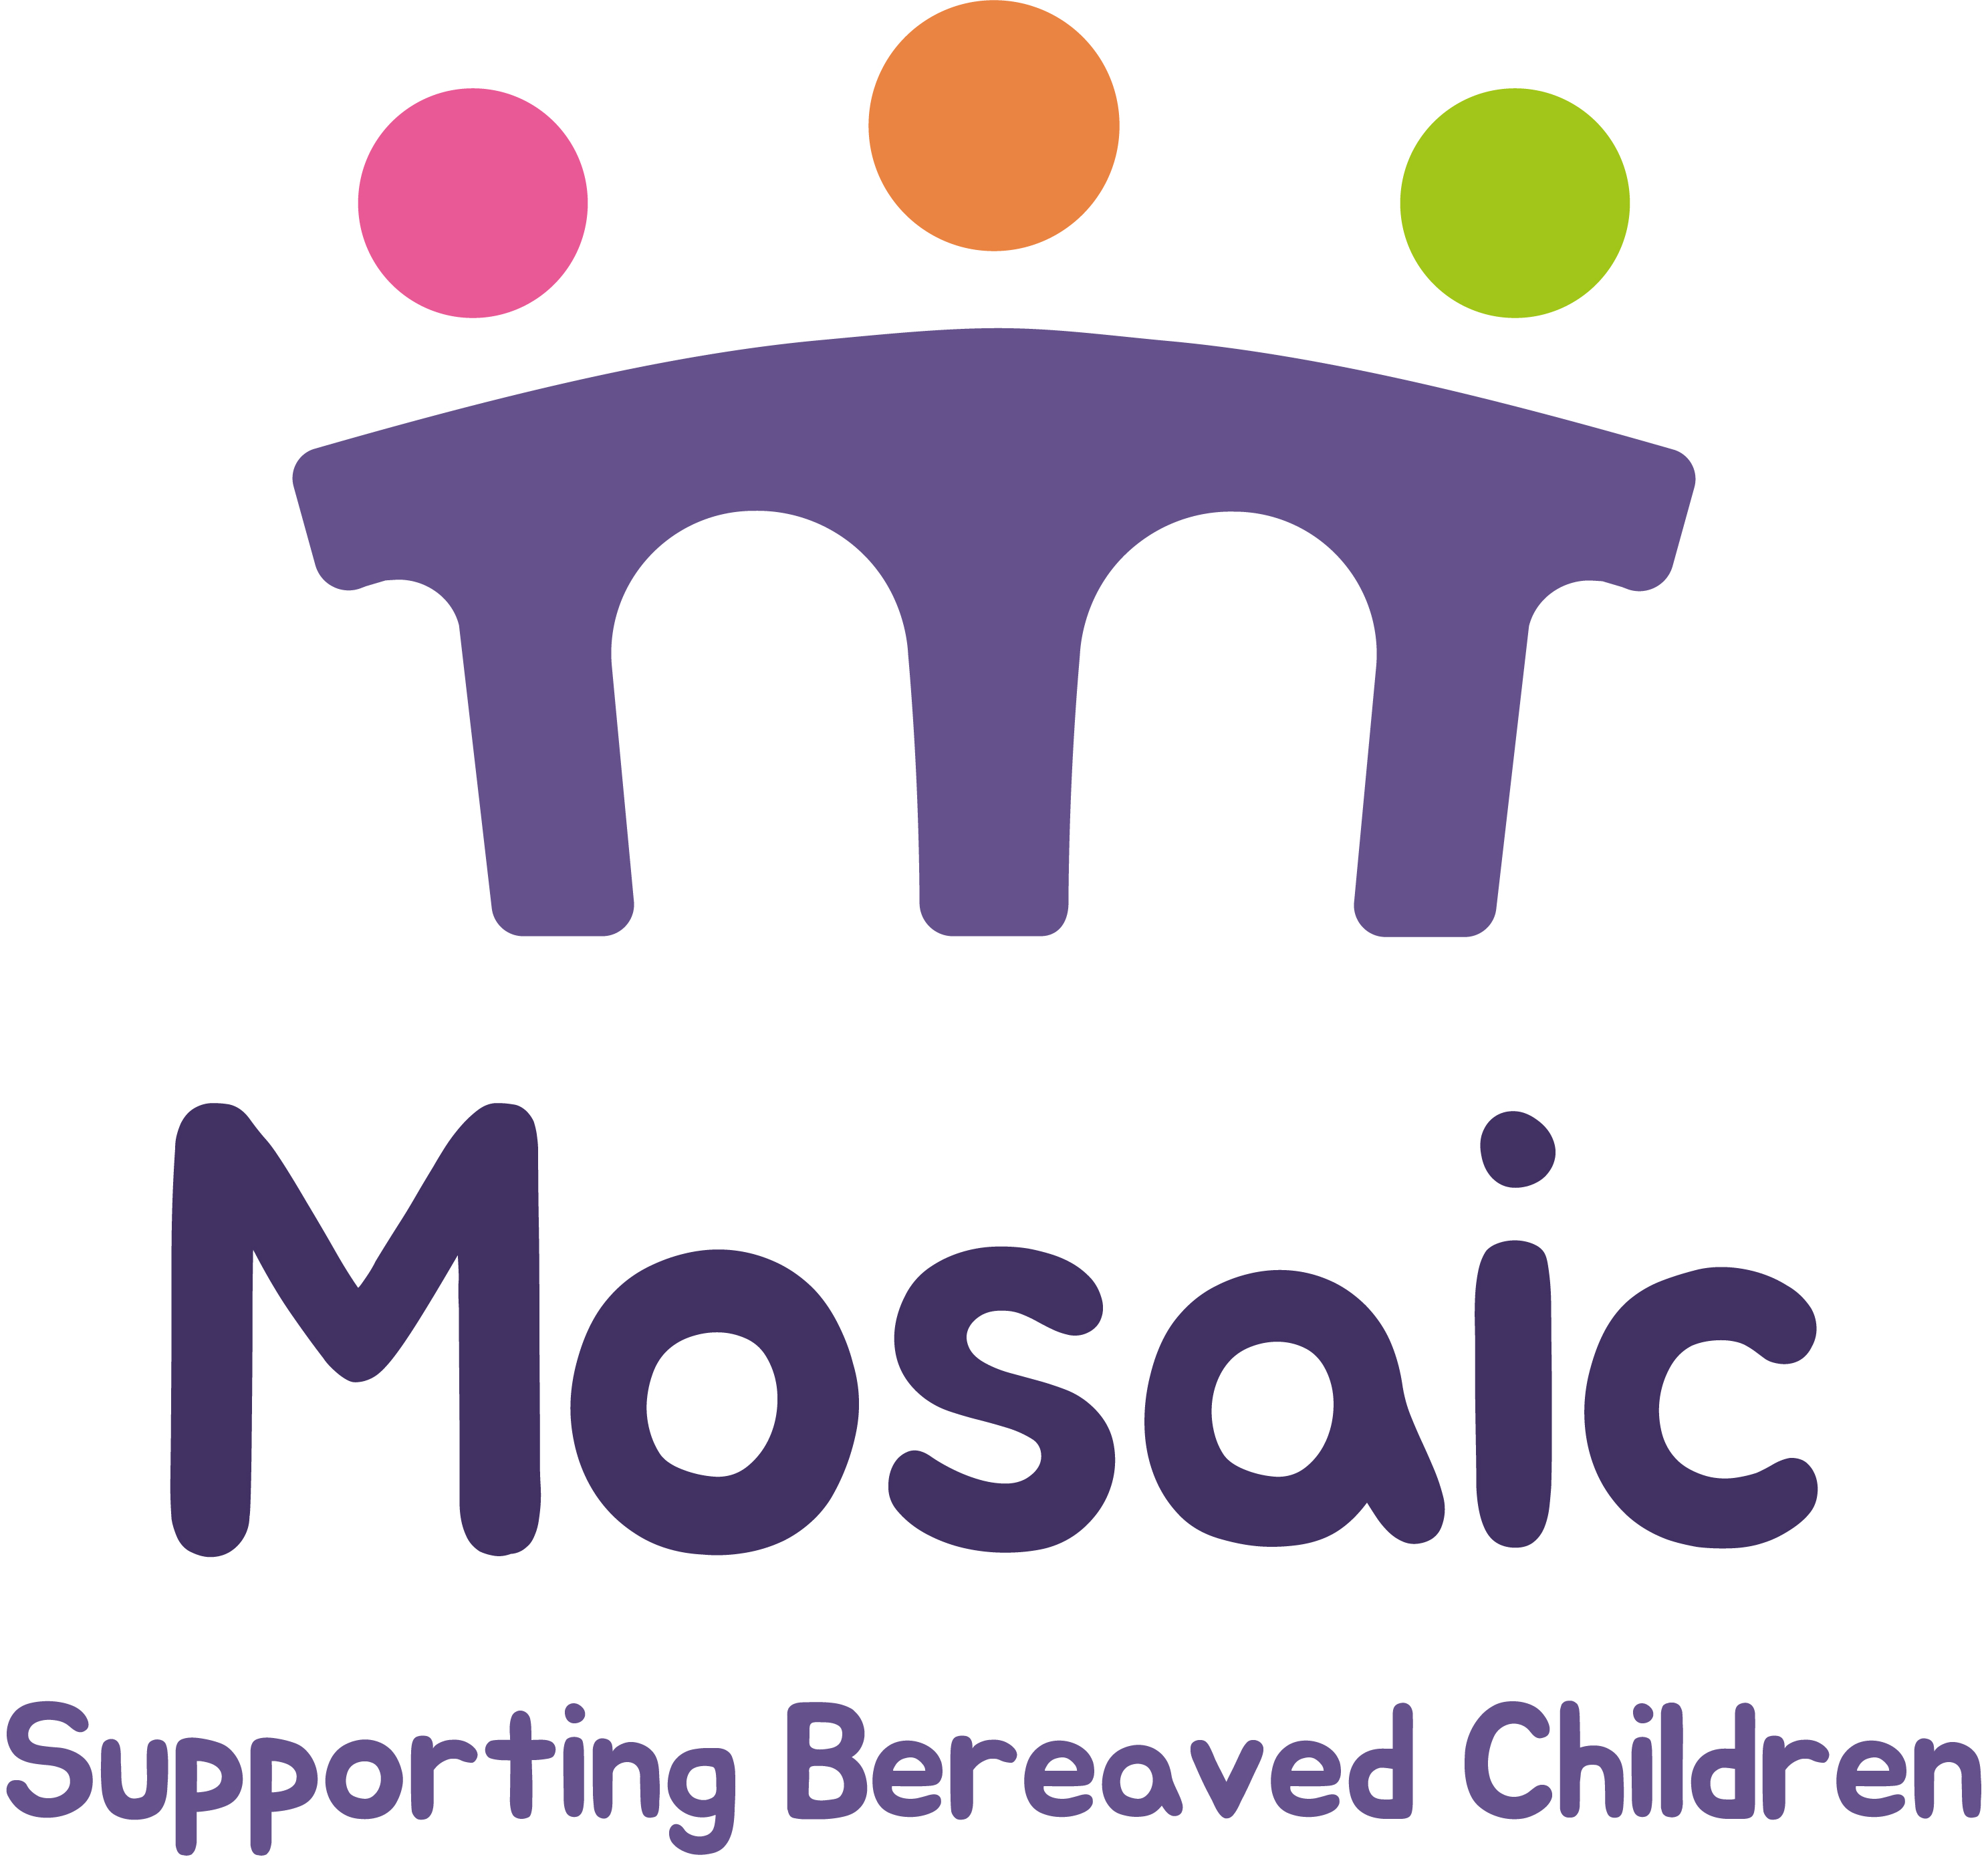

Fundraising Coordinator, Mosaic

JOB DESCRIPTION

Hours: 28 hours per week over 4 days (two days working from home, two days in the office, and TOIL for weekend events)
Responsible to: Head of Funding

Mosaic is a charity which plays a unique role in Dorset helping bereaved children, young people and their families. We are in an exciting period of growth as an organisation and this new post dedicated to Fundraising will play a pivotal role in our ongoing success.

Purpose of post:

- To work closely with the CEO and Head of Funding to coordinate the community, corporate and grants fundraising functions.
- To increase fundraising income, using our strategy to support our services
- To raise the profile of the organisation throughout Dorset and increase stakeholder engagement.

Main duties and responsibilities:

Fundraising

- Support and diversify Mosaic’s existing community fundraising strategy and activities
- Organise a series of community fundraising activities and events, such as sponsored runs, quizzes, etc
- Implement the Mosaic fundraising strategy to support the organisation, advising staff and trustees on potential challenges and developments.
- Develop and implement a corporate partners’ plan, building relationships with local businesses
- Lead on individual supporter relationship management to encourage long-term, repeat giving, meeting targets set for the year.
- Ensure our website and social media channels are kept up to date with fundraising news and Mosaic activities that inspire engagement and giving
- Maintain excellent financial records of all fundraising activities and provide comprehensive financial updates and written reports to funders, donors, CEO and trustees.
- Advise the Head of Funding on updates from the Fundraising Regulator and any other key organisations
- Work with Mosaic staff to gather powerful case studies, stories, images and evidence for fundraising and marketing purposes
- Manage your own administration in connection with the post, including word processing, data handling and correspondence.
- Carry out all tasks according to our policies and standards, on confidentiality, safeguarding, equal opportunities and health and safety policies

The post may involve occasional evening or weekend work to manage fund-raising events, for which time off in lieu may be claimed.

Person specification

Category | Essential | Desirable
Experience | • Experience delivering community or events fundraising activity in a charity or customer-facing environment.  • Demonstrable experience managing multiple tasks or fundraising projects with competing deadlines.  • Experience using a database to record information.  Experience in working with corporate partners to develop sustainable relationships | • Experience delivering charity events  • Experience working with volunteers.
Skills & Abilities | • Able to plan and deliver small–medium events within agreed timelines and budgets.  • Strong written and verbal communication skills, including a confident telephone manner.  • Excellent organisational and time-management skills, with close attention to detail.  • Competent IT user (Microsoft Office, online fundraising platforms). | • Proven experience in running a suite of events in different locations according to community need.
Knowledge | • Understanding of community and events fundraising principles.  • Awareness of GDPR/Data Protection requirements in a charity context.  • Understanding of safeguarding, and risk considerations for events. | • Knowledge of the wider charity sector and fundraising environment.
Personal Qualities | • Warm, professional and empathetic • Confident in talking to different groups  • Flexible and comfortable working occasional evenings and weekends at events across Dorset  • Holds a full UK driving licence. | • Willingness to learn about bereavement and to be able to communicate with community groups and corporates.

Confidentiality

The post holder is required to maintain the confidentiality of all information in accordance with the Mosaic Confidentiality Policy.

Health & Safety

All staff must be sure that the agreed safety procedures are carried out to maintain a safe environment for employees, families and visitors.

All staff must undergo an enhanced DBS (disclosure and barring service) check and receive regular training on safeguarding and other matters.

Equal Opportunities

Mosaic is committed to providing a working environment in which everyone feels valued, respected and able to contribute to the success of the business. We employ a workforce that recognises diversity and the importance of inclusion and diversity. Mosaic will seek to ensure that this staff recruitment policy adheres to the Equality, Diversity and Inclusion policy whereby there is a commitment to equality of opportunity for all and no individual will be discriminated against in recruitment, training or the planning and delivery of any of our activities.

