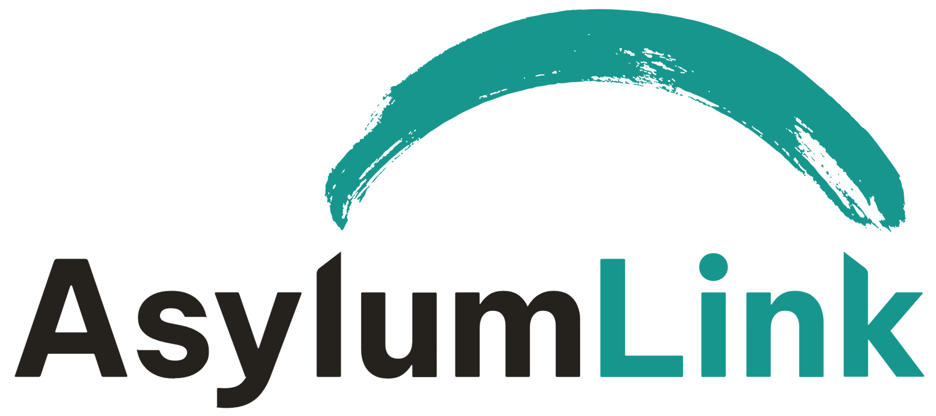

JOB DESCRIPTION: Fundraising and Communications Manager

Annual Salary: £33,100 FTE (Band 4, entry level), equivalent to £23,170 pro rata

Hours: 25.9 hours per week (0.7 FTE), normally worked across 4 days Monday to Thursday.
Flexibility is available over daily start and finish times; the postholder must be available to attend fortnightly Wednesday staff meetings from 13:00 to 14:30.
Some occasional evening or weekend work may be required for fundraising activities and events, with time off in lieu.

Location: St Anne’s Centre, Overbury Street, Liverpool, with some home working by agreement

Reports to: Chief Executive Officer

OVERVIEW OF THE ROLE
The Fundraising and Communications Manager will lead fundraising activity for Asylum Link Merseyside (ALM), with a particular focus on grant funding, while supporting the development of a more diverse income base. This will include developing high-quality funding applications, maintaining relationships with key funders, coordinating selected fundraising campaigns and activities, and growing the base of individual and corporate supporters.

The postholder will also coordinate and oversee ALM’s external communications, ensuring that its organisational website, fundraising pages, social media, publicity and supporter communications are accurate, engaging, consistent with ALM’s brand and aligned with its strategic priorities.

Given the part-time nature of the role, priorities and the balance between fundraising and communications will be agreed with the CEO through annual objective setting and performance management, with grant fundraising and funder reporting normally taking precedence.

KEY RESPONSIBILITIES:

Grant Funding
- Research and identify potential funding sources, including trusts, foundations, corporations, and individuals.
- Develop high-quality funding applications that contribute substantially to ALM’s income requirements and support its strategic priorities.
- Develop and manage a fundraising pipeline to maximise fundraising effectiveness.
- Work with relevant staff to draft realistic project proposals, budgets, outcomes and delivery plans.
- Follow ALM’s agreed proposal development and approval process, ensuring that applications receive the necessary internal approval before submission.
- Maintain accurate and accessible records of applications, funding agreements, grant conditions, reporting deadlines and relevant correspondence.
- Ensure that successful grants are handed over effectively to the staff responsible for delivery and financial monitoring.
- With the CEO, build and maintain relationships with funders as required.
- Keep up to date on the changing political landscape and policy context to inform the development of funding applications.

Diversified Income Generation
- Develop selected non-grant income streams, which may include individual giving, online fundraising, corporate partnerships, sponsorship and community fundraising.
- Explore new earned or unrestricted income opportunities, subject to agreement with the CEO and available capacity.
- Coordinate volunteers involved in fundraising activities, including providing direction and support to the volunteer small fundraising group.
- Develop and maintain positive relationships with individual donors, community supporters and corporate partners.
- Plan and deliver fundraising appeals and campaigns, including digital and match-funding campaigns.

Grant Management and Reporting
- Prepare high-quality and timely reports for funders, drawing on monitoring information provided by staff responsible for delivering funded work.
- Prepare written reports and verbal updates for the CEO as required, including progress against fundraising targets.
- Maintain oversight of grant conditions and reporting deadlines, working with programme and finance staff responsible for monitoring delivery and expenditure.
- Ensure that reporting requirements and other grant conditions are clearly communicated to the staff responsible for delivery.
- Ensure that funder approval is obtained and recorded before material changes are made to agreed activities, budgets or delivery periods.

Communications
- Develop a proportionate annual communications plan aligned with ALM’s strategic priorities and fundraising objectives.
- Oversee ALM’s external communications, including its website, fundraising pages, social media, newsletters, supporter communications, publicity materials and media activity.
- Coordinate a regular programme of content, drawing on information and contributions from colleagues and volunteers across ALM, ensuring that communications are timely, accurate and consistent in tone and branding.
- Maintain oversight of the content and accuracy of ALM’s website and coordinate necessary updates.
- Refer sensitive, potentially controversial or strategically significant external communications to the CEO for approval.
- Keep up to date with relevant developments in digital communications and fundraising, including the appropriate and responsible use of AI.

External Representation and Relationships
- Represent the organisation at relevant events to build awareness and support.
- Build relationships with relevant fundraising networks.
- Respond to external fundraising and partnership enquiries in consultation with the CEO and other relevant colleagues.

General Responsibilities
- Work collaboratively with staff, trustees and volunteers and contribute actively to team meetings and organisational planning.
- Maintain appropriate confidentiality and comply with ALM’s policies, procedures and data-protection responsibilities.
- Promote ALM’s values and its commitment to dignity, inclusion, equality and lived-experience involvement.
- Carry out other reasonable duties consistent with the nature and level of the role, as agreed with the CEO.

SKILLS AND EXPERIENCE

Essential
- A successful track record of fundraising, including preparing high-quality applications to trusts and foundations.
- Excellent written communication skills, with the ability to produce persuasive applications, clear reports and engaging public-facing content.
- Experience of managing relationships with funders, donors or other supporters.
- Strong organisational skills, including the ability to manage competing priorities, deadlines and accurate records.
- Good interpersonal skills and the ability to work collaboratively with colleagues, volunteers and external stakeholders.
- Sound judgement and a commitment to ALM’s mission and values.

Desirable
- Knowledge of the UK voluntary-sector funding environment.
- Experience of coordinating digital or external communications.
- Knowledge of issues affecting people seeking asylum and refugees.

Eligibility
- Candidates must have the right to work in the UK.
- Applications from people with lived experience of the asylum system are encouraged.

