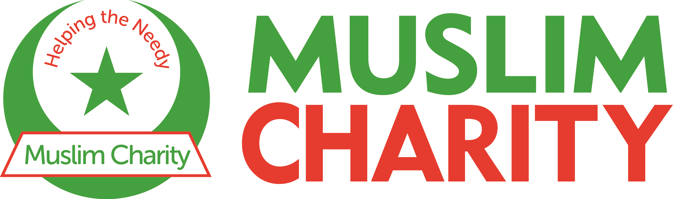

Organisation: Muslim Charity Helping The Needy
Position Title: Fundraising Administrator
Reporting to: Community Engagement and Fundraising Manager
Type: Full-Time
Hours: 37.5 hours per week
Salary: £25,000 to £28,000 per annum
Location: Muslim Charity, 9 Hessel Street, London, E1 2LR
Application deadline: 26th December 2025

ABOUT US:

Muslim Charity was founded over 25 years ago as a compassionate response to suffering and to tackle poverty across the globe. Muslim Charity has touched millions of vulnerable lives and implemented hundreds of relief and development projects as part of its humanitarian objectives and goals.

ROLE OVERVIEW:

The Fundraising Administrator plays a central role in supporting Muslim Charity’s Community Engagement and Fundraising Team through day-to-day operations. This role combines administration, volunteer coordination, community hub support and frontline communication to ensure our fundraising activities, events and community initiatives run smoothly and effectively.

KEY RESPONSIBILITIES:

Fundraising and Administration
- Maintain and track progress of departmental fundraising plans.
- Support colleagues in organising fundraising events, campaigns, challenges and field visits.
- Act as first contact for fundraising and volunteer enquiries via phone, email and social media.
- Ensure smooth communication with the Programmes Department for project feedback and reporting.
- Maintain databases, online donation pages (JustGiving, LaunchGood, Enthuse) and fundraising records.
- Provide administrative support for regional, national and international fundraising activities.

Manage Office and Community Hub
- Oversee daily operations of the Muslim Charity Community Hub at Hessel Street, London, ensuring it remains a safe, welcoming and vibrant space for local residents.
- Ensure compliance with health and safety, safeguarding and data protection policies in collaboration with the Line Manager and relevant staff.
- Manage use of facilities, office supplies and equipment, bookings of the Community Hub, documentation of the organisation’s minibus for community events.

Volunteer Recruitment and Coordination
- Assist with recruitment, induction and retention of volunteers to support fundraising, community projects and administrative work.
- Provide ongoing support, supervision and recognition for volunteers, fostering a positive and inclusive volunteering culture.
- Maintain accurate volunteer records and ensure all policies (including safeguarding) are followed.

Partnership and Relationship Development
- Support the development and maintenance of positive relationships with community groups, local partners and supporters.
- Identify opportunities for collaboration, sponsorship and local engagement.
- Represent Muslim Charity at local events, fairs and community forums.

Monitoring and Evaluation
- Support monitoring and evaluation of community and volunteer projects and assist in producing regular reports for management.
- Share learning, feedback and best practice across teams to enhance future delivery.

Any other duties commensurate with this post.

KEY WORKING RELATIONSHIPS:

- Reporting to the Community Engagement & Fundraising Manager
- Working with the Fundraising Team
- Coordinating with the Programmes Team
- Volunteer groups
- TeamMC groups – Cycle Club, Running Club, Hiking Club etc.

PERSON SPECIFICATION:

ESSENTIAL:

- Experience in administration, ideally within a charity, fundraising or community-focused environment.
- Strong organisational skills, with the ability to manage multiple tasks, meet deadlines and maintain accurate records.
- Excellent communication skills, both written and verbal, with confidence in handling enquiries via phone, email and social media.
- Good interpersonal skills, with the ability to build positive relationships with volunteers, supporters and community members.
- Competence in IT systems, including Microsoft Office, online forms, cloud-based tools and the ability to manage databases/CRM systems.
- Experience supporting events (planning, logistics, coordination) in either a paid or voluntary capacity.
- Understanding of safeguarding, data protection, health & safety and willingness to follow organisational policies and procedures.
- Ability to work flexibly, including occasional evenings and weekends to support community events or fundraising activities.
- Commitment to the mission, values and humanitarian principles of Muslim Charity.

DESIRABLE:

- Experience working with volunteers, including recruitment, induction, supervision or recognition activities.
- Experience maintaining or overseeing community spaces, drop-in hubs or similar public-facing environments.
- Familiarity with charity fundraising platforms (e.g., JustGiving, LaunchGood, Enthuse) and online donation processes.
- Knowledge of East London communities, local organisations and community networks.
- Experience in partnership building, community outreach or representing an organisation at local events.

At Muslim Charity, we believe diversity strengthens our community and enriches our mission. We are committed to fostering an inclusive environment where all individuals, regardless of background, race, gender, age, disability or faith, are valued. By embracing diverse perspectives, we enhance our ability to serve those in need. Please note that Muslim Charity reserves the right to interview and appoint a suitable candidate before the stated application deadline.

