

Faculties Development Manager

Job Description and Person Specification

1. Job Details
Job title: Faculties Development Manager
Department / Directorate: Examinations, Education and Faculties
Reporting to: Head of Faculties
Job Grade: Grade 5

2.Dimensions
1. Budget responsibility: Holds delegated accountability for Faculty budgets across an assigned portfolio. Leads preparation, monitoring, and forecasting of Faculty budgets; approves expenditure within agreed limits; identifies and manages financial risks; advises Faculty Executives on financial implications of proposed activity.
2. Number of direct/indirect reports: Formal line management of up to three staff (Faculties Development Lead, Faculties Coordinator and/or Faculties Administrator): performance management, development planning, wellbeing support, and day to day direction. Senior operational direction to the Faculties Development Lead on cross Faculty initiatives within their portfolio; professional guidance across the wider Faculties team.
3. Size/scope of projects or services managed: Strategic and operational leadership across three Faculties, including multiple concurrent governance cycles, development projects, income generating initiatives, and member engagement programmes. Works collaboratively with the other Faculties Development Manager on Faculties team wide objectives, cross Faculties initiatives and shared priorities across all six Faculties.

4. Geographic coverage: UK-wide and international Faculty membership and stakeholder networks; occasional UK travel; some international engagement may be required.

3. Job Purpose
The Faculties Development Manager leads the strategic and operational performance of three of the College's six Faculties. The role is accountable for Faculty governance, financial sustainability, member value, and team delivery, translating the Head of Faculties' strategic direction into effective, measurable outcomes across an assigned Faculty portfolio.

The postholder provides formal line management to Faculties Development Lead, Faculties Coordinators and the Faculties Administrator. They hold delegated authority for Faculty budgets and delivery plans, and acts as the primary professional relationship manager for Faculty Chairs and Office Bearers within their portfolio. The role sits at the boundary of strategic leadership and operational delivery, advising Faculty Executives, driving income generation, and holding accountability for Faculty performance.

The Faculties Development Manager is a key enabler of College strategy, ensuring their Faculty portfolio contributes to member value, financial sustainability, and governance excellence.

The two Faculties Development Managers work as part of a collaborative leadership team, led by the Head of Faculties, working across the full team to deliver strategic direction set by the Head of Faculties, contribute to its development, and ensure consistent performance across all six Faculties, whilst each taking accountability for the performance and delivery of their assigned portfolio.

Faculties Operating Model
The Faculties operate within a defined model of delivery, assurance, accountability, and strategy:
- Administrator: supports delivery
- Coordinator: delivers governance and operational outcomes within assigned Faculties applying agreed standards
- Development Lead: assures consistent application of standards, identifies gaps and leads cross Faculty delivery
- Development Manager: accountable for Faculty performance, governance compliance, and financial outcomes within agreed standards
- Head of Faculties: defines the operating model and standards, and holds overall accountability for system effectiveness, consistency, and strategic alignment
Each role is expected to operate within this structure, working within defined boundaries and escalating appropriately to avoid duplication of responsibility.

4. Key Accountabilities and Responsibilities
The Faculties Development Manager holds accountability for the strategic performance of their Faculty portfolio, not simply supporting delivery but accountable for it.
- Lead development of individual Faculy annual plans, objectives, and budgets, ensuring they are evidence based, ambitious, and aligned with College strategy and governance standards.
- Hold Faculty Executives accountable for delivery against agreed plans, providing challenge, support, and clear reporting on progress.
- Identify and develop opportunities for Faculty growth across membership, education, events, sponsorship, and accreditation , taking proposals from conception to implementation.
- Produce quarterly Faculty reports and impact summaries that demonstrate measurable progress against strategic objectives.
- Advise Faculty Chairs and Executive Committees on priorities, resource allocation, and return on investment, providing evidence based recommendations that shape Faculty decision making.
- Partner with the Head of Faculties to ensure Faculty strategy is aligned across all six Faculties and contributes coherently to College-wide objectives.
Governance Leadership
- The Faculties Development Manager is the accountable governance owner for their Faculty portfolio, responsible for the quality, compliance, and integrity of governance across assigned Faculties.
- Ensure all Faculty activities comply with College governance frameworks, charity regulations, and the Charity Governance Code.
- Support the Development Lead and Coordinator to deliver induction, succession planning, and term limit management of Faculty Office Bearers and Committee members within the portfolio.
- Oversee governance records, committee documentation, and reporting frameworks across assigned Faculties, holding the Faculties Coordinator and Administrator accountable for delivery to standard.
- Resolve complex or sensitive governance matters, providing professional judgment on interpretation of policy and regulatory requirements, escalating to Head of Faculties where required.
- Work with the Development Lead to ensure cross Faculty governance standardisation and drive improvement where standards fall short.
People Leadership and Team Management
- The Faculties Development Manager provides formal leadership and line management to their direct reports, and role models the professional culture and standards for the team they lead.
- Provide effective line management to Faculties Development Lead, Faculties Coordinators and Faculties Administrator: set clear objectives, hold regular one to ones, conduct performance reviews, and support development.
- Build individual and collective capability within the team, identifying development needs and creating opportunities for growth and progression.
- Promote a culture of accountability, continuous improvement, and member focus across the team.
- Manage workload allocation and capacity across direct reports, identifying and resolving pressure points before they affect delivery, escalating to Head of Faculties where required.
- Model the professional standards and behaviours expected across the Faculties team.
Financial Sustainability and Income Generation
- Hold delegated accountability for Faculty budgets: lead preparation, monitor performance, manage variances, and report to the Head of Faculties and Faculty Executives.
- Identify and lead income generation opportunities through membership growth, events, sponsorship, and educational activity, developing the business case and driving delivery.
- Advise Faculty Executives on the financial implications of proposed projects, ensuring initiatives demonstrate a clear return on investment before approval.
- Promote efficient use of resources and challenge proposals that do not represent value for money.
- Ensure financial reporting is accurate, timely, and supports sound decision making at Faculty and College level.
Stakeholder and Volunteer Leadership
- Serve as the primary senior relationship manager for Faculty Chairs and Office Bearers within the portfolio, building trust, setting expectations, and providing strategic oversight of volunteer relationships managed day to day by the Faculties Development Lead and Faculties Coordinator.
- Represent assigned Faculties within internal College networks and at external events, ensuring Faculty achievements and priorities are visible and well understood.
- Act as the escalation point for volunteer situations that the Development Lead or Coordinator have been unable to resolve, applying sound judgement and College governance principles to high risk or high stakes cases. Escalating to Head of Faculties where required.
- Lead Faculty engagement with cross College partners including Education, Membership, Finance, Governance Risk and Compliance, Partnerships, and Marketing, ensuring Faculty activity is well-integrated and strategically aligned.
- Ensure Faculty communications, events, and member engagement activity meet College standards and deliver demonstrable member value.
- Faculties Development Managers identify and develop external partnerships that advance Faculty objectives, ranging from one off collaborative activity such as joint webinars or sponsored events through to formal agreements including formal partnership agreements and co-created educational outputs. They lead the relationship from initial identification through to delivery, ensuring partnerships deliver measurable value for members and align with College strategy.
Cross Faculty Development and Continuous Improvement
- Contribute to the College wide Faculty strategy and cross Faculty improvement agenda, working with the Head of Faculties and the other Faculties Development Manager to identify and share best practice.
- Lead or sponsor cross Faculty improvement projects within the portfolio where Faculty-level leadership is required.
- Provide strategic direction to the Development Lead on cross-Faculty initiatives, ensuring they are aligned with Faculty plans and priorities.
- Champion data driven decision making and embed evaluation and impact measurement across Faculty activity.
- Contribute to the development of team training, guidance materials, and induction resources that raise standards across the Faculties team.

5. Impact of the Role
The Faculties Development Manager directly determines the strategic performance, governance quality, and financial sustainability of three Faculties. Their decisions on Faculty plans, budgets, and volunteer management shape Faculty outcomes and the College's reputation in those professional communities.

The postholder operates with significant delegated authority, making management decisions independently, leading income generation, holding governance accountability, and managing senior volunteers, escalating where matters require Head of Faculties input, or where expenditure or decisions fall outside delegated limits.

The quality of volunteer relationships held by the postholder has a direct and material impact on the College's reputation. Faculty Chairs and Office Bearers are senior clinical professionals whose experience of the College is largely shaped through the Faculties team. Trusted, well managed relationships provide an early warning system, identifying and containing issues before they escalate to formal risk. Poor volunteer management carries the opposite effect. The postholder is expected to hold relationships that are honest, boundaried, and genuinely trusted, so that difficult conversations happen early and the College's interests are protected.

Their effectiveness as a people manager directly affects the performance, wellbeing, and development of their direct reports, and sets the professional culture for the wider Faculties team.

6. Communication Requirements
- Senior level engagement with Faculty Chairs, Office Bearers, and Executive Committee members, requiring the ability to influence, negotiate, provide professional challenge, and manage complex interpersonal dynamics with senior clinicians and volunteers.
- Regular strategic dialogue with the Head of Faculties, contributing to Faculty strategy, raising risks and opportunities, and translating direction into Faculty level plans.
- Cross College partnership with Education, Finance, Membership, Governance Risk and Compliance, Partnerships, and Marketing, negotiating and aligning priorities to maximise Faculty impact.
- Preparation of high quality reports, briefing papers, Faculty plans, and performance summaries for Faculty Executives, Head of Faculties, and SLT.
- Management communications with direct reports: clear, consistent, and timely, setting expectations, providing feedback, and addressing issues constructively.
- External representation of the College and Faculties at events, partner meetings, and professional forums.

7. Innovation and Problem Solving
- Leads resolution of complex, cross functional governance, operational, and strategic challenges across multiple Faculties, applying professional judgement and escalating only where strategic or resource decisions require Head of Faculties input.
- Identifies and drives systemic improvements to Faculty operations, governance, and member engagement, developing solutions that are sustainable and scalable across the portfolio.
- Balances competing stakeholder expectations and resource constraints, making active prioritisation decisions that maintain delivery and stakeholder confidence.
- Develops creative and evidence based approaches to income generation, Faculty development, and member engagement within the College's strategic and financial framework.
- Acts as a senior problem solving resource for the team, coaching direct reports to resolve issues at the appropriate level rather than escalating unnecessarily.

8. Knowledge, Skills & Experience
Essential
- Significant management experience in a professional body, membership organisation, healthcare, education, or charity setting, including formal line management of staff.
- Demonstrable track record of leading volunteer, programme, or operational delivery at a senior level, with accountability for outcomes against plans and budgets.
- Strong working knowledge of governance frameworks, committee structures, charity regulation, and compliance requirements.
- Proven ability to build and manage relationships with senior professionals and volunteers, including in complex, sensitive, or contentious situations.
- Financially literate, with experience in budget accountability, financial planning, monitoring, and reporting.
- Demonstrated ability to identify and develop income generation opportunities, building business cases and leading delivery.
- Excellent written and verbal communication, including preparation of strategic reports, briefing papers, and Faculty plans for senior audiences.
- Experienced people manager with a track record of developing individuals and teams, managing performance, and promoting wellbeing.
- Proficient in Microsoft Office 365, including Teams, SharePoint, and Excel.
Desirable
- Experience in a professional body, Royal College, or healthcare regulatory environment.
- Experience leading or sponsoring organisational change or governance improvement programmes.
- Postgraduate qualification in management, education, governance, or a related field.
- Familiarity with the Charity Governance Code or equivalent professional governance frameworks.
- Understanding of membership systems, volunteer governance, and professional standards frameworks.

9. Risk and Working Conditions
- Edinburgh based with hybrid working flexibility; occasional UK travel for Faculty meetings, events, and stakeholder engagement; some international travel may be required.
- Evening and weekend commitments occasionally required to support Faculty governance meetings or events.
- High mental demands: simultaneous management of multiple Faculty portfolios, senior volunteer relationships, budget accountability, and team leadership under competing deadlines.
- Requires sustained resilience and sound judgement when balancing the expectations of senior clinicians, Faculty Executives, College leadership, and direct reports.
- Regular exposure to sensitive governance, financial, and personnel matters requiring discretion and compliance with data protection and College confidentiality standards.
- Must lead with clarity and authority in situations of ambiguity, managing volunteers whose engagement is shaped by differing motivations, professional priorities, and availability.

10. Organization Chart
Two Faculties Development Managers sit within the team, each reporting to the Head of Faculties. Both Managers lead across all six Faculties, working collaboratively as a leadership team with the Head of Faculties. Individual portfolio responsibility and areas of ownership are agreed with the Head of Faculties.
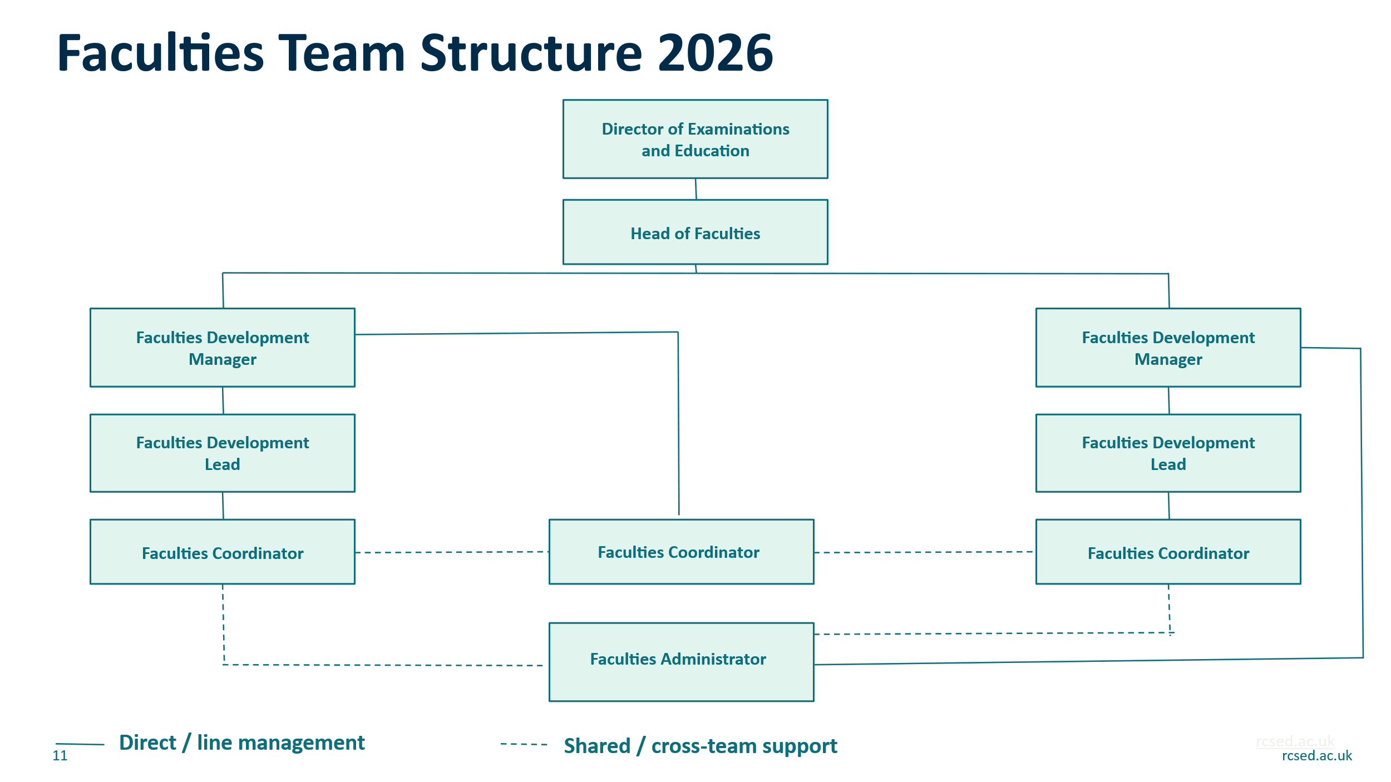
11. Person Specification

Criteria | Essential | Desirable
Formal line management of staff, including performance management and development | Yes
Senior level leadership in a professional body, membership, healthcare, charity, or education setting | Yes
Accountability for programme, or operational budgets | Yes
Governance leadership including complex committee management and regulatory compliance | Yes
Managing senior professional or volunteer stakeholders in complex or sensitive situations | Yes
Identifying and developing income generation opportunities | Yes
Leading or sponsoring organisational change or improvement programmes |  | Yes
Experience in a Royal College, professional body, or healthcare regulatory environment |  | Yes

Qualifications
Criteria | Essential | Desirable
Degree in relevant subject | Degree-level education or equivalent professional experience | Postgraduate qualification in management, education, or healthcare leadership
Professional certification (e.g. CIPD, ACCA) |  | Professional certification in management, education, or healthcare leadership
Evidence of continuing professional development | Demonstrable commitment to ongoing professional learning and leadership development

3. Skills & Knowledge
Criteria | Essential | Desirable
Excellent written and verbal communication, including strategic reports and papers for senior audiences | Yes
Strong organisational and planning skills across multiple concurrent priorities and deadlines | Yes
Financial literacy: budget accountability, planning, monitoring, and reporting | Yes
In-depth understanding of governance frameworks, charity regulation, and committee standards | Yes
Proficiency in Microsoft 365 (Teams, SharePoint, Excel, Outlook) | Yes
Ability to analyse data and produce evidence-based recommendations | Yes
Knowledge of membership engagement, volunteer management, or professional standards frameworks |  | Yes
Familiarity with the Charity Governance Code or equivalent frameworks |  | Yes

4. Behavioural Competencies
Competency | Description
Strategic Leadership | Translates Head of Faculties' strategic direction into Faculty level plans with clear outcomes. Holds Faculty Executives accountable for delivery. Advises with authority on priorities, resources, and risk.
People Leadership | Provides effective, consistent line management. Develops direct reports through clear objectives, regular feedback, and genuine investment in their growth. Addresses performance issues directly and constructively.
Governance Accountability | Holds accountability for the governance quality and compliance of assigned Faculties. Ensure governance standards are met and holds accountability for compliance and ensures it is met, does not delegate governance responsibility.
Financial Stewardship | Leads Faculty budget processes with discipline and transparency. Challenges spend that does not demonstrate value. Proactively identifies income opportunities and manages financial risk.
Stakeholder Leadership | Builds senior relationships grounded in trust, clarity, and professional authority. Manages complex volunteer dynamics with diplomacy and confidence. Represents the College credibly at all levels.
Collaboration | Works constructively across College Directorates and with the wider Faculties team. Shares insight, supports cross Faculty alignment, and contributes to a culture of collective accountability.
Communication and Influence | Communicates with clarity, authority, and diplomacy. Influences decisions through evidence and professional credibility. Adapts style for diverse audiences from senior clinicians to administrative colleagues.
Accountability and Integrity | Takes ownership of Faculty outcomes and team performance. Delivers on commitments. Models the professional standards and values expected across the Faculties team.

11. Signature and Date
Prepared by: Gill Mitchell, Head of Faculties
Date: 04/11/2025
Approved by:
Head of Department
Date:

