Faculties Coordinator

Job Description and Person Specification

1. Job Details
Job title: Faculties Coordinator
Department / Directorate: Exams, Education and Faculties
Reporting to: Faculties Development Manager
Job Grade: Grade 3

2. Dimensions
Budget responsibility: Responsible for input and tracking of working budgets for Faculty events and projects; provides input to support management decision making and Faculty reporting.
Number of direct/indirect reports: No formal line management. Provides mentoring to Administrators within the Faculties team. Acts as first point of escalation for operational issues.
Size/scope of projects or services managed: Operates within agreed processes covering governance and project delivery across assigned Faculties and defined workstreams; runs concurrent governance cycles, projects and member engagement workflows within agreed parameters.
Geographic coverage: UK wide and international membership and volunteer engagement across multiple Faculties.

3. Job Purpose
The Faculties Coordinator is responsible for governance delivery and operational processes across assigned Faculties and workstreams. The role is the primary point of contact for assigned governance cycles, projects and member and volunteer processes within the postholders portfolio of activity.

The Coordinator works within defined frameworks under the direction of the Faculties Development Manager, escalating where issues extend beyond Faculty level delivery. On cross Faculty projects and initiatives, task direction is provided by the Faculties Development Lead.

The role provides a development pathway toward the Faculties Development Lead.

Faculties Operating Model
The Faculties operate within a defined model of delivery, assurance, accountability, and strategy:
- Administrator: supports delivery
- Coordinator: delivers governance and operational processes within assigned Faculties applying agreed standards
- Development Lead: assures consistent application of standards, identifies gaps and leads cross Faculty delivery
- Development Manager: accountable for Faculty performance, governance compliance, and financial outcomes within agreed standards
- Head of Faculties: defines the operating model and standards, and holds overall accountability for system effectiveness, consistency, and strategic alignment
Each role is expected to operate within this structure, working within defined boundaries and escalating appropriately to avoid duplication of responsibility.

4. Key Accountabilities and Responsibilities
Governance and Project Delivery
- The Faculties Coordinator is responsible for governance and project delivery within defined standards across assigned Faculties, not just task completion but outcome quality and compliance.
- Works collaboratively to support the delivery of the full governance cycle for assigned Faculties: planning, scheduling, papers, agendas, minutes, and action close out to agreed standards and timescales.
- Supports active monitoring of governance compliance, including term limits, conflicts of interest, quorum requirements, and attendance, escalating risks proactively to the Faculties Development Manager.
- Hold operational accountability for board and committee actions: track, chase, and unblock outstanding items; do not simply record them.
- Applies governance standards within assigned Faculties and escalates non-compliance, policy interpretation or cross Faculty issues.
Project and Programme Delivery
- Deliver defined Faculty projects within assigned Faculties, managing to time, quality, and budget with clear milestone management.
- Prepare high quality committee papers, briefing notes, minutes, and action logs for assigned Faculties, to agreed standards and timescales.
Member and Volunteer Engagement
- Manages day to day contact for volunteers within assigned Faculties and activities, ensuring professional and responsive engagement.
- Support volunteer recruitment, induction, and term limit management within assigned Faculties, working within agreed processes.
- Manage routine volunteer relationships within assigned Faculties, escalating to the Development Lead where issues involve cross Faculty implications, policy interpretation, or persistent non-compliance or anything beyond day to day operational management
- Orchestrate membership workflows, including assessed membership processes, monitoring service levels, pipeline progression, and applicant communications to drive conversion and engagement.
Financial Stewardship
- Input into working budgets for Faculty events and projects, forecasting spend against plan and flagging variances early.
- Prepares and inputs financial data to support management decisions and Faculty reporting.
- Contribute key information and insights to business cases using data to inform resource and investment decisions.
Team Support and Continuous Improvement
- Provide guidance and support to Administrators, promoting consistent service standards across the Faculties team and quality of delivery within assigned Faculties.
- Act as first point of escalation for operational issues arising within the delivery remit, resolving within defined parameters and escalating where required.
- Apply agreed standards and processes within assigned Faculties, supporting the implementation of improvements led by the Development Lead.
- Contribute to team resilience through cross cover actively sharing knowledge to support continuity of service during peak periods.

5. Impact of the Role
The Faculties Coordinator plays a direct role in the quality, consistency, and reliability of governance and strategic delivery across assigned Faculties. The postholder ensures reliable and consistent delivery of governance and operational activity within assigned Faculties.

The postholder exercises judgement within defined frameworks and processes, making routine operational decisions without referral. Escalates where issues involve policy interpretation, cross Faculty implications or risk. Their work directly affects the College's governance reputation and member and volunteer experience

6. Communication Requirements
- Regular engagement with volunteers, requiring diplomacy, negotiation, and professional boundary setting.
- Close working relationship with Faculties Development Managers and Faculties Development Lead, providing progress updates, raising risks early, and contributing to planning.
- Liaison with internal College teams (Finance, Education, Examinations, Membership, Marketing and Communications, Governance, Risk and Compliance, Partnerships) to ensure coordinated delivery.
- Preparation of high quality committee papers, briefing notes, minutes, and member communications for assigned Faculties and projects.

7. Innovation and Problem Solving
- Resolves operational and governance issues with support within defined paramaters and guidance from the Development Lead and Manager, applying sound professional judgement, escalating where risk, policy, or strategic direction requires senior input, first to Faculties Development Lead and then to Faculties Development Manager where required.
- Identifies and contributes to process improvements within assigned Faculties, implementing changes led by the Development Lead.
- Manages competing priorities across multiple governance cycles, projects, and Faculties simultaneously, making active trade off decisions.
- Applies creativity and pragmatism in problem solving for operational problems, escalating to the Faculties Development Manager as required

8. Knowledge, Skills & Experience
Essential
- Experience coordinating projects or programmes with multiple stakeholders and concurrent workstreams.
- Understanding of governance frameworks, compliance requirements, and meeting administration standards.
- Excellent written and verbal communication, with the ability to draft professional papers, minutes, and briefings for senior audiences.
- Confident in managing senior professionals and volunteers, including in challenging or sensitive situations.
- Strong financial awareness with experience tracking budgets and preparing management information.
- Proficient in Microsoft Office 365, particularly Teams, SharePoint, and Excel.
Desirable
- Experience in a professional body, healthcare, education, or regulatory environment.
- Familiarity with CRM systems and membership management processes.
- Project management training or equivalent structured project delivery experience.

9. Risk and Working Conditions
- Edinburgh based with hybrid working available; occasional UK travel to support events or meetings.
- Occasional evening or weekend work to support governance commitments or events. Advanced notice given where required.
- High mental demands: complex multi Faculty governance cycles, competing deadlines, and senior volunteer relationships require sustained concentration, professional resilience, and sound judgement.
- Responsibility for confidential governance and personal data requiring discretion and compliance with data protection standards.

10. Organization Chart
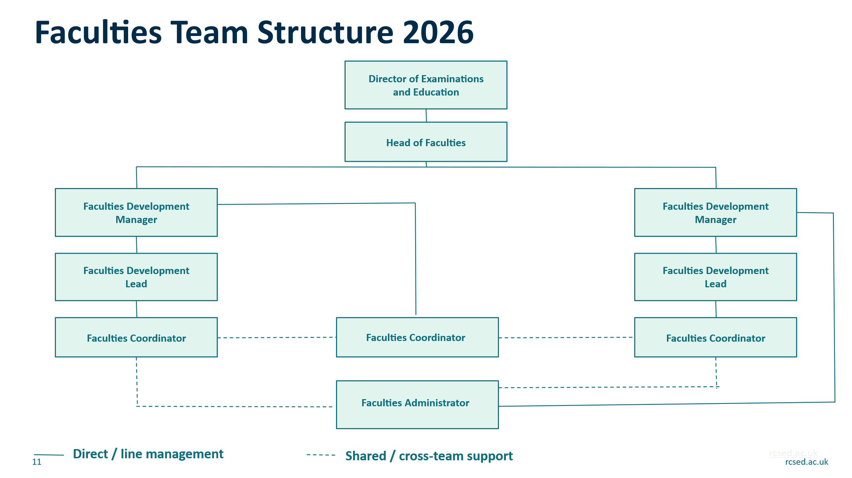

11. Person Specification

Qualifications
Criteria | Essential | Desirable
Degree in relevant subject | Degree-level education or equivalent professional experience
Professional certification | Demonstrable commitment to ongoing professional learning and leadership development

2. Experience
Criteria | Essential | Desirable
Governance / committee administration | Yes
Project Coordination or event support | Yes
Working with volunteers or senior professionals | Yes
Experience in a professional body, healthcare, or education setting |  | Yes

3. Skills & Knowledge
Criteria | Essential | Desirable
Strong written and verbal communication | Yes
Excellent organisation and prioritisation | Yes
Microsoft 365 (Teams, SharePoint, Excel) | Yes
Understanding of governance processes |  | Yes
Budget input, tracking and reporting |  | Yes
Knowledge or membership or education environments |  | Yes

4. Behavioural Competencies
Competency | Description
Governance Ownership | Takes responsibility for the quality and compliance of governance delivery across assigned Faculties; does not delegate standards.
Collaboration | Works constructively with colleagues, volunteers and partners; shares information openly; and contributes to collective problem-solving across Faculties.
Communication | Provides clear, authoritative, and professional communication; adapts tone and approach for different audiences; manages difficult conversations with confidence and respect.
Member Focus | Understands member needs and ensures decisions and actions enhance member value, engagement and experience.
Accountability | Takes ownership of delivery outcomes, not just tasks; meets deadlines reliably; upholds governance standards with accuracy and integrity.
Adaptability | Responds calmly and effectively to change and competing demands; adjusts priorities confidently when needed; and maintains professionalism under pressure.
Professionalism | Demonstrates integrity, respect and discretion; represents the College positively; and upholds organisational values in all interactions.

11. Signature and Date
Prepared by: Gill Mitchell Head of Faculties
Date:
Approved by:
Head of Department
Date:

