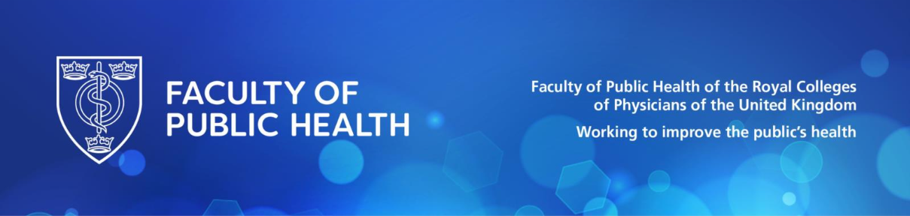
Events Coordinator

Accountable to: | Director of Operations & Membership Systems
Hours/Contract: | 35 hours per week – 2 years fixed term with the intention to make permanent
Salary: | £30,000 per annum
Place of work: | Currently, a minimum of one day per week in our London office and home working
Key Responsibilities

- Plan and deliver a wide range of Public Health related events including producing event ideas and working with key stakeholders to scope and finalise a portfolio of events for the year ahead.
- Manage in person event logistics including venues, accommodation, catering, AV and delegate communications.
- Coordinate online events using platforms such as Zoom and Teams.
- Manage event registrations for all FPH events.
- Coordinate the in-person Annual Awards Ceremony, including venue liaison, event planning and prep and on the day management

Events Administration

- Create event plans, timelines and schedules, coordinating across departments
- Manage event approvals including liaison with the comms team for advertising
- Liaise with event organisers/speakers for logistics and planning
- Arrange online events and webinars as per requests, including sharing meeting details
- Coordinate and host online events and provide support to the chair/organiser as required during the event
- Support event evaluation and continuous improvement including the dissemination of feedback requests and recording links
- On the event day involvement and support including arranging set up
- As required, source venue space for FPH in person events and meetings
- Identify and negotiate bulk accommodation for FPH events
- Identify, develop, implement and maintain administrative procedures/systems for events management

Other administration

- Courier and postage bookings and arrangements
- Maintain a supplier contact list
- Arrange travel and hotel arrangements for a range of stakeholders including staff

Person Specification

We’re looking for a highly organised, creative, and proactive Events Coordinator to plan and deliver our programme of in-person and online events.

You’ll be the go-to person for making sure everything runs smoothly — from planning and logistics to communication and on-the-day delivery. Working closely with other staff, key stakeholders, and local event hosts, you’ll play a key role in bringing the FPH Membership community together. We’re looking for someone who:

Essential

- Has substantial experience (at least 2 years’) in organising and delivering successful events in a charity or, membership setting
- Has experience of and is confident running both in-person and virtual events
- Brings strong organisational skills, attention to detail, and a solutions-focused mindset
- Is great at building relationships and working with a range of stakeholders
- Is comfortable working independently from home, while staying connected with a remote team
- Proficiency in Microsoft Office and experience using Zoom/Teams webinar tools
- Excellent written communication skills and strong verbal communication skills, able to engage with high-level internal and external stakeholders
- An understanding of how to effectively utilise Microsoft Dynamics CRM or the willingness to learn and adapt their skills

Desirable:

- Can create professional-looking event materials using Canva (or similar)
- A background or interest in Public Health would be ideal, but curiosity and enthusiasm are just as valuable

Benefits of working for FPH

- Competitive salary
- Employer contribution to pension scheme of up to 12.5% of salary
- Annual leave of 29 days per annum, plus bank holidays
- Employee Assistance Programme – helpline and advice
- Free annual eye-test and £100 contribution towards eyewear
- Cycle to Work Scheme/ Season Ticket Loan
- Central London location in Regent’s Park
- Life Assurance Scheme
- Health and Wellbeing Contribution
- Annual Vaccines

NB. Some of these benefits are only applicable upon successful completion of probationary period.

Inclusion matters
The organisation is committed to fairness, equity and inclusion. You will be welcomed, supported and valued for who you are, and encouraged to bring your full self to work. People from all backgrounds and identities are invited to apply. We want you to have every opportunity to demonstrate your skills, ability and potential; please contact us if you require any assistance or adjustment so that we can help with making the application process work for you.

Application

The deadline for applications is Sunday 18th January 2026. Early applications are strongly encouraged.

To apply please email jobs@fph.org.uk with your CV and a covering letter of no more than 500 words.

