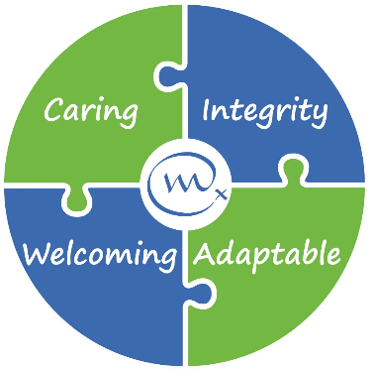

Job Vacancy
Weldmar Hospicecare provides specialist care for adults in Dorset who have a life limiting illness, and support for their loved ones. We are dedicated to fostering a culture of equality, diversity, and inclusion across all aspects of our organisation. 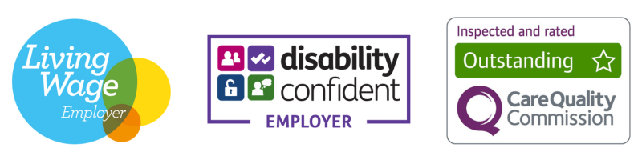
Weldmar Hospicecare is Dorset's largest independent charity and moving in an exciting new direction in fundraising. This is a brand new role, driving our events and community fundraising strategy.

You'll lead a dedicated team of both staff and volunteers, delivering high quality mass participation campaigns, and build lasting partnerships with our supporters and fundraisers.

Working alongside fellow fundraising managers and reporting to the Director of Fundraising, your key responsibilities will be to:

- Develop and implement annual engagement strategies, including bespoke and ‘off the shelf’ challenges and events.
- Hold line management responsibility, providing regular supervision, identifying development opportunities, and fostering a collaborative environment.
- Oversee income targets, budgets, and KPIs with a focus on high ROI.
- Represent Weldmar at networking events and lead the development of community ambassadors.

If you are proactive, with an in-depth knowledge of charity income generation, we'd love to hear from you. You should have a proven track record of hitting financial targets and the leadership skills to motivate both staff and volunteers. Excellent communication skills are essential, as you will need to engage with everyone from corporate partners to patients and their families with empathy and professionalism.

A Basic Disclosure and Barring Service (DBS) Check is required for this role.
Closing Date: 1st June 2026 Interview date: W/C 8th June 2026
For a Candidate Pack including full job description, go to weldmarhospicecare.org/jobs
For more information, contact recruitment@weld-hospice.org.uk or call 01305 269898
Events and Community Fundraising Manager
Permanent Contract
£40,625 Per Annum for 37.5 hours per week

