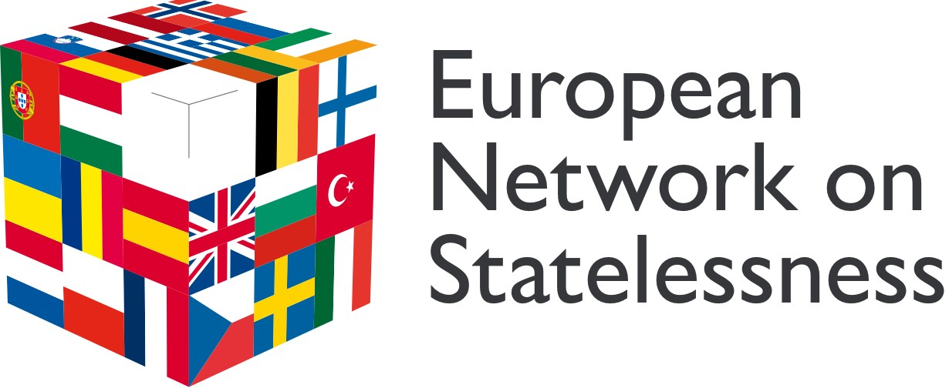

Digital Trustee – December 2025

Type of Role: Volunteer Trustee (This role is not remunerated. Out-of-pocket expenses will be covered.)

Location: London (United Kingdom) & online

Time Commitment: The appointment of Trustees is for an initial three-year term. The time commitment for Trustees is estimated to be 30-60 hours per year, including quarterly Board meetings alternating online and in-person (usually during office hours), sub-committee meetings, and other engagement (flexible and mostly out of office hours).

Applications will be reviewed on a rolling basis.

About Us
The European Network on Statelessness (ENS) is a civil society alliance of organisations and individuals working to promote the right to a nationality in Europe. Our network brings together over 180 members in more than 40 countries and includes grassroots community organisations, national and international NGOs, legal advice agencies, think tanks, individuals with lived experience of statelessness, and other experts. Since establishing in 2012, we have been dedicated to raising awareness about statelessness and the right to a nationality, supporting legal and policy development, and building civil society’s capacity to act. At the heart of our work lies the understanding that stateless people and their communities should be the leaders of change.

ENS is a Charitable Incorporated Organisation (CIO), registered with the Charity Commission of England and Wales (Charity No 1158414). While both the CIO and its secretariat are based in the UK, we are committed to ensuring that our Board of Trustees reflects the diversity of our membership. To achieve this, we actively seek to include trustees based in countries across Europe, ensuring broad representation and perspectives.

About the Role
As a Digital Trustee with expertise in AI and digital technologies, including regulation of AI use within organisations, you will play a pivotal role in providing strategic direction to our ethical AI adoption and digital transformation. This position is a voluntary trustee role, requiring a passionate and dedicated individual with experience in emerging tech trends, particularly in the non-profit sector and a genuine commitment to the values and objectives of our organisation.

Main Responsibilities
As a trustee of ENS, you will have a range of statutory duties as detailed by the Charity Commission here.
In addition, you will:
- Contribute to the board’s role in setting strategic direction to the charity, setting overall policy, defining goals and setting targets and evaluating performance against agreed targets;
- Support fundraising and act as an ambassador for ENS;
- Attend four Board meetings per year (mix of hybrid and face-to-face), including one/ two in-person away days and relevant subcommittee meetings as required;
- Provide oversight on digital risk and cybersecurity;
- Champion regulated, ethical AI use within ENS;
- Advise on training and development needed to ensure that staff have the necessary digital skills;
- Provide support and advice to the ENS Senior Leadership Team in relation to digital transformation in support of improved operational effectiveness.

Personal attributes
- Experience with digital transformation, AI applications, and emerging tech trends;
- A deep understanding of the ways in which digital transformation and ethical AI adoption is planned and delivered in small-medium organisations, preferably in the non-profit sector;
- Familiarity with ethical AI, data privacy, and responsible innovation
- Competency in systems such as MS365, Canva, CRM and collaborative platform
- Good communication and interpersonal skills;
- Tact and diplomacy, willingness to challenge and constructively criticise.
- Understanding and acceptance of the legal duties, responsibilities and liabilities of trusteeship.
- Commitment to ENS's aims and values and willingness to devote time to carry out responsibilities.
- Willingness to be available to staff and trustees for advice on an ad hoc basis;
- Ability to distil complex technical topics into accessible insights.
- Be eligible for a trustee role. More information about people disqualified from being a charity trustee can be found here.

How to Apply
If you are enthusiastic about making a positive impact and possess the skills and dedication required for this role, please submit a CV and cover letter outlining your relevant experience and interest to ENS Director, Chris Nash at chris.nash@statelessness.eu. Feel free to reach out for an initial informal conversation if you have any questions about the role.

We particularly welcome applications from stateless (or formerly stateless) individuals, and people from a migrant, refugee, or minority background. If you require support with your application, please get in touch to discuss this further with us.

Data policy
The European Network on Statelessness (ENS) is a registered Charitable Incorporated Organisation in England (charity number 11583414). Our address is Canopi, 82 Tanner Street, London, SE13GN, United Kingdom. ENS is committed to ensuring that your privacy is protected. Any data requested will be used for recruitment purposes only; to screen candidates and judge their suitability to progress to interview. ENS will not share the data with other organisations for marketing purposes. Data collected in the UK is held in accordance with the General Data Protection Regulation (EU) 2016/679 and the UK Data Protection Act 2018. The information we collect from you will be stored in the European Economic Area ("EEA"). We will keep your personal information for 12 months after which it will be deleted, unless a longer or shorter retention period is required by law, is necessary in the course of legal proceedings or is otherwise needed for a particular purpose under applicable law. We may keep your personal information for a shorter period if you ask us to delete your personal information. In such a case, ENS will aim to delete your personal information within a maximum period of one month from the date of the request. You have the right to request a copy of data we hold on you, to rectify your data and to restrict processing of your data. You can email at info@statelessness.eu or write to us at c/o European Network on Statelessness, Canopi, Arc House, 82 Tanner St, London SE1 3GN, United Kingdom. For more information on how we process data and your rights please read our general privacy policy.

Safeguarding
ENS is committed to Safer Recruitment and all appointments are subject to satisfactory references and checks as required and in line with our Safeguarding Policy and Procedures. More information, including a copy of ENS’s Safeguarding Policy, can be provided on request.

