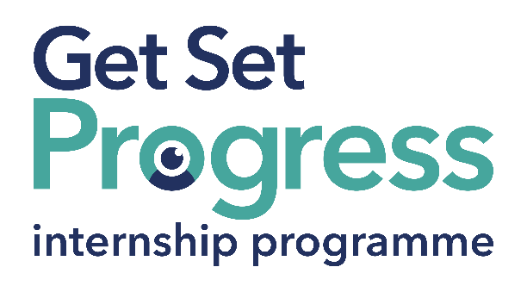

Employment Intern

Join us at Thomas Pocklington Trust
Thomas Pocklington Trust (TPT) and RNIB are collaborating with organisations from both the sight loss and wider charity sector as well as corporate organisations to create new opportunities for blind and partially sighted people to find employment through the Get Set Progress (GSP) Internship programme. Thomas Pocklington Trust is delighted to be offering an internship as part of the Get Set Progress scheme. This internship may be suitable for someone looking to gain experience, develop workplace skills, build confidence in employment, or take the next step in their career. We welcome applications from people at different stages of their employment journey.
Thomas Pocklington Trust is a national charity dedicated to delivering positive change blind and partially sighted people.
Our mission is to support blind and partially sighted people of all ages to live the life they want to lead.

Our Values
Our values define everything we do:
Authentic - Everything we do is anchored in inclusion and the lived experience of blind and partially sighted people.
Constructive - We are proactive and have a “can do” approach, seizing opportunities and solving problems.
Tenacious - We are passionate and persistent in our work, and we will do the right thing, even when it is hard.

Job description

Role: Employment Intern
Department: Employment
Reporting to: Employment Manager
Location: Hybrid – you’d normally be in the office twice a week.
Salary: Based on the Real Living Wage
Contract type: Fixed Term, 9 month contract

Purpose of the role:

To support the delivery of Thomas Pocklington Trust’s Works For Me and Get Set Progress Internship programmes. To be the first point of call for clients into our service and to contribute to the smooth running of the Employment Team through administrative tasks.

This would be a great opportunity for someone who is motivated and enthusiastic. Whether you are looking to start or re-start your career, or build on existing experience, the role offers the opportunity to develop new skills and gain valuable experience within an employment support team.

Main responsibilities:

- To answer phone calls and emails from job seekers and (with training) and to act as first contact for new clients of the Works For Me Employment Programme or the Get Set Progress Internship Programme.
- To develop casework and advice skills.
- To support individuals with writing CVs, job searching, preparing for an interview, writing applications
- To learn to input client information into the Salesforce database.
- To take minutes of Employment Team meetings.
- To assist in maintaining a safe working environment and attend training in basic and specialist Health and Safety requirements.
- Positively work in support of the principles outlined in the Equality and Diversity Policy.
- Any other relevant task as directed by the Employment Manager, Development Manager, Head of Employment.

Person specification

Essential criteria:

- Works well with others and builds positive working relationships.
- Strong problem-solving skills, with the ability to identify practical solutions and changing situations
- Willingness and ability to develop coaching and influencing skills
- Can use Microsoft Office, including Word, Excel, Outlook and Teams, and is willing to learn new systems.
- Can work independently, use initiative and keep learning.
- Communicates clearly in writing and in conversation with different people.

Desirable Criterion

- Some experience in recruitment, careers guidance, or providing advice and support to job seekers

Important information:

- This role has a Genuine Occupational Requirement that the successful applicant be a person who is blind or partially sighted, in line with The Equality Act 2010.
- Interns need to be able to travel to the TPT Hub in London on average twice a week for collaboration and for intern development events throughout the course of the internship programme (costs covered by TPT).
- Having not previously undertaken the Get Set Progress internship programme.
- Successful applicants must have the Right to Work in the UK for the duration of the Internship. Sponsorship will not be provided.

Closing date: 14th July 2026

What are the benefits of a Get Set Progress internship for me?
As part of your 9-month internship, you will be part of a large cohort of fellow interns and gain the following:
- Obtain valuable work experience within the charity sector
- Technology support (Including Microsoft Office) and upskilling opportunities
- Online and in-person Training and development opportunities
- Opportunity to present and network with Senior leaders within the Sight Loss Sector
- Opportunities to build relationships with fellow interns
- A personal mentor offering support, advice and guidance throughout your internship
- Help deliver positive changes for people with sight loss


As part of the GSP Internship programme, you will also be enrolled on the TPT Works For Me Employment Programme, where you will gain bespoke employment support, guidance and advice from the TPT Employment Team, some of the skills that you will receive support and guidance around include:
- CV writing
- Job searching
- Cover letter and speculative letter writing
- Application form writing
- Interview techniques

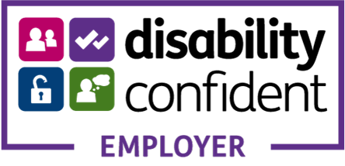

Thomas Pocklington Trust (TPT) is a charity established to provide services for visually impaired people: our mission is to improve the lives of people living with sight loss.

TPT is registered with the Disability Confident Scheme as a Disability Confident employer. Therefore, we believe in treating all employees fairly and we are committed to recruiting equally. TPT’s charitable objective and aim is to support visually impaired individuals back into work. For this reason, we are actively seeking applications from all backgrounds including disabled/visually impaired individuals and people who have lived experience of sight loss. We also guarantee all disabled applicants that reach the minimum appointment criteria an interview. We are happy to accept applications from all suitably qualified persons who have the appropriate skills and talent regardless of their age, gender, race, religion, disability, sexual orientation or marital status.

End of Document

