Job description

General information

Job title: Digital content officer
Team: Income and transformation
Department: Digital
Job location: Andover/Home/Hybrid
Reports to: Digital content manager
Number of direct reports: 0
Number of volunteer reports: 0
Financial responsibility: Up to £15,000 Expenditure
Matrix reporting lines to: N/A
Level of disclosure check required and related workforce: Basic

Overall purpose
Every day, around 300 people are diagnosed with macular disease. It’s the biggest cause of sight loss in the UK. Macular disease is cruel and isolating. It steals your sight, your independence, and your ability to do the things you love. There is only one way to Beat Macular Disease for good.
The Macular Society is working to deliver our ultimate ambition – to Beat Macular Disease for the next generation. We are determined to end the fear and isolation of macular disease with world-class research and the best advice and support.
Our Digital team deliver a first-class digital experience to those looking for support and to support us through our website and busy email programme. The Digital content officer provides essential delivery and administrative support to the Digital content manager and the Email marketing manager, helping to ensure that digital communications are accurate, timely, accessible and consistently delivered.
This role exists to keep digital and email communications running smoothly, freeing up senior colleagues to focus on strategy and optimisation.
This is a great opportunity to gain hands-on experience across website, email and social media, working with experienced digital specialists in a supportive environment.
You’ll contribute to creating accessible digital content that supports people with sight loss to access vital information and services.

Organisational chart

Our values

We will Beat Macular Disease by…

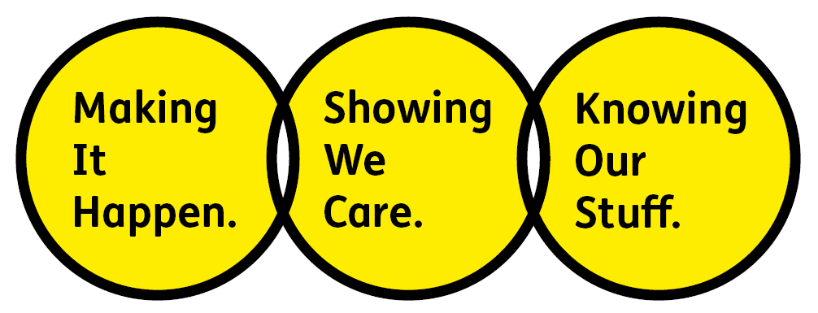

Showing We Care - we are Supportive and Caring

Knowing Our Stuff - we have Integrity and we act Honestly

Making It Happen - we are Ambitious

Key accountabilities of the role

- Review, publish and maintain digital content across our website, emails and social media. Ensuring accuracy, accessibility, SEO best practice and a high-quality user experience.
- Provide day-to-day delivery support to ensure digital campaigns and content are executed accurately and on schedule.
- Collaborate with internal teams to gather, prepare and publish content that meets user needs and the charity’s priorities.
- Create compelling, authentic digital content for social media and online channels (copy, images and short-form video), ensuring alignment with brand guidelines and accessibility standards.
- Monitor social media channels, responding to comments and messages in a timely, sensitive and inclusive manner.
- Create and promote multimedia content such as videos, podcasts and webinars.

All employees are expected to comply with Macular Society terms and conditions, rules, policies, procedures, codes of conduct, quality standards, authorisation processes, risk management policies etc. and relevant external regulations.

Competencies

1. Supports their team and colleagues.
2. Works well with others across the Macular Society.
3. Is committed to quality and service.
4. Understands how the Macular Society operates and follows agreed procedures.
5. Delivers their objectives and core activities as required.
6. Takes responsibility for their own performance and development.

Person specification

Essential:
Knowing Our Stuff
- Strong attention to detail and accuracy in all work.
- Clear written communication skills, with the ability to follow tone and style guidance.
- Understanding of SEO, accessibility and digital best practices.
- Comfortable using digital systems and tools.
- Experience working on social media, producing multimedia content.
- Ability to follow processes, templates and established ways of working.
- Willingness to learn new tools, systems and best practice.

Making It Happen
- Good organisational skills and ability to manage multiple tasks.
- Able to work from briefs and deliver tasks to agreed deadlines.
- Proactive in managing workload, asking questions and seeking clarification when needed.
- Reliable and consistent in completing tasks to a high standard.
- Comfortable working across teams and responding to changing priorities.

Showing We Care
- Interest in digital communications or marketing, particularly in a purpose‑led charity.
- Thoughtful approach to content delivery, with awareness of audience needs.
- Ability to work sensitively with content relating to health, disability or personal stories.
- Collaborative and supportive approach to working with colleagues across the organisation.
- Commitment to accessibility and inclusive communication.

Desirable:
- Knowledge of and empathy with issues relating to sight loss.
- Previous experience working for a charity.
- Awareness of accessibility and inclusive content.
- Understanding of fundraising techniques and different fundraising areas.
- Ability to write and edit HTML.
- Experience of Dot Digital and Umbraco or similar.
- Experience using Photoshop or similar image editing software.
- Understanding of Data Protection legislation.

Eligibility to work in the UK:
- Proof of identity and eligibility to work in the UK.

Volunteering:
From time to time, you may be asked to support / volunteer your time (TOIL available) at Macular Society events that take place outside of normal working hours.

Safeguarding:
The Macular Society is committed to safeguarding and promoting the welfare of all children, young people and vulnerable adults with whom we work. We expect all our employees and volunteers to demonstrate this commitment.
The post holder is required to carry out other such duties as may
reasonably be required, commensurate with the grade of this post. All
employees are expected to excel in being supporter centric,
demonstrate advocacy for the Macular Society at all times and be a fundraiser.
This job profile is accurate as at the date shown below. In consultation
with the post holder it is liable to variation by management to reflect
or anticipate changes in or to the role.

Annual leave: 27 days plus bank holidays (pro rata for part time)
Based: Andover/home/hybrid
Contract Type: Permanent
Date of Evaluation: May 2026

