
Confidential

Deputy CEO
Application Form
Job Description
Our Safeguarding Principles:
We believe that:
● Children and young people should never experience abuse of any kind.
● We have a responsibility to promote the welfare of all children and young people, to keep them safe, and to practice in a way that protects them.
We recognise that:
● The welfare of the child is paramount.
● All children, regardless of age, disability, gender reassignment, race, religion or belief, sex, or sexual orientation have a right to equal protection from all types of harm or abuse.
● Some children are additionally vulnerable because of the impact of previous experiences, their level of dependency, communication needs or other issues.
● Working in partnership with children, young people, their parents, carers and other agencies is essential in promoting young people’s welfare.
Section 1
Applicant Details
Full name:
Preferred name (optional):
Pronouns (optional):
Contact information
Email:
Phone:

Stomping Grounds North East CIO (SG) is committed to encouraging equality, diversity and inclusion among its workforce and the communities we serve. SG seeks to promote this in all areas of its work and practice. In doing so, we aim to create and maintain an inclusive organisational culture which embraces and values diversity and also provides a healthy environment for everyone to feel safe, valued and treated fairly and with respect. The following questions are optional, collected solely for monitoring purposes and will not influence our decision on your application. In line with our anonymous shortlisting process, compliant with our recruitment policy, these details are hidden from the shortlisting panel to ensure fairness and equality throughout the recruitment process. All data is managed securely and in full compliance with GDPR. For further information, please refer to the privacy section on our website.
Gender
Female ☐
Male ☐
Non-binary ☐
Prefer to self-describe ☐: __________
Prefer not to say ☐
Is your gender identity the same as the sex you were assigned at birth?
- Yes ☐
- No ☐
- Prefer not to say ☐

Ethnicity (Select the option that best describes your ethnic background)
White
- English / Welsh / Scottish / Northern Irish / British ☐
- Irish ☐
- Gypsy or Irish Traveller ☐
- Any other White background ☐ – please specify: __________
Mixed / Multiple ethnic groups
- White and Black Caribbean ☐
- White and Black African ☐
- White and Asian ☐
- Any other Mixed / Multiple ethnic background ☐ – please specify: __________
Asian / Asian British
- Indian ☐
- Pakistani ☐
- Bangladeshi ☐
- Chinese ☐
- Any other Asian background ☐ – please specify: __________
Black / African / Caribbean / Black British
- African ☐
- Caribbean ☐
- Any other Black / African / Caribbean background ☐ – please specify: __________
Other ethnic group
- Arab ☐
- Any other ethnic group ☐ – please specify: __________
- Prefer not to say ☐

Disability Status
The Equality Act 2010 defines a disability as a physical or mental impairment which has a substantial and long-term negative effect on your ability to carry out normal daily activities.
- Yes ☐
- No ☐
- Prefer not to say ☐
We are committed to making reasonable adjustments to ensure that all candidates can access and participate fully in our recruitment process.
If you require any adjustments or support at any stage of the application or interview process, please let us know by contacting us at admin@stomping-grounds.org.
If you answered yes to the above question, do you consider yourself to have any of the following conditions or impairments? (Mark all that apply)
- Physical or mobility impairment (e.g. using a wheelchair, difficulty walking, limb loss) ☐ self describe: __________
- Sensory impairment – Visual (e.g. blind, partially sighted) ☐
- Sensory impairment – Hearing (e.g. Deaf, hard of hearing) ☐
- Mental health condition (e.g. depression, anxiety, bipolar disorder) ☐ self describe: __________
- Learning disability (e.g. Down’s syndrome, global developmental delay) ☐ self describe: __________
- Neurodivergent condition (e.g. autism, ADHD, dyslexia, dyspraxia, dyscalculia) ☐ – self describe: __________
- Long-term medical condition (e.g. epilepsy, diabetes, cancer, HIV, multiple sclerosis) ☐ –self describe: __________
- Speech, language or communication condition ☐
- Other condition or impairment ☐ – please specify: __________
- Prefer not to say

Religion or Belief
What is your religion or belief?
- No religion (Atheist) ☐
- Christian (including Church of England, Catholic, Protestant, and all other denominations) ☐
- Buddhist ☐
- Hindu ☐
- Jewish ☐
- Muslim ☐
- Sikh ☐
- Any other religion or belief ☐ – please specify: __________
- Prefer not to say ☐

Stomping Grounds North East is taking positive action to address an under-representation of both disabled and minoritised ethnic employees within our workforce. We offer disabled and minoritised ethnic applicants the option of requesting that their application is considered under the terms of our Disability or Minoritised Ethnic Group Guaranteed Interview Schemes. If you wish to be considered we will automatically offer an interview.

I wish to be considered under Stomping Grounds North East Disability Guaranteed interview scheme *
Please Select an Option Yes ☐
No ☐
I wish to be considered under Stomping Grounds North East Minority Ethnic Group Guaranteed interview scheme *
Please Select an Option Yes ☐
No ☐

Section 2
Suitability for the Role
Please try to keep each answer under a 500 word count.
Your personal statement:

Please tell us why you want to work for Stomping Grounds making specific references to how you meet the essential and desirable criteria outlined for this role in the job application.

Tell us about a time that you have successfully led people through change.

What strategies did you use?

How did you support people who found the transition difficult?

What was the outcome?

Tell us about a time where you have successfully navigated team conflict. How did you support individual staff with the conflict? How did you support the surrounding teams?

Effective Wellbeing Programme

What would you include in an effective wellbeing programme for employees?

How would you deliver and fund the programme?

Team Leadership
How would you define an “inclusive team”?

Tell us about any experience you have of leading a diverse team, and what strategies you have used to ensure employees with different needs can work collaboratively and cohesively?

3 Year Strategy

Referring to our 3 year strategy in the application pack here, or by referring to it on the job description, choose an objective. Outline how you would break this objective down into an action plan.

Define Key Performance Indicators for the objective, and outline what additional support and resources the organisation would need to achieve them.

Who would you identify as Stomping Grounds key stakeholders?

For each one, what strategies would you employ to ensure positive and long term engagement?

What is your number one reason for applying for this position?

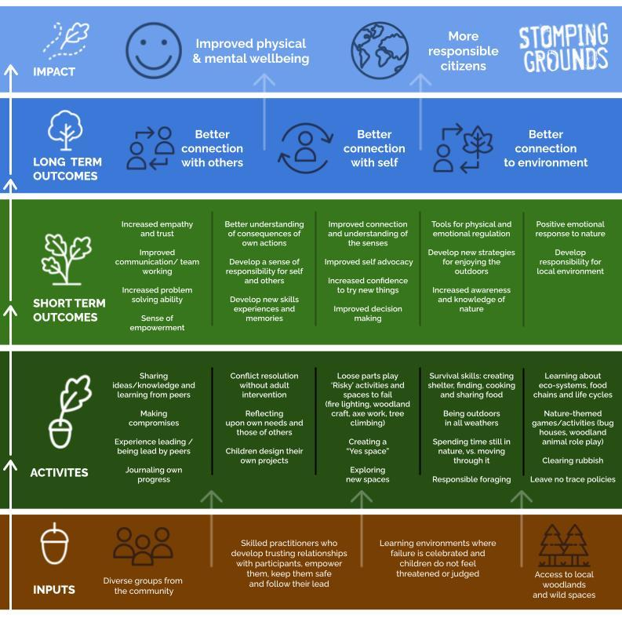
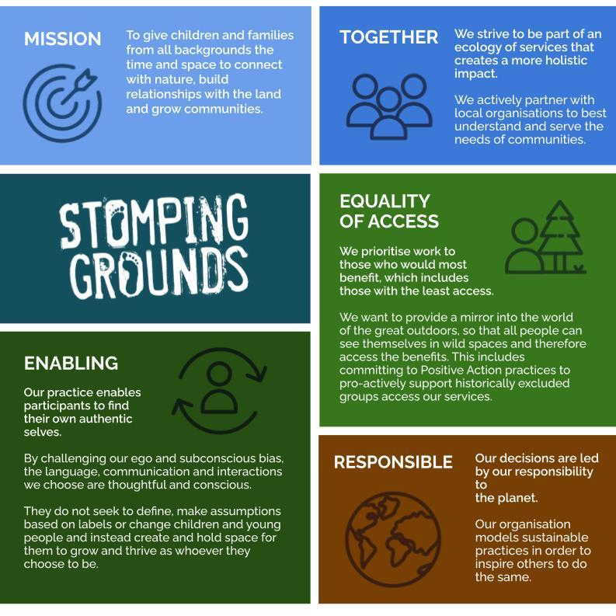

Mission and Values

Referring to our Mission and values, can you explain how you embody these values in your current or previous employment and your lived experience?

Please give some examples of how you would ensure you embody these values when working with Stomping Grounds

What do our values mean to you in practice?

How would they translate in the day to day of the deputy CEO role?

Section 2a

Details of Present Employment:
Are you presently employed: Yes ☐ No ☐
If no, please proceed to the next section.
Details of present post:
Role:
Name of employer:
Name of school / Academy (if applicable):
Address:
Telephone Number:
Permanent ☐ Temporary ☐
Full time ☐ Part-time ☐ Job share ☐

Description of key duties/responsibilities:

Date of appointment:

Notice required:

If notice has already been given, the date it is due to expire:

Reason for leaving:

Gross annual salary (include details of salary scale):
Section 2b

Employment History and Work Experience:
Please complete in chronological order, starting with the most recent:

Employer’s name, address  and nature of business | Full or part-  time | Job title and brief description of duties and responsibilities | Dates employed month  /year (from-to) | Reason for leaving

If any periods of time have not been accounted for in your application, for instance, periods spent raising a family or of extended travel, please give details of them here with dates. The information provided in this form must provide a complete chronology from the age of 18. Please ensure that there are no gaps in the history of your education, employment, and other experience. Failure to provide a full account may lead to your application being rejected.

Dates (from – to) | Activity

Section 3:

Education and Training:
Please complete in chronological order, starting with the most recent:

Full name and address of establishment | Full or part- time | Dates attended month / year  From - to | Date of award | Awarding body and registration number (if known) | Award and classification

Post-Graduate Qualifications.

Higher Education Qualifications

School / College Qualifications

Continuing Professional Development
Please list any courses you have completed and/or any professional development in which you have been involved in the past 3 years which you consider relevant to this post.

Course Title | Course Provider | Length of Course | Dates  From – To | Award / Classification (if applicable)

Section 4:

References:
In accordance with Keeping Children Safe in Education we will obtain and scrutinise references prior to an interview and referees will be contacted to provide further clarification as appropriate. All information provided by referees will also be compared for consistency with the information you provide on this form and you will be asked about any discrepancies. Please advise if you do not want us to take up references at this stage and provide reasons. Please provide two references below. If you do/did not work with children/young people in your present/most recent employment please make sure that your second reference is from an employment where you did work with children/young people.
Present/ Most Recent Employer:
Name:
Address:
Role:
Telephone:
Email:

Reference two: Professional
Name:
Address:
Role:
Telephone:
Email:

Section 5

Disclosure of Criminal and Child Protection Matters and Disclosure and Barring Service Checks
Stomping Grounds is obliged by law to operate a checking procedure for employees who have access to children and young people.
Please confirm whether you have ever been the subject of any child protection concern either in your work or personal life, or been the subject of, or involved in, any disciplinary action, including any which are expired.
Yes ☐ No ☐
If yes please provide full details:

It is an offence to knowingly apply for, offer to do, accept, or do any work in a regulated position if you have been disqualified from working with children. Any offer of employment will be subject to checks being carried out to ensure that you are not subject to a prohibition order or an interim prohibition order.
In the event of a successful application, an offer of employment may be made to you which is conditional upon receipt of satisfactory Disclosure and Barring Service Checks (“DBS Checks”) in relation to criminal and child protection matters. Please note that a conviction will not necessarily be a bar to obtaining employment.

Rehabilitation of Offenders Act 1974
If you have any convictions, cautions, reprimands or final warnings that are not “protected” as defined by the Rehabilitation of Offenders Act 1974 (Exceptions) Order 1975 (as amended in 2013), then the details of these must be disclosed if you are invited for interview.
If you are invited for an interview, please bring The Rehabilitation of Offenders Act 1974 – Disclosure Form with you to the interview in a sealed envelope marked “Confidential – Rehabilitation of Offenders Act 1974 – Disclosure Form”. You will be asked to hand the form to the interviewer at the end of the interview. If you do not have disclosable convictions, please complete the relevant section of the Disclosure Form.

Request for Your Consent to Process Your Data
In compliance with the General Data Protection Regulation (GDPR), we wish to ensure you are aware of the purpose for which we are requesting your consent to collect and process the data we have asked you to provide on this application form.

Important information regarding your consent:

Request for your consent
Please ensure that you read the sections above before providing your consent below:
· I confirm that I have read and understood sections 1-5 above. Yes ☐ No ☐
· Please check this box if you have any objection to our collecting and processing your personal information as described in sections 1-5 above ☐
· I agree to my personal data being shared as stated in sections 1-5 above: Yes ☐ No ☐

Section 6

Immigration, Asylum and Nationality Act 2006
Stomping Grounds will require you to provide evidence of your entitlement to undertake the position applied for and/or of your ongoing entitlement to live and work in the United Kingdom in accordance with the Immigration, Asylum and Nationality Act 2006. By checking the box below you confirm that you are legally entitled to work in the United Kingdom and that you will promptly provide documentary evidence of such entitlement when requested: ☐

Immigration Act 2016
The ability to communicate with members of the public in accurate spoken English is an essential requirement for the post. The requirement applies to public sector workers with public-facing roles as per the statutory code of practice relating to Part 7 of the Immigration Act 2016.

Section 7

Declaration
If you know that any of the information that you have given in this application form is false or if you have knowingly omitted or concealed any relevant fact about your employment eligibility that comes to our attention, then your application form may be withdrawn from the recruitment process. Please note that checks may be carried out to verify the information you have included.
Providing false information is an offence and may result in this application being rejected. If such a discovery is made after you are employed, then you may be liable to be dismissed summarily. You may also be reported to the Teaching Regulation Agency (TRA) (England only) and/or the Police, if appropriate.
By signing below, I hereby certify that all the information given by me both on this form and in any supplementary pages and/or the supporting evidence provided, is correct to the best of my knowledge and belief, that all the questions relating to me have been fully answered and that I possess all the qualifications that I claim to hold.
I acknowledge that it is my responsibility as the applicant, if invited for an interview, to disclose information to the panel that may affect my suitability and/or eligibility to work with children and/or vulnerable adults.

E-Signature:

Date:

