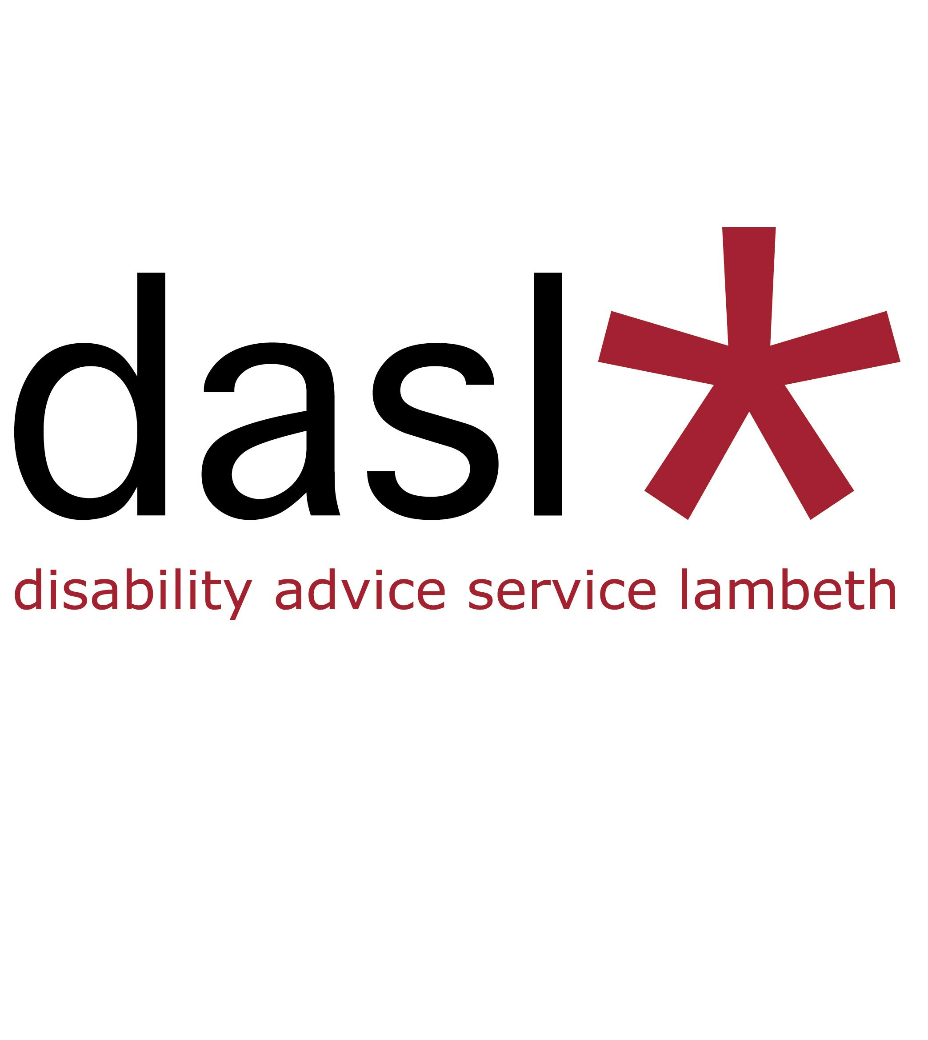

Trustee Role Description and Person Specification

Disability Advice Service Lambeth (dasl) is Lambeth's leading pan-impairment Disabled People's Organisation, operating for nearly 25 years.

We need trustees to make sure that we are running the organisation in the best interests of Disabled people living and working in Lambeth.

We are proudly peer-led – this means we put the voice and views of Disabled people first. We are led by what our members need.

We provide high-quality services and influence and campaign to change systems that exclude or oppress Disabled people.

We work for the full inclusion of Disabled people in Lambeth:
- to achieve our legal rights and entitlements
- to be in control of our lives
- to be active in our communities and not isolated
- to grow our skills and fulfil our personal ambitions
- to be listened to and influence change together

Here’s your chance to make a difference.

The duties of a trustee are:

1. To help the organisation follow its governing document (its Memorandum and Articles of Association), as well as follow any relevant law i.e. company and charity law.

2. To help the organisation reach its goals, which are in its governing document.

3. To help make sure the organisation only uses its resources (money and staff time) to achieve its goals, meaning that they should not be used on activities that won’t do this, no matter how good those activities are.

4. To give strong guidance to the organisation by setting overall policy, goals, as well as evaluating performance against agreed goals.

5. To promote the good name and values of the organisation.

6. To help with the effective and efficient management of the organisation.

7. To help with the financial stability of the organisation and the proper investment of its funds.

8. To take part in staff selection, disciplinary, complaints and other panels

9. To appoint the Director and monitor their performance.

In addition to the statutory (legal) duties listed above, each trustee should use your specific skills, knowledge and experience to help the Management Committee make good decisions.

This may involve:
- reviewing Committee papers
- providing advice and guidance on new initiatives
- representing dasl on public occasions
and
- taking a proactive role and leading discussions on key issues where they have special expertise

Trustee Person Specification

- A willingness to devote the necessary time and effort.
- An ability to exercise sound, independent judgement.
- An awareness of, and commitment to, the rights of Disabled people, diversity and inclusion.
- Lived experience as a Disabled person, having an impairment or health condition.
- An ability to think creatively.
- A willingness to speak your mind.
- An acceptance of the legal duties, responsibilities and liabilities of trusteeship.
- An ability to work effectively as a member of a team.

