Job Title | CRM Manager
Contract Type | Permanent, Full-Time
Location Type | Home-based
Reports To | Head of Business Systems
Disclosure & Barring Check | NA
Pay Grade | Band 5

Evaluation Date

Purpose of the Role

The CRM Manager is responsible for overseeing, maintaining and optimising the core Dynamics 365 CRM platforms utilised within Rethink Mental Illness, ensuring they are effectively used whilst maintaining data integrity, supporting complex operational processes, adhering to data legislation and enabling an effective supporter and service user experience across multiple organisational functions.

Acting as a lead operational expert for CRM platforms, the CRM Manager fosters a culture of continuous improvement and digital enablement through ensuring the team provides a strong and effective business partnering relationship with key stakeholders.

The CRM Manager will be the subject matter expert for CRM functionality, overseeing a complex CRM estate utilised by over 900 users across multiple operational functions including service delivery, case management, fundraising, marketing and compliance processes. They will ensure the effective operation and development of the CRM platforms, working collaboratively with internal stakeholders and external partners where required to ensure systems continue to meet organisational needs and future ambitions.

Responsibilities of the Role

I am responsible for the management of the Dynamics 365 CRM platforms, leading on configuration, development and optimisation to ensure they meet current business needs and are positioned to enable future ambitions.

I develop and embed business partnering relationships with key stakeholders, ensuring understanding of their strategic goals, working collaboratively to define and solve problems and acting as a change agent on their behalf.

I ensure effective communication to stakeholders, working collaboratively to understand challenges, investigate issues, support design of new processes and oversee the implementation of system improvements.

I support the design and improvement of operational processes, customer journeys, data collection and reporting requirements, ensuring the CRM platforms are configured for efficiency and ease of use.
I manage relationships with external suppliers and partners where required, ensuring effective collaboration and value for money.

I manage a team of CRM specialists, providing effective line management, coaching and support to foster high performance, continuous improvement and a collaborative, supportive team culture.
I oversee the development of documentation, training materials and support for users, actively promoting and driving self-service and the development of CRM and data champions across teams.

I ensure data migration, quality and integrity between systems, adhering to data protection regulations and organisational policies, whilst advising leadership on related risks and ensuring appropriate documentation is maintained.
I manage CRM development projects, including upgrades and enhancements, ensuring changes are appropriately tested, documented and delivered in line with business and technical requirements.
I work collaboratively with colleagues across the organisation to ensure CRM platforms effectively support operational processes and enable effective data management and reporting across multiple business functions.

I am responsible for developing data management best practices and governance processes, including data hygiene, imports and exports, whilst providing guidance on the effective and compliant use of CRM data and segmentation tools.

General Duties:
- Actively model Rethink’s CARES Behaviours and Values, bringing them to life in everyday practice.
- Act in accordance with the provisions of Data Protection legislation (as amended).
- Ensure all records, personal, staff, EbE and volunteer data are managed in line with Data Management and Information Governance policies, relevant legislation, codes of practice or contractual obligations.
- Comply with legal and regulatory requirements such as provisions set out in the Health and Safety at Work Act 1974.
- Act in accordance with the charity’s Health & Safety and Safeguarding policies and to notify your line manager promptly if there are any concerns.
- Participate in regular supervision and appraisal and undertake any relevant training.
- Work in accordance with the charity’s national policies and local operating procedures and those of external regulators or professional bodies.

Key Working Relationships
You will work with the following people and teams:
The Business Improvement and Technology Directorate provides strategic leadership across technology, systems, data, performance, compliance and audit, strengthening Rethink’s digital maturity and driving a culture of continuous improvement.

The Business Systems team sits within the Technology and Data function and is responsible for maximising the effectiveness of core business systems used across Rethink Mental Illness and Mental Health UK. This includes the operational management of systems, oversight of change and development cycles, delivery of high quality support, and maintaining strategic direction to ensure systems align with organisational goals. The team also focuses on reducing complexity for end users and driving efficiencies through shared ways of working across both organisational units.
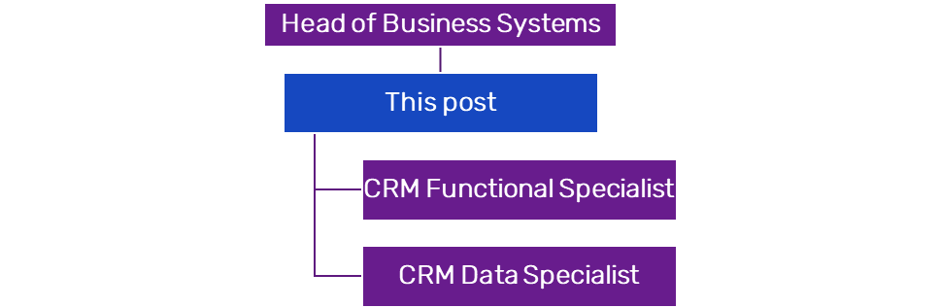

PERSON SPECIFICATION
Essential Criteria:

- Experienced CRM Manager, ideally with Fundraising experience within the NfP sector
- Advanced knowledge of the Microsoft Power Platform, including Dynamics 365, Model-Driven Power Apps and Power Automate, with experience of configuration and administration within complex operational environments
- Experience of working with complex CRM environments supporting multiple operational functions and large user bases
- Experienced project manager, having delivered CRM improvement projects and system enhancements
- Strong analytical and problem-solving skills with the ability to investigate complex system and process issues
- Experience of applying data protection policies and compliance to working practices
- Experience of managing and integrating data across multiple platforms and systems, including fundraising and engagement platforms like JustGiving, Enthuse, Eventbrite, Funraisin
- Experience of delivering training, coaching and support to colleagues in the effective use of CRM platforms
- Ability to communicate effectively both verbally and in writing
- Able to engage and influence stakeholders across different levels, translating complex information into succinct summaries
- Experienced people manager, having managed and supported teams, overseeing workload prioritisation, development and alignment to plans
- Experience of working collaboratively across technical and operational teams to deliver system and process improvements
- Experience of managing relationships with external suppliers to oversee contracts or deliver products

Desirable:

- Experience of delivering projects using agile/SCRUM

Experience or Knowledge of working with Salesforce

Rethink CARES Behaviours and Values:
- Connect – We work together, we celebrate together
- Accountable – We do what we say we will do
- Respect – We believe everyone counts
- Evolve – We challenge, we listen, we change
- Success – We deliver results
- Passion - We are passionate about leading the way to a better quality of life for everyone severely affected by mental illness.
- Commitment - We work tirelessly to provide support for everyone severely affected by mental illness.
- Openness - We are open and transparent in all our work with beneficiaries, supporters, partners and the public to achieve change for people severely affected by mental illness.
- Hope - We offer hope of a better quality of life for all those severely affected by mental illness.
- Expertise - We constantly use our expertise to provide practical and personal support for people who are severely affected by mental illness.
- Understanding - People who are severely affected by mental illness are at the heart of everything we do in our organisation – our membership, our governance and our workforce.
- Equity - We believe that in a world where discrimination and disadvantage exist treating people with equity is critical to ensure justice and fairness for all.

This list of duties is not exhaustive. Line managers may require the post-holder to undertake additional reasonable responsibilities and projects consistent with the profile and grade of the post.

