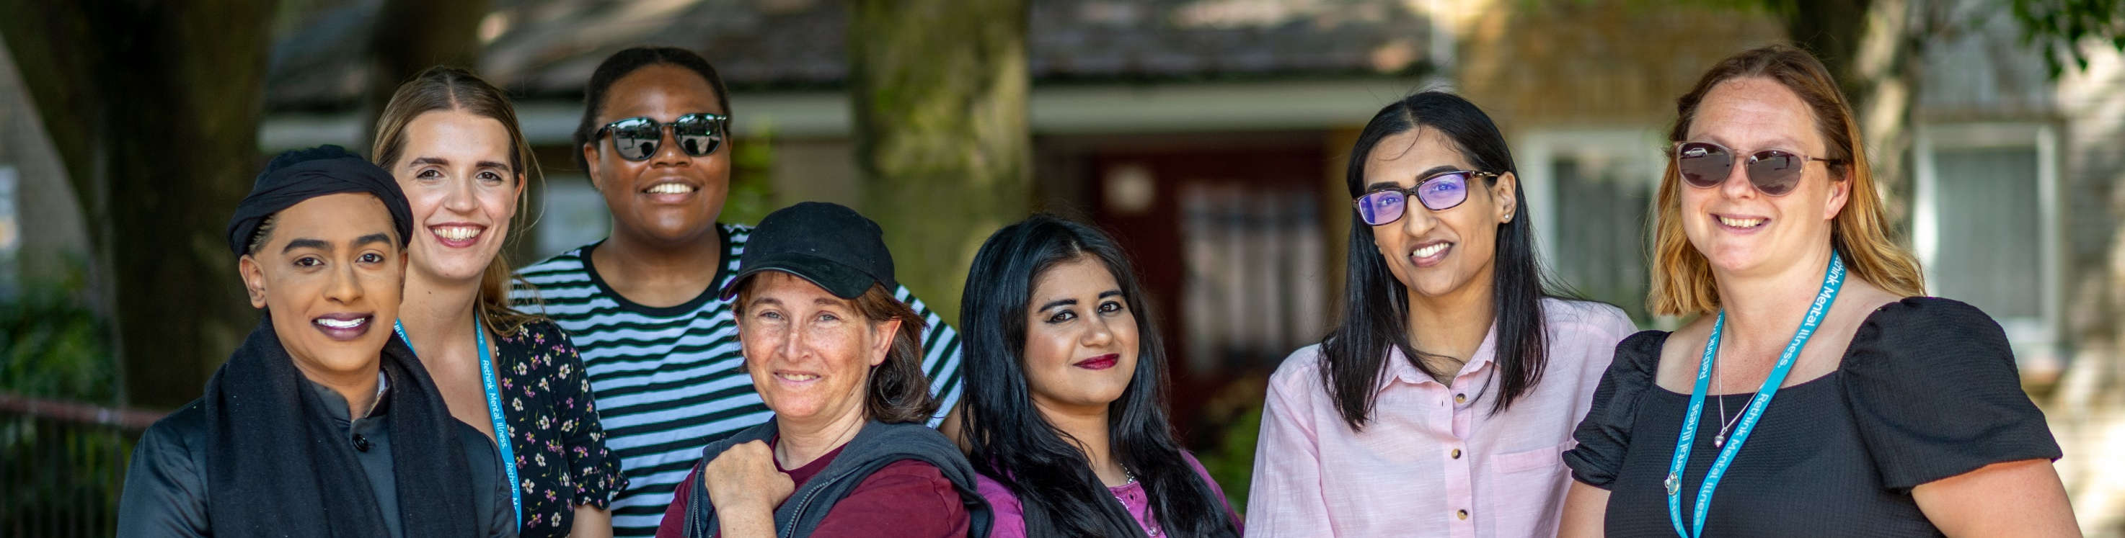


Volunteer Role Description

Your volunteer role description provides an outline of the tasks you will complete when volunteering.
Whatever your role, or however much time you donate, you will be helping to improve the lives of people severely affected by mental illness. We appreciate and value your commitment to volunteering with Rethink Mental Illness.
Role title:  Role details | Community Support Volunteer
Where the role is based | In the community
You will be supported by | Volunteering Coordinator
Level of DBS check | Enhanced with Adults
Service details

Service | Empowering Minds Gloucestershire
Location of the service | Gloucestershire
Days and times volunteering is available | Flexible throughout the week
Service code | 6751
The purpose of your role

As a Community Support Volunteer, you will complete face-to-face befriending activities with service users. You need to be able to travel around the locality in which you live to be able to do this. Ideally, you will be able to commit to a minimum of 1/2 a day (3-4 hours) of volunteering per week on a flexible basis, with the option to increase.
You will be working alongside our team of community link workers.
There may also be the opportunity to also attend different community events to advertise the service.
There will be full training opportunities to ensure that you are successful in your volunteering role, as well as regular check-in meetings.

The service you support

Empowering Minds is a Gloucestershire-based service for people aged 18+ with a mental illness who live in Gloucestershire or are registered with a Gloucestershire GP. We support individuals in all six localities: Forest of Dean, Tewkesbury, Gloucester, Cheltenham, Stroud and the Cotswolds.
You will complete the following tasks

- Meet with service users in locations and times that meet their needs (this also includes weekends and evenings where needed / appropriate). This could include going on walks, meeting up for a coffee, or supporting to attend appointments such as CAB, Recovery Team or GP appointments as required by the client.
- Support service users to access and attend social and community groups.
- Provide emotional and practical support based on your own lived experience.
- There may be the opportunity to complete low-risk, graded exposure work. This may include things like supporting someone when going on a short bus journey.
Necessary skills, experience, and attitude

It’s essentials to have the following:
- Lived experience of mental illness, whether that is caring for someone else or yourself.
- Excellent communication skills.
- Flexibility.
- Experience of working with people in some way, whether formally through employment or informally working as part of a team.
- Basic computer skills.
- Reliability and good timekeeping.
- Have a good understanding of confidentiality and safeguarding.

Although it’s not essential, you may also have:
- Experience of supporting someone with ill mental health / mental illness.
- Good knowledge of your local area and organisations.


You’ll have our support and guidance,
every step of the way

Values and behaviours

You will demonstrate and apply Rethink Mental Illness values:
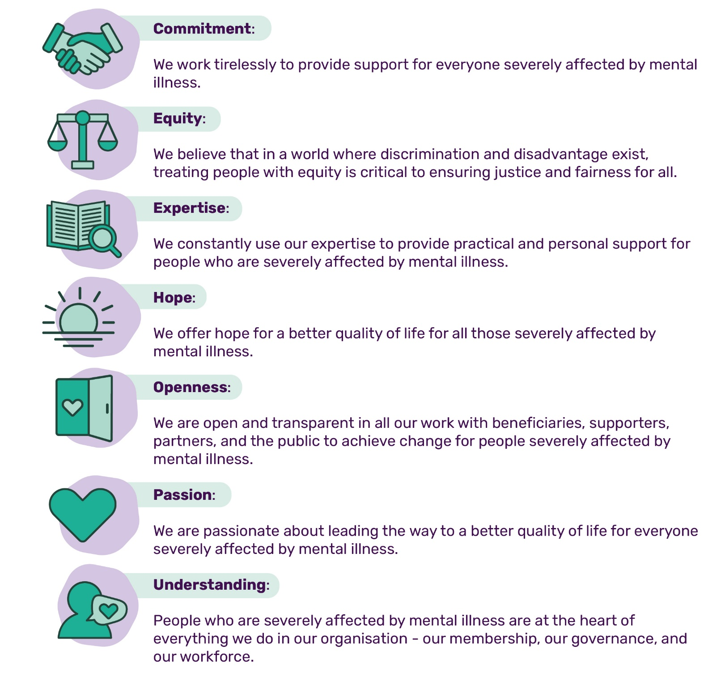
You will demonstrate and apply Rethink CARES behaviours of:
 |  |  |  |  |  |  |  | 
We work together, we celebrate together |  | We do what we say we will do |  | We believe everyone counts |  | We challenge, we listen, we change |  | We deliver results
The training and support you will receive
As part of your induction, you will complete the following e-learning modules:  - Safeguarding adults  - Data security |  |  |  |  | You will have access to:  - Regular check-in sessions with your Volunteer Manager  - A range of wellbeing resources
 | What you will get out of volunteering
 | There are lots of benefits to volunteering. Here are just a few:
 |     Develop your existing skills or learn new ones |  |     Enhance your CV and boost your employability |  |  |  |   Reimbursement for out-of-pocket expenses
 |   Find a passion and maybe a step towards a new career |  |   Access to internal vacancies |  |  |  |   Access to Rethink’s Volunteer Assistance Programme
 |   Impact positively on your own mental health, as well as others |  |   Meet new people and increase your self-confidence |  |  |  |   Gain a reference from Rethink Mental Illness

