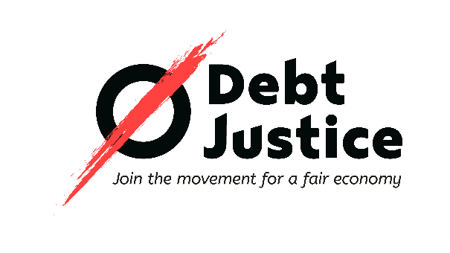
Debt Justice

Oxford House

Derbyshire Street

London

E2 6HG

Please return this form to: application@debtjustice.org.uk
Closing date: 9am, Monday 6 July 2026

Application Form
Post applied for |  |  |  |  | Where did you hear about this post?
Community Organiser
If successful, when could you start?
Personal details
First name(s) |  | Last name |  |  | Address for correspondence
Phone number
Email address
References
Please give details of two referees, of which at least one should know you in a work context (ideally your line manager at your current/last employer). We will not contact your referees unless you are conditionally offered the post.
Name |  |  |  |  |  | Name
Position held and relationship to you |  |  |  |  |  | Position held and relationship to you
Organisation and address |  |  |  |  |  | Organisation and address
Telephone number |  |  |  |  |  | Telephone number
Email address |  |  |  |  |  | Email address

Relevant employment
Current or most recent employment/experience first. Please include all relevant work, whether permanent, temporary or voluntary.
From | To | Employer’s name | Job title | Description of main responsibilities and achievements

Education or training
Please list details of your educational/professional qualifications and any relevant training.
Date | Qualifications/training | Grade attained

Supporting information
Please state how you consider your experience, knowledge, skills and abilities match those of the Person Specification. Wherever possible, provide examples from your experience. This could be from either current or previous employment, volunteering, activism or any other hobbies or interests. It is important that you cover each of the areas detailed in the Person Specification since this is the information that will be used for shortlisting.
ESSENTIAL
- Formal or informal experience of bringing people together to act collectively on shared concerns, including through organising, campaigns, activism, mutual aid or community initiatives

- Strong interpersonal and relationship-building skills including the ability to build trust through one-to-one conversations

- Experience of facilitating group discussions, workshops or training sessions

- Experience of supporting others to grow in confidence or take on leadership roles

- Ability to help people develop and share their stories in ways that support collective action

- Experience of working with and building relationships with global majority communities including black and brown communities, including in community-based or movement settings

- Lived experience of racialisation and an understanding of how racism and structural inequality shape experiences of economic injustice

- Commitment to centring the leadership, agency and expertise of people directly impacted by injustice

- Ability to work collaboratively as part of a team

- Organised and able to work to deadlines and take responsibility for delivering work with minimal supervision

- Reflective, with a willingness to learn from experience, feedback and practice

- Commitment to anti-oppression and to tackling all forms of oppression, bigotry and exclusion

- Commitment to Debt Justice’s vision, mission and values

DESIRABLE

- Connections with grassroots organisations, community groups and networks in the boroughs of Southwark or Lambeth

- Understanding or knowledge of household debt in the UK

- Experience of developing or contributing to strategic campaigns

- Experience of influencing decision-makers at a local level

- Familiarity with community organising approaches such as relational organising, public narrative and leadership development

Additional Information
Are you subject to any conditions relating to your employment in the UK?  If yes, please specify below | Yes | No
Have you any unspent convictions for criminal offences subject to the provisions of the Rehabilitation of Offenders Acts 1974 and 1984? | Yes | No
Declaration
By submitting this application, I consent to my personal data being processed for recruitment and employment purposes in accordance with the Data Protection Act 2018 and the UK General Data Protection Regulation (UK GDPR).
I understand that if I am appointed, this form will form part of my personnel record. If I am not appointed, my information will be securely retained for 12 months and then destroyed.
I certify that the information provided is correct and complete to the best of my knowledge. I understand that any deliberate false statements or omissions may lead to the rejection of my application or, if I am appointed, dismissal.
Signed |  | Date

Applications received after the closing date will not be considered.

