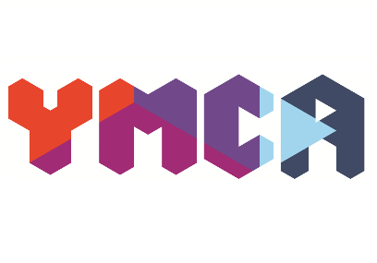
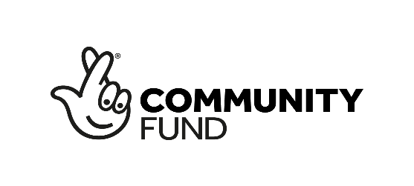

Community Hub Manager

Based: Parcel Terrace, Derby
Salary: £18,579.60 (£15.88ph)
Hours: 22.5 hrs per week

This is an exciting opportunity for you to join the YMCA; a charity at the heart of the community in Derby and Derbyshire. We are committed to helping people at times of need, regardless of gender, race, ability or faith/belief. Our values to Protect, Trust, Hope and Persevere underpin all of our services across the county.

We’re looking for someone who is passionate about people and community—someone who thrives on creating welcoming spaces where everyone feels they belong. You’ll be driven by a genuine desire to make a difference, helping to bring YMCA Derbyshire’s vision of thriving individuals and communities to life. You’ll have a natural ability to connect with others, inspire your team, and build strong partnerships that help the Hub reach its full potential.

You’ll be a hands-on and proactive leader who can balance heart with head—just as comfortable supporting a person using our community pantry as you are managing budgets or ensuring we are compliant with Health and Safety.

Someone with a keen eye for detail, great organisational skills, and the confidence to make things happen. Above all, you’ll share our belief that everyone deserves the chance to flourish in body, mind, and spirit—and you’ll bring energy, empathy, and positivity to everything you do.

Interested?

Learn more and apply at: ymcaderbyshire.org.uk

What we offer:
- 25 days holiday as standard with an extra 2 days after 5 years of service
- People celebration event each year. (Celebrating our Peoples Achievements)
- Recognition initiatives such as employee of the year and star of the quarter
- Smart Health app where you will have access to an online doctor for you and your family as well as nutritional advice and Mental Health assistance.
- Life Assurance 2 times your annual salary
- Real Living Wage
- Christmas/ Easter and Quarterly Treats
- Your Birthday off every year
- Long Service rewards
- Training and Development
.............. and more

At YMCA Derbyshire we aim to transform the lives of the people we work with for the better. We are looking for brilliant people who will ensure that safeguarding the people we work with is a priority.
This post is post is subject to an Enhanced DBS check.
YMCA Derbyshire are proud to be a 'Disability Confident Employer'. If you’re disabled, we will guarantee you an interview if you meet the minimum criteria for the role you’ve applied for. Are you a disabled candidate who would like to apply on this basis?

If you do not wish to apply under the scheme but do require us to make reasonable adjustments for you to attend an interview, then please let us know what those adjustments will be.

Equality and Diversity Statement
YMCA Derbyshire is committed to promoting equality and diversity in all aspects of its operations. We value and embrace individual differences and believe that everyone should be treated with respect and dignity. We welcome people from all backgrounds, irrespective of age, disability, gender, race, religion, sexual orientation, or any other characteristic.
For an informal chat please contact Wayne Exton on 07566 792 575 during the hours of 9-5.

Closing date: 30th January 2026
We reserve the right to close this vacancy early if we receive sufficient applications for the role. Therefore, if you are interested, please submit your application as early as possible.
Interview date: TBC

