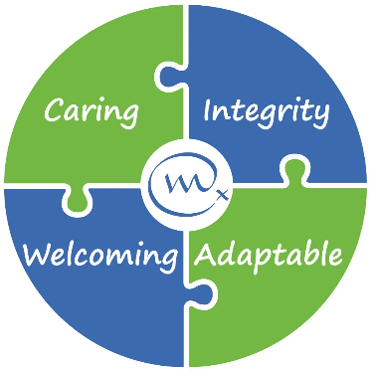

Job Vacancy
Weldmar Hospicecare provides specialist care for adults in Dorset who have a life limiting illness, and support for their loved ones. We are dedicated to fostering a culture of equality, diversity, and inclusion across all aspects of our organisation. 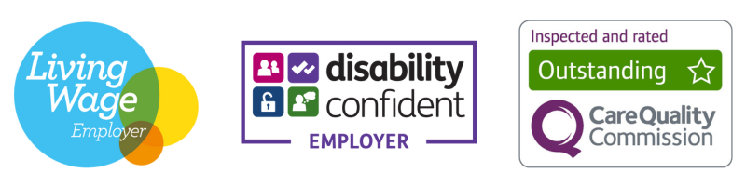
Weldmar Hospicecare is looking for a dynamic and confident individual to fill an exciting new role as a Community Fundraiser. You will be the heart of our public-facing fundraising, acting as a vital link between the charity and the incredible people of Dorset who raise money for us.

Your responsibilities will be to:

- Be the primary point of contact for members of the public, schools, and local groups, offering guidance and encouragement to help them achieve their fundraising goals.
- Build and retain strong relationships, ensuring every supporter feels valued and understands the difference their contribution makes.
- Play a key role in planning and delivering mass participation fundraising campaigns.
- Represent Weldmar at community events, delivering talks and presentations and attending cheque presentations.
- Use our CRM (Raiser’s Edge) to record communications and manage donor records, ensuring all public support is acknowledged rapidly and personally.

We are looking for someone with excellent interpersonal skills who is equally comfortable talking to a large audience or having a quiet, empathic conversation with a bereaved supporter. You don’t need specific qualifications, but you do need great IT skills, a track record of providing excellent customer service, and the ability to manage a busy, varied workload. A full driving licence is essential to reach our supporters across the county.

A Disclosure and Barring Service (DBS) Check is required for this role.

Closing Date: 8th June 2026 Interview date: W/C 15th June 2026
For a Candidate Pack including full job description, go to weldmarhospicecare.org/jobs
For more information, contact recruitment@weld-hospice.org.uk or call 01305 269898
Community Fundraiser
Permanent Contract
£29,185 Per Annum for 37.5 hours per week
(30 hours per week would also be considered)

