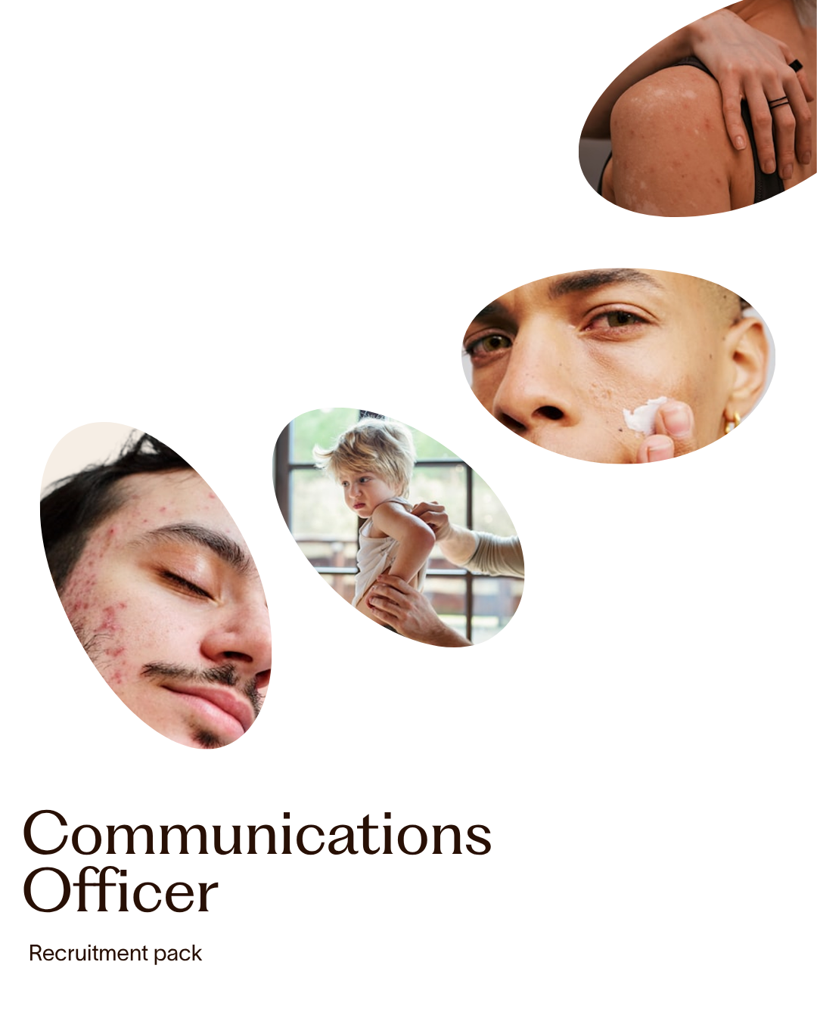

Recruitment Pack
Communications Officer
Job title | Communications Officer
Location | We offer a hybrid model of working. Our office is near London Bridge, which will be your location and contract base. You are expected to work two days per week in our London office.
Salary | c£30,000 per annum
Hours | Full time, 35 hours per week
Travel expenses | Staff are expected to pay travel costs to and from their home to the London office, regardless of where they live. Staff are able to claim travel expenses for journeys to places other than the London office, for work purposes.
Contract | Permanent
Annual leave | 28 days per annum, including three mandatory days over the Christmas and New Year period, plus bank holidays
Reports to | Head of Communications

About us
Eczema UK is dedicated to making life better for everyone affected by eczema. As a small and agile organisation, we are ambitious, impactful and committed to making our voice heard where it matters most.
Around 1 in 5 children and 1 in 10 adults in the UK live with eczema — a condition that is too often dismissed, yet affects every aspect of daily life. We exist to change that. Our mission is to empower everyone affected by eczema to live well with the condition, supported by a charity that puts their needs first.
We are funded entirely by voluntary donations, which support everything we do — from providing trusted information and advice through our website, publications, webinars and awareness campaigns, to funding vital research and campaigning for better eczema care across the UK.
We have big plans to grow our communications work, reaching more people across our large and diverse eczema community and driving greater public awareness of the real challenges of living with this condition. This includes building on successful initiatives such as Eczema Awareness Week each September, and our recent campaign to introduce clear strength labelling on steroid creams and ointments.
If you are passionate about making a difference and want to be part of a small team with a big mission, we would love to hear from you. You would be based at our offices near London Bridge, with the flexibility to work from home part of the week — we ask that you come into the office at least two days a week to support effective team collaboration.

The role
We are excited to be recruiting a Communications Officer to help strengthen and expand the reach of Eczema UK’s work.
This is a new role, created as the charity grows and takes on increasingly proactive campaigns and community engagement. You will play a hands-on role in delivering our day-to-day communications — creating and scheduling content across our social media channels and website, supporting the production of our monthly e-newsletter, and monitoring and engaging with our online community.
Beyond digital communications, this role offers real variety. You will provide valuable support across our wider operations — from helping to coordinate webinars and podcasts to assisting with health information, research and policy work. No two days will be quite the same.
This is a fantastic opportunity to join a small, friendly and ambitious team at the heart of a charity making a genuine difference to the lives of everyone affected by eczema.
Job purpose
To support the day-to-day delivery of Eczema UK’s communications, digital content and organisational operations. This role plays a key part in helping the wider team function effectively.

Key responsibilities
Digital Communications and Content
- Support the planning, creation and scheduling of social media content across platforms (Instagram, Facebook, LinkedIn, TikTok and YouTube), in line with organisational messaging, brand tone of voice and editorial calendar
- Coordinate and support our eczema community champions
- Assist with the planning, drafting and formatting of our monthly supporter e-newsletter using Mailchimp
- Monitor e-newsletter mailing lists and support with performance tracking
- Monitor media coverage of eczema-related topics and maintain records of press coverage
- Act as a first point of contact for media enquiries, coordinating responses and media briefing documents using pre-approved sources
- Monitor and respond to community engagement on social media in line with Eczema UK’s community engagement guidelines, escalating comments or queries when needed
- Assist with uploading and updating content on the website, including information resources and event content
- Support logistics for webinars, podcasts and online talks, including scheduling, tech set-up and note-taking
- Provide communications and administrative support for charity campaigns, including planning and delivery
- Support and occasionally attend events to promote Eczema UK, such as the British Association of Dermatologists Annual Meeting

Team and Office Support
- Support the Head of Communications and wider team with meeting organisation, minute-taking and note circulation
- Help track performance data and KPIs across communications, research and fundraising activities
- Manage the main email inbox and coordinate responses or internal referrals
- Act as a point of contact for general office queries

General Responsibilities
- Adhere to Eczema UK’s policies and procedures
- Comply with data protection regulations, ensuring personal information remains confidential
- Take responsibility for your own personal learning and development, and support the learning and development of others
- Ensure your work is accurate, meets quality standards and is delivered to agreed deadlines
- Undertake any other reasonable tasks or projects as required
This job description is not exhaustive and serves to highlight the main requirements of the role. The Chief Executive may stipulate other reasonable requirements from time to time.

Person specification
All requirements below are essential unless marked as desirable. They are assessed through your application form, interview, skills assignments and references.
Qualifications and Knowledge | Application | Interview
Graduate or equivalent level of education or training | ✓
Excellent knowledge of English grammar and usage | ✓ | ✓
Good general knowledge of communications, especially digital | ✓
Professional qualifications in PR, public affairs or marketing (desirable) | ✓

Experience | Application | Interview
Experience working in communications, particularly social media, websites and email newsletters | ✓ | ✓
Experience of media work (desirable) | ✓
Experience creating content across Instagram, Facebook, LinkedIn, TikTok and YouTube | ✓ | ✓
Experience using social media management platforms such as Sprout Social (desirable) | ✓ | ✓
Experience of Microsoft Office, email platforms such as Mailchimp, and CRM systems (desirable) |  | ✓

Skills and Abilities | Application | Interview
Excellent verbal and written English, with the ability to adapt style for different audiences and channels | ✓ | ✓
Strong social media content creation skills, including video | ✓ | ✓
Excellent time management, confident delivering to deadlines |  | ✓
Strong organisational skills and attention to detail, able to manage multiple projects | ✓ | ✓
Excellent interpersonal skills, able to build relationships at all levels |  | ✓

Values, Attitudes and Behaviours | Application | Interview
Empathetic and able to understand the challenges faced by everyone affected by eczema | ✓ | ✓
Passionate about developing and delivering effective, supporter-focused communications | ✓ | ✓
Well-organised, naturally strives to exceed targets | ✓ | ✓
Able to manage and prioritise own workload with minimal supervision | ✓ | ✓
Highly self-motivated, proactive and resourceful | ✓ | ✓
Exceptional ability to work collaboratively within a small team | ✓ | ✓
Confident using initiative and making decisions independently within remit |  | ✓
Willing and able to learn and adapt quickly to changing situations |  | ✓
Committed to the vision and aims of Eczema UK, including equality and diversity | ✓ | ✓
Able and happy to travel independently and work occasional evenings, weekends or overnight stays |  | ✓

Equality, Diversity and Inclusion
Eczema UK is committed to achieving greater equality, diversity and inclusion, to better reflect the diverse communities we serve. We are focused on being an inclusive organisation and integrating the principles of equality and diversity into all aspects of our work and strategic planning.

How to apply
To apply, please send the following to emartin@eczema.org by 9am on Monday 13 July 2026:
- A CV outlining your employment history and academic and professional qualifications
- A supporting statement of no more than two A4 pages, explaining how you meet the requirements of the role and why you are interested in joining Eczema UK
If you would like an informal and confidential conversation about the role before applying, please contact Eleanor Martin, Head of Communications, at emartin@eczema.org.
Please let us know if you require any adjustments for interview or have any anticipated difficulties with the proposed dates.
Closing date: 9am, Monday 13 July 2026
In-person interviews: Week commencing 20 July 2026, London

Eczema UK
82 Tanner Street, London SE1 3GN | T: 020 7281 3553 | E: info@eczema.org | eczema.org.uk
National Eczema Society, trading as Eczema UK, is a registered charity in England and Wales (no. 1009671) and a company limited by guarantee (no. 2685083)

