Role Profile
Post Title: | Commercial Compliance Manager

Post Number in PeopleHub if known:
Department: | Commercial
Job Band / Job Family: | Band G/Business Support
Effective Date: | July 2026

1. Purpose
- The Commercial Directorate incorporates Fundraising and Retail Operations alongside other Commercial activities such as the International Learning Academy at Sue Ryder. The role will focus predominantly on fundraising operations compliance and provide leadership and assurance guidance for other commercial operations. The postholder will:
- Develop and implement a compliance framework across all fundraising operations at Sue Ryder which includes, maintaining awareness of external legal and regulatory requirements, engaging stakeholders to review and update policies, work with subject matter experts to create compliance procedure guides and bespoke training.
- Build and maintain reporting and other mechanisms including quality checking and auditing, which clearly identify where assurance is available or where not, provides leaders with data to focus on improving compliance.
- Provide day to day compliance advice to staff within the Commercial team and support incident management and escalation.

2. Key Relationships
- This role reports to the Head of Commercial Support and Governance and sits alongside the Supporter Services and Standards Manager, Retail Operations Manager and Retail Support & Projects Manager.
- The postholder works closely with the Fundraising Operations & Development Lead.
- Key internal contacts - Fundraising, Retail, Healthcare, Marketing and Communications, Volunteering, Finance, Compliance & Risk (including Sue Ryder’s Data Protection Officer), Health & Safety, People, Learning & Development and IS&T.
- Key external contacts – Supporters, Customers, Volunteers, External steering groups, The Fundraising Regulator, Chartered Institute of Fundraising (CIOF), Direct Marketing Association (DMA), Information Commissioners Office (ICO), Gambling Commission, Direct Marketing Association (DMA), HMRC and other appropriate regulatory bodies as required.
- The postholder will line manage the role of Retail Gift Aid and Data Compliance Manager
- Responsible for working alongside and/or line managing volunteers within your team if applicable

3. Qualifications required
- Educated to degree level or equivalent work experience
- Evidence of continuing professional development in a relevant area.

4. Proven Knowledge, Skills and Ability
Technical Skills:
- Expert knowledge of the CAP code, General Data Protection Regulation, Privacy and Electronic Communications Regulations (PECR), Code of Fundraising Practice and other charity requirements set by the ICO, the Fundraising Regulator, Gambling Commission’s Licence Conditions and Code of Practice and HMRC Gift Aid Standards.
- Ensure awareness of and react to any Fundraising and HMRC Gift Aid regulation changes.
- Proven experience of creating and reviewing policies and guidance in a fundraising or retail environment.
- Experienced in implementing reporting mechanisms (SLA/KPIs) using multiple data sources and systems.
- Experience of internal and external audit processes and risk management
- Actively researches the external environment to identify innovative ideas and bring new thinking to enhance and improve service delivery.
- Proficient with various computer and communication software relating to fundraising, retail and/or learning and development environments.
Project Management:
- Understands and has experience of project management processes.
- Experienced in implementing change and improvements.
- Able to manage time, plans, projects, and tasks effectively.
Strategic and Analytical Skills:
- Logical thinker able to translate high level planning into operational plans.
- Capable of making operational improvement recommendations.
- Detail-oriented and technically minded.
- Self-starter with proactive problem-solving abilities.
Interpersonal and Leadership Skills:
- Excellent teamwork, emotional intelligence, and leadership skills.
- Able to develop a network of relationships across the organisation to deliver objectives.
- Skilled in negotiation and able to influence and motivate others.
- Collaborative and flexible in driving process improvements.
- Experienced in working as part of a team to achieve organisational and personal objectives.
Communication Skills:
- Strong oral and written communication skills.
- Able to develop, brief, and communicate complex plans and deliver training.
Performance and Adaptability:
- Capable of managing competing priorities to meet business need, balancing risk and commercial benefit
- Consistently meets targets and exceeds expectations.
- Demonstrates commercial acumen in specialised areas.

5. Complexity and Accountability
- Has no authority to make variations or propose salary changes.
- Can initiate recruitment and dismissal, subject to delegated level of authority and following advice from People team.
- Able to authorise expenditure within approved budget.

6. Key Responsibilities
- Develop and implement the compliance framework, which includes creating an audit and assurance program for Fundraising, leading on audits where applicable.
- Review and update all compliance policies and procedures, recommending and gaining agreement with subject matter experts for appropriate review periods.
- Ensure adequate training resources are available for compliance related matters and ensure regular reporting to monitor compliance and inform managers.
- Collaborate with stakeholders, including the Junior Data Protection Officer, to update data protection processes. Regularly review consent statements ensuring these are appropriate and standardised, managing third-party consent documentation.
- Review, advise and agree sign off with subject matter experts on fundraising materials sent out across Sue Ryder.
- Work with key stakeholders, Director of Fundraising, Head of Commercial Support and Governance, Supporter Services & Standards Manager, Retail Operations Manager, Director of Risk and Governance and the Legal Directorate to identify and address compliance gaps and risks.
- Assist the Lottery team with overall gaming compliance where appropriate, supporting with reviewing lottery policies, processes, and training for Fundraising and Retail.
- Advise on and approval of new Gift Aid initiatives and ensure assurance through regular Fundraising Gift Aid audits.
- Work with stakeholders to build and deliver a compliance strategy and ongoing communications plan.
- Work collaboratively with Fundraising teams to ensure compliance is embedded in campaign planning and execution.
- Monitor and manage all relevant incidents or breaches logged within commercial to determine if escalation is necessary.
- Provide leadership for the Retail Gift Aid operations team through the Retail Gift Aid and Data Compliance manager.
- Keep abreast of fundraising trends and up to date with all relevant charity law, regulations and codes of practice.
- Provide day to day support to Commercial leaders and managers on compliance matters relating to data protection, fundraising compliance and retail compliance.

7. Behaviours
Operate within the Sue Ryder values and behaviours standards:
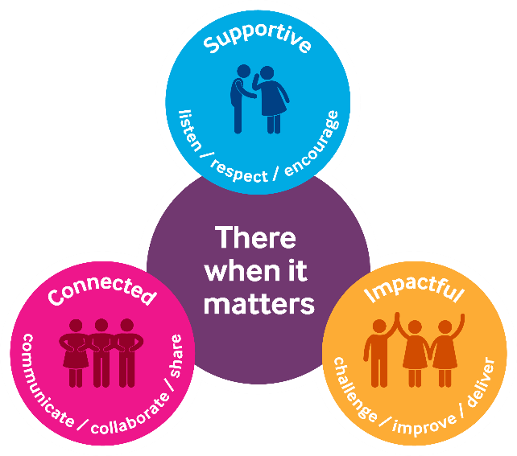
Supportive:
Our first value is supportive. We're here for people when it matters, and that includes each other. We encourage, inspire and help one another, and celebrate success.
The behaviours for this value are listen, respect and encourage.
We will take time to listen and understand; respect and value each other’s differences; and encourage and nurture each other.
Connected:
Our second value is connected. When we work together, we can achieve so much more for the people we support. We respect that everyone at Sue Ryder plays a vital part in delivering quality care.
The behaviours for this value are communicate, collaborate and share.
We will communicate effectively; actively collaborate and appreciate each other’s contribution; and share ideas, experience and knowledge.
Impactful:
Our third value is impactful. We find new and inspiring ways to positively impact the people we support – from small gestures to big breakthroughs. This proactive attitude drives us forward to achieve our ambitions and transform lives.
The behaviours for this value are challenge, improve and deliver.
We will welcome feedback and constructively challenge each other; reflect, learn and continue to improve; and each play our part to deliver the charity’s aims

8. General
In addition to the specific duties and responsibilities outlined in this job profile, all Sue Ryder colleagues should understand the impact that their role has on achieving our organisational aims. Our values tell us how to do this, as they guide us in our choices and influence our behaviour. We ask all our staff and volunteers to follow our values – supportive, connected and impactful – while being an ambassador for Sue Ryder. We refer to this as the ‘We are Sue Ryder’ one organisation vision.
In practice, this means:
- Being able to talk confidently about Sue Ryder, our services and campaigns.
- Being able to talk confidently about why we need to fundraise, how we are funded and how people can get involved.
- Promoting an equitable, diverse and inclusive environment within the charity.
- Keeping up to date with our internal communications, and following the correct organisation processes and using the right systems.
- Always connecting with experts from across the organisation to ensure best practice and maximum impact.
Colleagues should also be aware of their specific responsibilities towards the following:
To adhere to all health and safety and fire regulations and to co-operate with the charity in maintaining good standards of health and safety.
- To uphold ethical and professional standards and not behave in a manner that is likely to bring the charity into disrepute.
- Demonstrate a commitment to on-going registration requirements or any national professional or occupational standards associated with the role.
- Demonstrate a commitment to on-going learning and development and to participate in any training relevant to the role.
All employees are expected to be competent with the use of technology and information systems and understand their duties and responsibilities with regard to the appropriate use of personal data, including sensitive personal data.
This job description is not exhaustive. It merely acts as a guide and may be amended to meet the changing requirements of the charity at any time after discussion with the post holder.

