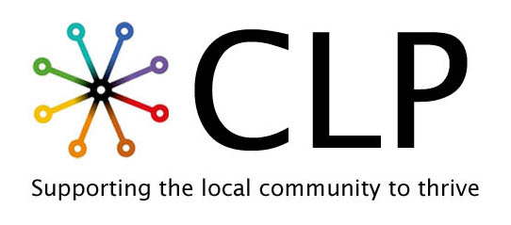
CEO - Person Specification
Category | Essential | Desirable
Qualifications | - Educated to degree level or able to demonstrate equivalent professional experience.  - Evidence of continuing professional development. | - Degree qualification or above in the field of sociology, psychology, politics or cognate field.  - Leadership, management or project management qualification.  - Fundraising, governance or safeguarding qualification/training.
Experience | - Experience of leading people, projects and/or organisational development within a relevant setting.  - Experience of supporting or contributing to income generation through funding applications, grant bids or similar proposals.  - Experience of developing and maintaining productive partnerships with a wide range of stakeholders.  - Experience of leading or contributing to successful projects, from development through to delivery and evaluation.  - Experience of contributing to financial planning and effective management of organisational resources.  - Knowledge of the issues faced by the Roma community, or other racialized, marginalised or excluded communities. | - Experience working within a charity or community organisation.  - Experience of managing budgets and resources responsibly.  - Proven experience of securing external funding through successful funding applications, grants or other income streams.  - Experience of developing social enterprise or earned income opportunities.  - Experience of working with the Roma community or other racialized, marginalised or excluded groups
Skills | - Excellent verbal and written communication  - Excellent interpersonal skills.  - Strong strategic thinking and problem-solving skills.  - Excellent relationship building skills.  - Financial awareness and commercial understanding.  - Collaborative leadership skills.  - Excellent organisational and time management skills.  - Competent IT skills.  - Full clean driving licence | - Excellent presentation and facilitation skills.  - Business development skills for growth and sustainability.  - Ability to influence and negotiate with stakeholders.  - Ability to measure outcomes and demonstrate impact.  - Skilled in recognising opportunities and innovative solutions to respond to community need.
Personal Characteristics | - Strong commitment to the organisation's vision and values.  - Passionate about improving opportunities for disadvantaged communities.  - Commitment to listening to and empowering communities to shape services.  - Positive, proactive and solutions focused.  - Inclusive leadership style.  - Integrity and professionalism.  - Commitment to equality, diversity and inclusion.  - Willingness to listen, learn and develop.

CLP welcomes applications from people from marginalised communities.

