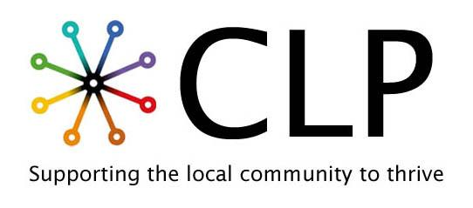
Job Description
Job Title: Chief Executive Officer
Reports to: Board of Trustees
Location: Rotherham
Contract: Full time (37.5hours/week), permanent
Salary: £45K to £50K per annum (dependent on experience). Salary progression may be considered annually, subject to performance and the charity’s financial position.
Role Purpose
The CEO will provide strategic leadership and operational oversight to ensure the organisation delivers its vision, mission, and values effectively and sustainably. Working collaboratively with staff, volunteers, and the wider community, with accountability to the Board of Trustees the CEO will lead organisational development, income generation, governance, safeguarding, and programme delivery.
This role requires a dynamic, passionate and values-driven leader who can balance strategic oversight with operational delivery, ensuring the organisation remains responsive, compliant, financially sustainable, and community-led.

Key Responsibilities
Strategic Leadership and Vision
- Champion and model the organisation’s vision, purpose, and values internally and externally.
- Lead regular review and development of organisational vision and strategy to ensure continued relevance and impact.
- Capture and demonstrate impact and outcomes
- Ensure strategic decisions reflect financial sustainability and operational capacity.
- Monitor organisational performance and adapt strategy in response to changing needs, opportunities, and challenges.

Programme and Project Leadership
- Oversee the planning, delivery, evaluation, and reporting of all organisational projects and programmes.
- Work collaboratively with staff to develop project plans aligned with strategic priorities and available resources.
- Allocate leadership responsibility across teams to ensure effective delivery.
- Develop systems to support project management, performance monitoring, evaluation, and reporting.
- Maintain oversight of all current projects and provide regular updates to Trustees/Directors.
Leadership and People Management
- Provide effective leadership, line management, and support to staff and volunteers.
- Lead workforce planning, recruitment, induction, supervision, appraisal, and professional development.
- Oversee all HR processes including performance management, disciplinary procedures, remuneration, and employee wellbeing.
- Ensure employment practices comply with relevant legislation and best practice.
- Support a culture of continuous learning, accountability, and collaboration.
Partnerships and External Relations
- Build and maintain strong relationships with local and national partners, stakeholders, funders, and networks.
- Represent the organisation at meetings, events, and sector forums.
- Stay informed on sector developments, policy changes, and emerging opportunities.
- Ensure staff, Trustees, and community members can contribute meaningfully to organisational development and influence decision-making.
- Embed community voice and lived experience at the heart of organisational planning and delivery.
Governance, Risk and Compliance
- Ensure the organisation operates in full compliance with charity law, employment law, safeguarding legislation, data protection, health and safety, and other regulatory requirements.
- Maintain and regularly review organisational policies, procedures, and risk management frameworks.
- Prepare and submit statutory documentation, including the Annual Report and business plan.
- Ensure governance structures remain effective, compliant, and fit for purpose.
- Support trustee recruitment, induction, training, and effective decision-making.
Safeguarding Leadership
- Maintain up-to-date safeguarding knowledge and ensure organisational compliance with legislation and local procedures.
- Ensure that a culture of safeguarding is embedded within CLP working practices.

Income Generation and Fundraising
- Lead organisational fundraising strategy to ensure long-term financial sustainability.
- Identify and secure grant funding, contracts, and earned income opportunities.
- Maintain oversight of funding pipelines, applications, and reporting requirements.
- Explore and develop social enterprise or business development opportunities.

Marketing and Communications
- Act as a public ambassador and spokesperson for the organisation.
- Raise organisational profile locally and nationally.
- Oversee communications strategy including website, social media, annual reports, and media opportunities.
Financial Oversight
- Work closely with finance leads/trustees to maintain oversight of budgets, financial planning, and compliance.
- Ensure sound financial decision-making supports organisational sustainability and growth.

Premises and Resources
- Maintain oversight of premises and operational resources to ensure they support effective service delivery and organisational growth.

This job is subject to a DBS check
This job requires the successful candidate to work from the office for a minimum of 4 days/week

