WARWICKSHIRE REMINISCENCE ACTION PROJECT
(WRAP)

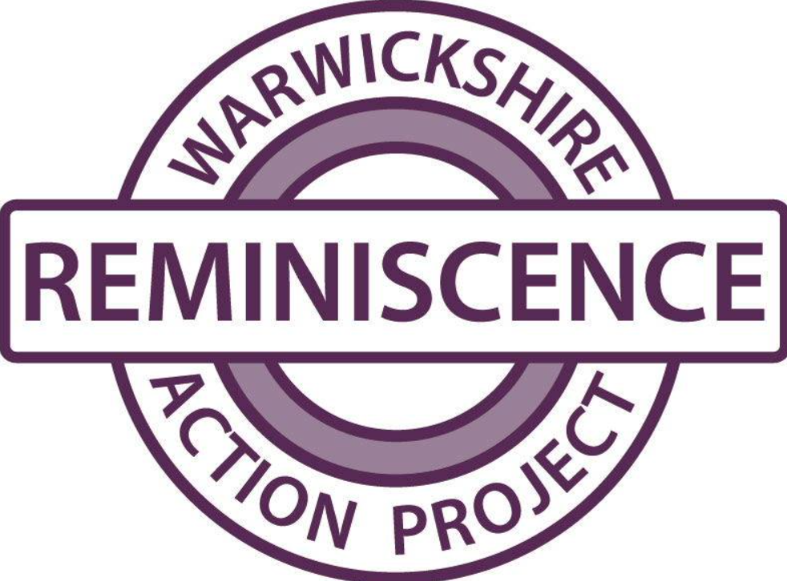

CHARITY MANAGER
JOB PACK
FEBRUARY 2026

Introduction
We are seeking a passionate, motivated and dedicated individual to join Warwickshire Reminiscence Action Project (WRAP) as its Charity Manager. This is an exciting opportunity to work in a charity that supports people with dementia, their carers and professional staff.
If you are committed to working with people to make an impact on health and wellbeing, reduce social isolation and be at the forefront of reminiscence training then this is the role for you.
How to apply
Please send a CV along with a covering letter explaining why you are interested in the role and how you meet the person specification. Please send it to JuneWrap1@hotmail.com. The closing date is 12 noon on Friday 27th February 2026. Interviews will be held on the week commencing 10th March 2026.
If you would like to discuss the role beforehand then please email June Butler, Chair of Trustees on JuneWrap1@hotmail.com or call 07900 241287 to arrange a time to talk.
Background on WRAP
Warwickshire Reminiscence Action Project or WRAP as it is commonly known started in 1999 and became a registered charity in 2005. We operate predominately in South Warwickshire but with a focus on Stratford district.
Our purposes are in summary:
- To preserve and protect the health of those with cognitive brain disorders by providing reminiscence therapy.
- To advance the education and training of carers who work with older people and/or those with cognitive brain disorders
- To advance the education of the public in reminiscence therapy by maintaining a centre of excellence for the development of reminiscence work
The prevalence of dementia in South Warwickshire is higher than the national average and the number of people living with dementia in Stratford District is estimated to increase by 64% by 2040. Warwickshire County Council’s Dementia Strategy estimates 8,500 people are living with dementia in the County. Stratford Upon Avon’s Joint Strategic Needs Assessment report 2019 says that ‘Population Growth in the over 65s is expected to outpace other groups within the next 15-20 years. Their recommendations include Support for people caring for friends or relatives including adults caring for older people with dementia or cognitive impairment.
NICE updated its quality standard on dementia in June 2022 and recommended people are offered activities to promote their wellbeing. A key recommendation was reminiscence therapy: aiding the recall of long-term memories through the use of conversation, objects, photos, videos. The very activities WRAP is excellent at.

The Services Delivered by WRAP
- A weekly 2-hour café held at Bishopton Community Centre. The café is intended to bring people together who are in a similar position to promote wellbeing, reduce loneliness and social isolation and help build up an informal network of support. A range of activities is offered including seated exercise, craft, quizzes and music.
- A Memory Box loan scheme. WRAP has over 80 memory boxes, on a wide range of topics. These are available to borrow to use in any setting, such as cafes, activity groups or care homes, to promote discussion and reminiscence.
- A Looking After a Loved One Programme (LAALO). This is a 6-week programme, 2 hours per week, held approximately 4 times a year. It is aimed at carers who are supporting someone living with dementia and it provides information and support to help people in their caring role. A team of professionals support the programme sharing information to help people plan for the future.
- A monthly music and singing group, also held at Bishopton Community Centre. Music can play an important part in the life’s pf people with dementia so this new group provides fun, socialisation and an emotional connection.
Beneficiaries
WRAP was set up in response to the lack of community support for people with dementia and their carers as identified by representative community groups set up by the Community Education Council. Our day services and cafes were set up as there was no such respite provision for carers in the area. Our LAALO programme was developed because people told us at the cafes that there was no emotional support for carers once their loved one had been diagnosed with dementia.
Our (memory) trigger boxes were developed in response to care homes making enquiries for something to help with their work with residents around memory recall. Our Reminiscence Training (accredited by the Open College Network West Midlands) was developed in response to the rise in requests.
The music group has been set up following feedback from our service users, and also in the knowledge that these groups work well elsewhere. This is a pilot project which started in January 2026.
WRAP supports people affected by dementia, including family and friends and anyone who has a cognitive impairment.
WRAP is managed by a Board of Trustees and they have been working with Warwickshire Community and Voluntary Action and local stakeholders to identify the key issues and options for WRAP's future.
WRAP is part of the Stratford Support Network and is a member of the Young Onset Dementia Forum and the Warwick District Dementia Support Network.

JLT/27/1/26

