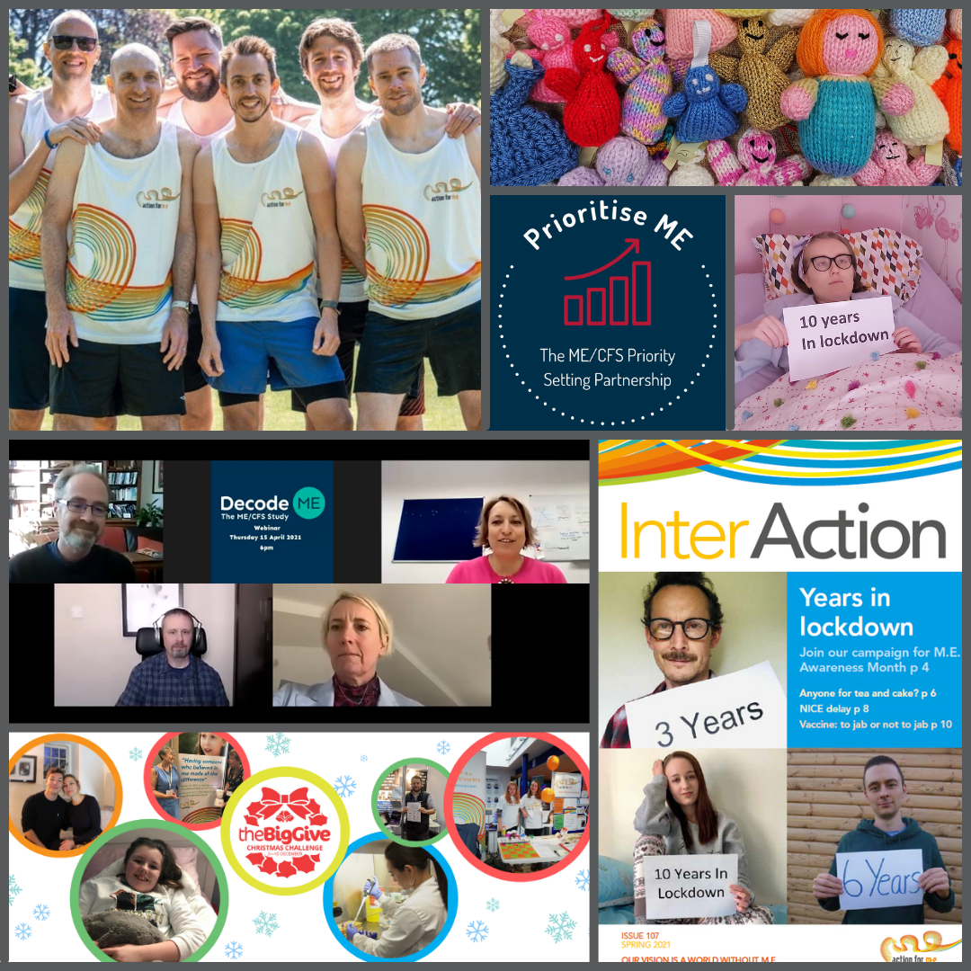
Thank you for considering joining Action for ME
Action for ME
Charity Administrator
Application Pack

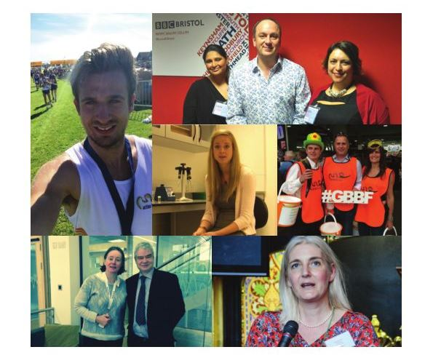

Myalgic Encephalomyelitis (ME) has been neglected and stigmatised for decades. It affects hundreds of thousands of adults and children in the UK alone, but the continued lack of investment means there is no cure and no effective treatments.

For the first time there is an increased awareness of post viral illness because of the Covid -19 pandemic. After decades of neglect this offers Action for ME an opportunity to accelerate our work for people with ME in a way we have never been able to do before.

The life-changing symptoms experienced by people with ME are being mirrored by more than half of those with long Covid. This could mean around 1.3m people are living with ME or ME-like symptoms in the UK.

We have identified areas where there is a critical lack of understanding and a severe unmet need and we have taken the decision to make a significantly increased investment in our work; to accelerate the ME research agenda; to increase the support in the healthcare and advocacy services we offer; and to do all we can to ensure the government address the neglect and health inequity faced by people with ME

Our 2022 – 2027 strategy Shaping our future together sets out our ambition to end the ignorance, injustice and neglect

of children and adults with ME. By working together with the ME community and focusing on the most urgent and important challenges, we will accelerate change for people with ME on a greater scale than has been known before.

We have a talented and committed team at Action for ME where we encourage collaboration and support development and growth. I am delighted that you are considering this role, and I hope this pack shows you the part that you can play in improving the lives of everyone affected by ME.



Sonya Chowdhury
Chief Executive

“I cannot even begin to imagine what this experience would have been like without Action for M.E. I know for certain I would have suffered a great deal more and almost certainly become more ill.” – Information & Support service user

Action with impact
We believe that change won't just happen; it must be made.

That's why action and impact are at the heart of everything we do.

Whether that's helping people today with support, information, or care. Or working towards securing future change through our research and campaigning work.

The intent of everything we do is to pursue positive impact for the lives, rights, and futures of people affected by ME.

About us
Action for ME is the only charity in the UK providing support, including healthcare, to people of all ages affected by ME.

The charity was founded by Sue Finlay in 1987 and since then has been taking holistic approach so we can make an impact on multiple fronts - from amplifying the voices of people affected by ME in Government and leading on breakthrough research, to providing "lifeline" support and unique healthcare services on a daily basis.

Myalgic Encephalomyelitis (ME), sometimes referred to and diagnosed as Chronic Fatigue Syndrome (CFS), is a chronic, fluctuating disease, causing symptoms such as post-exertional malaise (PEM), sleep problems, problems with thinking and memory (brai n fog), pain and crushing fatigue.

There are an estimated 1.3 million people living with ME or ME-like symptoms, including PEM, in the UK alone.

Even in its so-called mildest form, ME can have a significant impact on an individual’s life, and not just on their health. A lack of understanding and awareness about ME means patients can experience disbelief, and even discrimination, from friends, family, health and social care professionals, employers and teachers.

Our vision
A world without ME

Our mission
Our mission is to improve the lives of people affected by ME. Better meeting their needs today while taking action to secure change for tomorrow.

Our 2022 – 2027 strategy, ‘Shaping our future together, has been developed in partnership with children, young people and adults with ME, their loved ones and carers, and others who share our values and ambitions.

This has included learning from the services and support we provide, our surveys and consultations, workshops and discussion groups, and from wider engagement with the ME community.
You have all been absolutely amazing and I am very grateful for this organisation. I felt lost and alone and very confused when I first reached out for advice. I had two phone calls which were so, so helpful, I felt listened to and valued. – Healthcare Services user

Our values
Shared values are held with high regard in our organisation and reflect how we seek to work with our supporters, partners and other key stakeholders.
They reflect the attitudes, beliefs and behaviours that we value in each other and underpin our whole approach and culture.

Collaboration
We will work collaboratively and inclusively with others to take action and achieve change.

Empathy
Most of our Trustees, and many of our staff team, have direct experience of ME themselves. Our collective, deep-rooted empathy is at the heart of our work.

Equity
We believe that everyone deserves fair and just access to resources, services, and opportunities. We are committed to identifying and addressing barriers that contribute to inequalities experienced by people affected by ME.

Our strategy
People with ME are at the heart of everything we do.

In our 2022 – 2027 strategy, we set out four ambitious outcomes which we believe will help us end the decades of ignorance, injustice and neglect faced by people with ME

Underpinning each ambition is our focus on ensuring we reach underserved communities, so they have better access to healthcare, information and services.
- The lives of people with ME are improved by effective access to the information, support and advocacy they need.

- The health of people with ME is improved via access to our holistic Healthcare Services, and the National Institute for Health and Care Excellence guideline for ME being effectively implemented across NHS services.

- Increased funding for high-quality research by more researchers leads to effective treatments for ME

- The UK Government establishes and leads a national strategy for ME

You can read about the difference our work makes to people living with ME in our annual report and accounts 2024 to 2025.

Our people
President
Clare Francis MBE

Vice President
Martin Arber

Patrons
- Lord David Puttnam CBE
- Lord Melvyn Bragg
- Julie Christie
- Alan Cook CBE
- Sarah Dorin
- Philip Mould OBE

Chair of Board of Trustees
Roger Siddle

Board of Trustees
- Jonathan Manuel
- Shaun De Boo
- Colin Morgan
- David Leigh
- Julianne Devine
- Philip Courtney
- Dr Nirmala Santiapillai
- Jeff Banks
- Wendy Lippmann
- Ros Boyle
- Eleanor Bulmer

We are an organisation led by people affected by ME, for people affected by ME We aim to have a minimum of 51% of our Trustees who have, or have had, ME themselves. Our Trustees are unpaid and meet at least four times a year and many sit on one of our four sub-committees.

Our Team
We have a staff team of just under 40, many working part-time, and approximately 70 volunteers who support our work in a number of different ways. Our head office is in Bristol and we have members of the team located across the UK, including Scotland, working remotely.

Our Services
We provide free Information and Support, Advocacy and Family Support services for adults, children and young people with ME, and their loved ones.

While our Information, Support and Advocacy team does not recommend any specific treatments or management approaches, our Healthcare Services team works with individual patients to offer personalised advice, care and support. We are not able to offer specialist legal, employment or medical advice, or specialist mental health support; instead, we signpost to specialist organisations that do.

Our Healthcare Services clinical team includes a doctor, physiotherapists, counsellors and multi-faith chaplains, offering individually tailored whole-person care. We are a small-scale healthcare service provider and do not have the complexity that the NHS and other larger providers have. We also offer a free children and young people’s counselling service.

Our Resources and Peer Support
We have lots of information and support on all aspects of living with ME Our booklets and factsheets are available for free online, or we can be sent by post or email, on topics including but not limited to:
- symptom management and accessing health services
- welfare benefits processes, rights and entitlements
- accessing social care
- liaising with your child's school
- getting reasonable adjustments at work.

Our peer-support forums for adults with ME and 18s and under with ME are free to join and users tell us they feel better supported, and less isolated.
Job Description

Job Title | Charity Administrator
Responsible to | Director of Operations
Responsible for | N/A
Salary | £24,642.09
Hours of work | 35 hours per week, Monday to Friday during normal office hours with flexibility
Annual leave | 30 days per year plus bank holidays
Office Base | Home / Hybrid / Office-based (Bristol)

Job Purpose
You will play a pivotal role supporting the Charity in several different ways. Working with the Senior Leadership Team, you will ensure the smooth running of the organisation, providing administrative support to the Director of Operations and the Chief Executive. As a self-starter you will manage a range of tasks such as diary management, meeting minutes, assisting with event administration and HR administration. No two days will be the same!

You will be the point of contact for our HR, recruitment and training systems, ensuring consistency and assurance across the organisation. You will support HR administration such as supporting recruitment, on-boarding and off-boarding of colleagues as well as taking minutes for Board meetings, so you will need to be able to maintain a high level of confidentiality.

As a team player, you will provide comprehensive, confidential and sensitive people-orientated administration support, developing a deep understanding of our organisation, our work and build strong, effective working relationships with colleagues.

Remote working at home can be challenging for some and for others, it works incredibly well. You will need to be able to work on your own, use your own initiative and ensure you are proactive in maintain good levels of communication and contact with your colleagues to ensure we deliver the best service possible to people with ME.

Key Duties

1. General administration
- Be a welcoming first point of contact, monitoring inboxes and responding to routine enquiries in a timely and sensitive manner, escalating more complex matters as appropriate
- Assist the Senior Leadership Team with booking meetings, diary management and events
- Supporting the Chief Executive in governance administration such as taking minutes of Board meetings and proof-reading papers
- Maintain databases and other management information/recording systems to ensure accurate and timely record-keeping
- Provide administrative assistance for various projects and initiatives, as needed

2. HR Administration
- Assist colleagues with general administrative tasks such as responding to queries, provide assurance that our systems are being used effectively by managers and data is accurate
- Run standard reports on our systems, providing data for our management information framework and absence management, for example
- Provide administrative support to managers for recruitment assisting with pulling together recruitment packs, setting up jobs on our recruitment software and assisting with organising interviews
- Be our organisation lead on our HR, recruitment and training platforms, setting up new starters and leavers and inducting people in using the systems, as appropriate
- Support general HR administration and ensure systems, records and data are maintained in compliance with Action for ME processes and in accordance with data protection legislation

3. Other key responsibilities
- Maintain confidentiality at all times and in line with relevant policies and procedures, ensuring compliance with GDPR and ensuring all data consent processes have been followed in relation to data protection.
- Positively promote the work and activities of Action for ME at all times.
- Undertake any other reasonable activity in line with the responsibilities of the post as requested by Director of Operations or the Senior Leadership Team

Person Specification

Essential skills and experience

- Organisational skills: Highly organised with the ability to manage multiple tasks, have an attention to detail and maintain accuracy under pressure
- Communication: Excellent verbal and written communication skills, with the ability to interact effectively with diverse audiences
- IT Literacy: Proficient with common office software, including Microsoft Office (including Word, Excel, Outlook, Teams) and the ability to quickly learn use of relevant software systems such as BreatheHR, our HR admin tool, and Recruitee, our recruitment tool
- Problem-solving: A creative and solution-focused mindset to address challenges and find innovative ways to improve processes
- Adaptability: Capable of managing changing priorities, working flexibly, and adapting to the needs of a busy charity environment
- Initiative: Take a proactive approach, demonstrating the ability to work independently, take initiative and also follow clear instructions when given
- Teamwork: A collaborative, team player with a proven ability to work effectively as part of a team, including a remote-working team
- Interest in the sector and/or a desire to take action to improve the lives of people with ME: A genuine interest in working in the Third Sector and in the work of our charity and the people we serve
- Experience: Demonstrable ability to be an effective Charity administrator. HR administration would be an advantage but not necessary

Terms and conditions

Outlined below are some of the main terms and conditions of employment relevant to all employees of Action for ME

- Probation
All posts are subject to three months’ probation. During this probationary period, either party may give the other one week’s notice in writing to terminate the employment. After successful completion of the probationary period, the notice stated on your contract of employment will apply.

- Annual leave
The holiday year runs from 1 April to 31 March. In each holiday year in addition to bank and statutory holidays the holiday entitlement for a full-time employee is 30 days (includes 3-4 days to be taken at Christmas as directed when the office is shut).

- Pension scheme
Action for ME operates a group pension scheme on an auto-enrolment basis. All employees will join the scheme on the completion of three month’s service unless they choose to opt-out. Action for ME will pay a pension contribution which is currently 4% of salary. Action for ME will not pay into a personal pension scheme.

- Salary payment
Salaries are paid on the 24th day of each month, by direct credit transfer into a bank or building society.

- Flexibility & Wellbeing
This post may require working outside of normal office hours and travel to attend meetings and events within the UK, including occasional overnight stays. We provide access to an Employment Assistance Programme and an optional monthly wellbeing session for all colleagues, regardless of hours worked with sessions determined by the team.

We offer a flexible working model, in accordance with six working principles developed by the team:

- Your working hours/practices do not disadvantage others
This means:
- Your working hours must not impact negatively on the people we are here to serve. The core hours of client-facing services must be delivered and boundaries with/for all clients must be maintained.
- Safeguarding and wellbeing remain a priority. You will reasonably be able to access management support when needed in an emergency and/or safeguarding concerns exist. This may include a ‘matrix management’ approach to provision.
- Your working hours must not disadvantage colleagues. You need to be available for colleagues/meetings in ‘normal working hours’ with a good percentage of cross-over time.
- Each team must manage its own outgoing post. Your line manager can provide details of the arrangement for your team.
- Flexibility all round. We all need to work flexibly to achieve the best results, and this will require compromise.
- Good stewardship is maintained. We must continue to be cost effective and efficient, ensuring we deliver value for money and that quality delivery is maintained. We will need to ensure all legal and regulatory requirements continue to be met.
- If you wish to compress your hours, this is limited to working 5 days in 4 for full time employees and no more than 8.75 hours per day (excluding lunch break) for part time employees

- Work where you work best
You will be supported to work in the location where you can use your talents most effectively and contribute to your team and Action for ME This means you will be supported to work in the office, at home, or a combination of the two in a pattern to be agreed on an individual basis with managers and their team members.

There are three broad interpretations of this principle:
- An office is the right place to work for some people. If this is you, and you will be based in the office a majority of your time, (4 days/week or more if full time or 90%+ of contracted time if part-time) you will require a desk and will be provided with one.
- Home is the right place to work for some people. If this is you, and you will be based at home the majority of your time, (4 days/week or more if full time or 90%+ of contracted time if part-time) you will be provided with suitable support to work from home full-time and will use hot desks when in the office.
- Some people need a mix of both home and office. If this is you, and you will be based either 2 days at home/3 days in the office or vice versa model (full time workers) you will be provided with suitable support to work from home and will use hot desks when in the office.

- Location doesn’t matter
This means we recruit and retain the best people wherever they live in the UK. All jobs will be advertised as home/flexible/office-based to attract the widest pool of talent unless funding/role requirements dictate otherwise.

- People can change their location. Staff who are currently home-based may wish to become office-based and vice versa. So long as due notice is given, and budgets and existing office contracts allow, a change in preference will be accommodated.
- ‘Home’ doesn’t have to mean ‘home’ - if you want to temporarily work somewhere else. If you have a secure internet connection suitable for professional meetings remotely, you can work from your house, a family members house, another office or suitable environment you can still work. This means even whilst accompanying family or friends whilst they are on holiday and you are working.

- Technology is our friend
This means:
- Everyone will be equipped to work from home or other location outside the office if required. This means we could cope with future lockdowns or business interruption at short notice if needed.
- We don’t wait until people are physically together to hold meetings. People should be able to meet remotely, in person, or a mixture of both at any time. This means we will have suitable video conferencing facilities on site in Bristol to support this.
- Outlook calendars are always up-to-date so that we know where colleagues are working and when they are, and aren’t, available for work-related discussions.

- Physically being with people and teams matters
This means, regardless of whether you are majority office, home or mixed office and home based all staff will commit to the following (unless reasonable adjustments are required):
- Being able to travel to and meet in Keynsham for team meetings no less than twice a year (this may be whole team meetings or individual team meetings).
- Being able to travel and hold 121’s in person with your manager at least twice a year. This may be in the office, or it may be in an agreed location out of the office.
- Line managers to meet face-to-face with new colleagues at least once in the first 3 months. Any exceptions to this to be agreed with the Chief Operating Officer
- Annual appraisals always taking place in person.
- Committing to at least one whole team event together each year as a whole Action for ME team (as part of an Away Day).
- Making an effort to find out about other teams and sharing with them what is happening in yours.

- Personal leadership is essential
This means:
- If things aren’t working/you spot issues, you take action to redress them at the earliest possible stage; this may include sharing concerns immediately with a manager or working with others to identify a solution.
- Individual performance levels must be maintained. Any reduction in performance will be addressed immediately, in accordance with policy and procedures.

- Colleague Benefits
A summary of the benefits offered to colleagues is as follows:

- Flexible Working: Full flexibility to work where and when you want, based on team-developed principles.
- Enhanced Pension Scheme: A 4% employer contribution, exceeding the statutory minimum.
- Generous Annual Leave: 30 days plus bank holidays
- Employee Assistance Programme (EAP): Access to BACP-accredited counselling and support services for staff and their families.
- Disability-Related Absence Pay: Currently being piloted.
- Enhanced Sick Pay: Improved for better employee support.
- Performance-Related Pay: Annual awards determined by the Board of Trustees.
- Compassionate Leave: Three days standard, with up to 10 days at the CEO's discretion.
- Additional Time Off: For dependant emergencies and discretionary unpaid leave.
- Eye Test Contribution: £30 every two years towards eye care.
- Cycle to Work Scheme: Promoting sustainable and healthy commuting.
- Wellbeing Session: Focus determined by staff. Budget and time off for attendance provided - as well as fortnightly online coffee mornings.
- Study Assistance Policy: Support for learning, development, and career growth through training and mentoring.
- Career Breaks: Opportunities for extended career development breaks.

How to apply:

Applications should be submitted via our recruitment website here: https://actionforme.recruitee.com/o/charity-administrator

Your cover letter should, in no more than two A4 pages, explain your reason(s) for applying for this role and how you fit all aspects of the person specification set out above.

Strong applicants will list each person specification bullet point related to experience, skills and behaviours and provide evidence of how they meet each of these criteria. If you are applying on a job-share basis, please indicate your preferred working hours per week in your application.

We are proud to be a member of the Disability Confident scheme and offer a guaranteed interview to applicants who can clearly demonstrate, via their written application, that they meet all essential criteria set out in the person specification.

Should you have any questions about the role, or require any reasonable adjustments to the recruitment process, please don’t hesitate to contact colleagues on recruitment@actionforme.org.uk

Please note that any applications sent directly to any Action for ME mailbox will not be considered.

Key Dates:

Deadline for applications | 9am on 30 October 2025
Shortlisting; shortlisted candidates will be invited to interview | 31 October 2025
Interviews | 12 November 2025 (online)

How to apply

To apply, please follow the below link to our application form via Recruitee:

https://actionforme.recruitee.com/o/charity-administrator

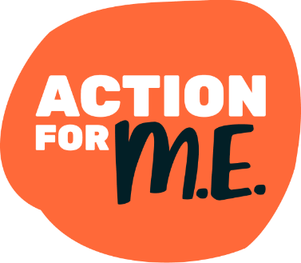

Cover image shows, top left to right: Jake, Ian, Paul, Dan, Chris, Rich and Matt who ran and cycled the virtual length of America’s Route 66 highway – 2,280 miles - to raise £4,500 for Action for ME; Christmas Angels knitted by our supporters to send to young people with the condition; the ME/CFS Priority Setting Partnership research project logo; Olivia, who has had ME for ten years, taking part in our 2021 #yearsinlockdown campaign.

Bottom left to right: Prof Chris Ponting, patient representative Andy Devereux-Cooke, Solve ME/CFS Chief Scientific Officer Dr Sadie Whittaker and Action for ME CEO Sonya Chowdhury at a webinar for DecodeME, the world's largest ME DNA study; the campaign banner for our Big Give Christmas Challenge; the cover of InterAction, our membership magazine, described by many readers as a lifeline.

