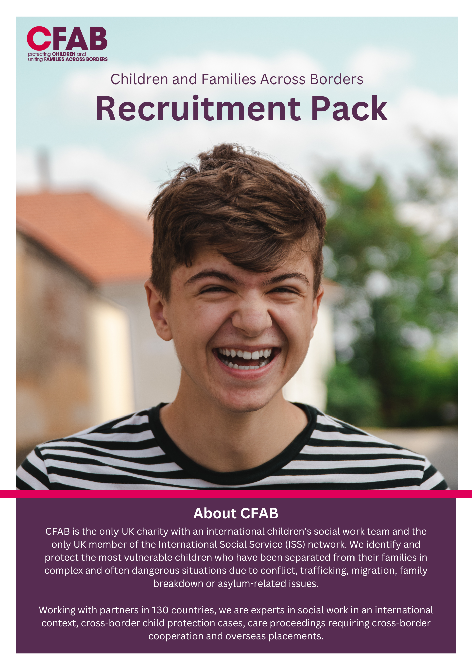

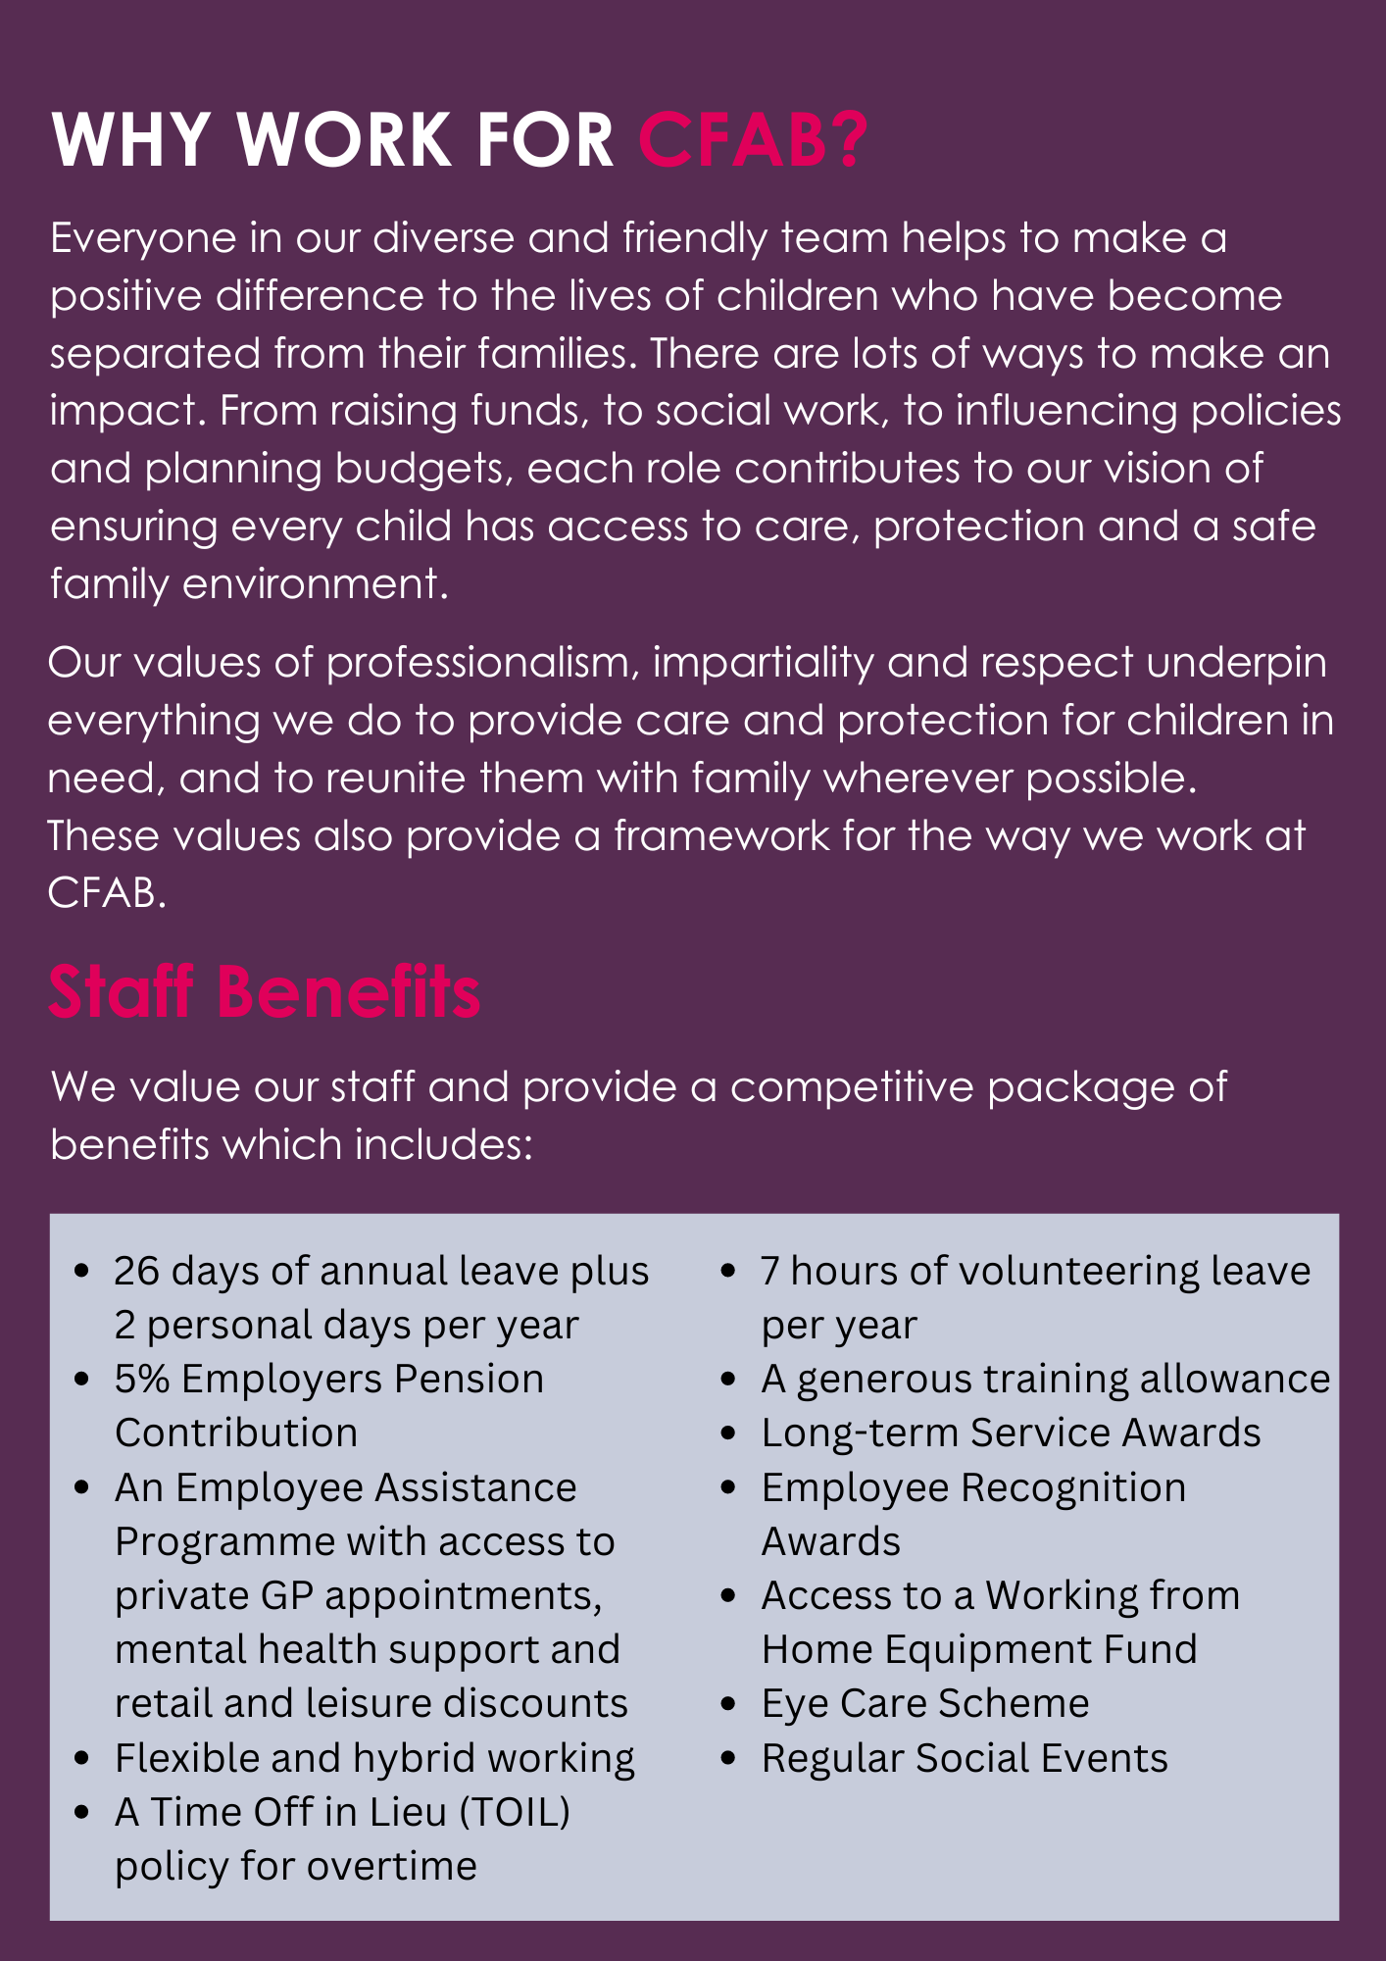

Job Title: Programme Support Officer
Reporting to: Head of Fundraising
Hours: full-time
Salary: circa £27,500 (Inclusive of London Weighting)
Contract Type: permanent
Location: Predominantly office-based (London), with some flexibility.

Application deadline:
To apply, please send a full CV and covering letter detailing how you meet the requirements of the role and outline why you are interested in working for CFAB to https://system.citrushr.com/Job?uid=ydgvzowfsozvuttdunur 26 November 2025 at 5pm.

As a cross-border, cross-culture children’s charity, Equality, Diversity and Inclusion is at the heart of what we do. We are committed to fostering a workplace that promotes mutual respect and allows equal opportunity for all. We seek applications for candidates with diverse backgrounds including, but not at all limited to, family overseas, experience being raised by non-biological parents, ethnic minority communities and people with health conditions or impairments.

We are proud to be a member of the Experts by Experience Employment Network (www.ebeemployment.org.uk), which aims to increase representation of people with lived experience in the charitable sector. Please feel free to use information and resources at https://www.ebeemployment.org.uk/ebe which may help in preparing your job application.

Main Purpose of Role:
The Programme Support and Administrative Officer will play a key role in ensuring the smooth operation of CFAB’s programmes and organisational functions. This role supports executive coordination, training delivery, family support administration, international social work logistics, and general office management. The postholder will work across teams to provide high-quality administrative support, contributing to the efficiency and effectiveness of service delivery.

Key responsibilities:
Programme Support and General Administration
- Monitor shared inboxes and switchboard calls.
- Respond to ad hoc staff queries and manage incoming post.
- Send initial and closure letters for client cases.
- Track inactive cases and follow up on referral forms.
- Prepare duty rotas, upload referrals and update the country information list.
- Support contract preparation and database maintenance for International Social Workers (ISWs).
- Support feedback collection and documentation.
- Assist with Mailchimp campaigns and mailing list research.
- Upload donations into Salesforce.
- Prepare donor thank-you letters and assist with prospect research.
- Provide general support across departments as needed.
Executive Support
- Schedule and coordinate meetings for the CEO and senior leadership, including diary management and events.
- Track meeting actions and follow-ups.
- Support minute-taking using ai and ad hoc research tasks.
Training & Learning Support
- Coordinate training calendars and liaise with teams.
- Update training materials and manage Eventbrite pages.
- Provide limited on-the-day training support and monitor certificates and surveys.
Facilities & Office Management
- Order stationery and maintain office tidiness.
- Support logistical tasks such as PAT testing, IT coordination, and office trackers.

Person specification: (Skills, Abilities, Knowledge and Experience)
Essential:
- Strong organisational and time management skills.
- Excellent written and verbal communication.
- Experience supporting senior executives or programme teams.
- Ability to manage multiple tasks and prioritise effectively.
- Comfortable working across diverse teams and functions.
- Proficient in Microsoft Office and general digital tools.

Desirable:
- Experience in a charity or social care setting.
- Familiarity with Salesforce or similar CRM systems.
- Understanding of safeguarding and trauma-informed practice.

This job description is a non-contractual document and may be changed at any time by CFAB. All employees are expected to be flexible over the tasks/duties and responsibilities of their roles in order to meet the needs of both of CFAB and our service users/partners.

