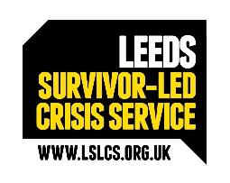
LEEDS SURVIVOR LED CRISIS SERVICE

Terms and Conditions

Job Title: Chief Executive Officer (CEO)

Location: Various Leeds based. Primarily Dial House, 12 Chapel Street, Halton, Leeds LS15 7RW

Physical Conditions: Dial House, Halton, is a three-storey listed building, with disabled access to the ground floor.

Salary: Starting at £45k and progressing to £51k

Hours: Monday - Friday, 9:00am – 5:00pm (flexible), with some out of hours work required, including to shadow occasional shifts

Brief Description: Leeds Survivor Led Crisis Service (LSLCS) is a growing, medium-sized mental-health crisis support charity.
We are a busy, innovative, Person-Centred, trauma-informed service, working across Leeds and West Yorkshire, with Children, Young People and Adults.
We are seeking to appoint a Chief Executive Officer with a proven commitment to survivor-led practice, outstanding organisational leadership capability, and relevant therapeutic competence, to provide strategic and inspirational leadership for the organisation’s future

Responsible to: Chair of Trustees

Annual Leave: 33 days including statutory (pro rata’d), increasing to 36 days after 3 years continuous service, and 39 days after 5 years.

Pension: Pension based on 3% contributory pension, after 3 months initial postponement.

Probationary Period: All posts are subject to a six-month probationary period.


