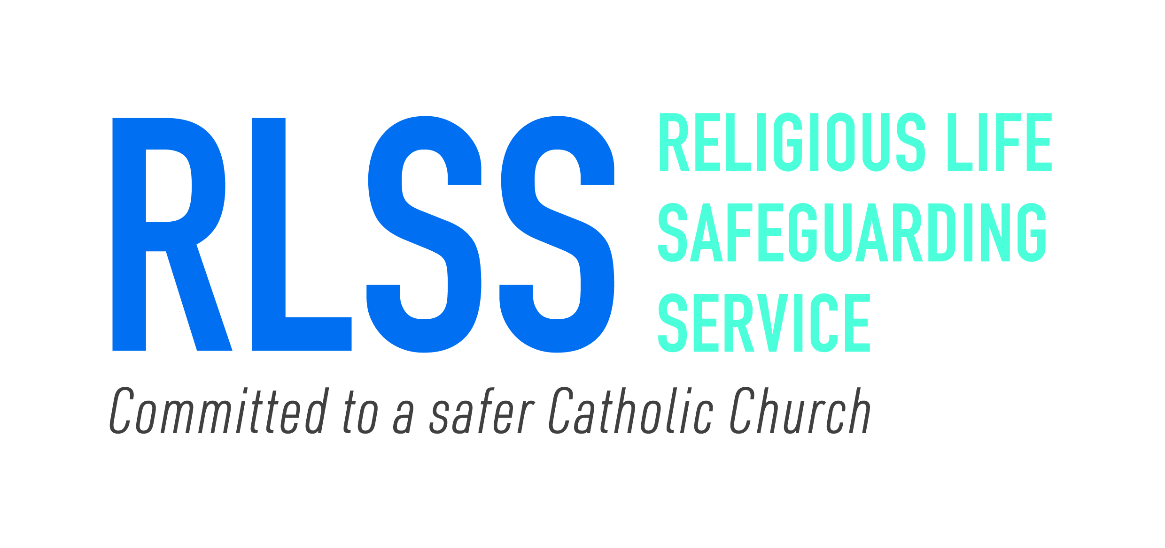

Religious Life Safeguarding Service

CHIEF EXECUTIVE

Recruitment Information Pack

June 2026

FOREWORD FROM THE EXECUTIVE CHAIR

Thank you so much for showing interest in becoming the new Chief Executive of the RLSS.
This is an exciting time to join the RLSS, who are a small, experienced team, providing safeguarding expertise and support to Religious Life Groups in England and Wales. Our work is challenging and ambitious and is underpinned by our values. Our engagement with our members and stakeholders, victims and survivors are key to our success.
With an excellent reputation for our work within our membership, we have the opportunity to build on what has been achieved so far.
Whilst continuing with our efforts to deliver against the existing strategy, we have now also begun to lay the foundations for the next strategy cycle, which we intend to publish later in the year. We are also in the process of becoming a charity, which we hope to achieve during 2026.
As such, the timing of this appointment allows the successful candidate an opportunity to work with the Board in articulating the longer-term vision for the RLSS, coupled to a plan that enables us to expand our reach, enhance our work, and deepen our impact.
The role of CEO at the RLSS is one of both challenge and immense reward, offering the chance to lead a passionate and skilled team dedicated to making a tangible difference.
If you feel you can bring to the RLSS the experience and values we are seeking, then please do forward an application to us.
I look forward to hearing from you.

Anne O’Brien – Executive Chair
RLSS

Background and History
In October 2019, an Independent Review (Elliott Review) of structures and arrangements of safeguarding within the Catholic Church in England and Wales was undertaken. In addition, the Independent Inquiry into Sexual Abuse (IICSA) published an interim report of safeguarding within the Catholic Church. The recommendations of both Reports were fully accepted by the Catholic Bishops’ Conference of England and Wales in November 2020.
Central to these recommendations was the replacement of an ‘alignment’ process of Religious to Diocese for the purposes of safeguarding support, to a dedicated entity, tailored to and developed with Religious.
This new model was built on a ‘One Church’ approach to safeguarding – a commitment across all Diocese and Religious Life Groups to be One Church working to a common standards-based approach, with transparency and accountability to fulfil our collective safeguarding duties.
In November 2020, a task group Chaired by Archbishop Malcolm McMahon, then Archbishop of Liverpool, was established to oversee the implementation of the recommendations. Delegated to the Conference of Religious (CoR) from the task group, a dedicated team from CoR supported by advisory panels, worked in consultation with Religious to design and develop what we know today as the RLSS.
The RLSS became operational in February 2022 and much has been achieved in that time.

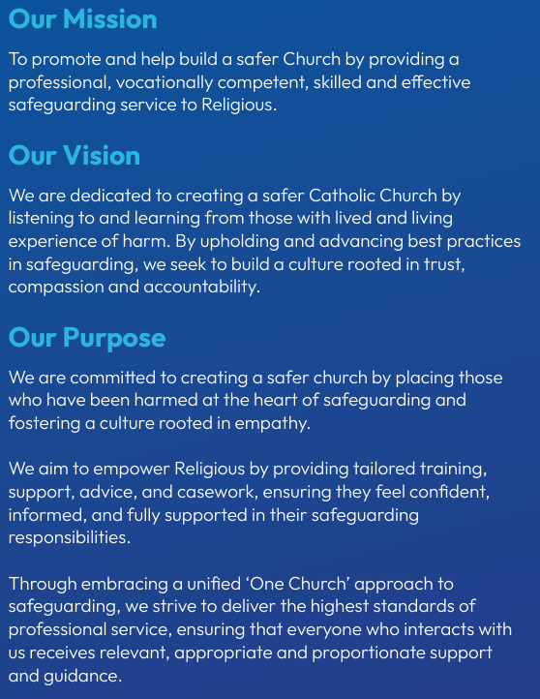

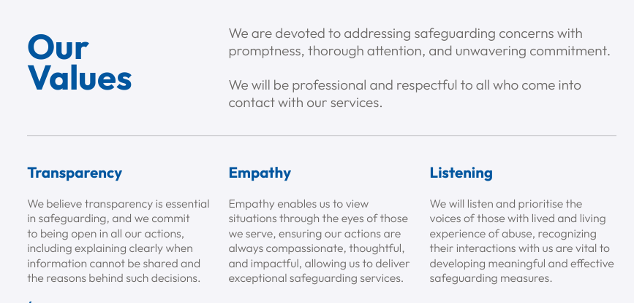
WHAT WE DO
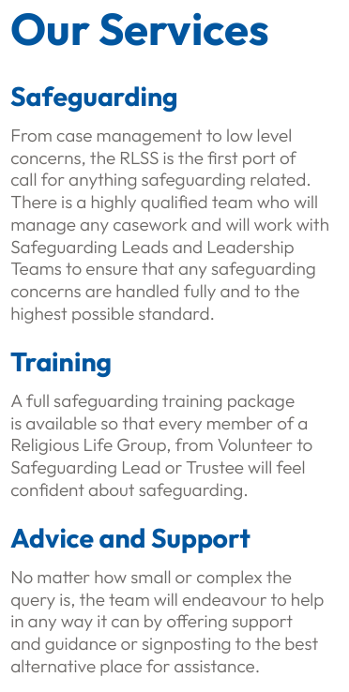
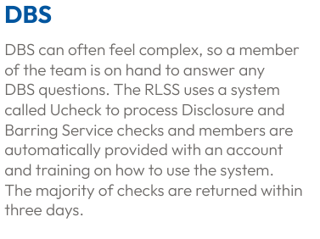

ROLE DESCRIPTION
Job Title: Chief Executive
Location: Liverpool
Reports to: Chair of Board
Renumeration: £75,000 - £80,000
Date: July 2026

Main Purpose of the Post
The Chief Executive will have overall responsibility for all aspects of the day to day running of the RLSS and all its services. This will include management of staff and ensuring the services are meeting the needs of those who require them, in addition to managing finances, membership and external relationships. The post holder will be accountable to and work closely with the Board Chair and its Directors to set the strategic direction and further develop the business model which will serve Religious Life Groups for the future.
Key Duties and Responsibilities
Strategy & Leadership and Governance
- Provide visible, ambitious, and focused leadership of the RLSS.
- Be overall responsible for the management of the RLSS working in conjunction with the Chair and Directors to provide leadership.
- Lead and contribute to the Board’s overall development of the strategy and annual plans to ensure achievement of a One Church approach to applying the Church’s safeguarding standards.
- Ensure risks to the overall objectives of the RLSS are identified, mitigated, and reported to the Board.
- Develop a culture of resilience, adaptability, and continuous learning within the organization to navigate challenges and maintain trust among victims/survivors and members.
- Develop and promote services and practice improvements which are designed to mitigate risk and improve understanding within safeguarding.
- Effectively sustain a culture that consistently meets the needs of and engages with victim/survivors and with Religious.
- Foster and develop a climate of shared accountabilities, learning and continuous improvement.
- Ensure the RLSS meets it statutory, legal, and regulatory obligations.
- Ensure appropriate presentation and reporting to the Board (and any sub committees and advisory groups) on the progress of the RLSS and on all matters relevant to the discharge of the Board’s responsibilities.
- Oversee all promotional activities, press releases, digital presence, radio, and newspaper interviews.
Staffing & Management.
- Be accountable for the recruitment, retention, ongoing development, and wellbeing of RLSS staff.
- Enthusiastically and effectively, lead, shape, and influence teams to deliver the vision and goals of RLSS to ensure best practice in the delivery of all its safeguarding services.
- Create a supportive working environment which promotes transparency and collaboration in safeguarding.
- Ensure that high quality people management is embedded across the service and foster a high performing culture with shared accountabilities and continuous improvement.
- Ensure the effective management and implementation of robust performance management and appraisal processes.
- Provide direction, support, and set clear objectives to immediate line reports.
- Provide or arrange professional supervision to safeguarding case working staff.
- Produce, review and update plans relating to service areas.
- Establish and maintain effective and secure record keeping systems.
- Ensure the management and implementation of regular quality assurance, audit, performance management and reporting, using effective management information systems, ensuring this meets CSSA’s requirements.
Collaboration/Networks.
- Contribute to strategic level initiatives with key partners, particularly the Catholic Safeguarding Standards Agency (CSSA) and relevant statutory agencies, to ensure joint planning, access to resources and the development of interagency strategies.
- Build strong and dynamic relationships and networks within and outside the Church to deliver better outcomes for Religious in safeguarding.
Policy and Procedure
- Ensure a robust and up to date Policy & Procedure framework approved by the Board is in place including HR, Health and Safety, Data Protection and operational delivery.
- Ensure there is a system in place to review approved policies and procedures to ensure that substantial changes or additions are brought to the Board for decision.
- Undertake operating compliance exercises including annual risk assessments, health and safety checks and reporting on incidents and near misses.
- Ensure

Finance & Resources
- In conjunction with the Board of Directors, develop a long-term funding strategy, including gathering data, completing research, developing models to ensure the service is cost effective.
- Agree and deliver to budget maintaining a reserve level in line with policy and monitor all budgets and provide financial reports to the Board of Directors.
- Be responsible and accountable for all finances and resources within the teams, ensuring value for money, the avoidance of waste, and the efficient and effective use of all resources.
- Ensure the equitable and timely allocation of work, assuring the most appropriate interventions that timescales are being met and appropriate records maintained.
- Be responsible for all contracts, tenancy agreements and leases.
- Have overall responsibility for the security of confidential information, use of computers and database information.
- Well-developed database and Microsoft Office skills.
This a summary of the key activities of the post. It is not intended to be an exhaustive list and the post-holder may be required to perform other duties which are appropriate to the scale and nature of the job role.
Role Requirements
Essential Criteria you need to be able to demonstrate:
Strategic and system leadership
- Experience of working at Chief Executive level in similar size/larger organisation.
- A strong track record leading organisations, setting direction and delivering outcomes
- Resilience and the ability to work under pressure whilst showing consideration to others.

Culture and capability building
- motivating people, driving, and evaluating performance, and building a positive and inclusive culture

Commercial and professional judgement
- Professional knowledge and experience that evidence a strategic and operational understanding of safeguarding
- Management skills including finance, planning, project management and marketing.
- Strong commercial acumen.
- Experience of negotiating and managing contracts.
- Excellent verbal and written communication skills, and competence in using digital technology for service delivery across the organisation.
- A creative thinker, proven leader with a ‘can do’ attitude which is results orientated.

Stakeholder engagement and influence
- Interpersonal and listening skills; an ability to deal sensitively with those in Religious Life, Victims/Survivors public, the vulnerable and their families/representatives.
- Skills in conflict resolution, negotiation and problem solving.
- Experience of reviewing evidence and taking appropriate action where necessary; applying sound judgement, with an attention to detail; maintaining confidentiality and building trust
- Ability to respond, sensitively and fully to complaints.

Desirable Criteria you need to be able to demonstrate:

- Understanding of the way in which faith-based organisations respond effectively/ dysfunctionally to safeguarding issues
- Senior management experience in the charitable sector

Due Diligence – Please note that as part of the safer recruitment process, due diligence including social media checks will be undertaken on appointable candidates.
Organisational Chart

Application Process
Should you wish to apply for this position, please supply the following by 12.00 on Friday 24th July 2026:
- A supporting statement (maximum two sides A4) giving evidence of the strength and depth of your ability to meet the criteria for the role. Please provide specific examples to demonstrate how you meet each of the experience, qualities and skill areas identified in the person specification.

- A comprehensive CV (maximum three sides A4) setting out your career history and including details of any professional qualifications.

- The details of two professional referees who can be approached for references. One must be your current or most recent employer. Referees will not be contacted prior to interview and only with consent of the candidate.

- In addition, please also complete and return via email the form at Annex A - conflicts of interest.

Completed applications should be emailed to corporatesupport@religioussafeguarding.org with RLSS CEO Recruitment in the subject field.
Further information:
Should you wish for further information relating to this role or for an informal discussion with the Executive Chair, please email corporatesupport@religioussafeguarding.org and this will be arranged.
Indicative Timetable
Please note that these dates are only indicative at this stage and could be subject to change. Please let us know in your application letter if you are unable to meet these timeframes.
Advert Closing Date | Friday 24th July 2026
Panel Interviews | Week commencing 3rd August 2026

Annex A
CONFLICTS OF INTEREST
In the table below, please provide details of:
- Any Directorships (held in the last two years), including relevant dates and the company, possible links to the role, the Catholic Church, (directly or indirectly). Please include any partnerships.
- Any significant shareholdings in companies, which may have a relationship with the role or the Catholic Church, through directorships, trading arrangements or links (directly or indirectly).
- Any possible conflicts of interests created by the employment, directorships or significant shareholding of a family relative or friend.
- Any other matter which may give rise to a potential conflict of interest.

Detail of interests held:

Description of Interest  For indirect Interests, please include details of the relationship with the person who has the interest | Relevant dates, or likely duration of the interest

DECLARATION
Please sign and date the declaration below:
I certify that the information included within these forms is, to the best of my knowledge and belief, true and accurate and complete.

Signed………………………

Date…...…………………….

