

CANDIDATE BRIEF

……………..

Fundraising & Income generation manager

september 2026


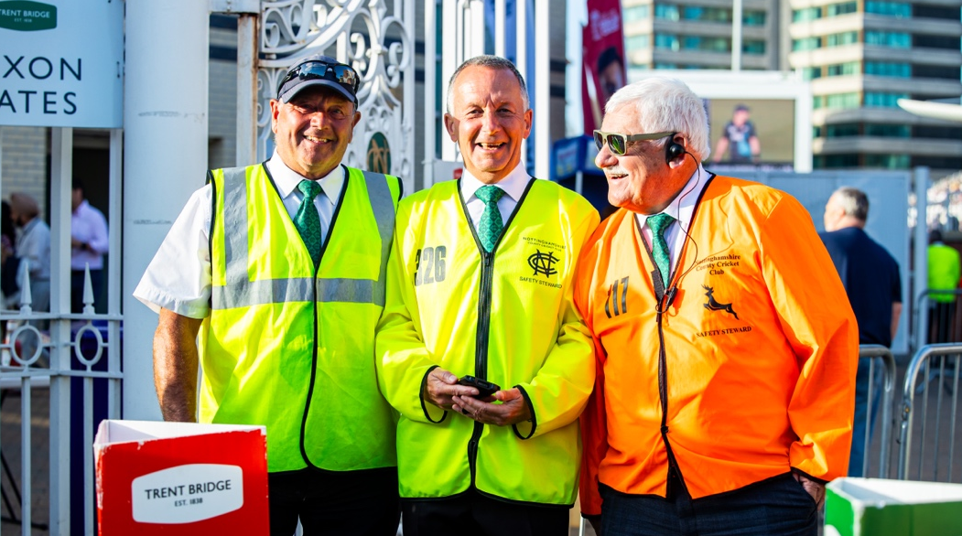


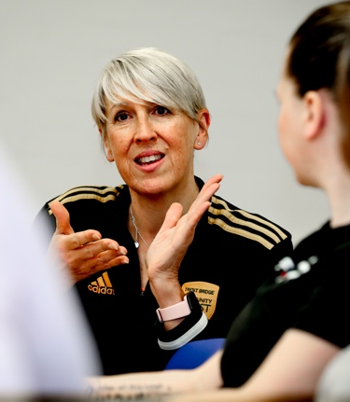


AN INTERNATIONAL SPORTING VENUE,
A PROFESSIONAL COUNTY CRICKET CLUB
AND A THRIVING COMMUNITY HUB
…………………….
Trent Bridge Community Trust is the charitable arm of Nottinghamshire County Cricket Club. Since 2008, we’ve used the power of cricket to connect communities, improve wellbeing, and create life-changing opportunities across Nottinghamshire.
Following our transition to charitable status, we are entering an exciting phase of growth and ambition. Our new Fundraising Strategy (2027–2030) sets a bold target to diversify income, increase sustainability, and expand our impact—especially for disadvantaged communities.
To help us achieve this, we are now looking for a Fundraising & Income Generation Manager to lead our income growth.
This is a new and pivotal role within the Trust, responsible for delivering an ambitious fundraising strategy to secure over £545,000 across three years, contributing to a wider £800,000 long term income vision.
You will lead on building diverse and sustainable income streams, helping us:
- Expand community and cricket programmes across the county
- Increase participation, especially among underrepresented groups
- Sustain vital health and wellbeing projects
- Strengthen our long-term financial resilience
If you have a proven track record in fundraising and income generation, have experience across multiple streams (grants, corporate, events or individual giving), skilled in developing pipelines and achieving financial targets, this is the challenge you are looking for!
If you are committed to making a difference in communities, are motivated by impact, inclusion and opportunity and excited about the power of sport in transforming lives then we want you on our team!
Why should you join us?
Be part of an organisation with strong community impact and heritage, help shape and lead a new fundraising function from the ground up and play a key role in building long – term sustainability and growth.

TRENT BRIDGE COMMUNITY TRUST
ROLE PROFILE

Job Title: Fundraising & Income Generation Manager
Reporting to: Head of Trent Bridge Community Trust
Contract type: Fulltime 35 hours/week
Salary: £35,000 - £40,000 per annum plus bonus
Start date: 1st November 2026

1. RELEVANT GENERAL OBJECTIVES
The Fundraising & Income Generation Manager will lead the delivery of the Trent Bridge Community Trust’s three-year Fundraising Strategy (2027-2030), securing a minimum of £545,000 (within a wider £800,000 long term ambition).
The roles aim is to:
- Build financial sustainability and resilience
- Reduce reliance on restricted and short-term funding
- Increase unrestricted income and diversified revenue streams
- Enable delivery of key programmes that improve health, wellbeing, and community participation through cricket

2. SPECIFIC ROLE RESPONSIBILITY
A. STRATEGIC FUNDRAISING LEADERSHIP
- Lead the implementation and delivery of the fundraising strategy and income action plan.
- Develop and manage a rolling 12–24 month fundraising pipeline.
- Set and monitor annual and quarterly income targets.
- Establish systems, processes and KPI dashboards to track performance.
- Identify new income opportunities aligned to Trust priorities.

B. INCOME GENERATION
Corporate Partnerships & Sponsorship
- Design and deliver tiered corporate partnership packages.
- Identify and secure new business partnerships across Nottinghamshire and the region.
- Develop programme, event and apprenticeship sponsorship opportunities
- Steward and grow existing partners (e.g. Tweezerman, Vertu, Russell Scanlan)
- Work closely with the club’s Commercial team to identify potential corporate/commercial partnerships.
Grants & Trusts
- Develop and manage a structured grant pipeline calendar.
- Write high-quality funding applications to Local Authorities, Charitable Trusts & Foundations, Government and statutory funders.
- Prioritise multi-year and unrestricted funding bids.
- Maintain and grow relationships with existing funders.
Donations & Individual Giving
- Develop a regular giving programme (yearly, multi years, monthly donors)
- Launch and manage digital fundraising campaigns (e.g. JustGiving)
- Grow and segment the supporter/membership database.
- Introduce targeted community appeals linked to community programmes.
- Establish a Patron’s programmes targeting high net worth members.
Fundraising Events
- Lead delivery of flagship events such as Charity Zipwire, Golf Day and Charity Auction.
- Develop and deliver new fundraising events.
- Maximise income through sponsorship and participation growth.

C. PROGRAMME & IMPACT ALIGNMENT
- Work with Managers to ensure all funding aligns to:
  - Volunteer growth (diverse and female volunteers)
  - Expansion of programmes into North Nottinghamshire
  - Apprenticeships and employability pathways
  - Health & wellbeing programmes
- Translate programme outcomes into compelling funding cases, social impact stories and social return on investment.
D. FINANCIAL SUSTAINABILITY & PLANNING
- Increase proportion of unrestricted income and multi-year funding agreements.
- Support annual budget planning and income forecasting.
- Monitor income vs expenditure alongside Managers and Trust Board.
- Contribute to achieving £300,000 reserves target.

E. STAKEHOLDER & RELATIONSHIP MANAGEMENT
- Build strong relationships with Funders and partners, corporate sponsors, Donors and supporters.
- Develop structured stewardship plans.
- Support the production of an impact report, case studies and funder updates.
- Support Trustees in fundraising activity and engagement.

F. PERFORMANCE & REPORTING
- Track and report on KPIs, including income secured vs targets, Application success rates, donor and partner growth.
- Provide quarterly reports to the Trust Board.
- Contribute to the annual review in February.
- Continuously refine approaches based on performance data.
G. SYSTEMS & INFRASTRUCTURE
- Lead the development and implementation of a CRM/fundraising database, Income tracking systems, fundraising processes and policies.
- Maintain a risk register of funding opportunities and contracts.

3. KEY PERFORMANCE INDICATORS
- Minimum of £545,000 secured over three years
- Annual income targets achieved (Breakdown shown in table below)
  - Year 1: £154,000
  - Year 2: £167,000
  - Year 3: £222,000
- Generate an increase in the proportion of unrestricted income
- Growth in corporate partnerships and individual donors
- Strong, active fundraising pipeline (12–24 months ahead)
- Measurable contribution to volunteer growth, programme expansion and new apprenticeship roles through the income generated.
- Improved financial resilience and reduced dependency on NCCC and ECB funding

Income Diversification | Year 1 KPI | Year 2 KPI | Year 3 KPI
Overall annual income generation target | £154,000 | £167,000 | £222,000
Corporate / Commercial Sponsors (Unrestricted) | 50%  £77,000  4 commercial / corporate sponsors | 50%  £83,500  4 commercial / corporate sponsors | 50% £111,000  6 commercial / corporate sponsors
Grants Funding Charities and Non-Charities (Restricted) | 20%  £30,800  4 grant applications | 20%  £33,400  5 grant applications | 20% £44,400  5 grant applications
Donations & Individual Giving (unrestricted) | 10%  £15,400  150 individual donations | 10%  £16,700  150 individual donations giving more | 10%  £22,200  200 individual donations
Events (unrestricted) | 20%  £30,800  3 Events | 20%  £33,400  3 Events | 20% £44,400  4 Events

EQUITY, DIVERSITY AND INCLUSION
Nottinghamshire County Cricket Club is committed to being an Equal Opportunities Employer.
The Club recognises the benefits of a diverse workforce and is committed to providing a working environment that is free from discrimination.
The Club will seek to promote the principles of equality and diversity in all its dealings with employees, workers, job applicants, clients, customers, suppliers, contractors, recruitment agencies and the public.
All employees and those who act on the Club’s behalf are required to adhere to this policy when undertaking their duties or when representing the Club in any other guise.

SAFEGUARDING
Nottinghamshire County Cricket Club is committed to safeguarding and promoting the welfare of children and young people and expects all staff and volunteers to share this commitment.
We ensure that we have a range of policies and procedures in place which promote safeguarding and safer working practice across our services and are committed to ensuring safeguarding practice reflects statutory responsibilities, government guidance and complies with best practice and the ECB requirements to ensure that all children participating in Cricket have a safe, positive and fun experience, whatever their level of involvement.

PERSON SPECIFICATION
Department: Trent Bridge Community Trust

 | ESSENTIAL | DESIRABLE
EXPERIENCE | - 3-5 years proven track record in fundraising and income generation  - Success in securing funding from multiple streams:  - Grants & trusts  - Corporate partnerships  - Events and individual giving  - Experience managing fundraising pipelines and targets  - Experience of developing and managing strategic partnerships that deliver measurable outcomes | - Experience in charity, sport, or community sector (desirable)
SKILLS & KNOWLEDGE | - Exceptional skills in bid writing and grant applications  - Strong understanding of funding landscapes  - Excellent relationship management and networking skills, with the ability to influence and engage a wide range of stakeholders  - Strategic thinking with strong delivery focus  - Strong competency in budgeting, forecasting and reporting.  - Ability to analyse data and drive performance  - Knowledge of fundraising compliance and best practice  - Commercial awareness. | - Good at building long-lasting relationships with key stakeholders  - Have knowledge of non-profit governance and structure
QUALIFICATIONS | - Degree or Equivalent in business, marketing or communications | - Introductory Certificate in Fundraising.  - Certified Fund-Raising Executive (CFRE)  - Specialized training from the Chartered Institute of Fundraising
QUALITIES & ATTITUDE | - Ability to think strategically  - Passion for community impact and social change  - Passion for community sport and increasing participation, particularly underrepresented groups.  - Entrepreneurial and proactive mindset  - Highly organised and results-driven  - Collaborative team player  - Resilient and adaptable in a changing funding environment  - Collaborative mindset with ability to work across teams and organisations.
OTHER | - Ability to travel independently between sites

HOW TO APPLY
To apply, please submit your CV and a covering letter outlining your suitability and experience to our recruitment link at Fundraising & Income Generation Manager - Job page - Nottinghamshire Country Cricket Club Careers

If you are interested in other positions, please visit our career page at https://careers.trentbridge.co.uk/

If you have any questions please email the HR Department at: recruitment@trentbridge.co.uk

Upon appointment, the successful candidate may be required to undertake an ECB DBS check and complete relevant ECB Safeguarding training.

Closing date: Monday 28th September 12noon.

Interviews: Friday 2nd October 2026

We reserve the right to close this vacancy early if we receive sufficient applications for the role. Therefore, if you are interested, please submit your application as early as possible

We are committed to safeguarding and promoting the welfare of children, young people and adults and expect the same commitment from all staff and volunteers

We are an equal opportunity employer. we celebrate diversity and are committed to building an inclusive environment for all employees. when submitting your details, please let us know if you require any support or reasonable adjustments during the interview process

No agencies please



Nottinghamshire County Cricket Club
Trent Bridge, Nottingham
NG2 6AG

0115 982 3000

recruitment@trentbridge.co.uk

