Business Development Manager
Job Description
rethink.org

Work type | ☒ Home based | ☐ Agile | ☐ Field | ☐ Fixed
Location | Homebased
Service or department | Operations/Service Development
Reporting to (title) | Head of Bid Management
Responsible for staff | ☒ Yes ☐ No
Budget manager | ☐ Yes ☐ No
Disclosure and Barring check | If a new or revised role, the level must be assessed by the People Team  Not applicable to the role
Pay band / Job role level | 5. Manager
Evaluated On (Date): | Click or tap to enter a date.
Job Code Reference: | Click or tap here to enter text.

Post Details
Overview of the role purpose:
As Business Development Manager, I work proactively and collaboratively with colleagues across the Charity to sustain and grow our services. I support and co-ordinate business development planning and end to end delivery of bids and proposals, delivering winning submissions, which further the delivery of Rethink Mental Illness’ Strategy. Writing at the highest standard, I articulate Rethink Mental Illness’ offer, strengths, capabilities and experience, I develop service budgets in collaboration with others. I have a strong interest in mental health, health and social care, and the sustainability of charities.

Service/Team Description
Overview of the service or team:
Our Business Development team sits within the Operations Directorate and works closely with colleagues across the Charity to develop and grow our core activities. These activities enable the Charity to deliver high quality mental health care and support to people when they need it and ensure we can help more people through our wider work.

Team structure:
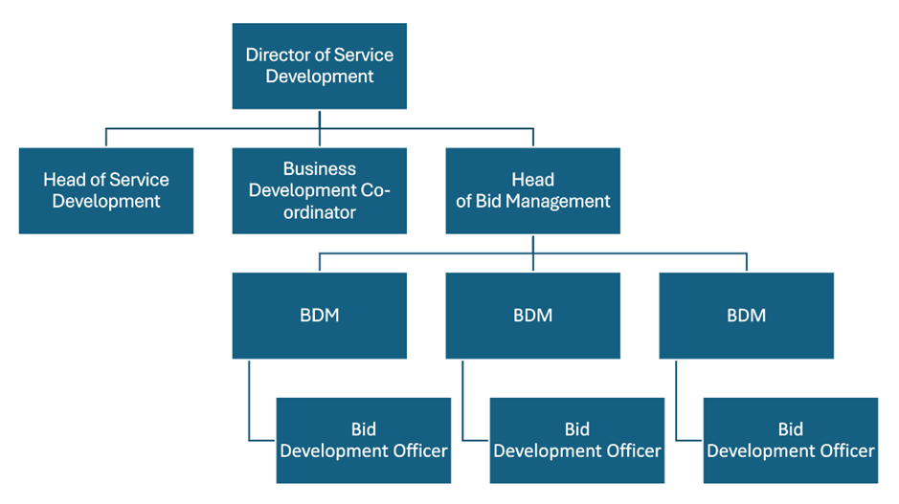
What I do and achieve
What I do:
- I manage the end-to-end bid development process in accordance with internal quality and governance protocols.
- I work collaboratively with teams across the organisation to create high quality bids, retenders and proposals and facilitate connected ways of working.
- I support and manage bid development officer/s
- I support the regional business development planning process, to sustain existing and develop new services.
- I connect with curiosity, purpose and impact, building an understanding of our work
- I generate insight from colleagues, data and evidence and use this to write high-quality tender submissions/proposals that clearly articulate our offer, meet commissioners and funders requirements; and lead to success in winning and retaining contracts.
- I lead the initial modelling of budgets, activity and staffing assumptions to develop service models and solutions with input from operational colleagues. I work with Finance and HR colleagues to finalise these ahead of bid submission.
- I think critically and write to the highest standard, producing high quality, innovative and engaging tender/proposal responses utilising the experience and expertise of colleagues.
- I liaise with subject matter experts to create coherent, informed, and well-structured tender responses and proposals.
- I review and accurately interpret all tender documentation and/or briefs to inform bid/no bid decisions, highlighting risks and ensuring a compliant response.
- I develop and maintain my expert understanding of Rethink Mental Illness’ capabilities, service delivery, organisational priorities and strategic objectives.
- I research the competition and identify Rethink Mental Illness’ points of differentiation, including added value and competitive advantage.
- I work with the Co-Production, Involvement, and Evidence & Impact teams to ensure the involvement of individuals with lived experience in all of our work.
- I support colleagues across the Charity to mobilise services by providing a structured handover of the successful tender; and support the transition period for new contracts into operational delivery as required.
- I conduct research that enables us to refine existing services and products; and enhances Rethink Mental Illness’ reputation as a thought leader in mental health service delivery.
- I Proactively contribute to the Bid Library as a reference for other staff involved in business development activities and to ensure a unified and consistent approach to proposals.
- Support the team’s systems and processes, and in particular the analysis of outcome feedback and application of lessons learnt for continuous improvement.
- Demonstrate a flexible attitude, resourcefulness, and take responsibility for personal development and growth within the team and pro-actively support the culture of continuous improvement.

Who I am
I have the essentials covered:
- I have a demonstratable record of accomplishment in generating income though writing successful competitive bids/proposals.
- I am highly organised, proactive, creative and have strong writing skills.
- I can analyse complex tender documents to understand commissioners needs.
- I have excellent interpersonal skills with the ability to bring people together and develop effective working relationships.
- I demonstrate behaviors consistent with the values of the Charity.
- I keep abreast of innovations and best practice in mental health and social care.
- I have well developed knowledge and awareness of the commissioning environment and current legislation and apply it in my practice.
- I am able to construct budgets
- I am knowledgeable in project management approaches.
- I am able to work flexibly and according to deadlines
- I value feedback, both giving and receiving it constructively
- I have excellent IT skills and proficient in the use of Microsoft Office packages.
I may also have:
- Experience and/or knowledge related to mental health and wellbeing
- Experience working in mental health, health or social care sectors
What I value and how I will behave
I can demonstrate and apply Rethink Mental Illness values of:
- Passion - We are passionate about leading the way to a better quality of life for everyone severely affected by mental illness.
- Commitment - We work tirelessly to provide support for everyone severely affected by mental illness.
- Openness - We are open and transparent in all our work with beneficiaries, supporters, partners and the public to achieve change for people severely affected by mental illness.
- Hope - We offer hope of a better quality of life for all those severely affected by mental illness.
- Expertise - We constantly use our expertise to provide practical and personal support for people who are severely affected by mental illness.
- Understanding - People who are severely affected by mental illness are at the heart of everything we do in our organisation – our membership, our governance and our workforce.
- Equity - We believe that in a world where discrimination and disadvantage exist treating people with equity is critical to ensure justice and fairness for all.
I can apply and demonstrate Rethink CARES behaviours of:
- Connect – We work together, we celebrate together
- Accountable – We do what we say we will do
- Respect – We believe everyone counts
- Evolve – We challenge, we listen, we change
- Success – We deliver results

General Duties:
- I will act in accordance with the provisions of Data Protection legislation (as amended).
- I will ensure all records, personal, staff and client data are managed in line with Data Management and Information Governance policies, relevant legislation, codes of practice or contractual obligations.
- I will comply with legal and regulatory requirements such as provisions set out in the Health and Safety at Work Act 1974.
- I will act in accordance with the charity’s Health & Safety and Safeguarding policies and to notify your line manager promptly if there are any concerns.
- I will participate in regular supervision and appraisal and undertake any relevant training.
- I will work in accordance with the charity’s national policies and local operating procedures and those of external regulators or professional bodies.
- The list of duties is not exhaustive; the line manager may stipulate other reasonable requirements and projects commensurate with the general profile and grade of the post.

