
V

Our Room Board Recruitment
A Creative Community for Male Trans and Non-Binary People who Sex Work

Thank you for expressing your interest in the Our Room Board.

It’s an exciting time to join Our Room’s Board, with our recent name change leading significant change within the organisation to make us more resilient, whilst looking to grow and develop the organisation for the future and supporting an ever-evolving sector.

The board is currently made up of individuals from a wide range of skills from across the private and public sector(s). However, we are actively seeking to increase the diversity of our Board and would particularly welcome applications from people who have lived experience, from minority ethnic backgrounds, all gender groups and/or with a disability.

Our participants are at the centre of everything we do, so new Trustees must be committed to helping us deliver on our mission and share Our Rooms values.

The board meet once a quarter for a formal board meetings & the AGM, however board members are also expected to work with all levels of the organisation across projects looking at operational change, strategic thinking/direction, and organisational promotion (i.e. attend creative events).

If you are interested in joining our team, please read the rest of this pack and make submit your applications. If you require any further information, please reach out to us.


Kind Regards,

Michael Stuart Our Room Chair

Our Room is an innovative Manchester based charity for male, trans and non- binary people who sex work. We provide specialist support and advocacy for people experiencing crisis or vulnerability. We are also passionate about arts- based engagement and strive to empower our participants through imagination and creativity. Our inclusive, arts-based approach can make a difference where mainstream support has fallen short. We are outward looking and are proud of our publicly performed creative work, along with the sharing of learning and insights and professional advice we offer.

OUR VISION
We aspire to a world where male, trans and non-binary people who sex work live happier, healthier, more creative lives.

OUR MISSION
To be a creative community for male, trans and non-binary people who sex work.

OUR VALUES
At Our Room charity values are not just words but guiding principles that shape everything we do:

Compassion is at the core of our mission.
Integrity is our moral compass, ensuring that every action we take is honest and ethical.
Creativity fuels our innovation, inspiring new ways to make a positive impact in our communities.
Empowerment is our commitment to uplifting individuals and giving them the tools to thrive.
Community is the heartbeat of our work, fostering connections and collaboration for the greater good.

We passionately believe in democratising the arts, making creativity accessible to all, regardless of background or circumstance. These values guide us as we strive to create a more compassionate, inclusive, and vibrant world.

We are the only organisation in the UK whose core remit is supporting male, trans and non-binary sex workers. We have supported marginalised and disadvantaged people in Manchester for almost 20 years.

Our approach explicitly acknowledges our participants as experts in their own experience. Our planning and evaluation processes imbed participant voice.

Our staff team includes people with lived experience. All our recruitment processes, including this one, actively encourage applications from people with lived experience. It is important to us all that ‘we see ourselves in the room’ as we know the difference this can make.

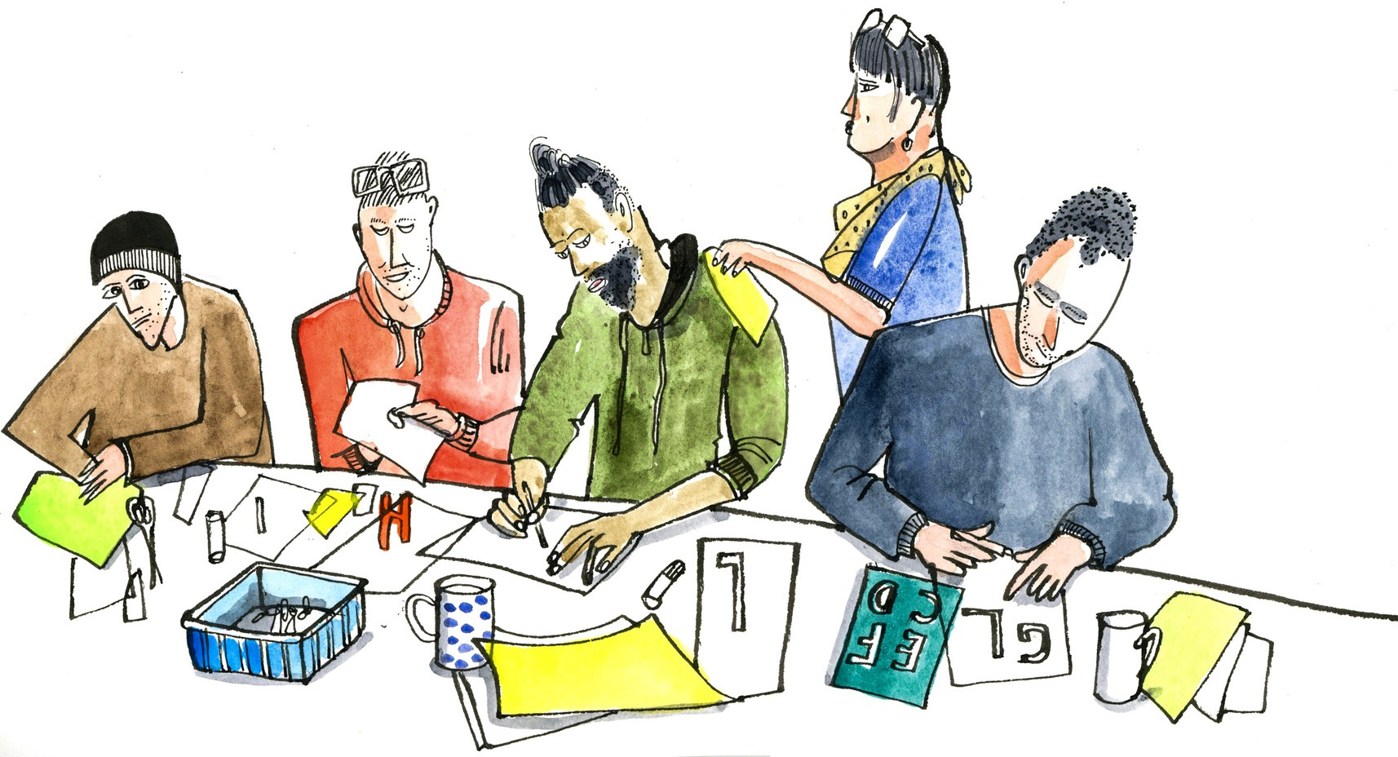
Image credit: Len Grant

We are at an exciting milestone in our journey as an organisation striving to make a difference, following a re-name, re-brand and successful income generation. This has been a catalyst to this invitation, for new people with an interest in our cause and relevant skills and experience to offer to join our Board.

It would be an exciting time to join us on a voluntary basis to help us deliver on our ambitions and contribute to steering Our Room in the years ahead.

You will help us:

Set and oversee our long-term strategic direction. Support our business planning and monitoring.
Ensure strong governance.
Explore new ideas and opportunities
Promote, advocate for and champion Our Room and what we do We are looking for the following leadership skills and experience: Adult health and social care
Arts and creative sector
Campaigning, influencing and advocacy linked to our purpose Charity law and regulation
Equity, diversity and inclusion and centring marginalised voices Financial management, financial control and budget planning * Marketing, communications and social media
Fundraising and income generation
*With a view to taking on a treasurer position

We particularly welcome applications from people with lived experience of sex work, people of colour, people from LGBTQI + communities and people with refugee or asylum seeker experience.

If you would like to talk to a current Board member about this opportunity please contact: admin@ourroom.org.uk

If you have the passion, skills and experience to join us please submit an expression of interest of no more than two sides of A4 to: admin@ourroom.org.uk

You are welcome to accompany this with a C.V. if you feel it would be useful.

Closing date for expressions of interest: 16th Jan 2026

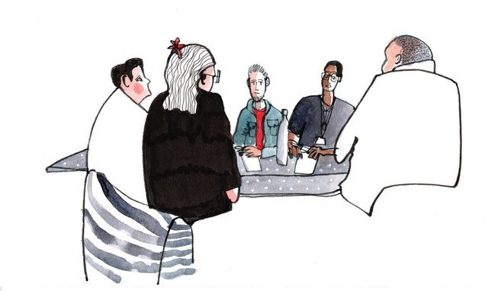
Image credit: Len Grant

Trustee (General)

Role Summary:
TRUSTEE ROLE DESCRIPTIONS
General Trustee Role

As a trustee, you will play a crucial role in the governance and strategic direction of Our Room Manchester. You will ensure the charity is effectively managed and operates in line with its mission and values.

Key Responsibilities:

Attend and actively participate in quarterly board meetings and sub- committee meetings.
Contribute to the development and implementation of the charity’s strategic plan.
Ensure compliance with legal and regulatory requirements. Support fundraising and development activities.
Act as an ambassador for the charity, promoting its work within your networks.
Skills and Experience:
Commitment to the mission and values of Our Room Manchester. Ability to work collaboratively and constructively in a team.
Willingness to contribute time and effort.
Experience in charity governance or relevant professional skills is desirable but not essential.

Specific Trustee Roles

All trustees are expected to take on the responsibilities of a General Trustee.
In addition we are also looking for individuals with experience and knowledge to fill the specific skillset roles of Treasurer.

Trustee (Treasurer)

Role Summary:

As Treasurer, you will oversee the financial affairs of Our Room Manchester, ensuring financial viability and proper financial records and procedures.

Key Responsibilities:

Provide financial oversight and report to the board on financial matters.
Ensure robust financial controls and risk management processes are in place.
Support the preparation of annual budgets and financial statements. Liaise with external auditors and oversee the annual audit process.
Advise the board on financial strategy and investment policies. Skills and Experience:
Professional accounting qualification (e.g., ACA, ACCA, CIMA) or equivalent experience.
Strong financial management skills and understanding of charity finance. Attention to detail and ability to communicate financial information clearly.

