

Prison Facilitator (bank staff)
Recruitment pack



Nobody left out of learning

About us

Shannon Trust is a charity that transforms lives by supporting people to learn to read and improve other basic skills. We believe nobody should be left out of learning. We operate in all prisons across England, Wales and Northern Ireland. We also work with a number of partner organisations in the community, supporting their service users to learn to read.

Over 50% of people in prison, and 16% in the community, have a literacy level below that of an 11 year old. Many cannot read at all. This means they have reduced access to education, training and rehabilitation programmes which could transform their lives, and give them hope for a better future outside of the criminal justice system

Many of our employees work remotely, with colleagues currently based in all parts of the country, from the North East to the South West and all points in between. We’ve always supported home working, so you can be assured we know how to make you feel welcome and part of the team. We also have prison based colleagues who do a fantastic job of growing our programmes in their prisons. We arrange in person meetings twice a year as a full staff team.

Our family friendly employee benefits includes flexible working, a generous holiday allowance, Employee Assistance Programme and employee discount scheme.

"I didn't think that at the age of 72 it was going to be worthwhile. I have now been reading for 2 years and enjoying it."
Shannon Trust learner



Our purpose, vision, mission and values

Purpose

We support people in the criminal justice system to learn to read, and improve other basic skills so they can pursue wider opportunities and thrive in the community

Vision

A future where everyone can experience the positive impact of learning

Mission

To connect the power of volunteers, mentors and partners to offer a range of effective, accessible and flexible learning opportunities in prisons and the community

Values

At Shannon Trust, we value:

The individual
We are supportive and non-judgmental – with our learners, mentors, volunteers and each other. By focusing on learners’ unique and individual needs, we can grow skills and confidence so they can reach their full potential.

Collaboration
We can’t achieve our vision alone, so we are resourceful and collaborative. By working with mentors, volunteers and partner organisations, we can ensure our programmes are widely accessible across the criminal justice system and communities.

Inventiveness
We know reading can be the first step to transforming lives, yet we also recognise wider needs. Ambitious, energetic and creative, we take a learner-led approach to innovation to increase the breadth and impact of our work.

Beliefs

We believe that…
- nobody should be left out of learning
- self-belief is essential to personal growth
- learning can increase confidence, transform lives and reduce reoffending

Looking after our people

At Shannon Trust, we value great people that work hard and have the skills and abilities to make a difference. We know the work we do can be challenging, so we want to recognise and reward our team members for their dedication. Our employee benefits package puts you front and centre, so you feel valued working with us.

Pay and other benefits
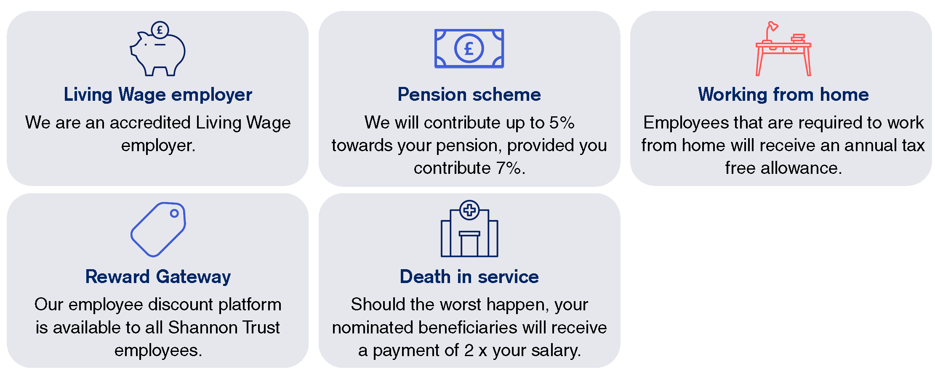

Putting you first
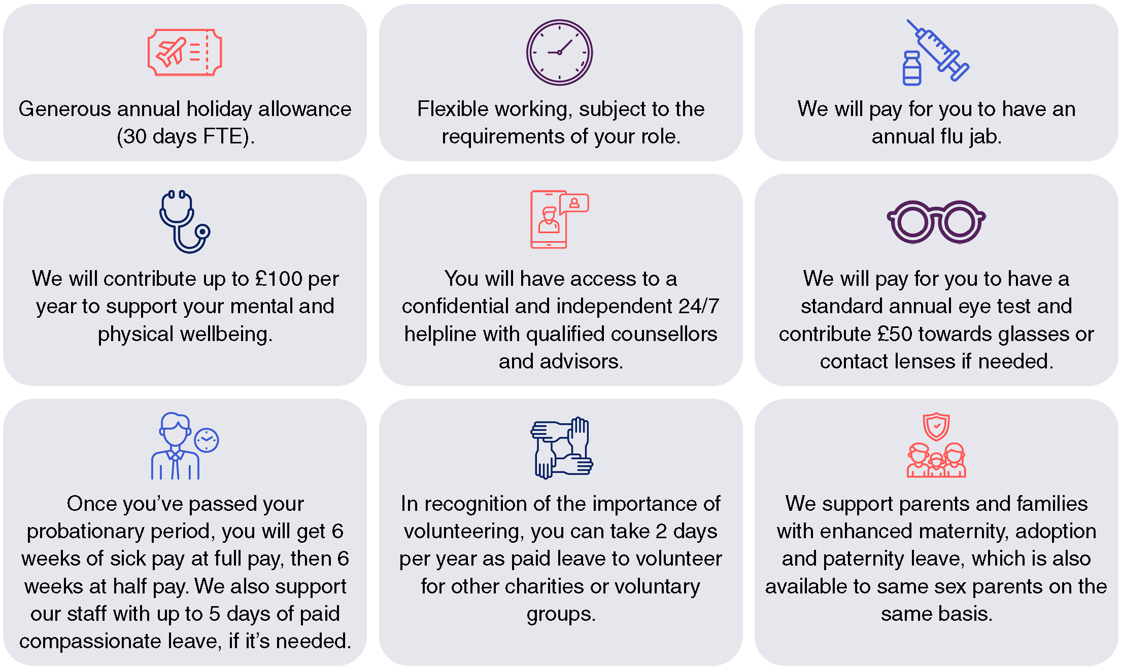

Find out more about our employee benefits on our website.

Key information

Location: Various (HMP Aylesbury/HMP Bullingdon)
Reporting to: Regional Manager/ Programme Manager
Hours: Various
Contract Type: Bank
Salary: £17.57 per hour

Role summary

Shannon Trust’s vision is of a future where everyone can experience the positive impact of learning. As a bank prison facilitator, your role is to make this a reality by ensuring continuation of service when cover is required and ensure successful delivery of the Shannon Trust reading and numeracy programme within various prisons. You will be working onsite at various prisons and will work closely with people in prison, prison officers, prison education staff, Shannon Trust volunteers and your Regional Manager/Programme Manager.

This is a bank role and so the number of days to be worked will vary and are not guaranteed. Ideally you will be based in the Central area and willing to travel across the region as the need arises.

Core objectives of the role
• To provide cover for both short and long term staff absences at a variety of prisons across the central region, ensuring the continuation of Shannon Trust’s programmes, which are delivered under contract from His Majesty’s Prison & Probation Service.

• To raise awareness of the Shannon Trust programme, encouraging referrals from staff and people in prison and/or on probation.

• To grow the programme, ensuring potential learners are identified and have access to the Shannon Trust programme throughout the prison.

• To ensure mentors are trained, equipped and supported to deliver the reading and programme.

• To utilise systems to ensure effective delivery, monitoring and evaluation.

• Provide initial point of contact support and supervision to Shannon Trust volunteers in your prison.

Our values

At Shannon Trust we value the individual. We are supportive and non-judgmental – with our learners, mentors, volunteers and each other.

We work with many people across the criminal justice system and beyond, supporting them to improve their basic literacy and numeracy skills. Developing those skills is critical in reducing re-offending and improving life chances.

We are an accredited ‘Ban the Box’ employer, meaning we do not ask applicants to declare convictions at the application or interview stage. We only ask for this information where necessary for the role, and not until after an offer of employment has been made.

We are a Disability Confident employer and commit to inviting any disabled applicant who meets the minimum role criteria to interview.

If a role involves prison security vetting, it's important to acknowledge that this process can involve lengthy wait times for the vetting to be completed, particularly for candidates with lived experience. At Shannon Trust, we're here to stand by our candidates, offering support every step of the way.

Equity, diversity, inclusion & belonging

We want everyone to feel welcome, respected, and able to do their best work. We’re an equitable and inclusive organisation and actively encourage applications from underrepresented or marginalised communities.

We’re committed to making the recruitment process as accessible as possible so if you need any reasonable adjustments at any stage, just let us know and we’re happy to support you. Also to help you prepare and feel confident, we share the key interview questions in advance with all candidates.

Use of AI

Shannon Trust commits to not using Artificial Intelligence (AI) at any stage in the recruitment process; all applications are fully assessed by a member of our team.

We know applying for jobs can take time and can feel tricky to get right. At Shannon Trust, we want to hear your voice, your experience and your motivation, not something generated by AI tools like ChatGPT or CoPilot.

Applications written in your own words help us understand what makes you the right fit for the role and allow us to assess everyone fairly. To keep the process fair for all candidates, applications that appear to be generated by AI may not be considered.

Right to work in the UK and visa sponsorship

To work at Shannon Trust you must already live in, and have the right to work in, the UK (for example, UK citizenship, settled or pre-settled status or a visa that allows you to work). Unfortunately, we’re not able to provide visa sponsorship for any roles at this time.

If you have any questions about the above or the recruitment process we’re here to help, please get in touch at hr@shannontrust.org.uk

How to apply

- find out more and apply

Closing date: 24th March 2026

Interviews to be held on a rolling basis.

Job description

Programme planning and delivery
- Create and maintain a prison action plan aimed at growing the programme and meeting the identified need.
- Hold responsibility for programme performance in your prison. Through effective programme management, resource management, planning and prioritisation, work with your regional manager/team manager and volunteer support teams to ensure each prison is on track to meet and, where possible, exceed its objectives and targets.
- Identify and troubleshoot operational challenges, such as security clearance delays or access issues, ensuring that our programmes continue to function effectively.
- Developing creative solutions in collaboration with prison staff is essential to maintaining a consistent delivery of our programmes.
- Work in partnership with induction officers, education providers, mentor coordinators and other agencies to raise awareness of the programme, increase referrals and achieve a ‘whole prison’ approach to delivery.
- Identify learners and mentors transferring between prisons and ensure ongoing support.
- Identify potential learners and hard to engage people in prison and/or on probation, ensuring they are offered the programme and matched to appropriate mentors.
- Working with wing officers and education, identify potential mentors and ensure they have access to Shannon Trust mentor training and ongoing support, development and supervision, ensuring sufficient numbers of mentors to meet demand. Work with prison security to ensure clearance for the role.
- Recruit a mentor coordinator to support delivery, where this is possible.
- Ensure systems are in place for mentors and learners to be unlocked for Shannon Trust sessions and able to meet in a suitable learning environment. Work with allocations/activity hubs/education/library and other areas to enable learners to have access to their mentors during the core day.
- Ensure learners have access to sufficient learning resources to include books, manuals, videos and digital programmes as appropriate.
- Work in line with Shannon Trust’s ethos of ‘learner choice’, ensuring multiple options for learning are available.
- Ensure quality programme delivery by ensuring organisational standards are being met, seeking ideas and opportunities for improvements. Share best practice and learning with other prisons to drive up standards and encourage innovation across the organisation.
- Develop solutions to overcome operational challenge

Reporting
- Contribute to effective contract management and delivery by ensuring that targets are met, and performance metrics are achieved. This includes monitoring and reporting on KPIs related to learner progression, mentor engagement, and overall programme success.
- Collaborate with the programme manager to ensure contractual obligations are met and participate in the preparation of quarterly and annual reports as required.
- Utilise systems (Nomis, Curious, Shannon Trust database/spreadsheets) to record and submit learner progression data and mentor training achievements.
- Provide relevant and timely information about the reading programme to the prison’s learning and skills manager and Shannon Trust’s regional manager/team manager.
- Contribute to the contract and quarterly reports and appropriate sharing of case studies.
- Monitor progress against targets in relation to numbers of new and retained learners.

Partnership
- Work in partnership with the prison’s Shannon Trust volunteer, to ensure mentor training is delivered and mentors are supported in their roles.
- Provide first line support and supervision to prison volunteers at your establishment, utilising Shannon Trust’s volunteer management system to record volunteer activity, and escalate any performance issues as appropriate.
- Work in partnership with prison staff, to include officers and staff from the library, education department and other agencies within the prison.
- Work in partnership with Shannon Trust mentors, ensuring they are kept up to date with Shannon Trust news, and that they have the opportunity to share ideas and feedback to the organisation.
- Facilitate a ‘feedback loop’ to ensure themes from mentor meetings and area meetings feed into organisational decision making, and that organisational updates are shared appropriately with regional teams.
- Work with mentors, prison SMT, prison partners and Shannon Trust volunteers to implement and maintain effective communication across the prison. Represent Shannon Trust at appropriate meetings and events.
- Work in partnership with relevant Shannon Trust criminal justice services in the community to develop referral pathways for mentors and learners to continue learning with Shannon Trust through the gate where appropriate

Other
- Put the learner at the heart of what you do, actively contribute to a culture of learning, reflection, teamwork and development, in line with the organisation’s values.
- Participate in regular one-to-ones and annual reviews, contributing to the identification of objectives and professional development goals.
- Carry out health and safety responsibilities in accordance with the Health & Safety Policy.
- To undertake other duties and responsibilities commensurate with the role, as may be reasonably required by Shannon Trust or as a mutually agreed development opportunity. This document will be subject to periodic review in consultation with the job holder.
- Protecting Children and Vulnerable Adults is a core responsibility of all staff. Staff are expected to alert their line manager to any concerns they may have regarding the abuse or inappropriate treatment of a Child or Young Person, or Vulnerable Adults.

Person specification

Experience

Essential requirements | Desirable requirements
- Previous experience (either in employment or a voluntary role) working within a prison.  - Demonstrable experience/proven track record of working towards and achieving contractual targets.  - The ability to monitor own contractual performance and be proactive in implemented targeted solutions.  - The ability to interpret data to understand it relates to contractual performance  - Experience managing a wide range of relationships at different levels, including building partnerships and working collaboratively with colleagues and external agencies. | - Experience of peer-led services, peer mentoring programmes and / or literacy and numeracy programmes.  - Programme delivery experience

Skills and abilities

Essential requirements
- Ability to confidently work independently and autonomously
- Good organisational and planning skills
- Excellent communication skills, with the ability to adjust your communication style to different audiences, including people in prison and/or on probation, volunteers, prison governors and staff.
- Ability to inspire, support and lead a team of peer mentors
- Strong problem-solving skills with the ability to navigate operational constraints and implement practical solution
- Good time management skills, with the ability to prioritise your workload, work autonomously and balance the needs of multiple programmes and priorities.
- Able to build positive relationships throughout the prison and within Shannon Trust.
- Ability to write clear, succinct reports, emails and other key communications.
- Ability to work in a results focused way, with a focus on the best outcomes for learners.
- Ability to foster and demonstrate the values, aims and objectives of Shannon Trust in your work.
- Ability to demonstrate the appropriate attributes required to facilitate programmes within a prison environment.

Knowledge and understanding

Essential requirements
- Understanding of contract management and ability to report on performance metrics and contribute to ensuring compliance with contractual obligations.
- Understanding of the reasons why adults might not be able to read, and the personal and practical barriers to engaging with education faced by people in prison and the community.
- Knowledge and understanding of the criminal justice system.

Technical and qualifications

Essential requirements | Desirable requirements
- IT literate and comfortable navigating a variety of different IT systems.  - Experience of using common Microsoft Office tools such as Excel, Word and Outlook. | - Experience using databases for effective record keeping.

Personal characteristics

Essential requirements
- Proactive, solution focused, patient and professional.
- Resilient and adaptable, with a calm and solution-oriented approach to working in challenging environments.
- Performance minded and results orientated, with learners at the heart of what you do.
- Non-judgemental attitude towards working with people in prison and/or on probation. Committed to anti discriminatory and inclusive working practices.
- Approachable and able to form positive working relationships.
- The right to work in the UK.
- Able to travel independently to designated prison and occasional staff meetings in a central location.
- Appointment will be dependent upon successful security vetting by His Majesty’s Prison and Probation Service.

