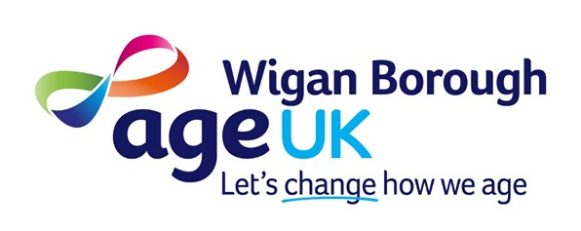

About Age UK Wigan Borough

Age UK Wigan Borough has been supporting older people for over 30 years. We are the largest voluntary organisation for people over 50 in the Borough and are widely respected for the quality and reliability of the work that we do.

As well as Support at Home, we currently provide the following services:
- Information and Advice. First response to people with a wide range of issues, providing information and signposting. In addition, we provide more detailed advice for people on benefits issues, delivered by a small, dedicated team. In 2025, we helped people secure £2.4 million in additional benefits.
- Bright Days. A varied programme of community activities ranging from Silver Choir to Ping Pong Parkinson, bingo to lunch clubs. In 2025, Bright Days activities attracted an average monthly attendance of 704 people.
- Steps to Success. Short-term, personalised support for people who face barriers to joining community activities, due to physical limitations, low confidence or mental health challenges. In 2025, our team of three supported 67 people to engage with new activities.
Across all services, 98.8% of people responding to our 2025 Quality Monitoring said that they would recommend Age UK Wigan Borough to their families and friends.

About Support at Home services

Out Support at Home services are commercial services, priced at a reasonable rate, designed both to meet the needs of older people in Wigan Borough and to bring a regular income into the charity, enabling us to provide other non-profitable services.

We currently provide three services within Support at Home:
- Handyperson service. We assist with small but essential jobs in the home such as installing grab rails, putting up shelving, assembling flat pack furniture and fitting handrails. In 2025, our team of three Handypersons completed 3966 jobs. This service is funded through a contract with Wigan Council and charges to customers.
- Home Help service. Our Home Helpers support people with domestic tasks, including cleaning, ironing, shopping, preparing light meals as well as providing a friendly face and chat. In 2025, our team of around 28 Home Helpers provided 12,597 Home Help visits. This service is entirely funded through charges to customers.
- Home Energy Checks. We undertake free home energy checks and provide basic adaptations during the winter period to ensure houses are as warm as possible. If larger needs are identified, we can refer to other agencies for support. This service is provided by our Handypersons for free as we have a grant through Age UK. Over the winter of 2025-2026, we provided 50 home energy checks.
Staff Team
The current staffing for the team is:
Home Help
- 2 x Assistant Team Leaders (37 hours and 22 hours). Each has responsibility for a team of Home Helpers, providing induction, reviews and supervisory support. ATLs also undertake assessments of new customers and are responsible for managing rotas.
- 30 Home Helpers. Over the past year, we have been through a process to move as many as possible onto a guaranteed hours contract and 20 are now on contracts of between 13 and 26 hours a week, plus overtime. The remaining 10 work on a zero hours contract, with the aim of providing a very flexible response to cover sickness, annual leave etc. Of these 10, four do not have vehicles and these have a few customers that they are able to walk to. We no longer take walkers on as Home Helpers.
- Administrator (37 hours). Supporting the management of rotas and other administrative tasks.
- Volunteer (4 hours). Supporting general administration, particularly sending and managing quality monitoring questionnaires.
Handyperson
- Assistant Team Leader (37 hours). Responsibility for the Handyperson service, including allocation of work, health & safety and management of team.
- 3 x Handypersons (each 37 hours).
- Administrator (20 hours)
- 2 x Volunteers. Volunteers go out with the Handypersons when required to do jobs that need two people and so reduce the cost to the customer.
Whilst the teams operate independently, they will support each other and cover when staff are off.
Challenges
- With such a large staff team, mostly working off-site, management can be challenging, ensuring that a consistently high level of service is provided within the professional boundaries of the service. We have strong induction processes, training systems and review procedures to try to manage this.
- The services are growing and demand is strong. It can be difficult to balance the demand with the capacity we have. At times, we have to manage a waiting list.
- Staff turnover. Many of our staff have been with us for a long time. However, some come and find that the work is not for them after a short period. We have almost constant recruitment to find suitable people, particularly for Home Help.
- Managing customer requirements. Due to the age of our customers, rotas change regularly, with people going into hospital, moving into a care home – or going on holiday. It can be a challenge to keep on top of the changes and we have a relatively high level of cancellations from customers each week.
Aspirations
- Our aim is to continue to grow the services, in particular the Home Help service both to meet the demand and to increase our income.
- We also wish to explore development of new related services. These could include gardening, decorating and assessments for low-level equipment, such as handrails.

