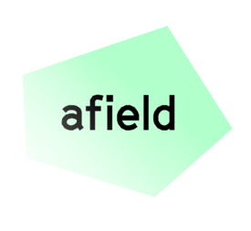
DRAFT INTRODUCTION TO AFIELD ARTS GRANTS

Afield aims to address a funding gap in the arts by providing grants to artists on low incomes/in financial hardship, whose research contributes towards environmental knowledge and justice.
Afield’s art programme aims to:
- Support structurally disadvantaged artists whose research foregrounds ecological care, interdependency, imagination and repair.
- Support excellence in the arts and demonstrate the intrinsic value of artistic contributions to ecological justice.
- Publish and disseminate artist research to challenge orthodox thinking and shift ecological perspectives.
Artists make a unique and vital contribution to ecological research. They can work outside of, across, with and/or against traditional disciplines and categories, and develop insights and ideas that go beyond established scientific, technical and cultural frameworks. Artists are able to imagine ways to be, act, and think that prioritise co-existence between humans and non-humans. Afield is committed to expanding and bringing new voices to ecological research.

We seek to fund artist research that might include:
- New knowledge, frameworks and paradigms (that disrupt and offer alternatives to current, exploitative models)
- Direct interventions
- Socially engaged learning, organising and solidarity-building
- Speculation, reimagining, and proposals for alternative ways of living
- More than human-perspectives.

We recognise that the current funding system for artists is broken. We aim to be a fair and transparent funder, creating an application process that doesn’t overburden applicants. Initially we will trial an open call approach, and in the first year we will award five grants of up to £30,000 for projects of up to three years, increasing the number of grants over time, and paying artists who are shortlisted to write a full proposal. We do not make our grants conditional on achieving predetermined outputs and outcomes, valuing the process itself as a form of knowledge-making. We are particularly interested in proposals from global majority artists, LGBTQIA+ artists, disabled artists and artists experiencing chronic illness.

Our fund is open to all ages, art disciplines and points in career. We are a learning organisation and we will trial different forms of mentoring and peer learning, to understand how best to support artists.

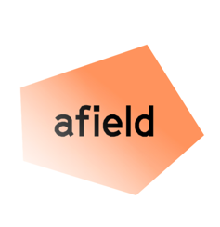
DRAFT INTRODUCTION TO AFIELD WILDING

Afield is tackling problems that are rooted in the structural inequalities underlying environmental injustice. They result from failures of government, private development, land ownership and urban planning to provide healthy inner-city ecosystems. The result is that local communities and the wider urban ecology suffer from:

- A lack of biodiversity;
- Habitat scarcity for all species
- Poor human (physical and mental) health and wellbeing arising from a lack of access to rich local ecosystems, and poor air quality;
- Climate change vulnerability.

These problems disproportionately affect poor communities. Environmental degradation reinforces social inequality and ecological decline. Therefore, the areas of the highest need in cities are often those with the lowest capacity to solve the problems. Residents have less free time, greater financial burden, and there are fewer voluntary organisations.

The problems are exacerbated by a lack of understanding amongst those in power, and within our culture more generally, of the value of inter-connectivity between humans and non-humans. Our framework for change is therefore one of:
- Mutual partnerships: working together to benefit humans and other species
- Mutual spaces: living together as part of an ecosystem, supported by governance such as long-term agreements or land ownership
- Mutual investment: giving back as much as we take from ecosystems

Afield’s approach is to support a small number of individuals with a visionary idea to create foundational, long-term, community-led wilding projects that benefit both humans and other species. We will support them to realise their ideas by funding up to three years of the London Living Wage, and providing a cohort programme of mentorship, peer support, technical skills, networking and learning based on our mutual framework.
To better understand how to focus our resources, we have commissioned a data map of London. It combines datasets representing access to green space, access to nature, indices of deprivation and brownfield sites. This has led us to shortlist 10 London boroughs, from which we will choose two as partners for our initial round: Waltham Forest, Newham, Barking, Croydon, Brent, Ealing, Lambeth, Lewisham, Hackney and Islington.
We will work with existing local networks and partners in these places to encourage people to apply for this opportunity, or we may approach individuals directly.
Our goal over the next five years is to support around 10 people on their way to wilding their community and neighbourhood.

