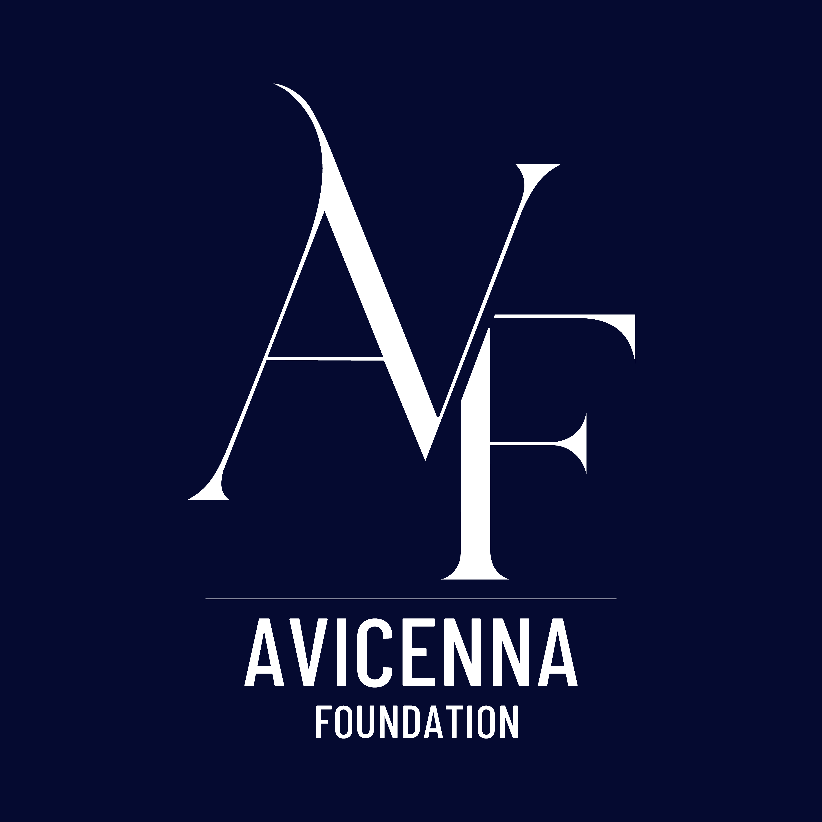
Job Title: Programme Manager
Location: Central London
Contract Type: Full-time
Reporting To: Chief Executive Officer (CEO)

About Avicenna Foundation
Avicenna Foundation is a pioneering leadership development organisation dedicated to empowering the next generation of British Muslim leaders. Our vision is a society where the full potential of the British Muslim community is unlocked, enriching the UK’s social, cultural, and economic fabric and inspiring global progress.

We run the most comprehensive scholarship and leadership development programme for young British Muslims in the UK. Our approach combines academic support, mentorship, emotional and spiritual development, and real-world exposure to create ethical, confident, and visionary leaders. Grounded in our core values; Hikmah (Wisdom), Akhlaq (Ethical Character), Ithar (Altruism), Khidmah (Service), and Ihsan (Excellence) - we aim to deliver a lasting impact on communities and society as a whole.

Role Purpose
The Programme Manager will be the operational anchor of the Foundation, playing a key leadership role in ensuring that every part of the organisation functions effectively and aligns with our strategic direction. Reporting directly to the CEO, you will oversee day-to-day operations, implement systems that drive impact and sustainability, and manage key relationships that are vital to our success.

The Programme Manager will serve as the organisational engine of the Foundation - designing, optimising, and scaling the systems that power our mission. You will lead operational excellence across the organisation, architecting clear processes, building robust SOPs, and ensuring that our programmes and internal functions can scale sustainably as we grow.

This role is ideal for someone who thrives in a builder environment; combining strategic insight with operational rigour to turn vision into repeatable, high-performing systems.

You will help shape the future of Avicenna, ensuring that our flagship Scholarship Programme continues to deliver excellence while we expand our reach, deepen our impact, and uphold the integrity of our mission and values.

The Right Fit
This role is ideally suited for someone who combines sharp operational acumen with a bold sense of purpose and ambition. As a growing organisation in its early stages, Avicenna Foundation is fast-paced and evolving - an environment that will challenge and stretch you. We are looking for someone with commitment, drive, and resilience; someone who brings both the right attitude and aptitude to lead through complexity and uncertainty.

You must be comfortable taking initiative, building systems from the ground up, and working across multiple priorities. In return, this role offers a rare and exciting opportunity to catalyse your career, helping build a pioneering organisation from the inside out and leaving a lasting mark on a movement for change.

We are looking for someone who brings a builder’s mindset - energised by designing structure from scratch, refining operational workflows, and implementing scalable systems.

You will excel here if you are proactive, solutions-driven, motivated by continuous improvement, and confident leading teams through change. If you enjoy creating clarity, building SOPs, and establishing high-performing operational environments, you will thrive in this role.

Key Responsibilities
- Lead and manage all internal operations including programme delivery and organisational development in coordination with colleagues across HR, IT, and finance teams.
- Work closely with the CEO to implement the strategic vision and translate it into effective plans and operations, serving as a key spokesperson for the organisation when required.
- Support the delivery and growth of the Avicenna Scholarship Programme, ensuring excellence in participant experience, programme execution, and outcomes.
- Build and manage a high-performing team culture grounded in ethical leadership, compassion, and excellence.
- Lead on operational risk management, governance, and legal compliance.
- Monitor and report on impact, outcomes, and organisational health metrics.
- Develop relationships with partners, funders, mentors, and other stakeholders to strengthen the Foundation’s ecosystem.

Person Specification

Essential:
- Proven experience in a senior operational or general management role, preferably within the nonprofit, education, or youth development sectors.
- Deep personal alignment with the values and vision of Avicenna Foundation.
- High levels of drive, resilience, and self-motivation.
- Strong strategic, analytical, and operational leadership skills.
- Experience overseeing budgets, organisational development, and team management.
- Excellent project management and problem-solving abilities.
- Strong communication and interpersonal skills; able to build trust and motivate diverse stakeholders.
- Adaptability and initiative, especially in a start-up or fast-growth context.

Desirable:
- Experience with leadership development or educational programmes.
- Familiarity with Zakat principles, British Muslim community contexts, or Islamic leadership values.
- Understanding of programme impact evaluation and reporting.

What We Offer
- A rare opportunity to shape a growing organisation at a strategic level.
- A values-driven, collaborative and mission-focused work culture.
- Flexible working arrangements.
- Opportunities for personal and professional growth.
- The chance to play a key role in a transformative movement—and help build a legacy.

Application Process and Timeline
We are looking to appoint a passionate and capable individual who is excited by the opportunity to shape an emerging organisation with transformational potential. The application process is designed to assess both skills and cultural alignment with the mission and values of the Avicenna Foundation.

How to Apply
Please submit the following documents via email to jobs@avicennafoundation.org.uk, with the subject: “General Manager Application”:
- A CV (maximum 2 pages)
- A Cover Letter (maximum 2 pages) explaining your interest in the role and how your experience aligns with the responsibilities and person specification

Application Timeline
Stage | Date
Application Deadline | 11:59pm, 12th April 2026
Shortlisting Notification & Psychometric Testing | Week commencing 13th April 2026
First Round Interviews (Online) | 15th and 16th April 2026
Final Interviews (In-person, Central London) | Week commencing 20th April 2026

We encourage early applications, as we may close the vacancy once a suitable candidate is identified.
If you have any accessibility needs or require accommodations during the application process, please don’t hesitate to let us know.

