

Job Description & Person Specification
Job Title: Art Worker
Contract: Fixed term contract (three months)
Hours: Part time, flexible (0.4 FTE/ 15 hours per week)
Location: Fully remote or hybrid to suit the needs of the successful candidate. Our office is based in Hammersmith, London.
Salary: £27,000 to £28,000 per annum pro-rata plus benefits
First Interview: 9th December 2025
Second Interview: 11th December 2025

About Starlight
No one enjoys medical procedures, least of all children. From facing everyday vaccinations to the most serious of surgeries and chronic conditions, all children experience varying degrees of apprehension and fear. Feeling scared, powerless, or anxious in healthcare settings doesn’t just trigger a child’s emotions; it can create traumas that impact treatment success and that can have a life-long impact. Starlight’s aim is to transform children’s health through better experiences, by putting play at the heart of every child’s healthcare.
Evidence shows that play in healthcare can reduce anxiety, fear and even pain; it helps children engage and prepare for their treatment and cope better with procedures; it minimises trauma and contributes to a better experience; and supports children to have some sense of agency and control in an environment where these opportunities are limited. Play can also reduce the number of attempts to deliver treatment, the need for sedation and the need for repeat appointments. Prioritising children’s right to play in healthcare results in healthier, happier children who are involved in their own healing and recovery as well as more efficient treatment and care.
We work in over 900 healthcare settings across the UK with an ultimate vision to ensure that no child endures trauma in healthcare.
Our Culture
We believe that our success depends upon focusing on our purpose and business results and taking individual responsibility for a culture where everyone can belong, feel safe and thrive. Our values are the agreed standards that govern our behaviour and are central to our decision-making and the choices that we make. Our development programme focuses on individual awareness of our own values, strengths, and preferences –what makes us who we are – to help all colleagues think for themselves, manage their environment, and make appropriate, balanced decisions for themselves, others and Starlight. We believe that our strength is in our differences and constantly strive towards an authentic workplace culture with equity, diversity, and inclusion as central principles.
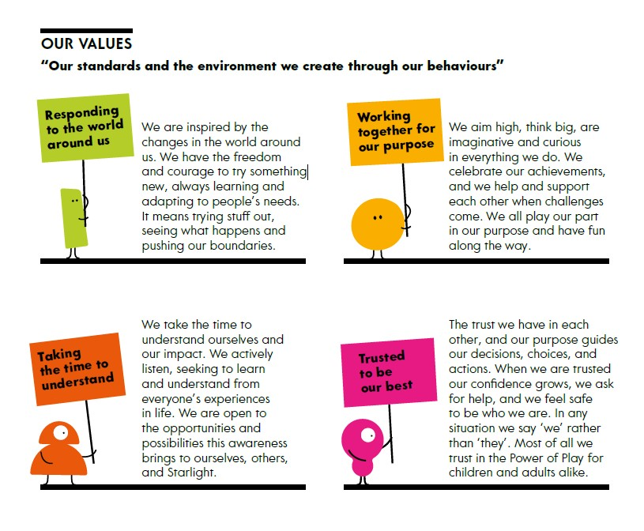

Our Strategy and the Art Worker

We know children can experience trauma from their healthcare. Health play and health play professionals have an enormous impact in protecting sick children’s mental health whether they’re in hospital, a hospice or going to the GP or dentist. We want the public, health services and government to understand how putting play at the heart of every child’s healthcare can transform their healthcare journey, and their health.
In order to support our strategy by raising awareness of why we exist and what we do, we are seeking a dynamic and driven creative professional to join the Marketing and Communications team. You will design engaging visual content for fundraising, marketing and brand awareness campaigns and events across print and digital platforms, and assets for our healthcare services and products.
Working closely with colleagues and external providers, you will deliver distinct and compelling content across all Starlight touchpoints including events, owned, earned and paid for channels. You are experienced in understanding different audience requirements and are able to advise colleagues and adjust design output accordingly.
Reporting to the Creative Lead, you’ll also support them in ensuring streamlined processes are implemented and project goals are achieved to the highest standard.
You’ll be committed to development, both for yourself and those around you. You’ll manage your own environment by constantly listening, responding and adapting. You will believe in the value of giving and receiving feedback as helpful information for us all to continually grow, and consciously make appropriate, balanced decisions for yourself, others and Starlight.

Key Areas of Responsibility

As our Art Worker, you’ll:
- Develop ideas for fundraising, awareness raising, policy campaigns and present concepts to colleagues at all levels.
- Understand the content needs of different teams to create compelling and eye-catching design materials for a wide range of projects. Liaise with colleagues to keep them informed and to highlight any issues
- Monitor the quality of creative assets/ outputs and provide creative expertise to colleagues and external providers to ensure brand consistency across all channels.
- Work closely with Marketing and Communications colleagues and other teams to build mutual understanding of creative requirements and how to reach different audiences.
- Develop, brief and maintain effective working relationships with external providers including copywriters, photographers, printers and merchandise suppliers.
- Support the development of effective systems and process for briefing, testing and evaluating creative outputs.
- Ensure all work adheres to brand guidelines and have a good eye for detail.
- Represent the Marketing and Communications team when necessary.

Person specification

Requirement | Essential | Desirable | Evaluation*
Experience and knowledge of working in the design industry, able to deliver creative assets/ outputs for both print and digital platforms including but not limited to social media, brochures, publications, merchandise and presentations. | √ |  | A /I
Proven understanding of design best practice across multiple platforms to create compelling and eye-catching content with audience in mind. | √ |  | A/I
A resilient team player who can respond quickly to organisational needs, prioritise their own work and work effectively under tight deadlines overseeing several projects simultaneously from start to finish. | √ |  | A/I
Strong interpersonal and communication skills; capable of presenting ideas to colleagues and external stakeholders at all levels; and representing the Marketing and Communications team internally and externally. | √ |  | I
Experience of implementing and ensuring brand application. | √ |  | A/I
Advanced and up-to-date knowledge and experience of using Adobe Creative Cloud including Photoshop, Illustrator, InDesign | √
Experience of briefing and supervising external providers such as printing and merchandise companies | √ |  | I
Basic motion graphics skills and/or experience using Adobe Animate, After Effects, Adobe Figma and of directing photoshoots. |  | √ | A
Understanding of EDI and demonstrate those principles within the role to create outputs that is inclusive. | √ |  | I
Commitment to personal development and to being able to manage your own environment and make appropriate, balanced decisions for yourself, others, and Starlight. | √ |  | I
Enjoy being part of a small team where individuals thrive on working outside of their designated roles from time to time to get things done. | √ |  | I

*I = tested at interview, A= tested via cv / supporting statement

What we offer

The opportunity and environment to be yourself and be your best. To work within a team with play at its heart. To have flexibility in where you work and the hours that you work. Personal development through our strengths and self-awareness Development Programme. A competitive salary and benefits package including ability to work flexibly between home and office, holiday entitlement of 25 days plus bank holidays increasing up to 30 days with service, office closed at Christmas in addition to holiday entitlement, matched pension contributions to 5%, life assurance, Vitality health cover, income protection, cycle to work scheme, season ticket loans.

To apply
Please apply for this role through Charity Job with your CV, portfolio of three to six examples of your work, accompanied by a supporting statement which demonstrates how your experience matches the person specification and highlights your most relevant, recent experience for this role.
The role will close on Friday 5th December. We reserve the right to close the role earlier if we receive a number of high-quality applications.

1st Interview: 9th December
2nd Interview: 11th December

Additional Information
Diversity Policy Statement
We believe that everyone has the right to be treated with consideration and respect. Starlight is committed to achieving a truly inclusive environment for all, by developing better working relationships that release the full potential, creativity, and productivity of each individual. We aim to ensure that all staff, volunteers, donors, partners, contractors, and the public are treated fairly. This will be regardless of sex, sexual orientation, gender, marital or civil partnership status, ethnicity, disability, medical status, age, religion or belief, political opinion, social or economic status, or ex-offender status. Starlight actively welcomes candidates from diverse backgrounds. If you are invited to an interview and need any adjustments made or have particular access needs, please let us know at that stage.
Shortlisting
Starlight is an equal opportunities employer, and we are committed to ensuring all applications are treated fairly. All applications are subject to our shortlisting process; if you are shortlisted, we will contact you and invite you to attend an interview on or before the dates in this document, please let us know on application if you have any difficulty with the dates. You will also be advised at this point if there will be any skills test, presentations etc. We may appoint to the role before the stated closing date if a suitable candidate is identified.
Employment Checks
All offers of employment are made subject to the following criteria: proof of eligibility to work in the UK, proof of residency and satisfactory employment screening, enhanced DBS and two most recent references.

