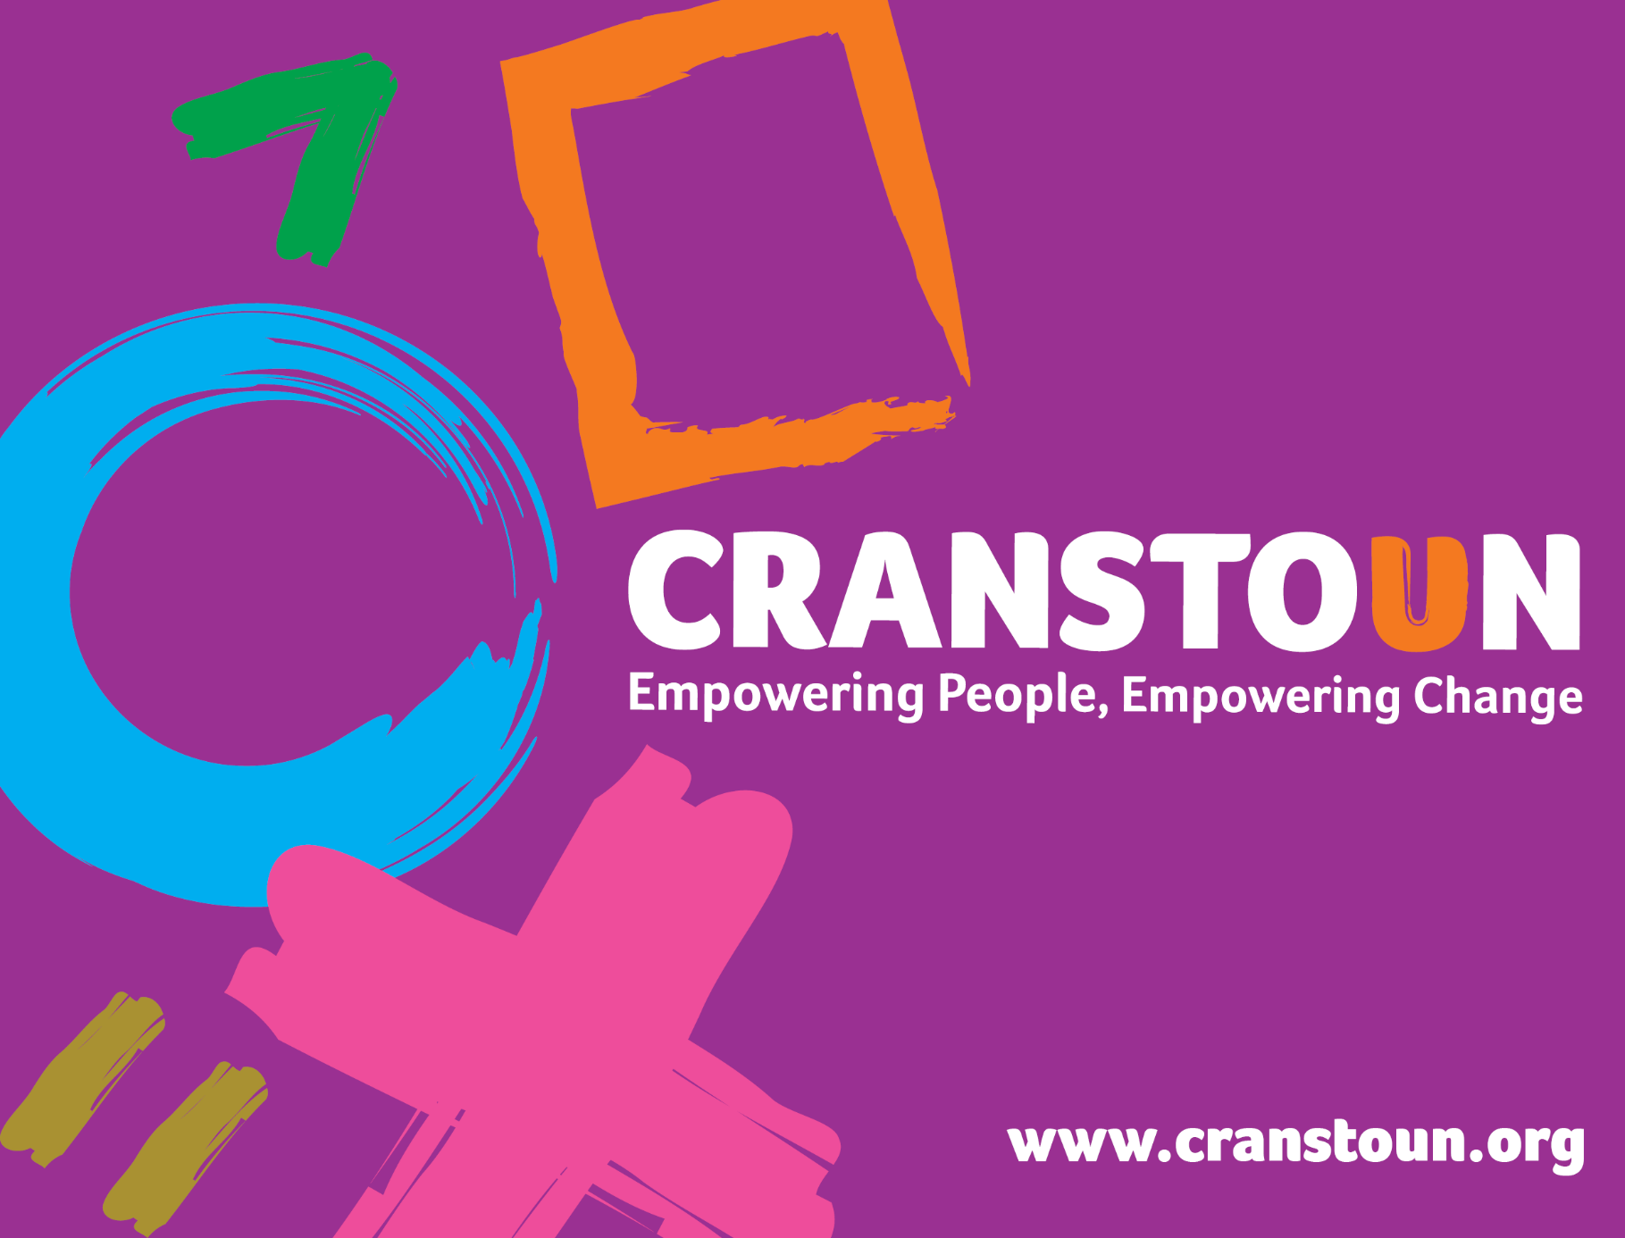

Post Information Pack: Trainee Domestic Abuse Worker

Service | Inspire To Change
Location | South Yorkshire

Cranstoun is a social justice and harm reduction charity with global ambition.
Our Vision: To be a world-class leader in rebuilding lives.
Our Purpose: To inspire and empower people to live healthier and safer lives.
Our Values: Ambitious, Creative, Compassionate, Collaborative, Respectful.


Note: This role is offered as supported employment and you will undertake training whilst working towards the Level 4 Domestic and Sexual Abuse Support Worker Apprenticeship. You will be allocated dedicated study time to complete this qualification. There is an expectation that the post holder will be able to take on a reduced caseload within 3 months, or on completion of our core induction training programme.

The apprentice role is expected to last for a period of around 21 months depending on qualification completion. Trainees who successfully complete the qualification and internal induction will be invited to apply for permanent Domestic Abuse Worker roles within the organisation when they become available.

By the end of your qualification and training you will be expected to competently carry out the following duties:

Job Description
Job purpose / context:

The post holder will deliver the partner support service element of the South Yorkshire domestic violence prevention programmes and interventions.

The partner’s support worker will champion the Cranstoun values across the organisation and drive the Cranstoun 'people' agenda ensuring a culture based on fairness, collaboration and trust.

The partner’s support worker will strive to make contact and work on a one to one basis with survivors/victims of men/women who are attending the services domestic violence prevention programmes. The partner’s support worker will pro-actively secure engagement, and support victims on an ongoing one to one basis and link to complementary services. To do this, the partner’s support worker will work with existing agencies in each location to design a co-ordinated, individual intervention plan to address identified needs and risks and promote understanding of the impact of abusive behaviours. The partner’s support worker will work closely with the IDVA service to review risk, develop safety plans and improve outcomes for all parties involved.

The partner’s support worker will be responsible over the long term for delivering outcomes, working typically with victims /survivors for five months during programme and up to six months post programme completion.

Responsible to: Service Manager

Responsibilities:

- Interagency Work

- Work to embed the partner’s support worker role into multi-agency responses to domestic abuse in the area.
- Effective understanding and implementation of institutional advocacy by pro-socially challenging partner agencies, acknowledging best practice and striving for change to benefit the individual, the service and the sector.
- Support other professionals in responding to service users in a way that is coterminous with the aims and ethos of violence prevention programmes.
- Working closing with other professionals to ensure that risk management and safeguarding duties are effectively met.
- Develop and maintain effective partnership working with statutory, private and voluntary agencies to address the issue of domestic abuse.
- Represent the service at operational multi-agency meetings, feeding back initiatives and outcomes to the team and contribute to the evaluation of the quality of activities these services offer.
- Provide a single point of proactive and regular contact for a range of professionals involved in the case of the victim/survivor.
- Be flexible and willing to work in all types of environments.

- Case Management

- Comply with children and adult safeguarding ensuring that service users and colleagues understand and comply with the service’s safeguarding framework.
- Contribute to regular service reviews which include monitoring data, evaluations, intake and output policy, and practice and work load reviews for the whole service.
- Attend monthly case management meeting with the Service Manager and violence prevention practitioners.
- Attend clinical supervision.
- Take appropriate steps to protect where there is an imminent risk to another person.

- Recording and administration
- Ensure that case files and records are accurate and complete, and are kept and in compliance with General Data Protection Regulations (GDPR).
- To enter all the required information into the electronic case management system to enable the ongoing support of the survivor, multi-agency working and risk management.
- Daily maintenance and accurate and secure audit trail of all relevant communication.
- Comply with the data protection and information sharing protocols.

- Direct work with Victims/survivors

- Ensure that there is a consistent delivery of services to the identified victims of domestic abuse, including comprehensive risk assessment, support planning, and referrals to multi agency panels including MARAC.
- Undertake assessment of risk and needs to inform the individual victim/survivor’s intervention plan
- Ensure that risk assessment and risk management procedures are followed at all times.
- Respect and value the diversity of the community in which the service works in, providing a service that recognises the diverse needs of service users and their families.
- Work closely with the IDVAs’ supporting the partners, ex-partners and new partners, and family members of service users in management risk and developing intervention plans. The welfare and safety of children and young people is paramount, considered in every aspect of your work, address parenting needs where appropriate and taking action to safeguard children.

- General

- Remain up-to-date and compliant with all relevant legislation connected to your work, including organisational procedures, policies and professional codes of conduct and practice guidance, in order to uphold standards of best practice.
- Represent the service at local events; deliver training and presentations as required.
- Be confident to evidence reflective practice in all aspects of work, sharing learning and
- Be committed to reviewing individual and team practice and undertake regular training.
- Act with integrity and respect when interacting with service users, employees, agencies and individuals.
- Competent in defensible decision making, recording and being held accountable
- Show initiative in tackling issues within the service and in relation to other agencies.
- Act as a champion for the implementation of the programme in your area
- Partake in evening and weekend work as required
- Adhere to the terms and conditions of employment agreed with Cranstoun, working within the policies of the organisation
- Undertake any additional duties as may be reasonably required and requested from time to time by Cranstoun or project funders.

This job description is subject to review and revision, as agreed by the post holder and Director of operations in order to maintain a relevance to work undertaken and any changes to the demands of the internal or external environment.

Person Specification

Qualifications & Experience

- Maths and English competencies will be assessed prior to enrolment. Following this there may be an expectation to complete functional skills as part of the apprenticeship in order to complete the qualifications required.
- Experience of working or volunteering within the domestic abuse field is desirable.

Abilities and attributes

- Good written and verbal communication skills with a good level of IT skills.
- Effective listening skills.
- A shared sense of Cranstoun’s values; Ambition, Creativity, Compassion, Collaboration and Respect.
- An ability to work collaboratively as part of a team; whilst also having the initiative to work independently as necessary:
- Capacity to manage raw emotions including conflict, challenge and trauma.
- Proactive and self-motivated.

Skills and Knowledge

- Ability and willingness to work independently and as part of a team.
- IT skills, including use of Microsoft Office.
- Empathy.
- Have excellent conflict and crisis management skills and the ability to deal with stressful and difficult situations.
- Have excellent interpersonal skills.
- Excellent networking skills and the ability to develop strong working relationships with other agencies.
- Willingness to complete.
- Knowledge and understanding of domestic abuse, including the impact on victims and their children, and the legal and practical remedies available is desirable
- Word processing skills and knowledge of Microsoft packages.

Other

- Ability to travel independently and efficiently – access to your own transport would be desirable.

