



Application Pack
Trusts Fundraiser
Closing date for applications: 7th September 2026
Alexander Devine Children’s Hospice Service

Alexander Devine Children’s Hospice Service (Alexander Devine) is a local charity that provides specialist care and vital support to babies, children and young people with life-limiting and life-threatening conditions, and their families, across Berkshire and into surrounding counties.

We individualise our approach to meet the unique clinical, emotional and practical needs of each child and their family, ensuring they receive the best possible care and support. Our comprehensive range of care services include Respite care, Specialist play, Symptom management, Family support, End of life care and Bereavement support. We provide care from our children’s hospice in Maidenhead as well as in the family home and across the community, including hospitals and schools.

Our hospice facilities offer opportunities for children and their siblings to experience fun, joy and adventures, and help families make precious memories for as long as they have. These include a hydrotherapy pool, sensory room, music room, games room, outdoor playground and sensory garden, six children’s bedrooms and two self-contained family flats. We also have a dedicated bereavement suite with its own garden.

Our children’s hospice service is free of charge for families, but it costs over £2.8 million a year just to maintain our current level of care. With very minimal government funding, our charity is almost entirely reliant on donations, fundraising and gifts in Wills to meet the costs of running our service. Which means every penny donated makes a huge difference to those we support.

We currently support over 165 children and their families, but we are committed to growing our service and reaching out to every child and family that needs us. In Berkshire alone, we know that there are an estimated 1,371 children with life-limiting conditions. And research shows that this number is likely to increase by at least a further 11% by 2030.

The charity was founded by John and Fiona Devine in memory of their son Alexander who sadly passed away from a rare brain tumour in 2006 at the age of eight. Their personal experience led them to realise a desperate need for a local children’s hospice service with a hospice facility in Berkshire.

www.alexanderdevine.org
Reg. Charity No. 1118947


Our values, vision and mission

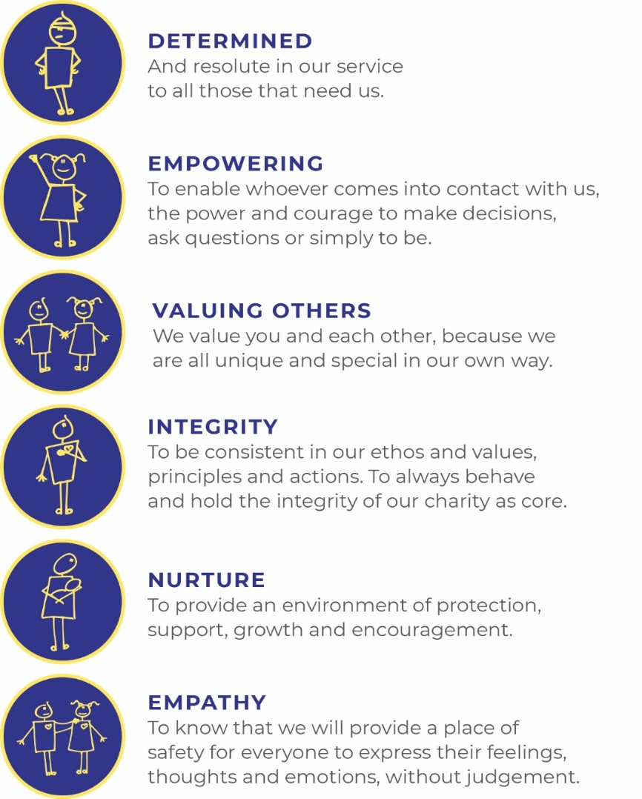
Our values
Our work is powered by our core values. They are key to everything that we do and the way in which we do it. Our expectation is that our values are upheld in all that we do and in our engagements, both internally and externally.

Our vision
We deliver palliative care to children and families through an holistic approach that meets the individual needs of each child and their family.

Our vision is to provide a service within Berkshire and surrounding counties that will give children and families a choice of care and support from a skilled and dedicated team. We work closely with the NHS, local authorities and other services in delivering our care.

Our mission
Reaching out to every child and family who needs us, offering support and care from people who understand.

The role
Trusts Fundraiser
Hours Part time – 3 days / 22.5 hours per week
Salary Band 5 FTE: : £18,752 - £22,963 per annum (£31,254 - £38,272 pro rata)
Location Hybrid – Minimum 1 day a week at Alexander Devine Children’s hospice in Maidenhead, Berkshire.
Benefits Competitive salary
Generous annual leave (plus your birthday as an additional day off)
Pension
Employee assistance programme
Death in Service Cover
Private Medical Insurance
Free on-site parking

Job purpose
As Trusts Fundraiser, you will play a vital role in helping to secure the funding that makes our work possible. Through building strong relationships with charitable trusts, foundations and grant-making organisations, you will identify exciting funding opportunities, craft compelling applications, and demonstrate the impact of our work through inspiring reports and stewardship.
This is an opportunity to combine strong writing and relationship-building skills with a genuine passion for making a difference. Alongside leading on trust and foundation fundraising, you will have the opportunity to support wider fundraising initiatives as needed, collaborating with colleagues across individual giving, philanthropy, corporate partnerships and community fundraising.

Grade | Band 5
Managerial reporting responsibility | Lead for Trusts and Supporter Engagement, Alexander Devine Children’s Hospice Service
Professional reporting responsibility | Lead for Trusts and Supporter Engagement, Alexander Devine Children’s Hospice Service

Job Description
Areas of responsibility

- Research and maintain a pipeline of trusts and foundations prospects in order to achieve agreed fundraising targets within set timescales.

- Plan, write and submit compelling and targeted applications to trusts and foundations and produce timely reports to donors.

- Create meaningful and enduring partnerships with funders by delivering exceptional stewardship, insightful impact reporting and personalised supporter care. By welcoming supporters to the hospice, attending events and actively networking, you will inspire confidence in our work, strengthen relationships and help secure ongoing investment in our services.

- Monitor and log application deadlines, outcomes and income received accurately on our CRM database.

- Ensure all donations are properly recorded and thanked.

- As part of the Supporter Engagement team, support the development, promotion and delivery of our legacy, in-memory and individual giving programmes.

- Use your skills to support the corporate, philanthropy and community teams with research, proposals, applications and reports to ensure all opportunities to build relationships and secure income are maximised.

- To champion, maintain, improve and interrogate our data in our CRM database, Salesforce, to ensure communications are appropriate and most effective and opportunities are identified and maximised.

- To attend and support fundraising events, networking events and meetings as required.

Duties in common with other members of staff
- Contribute positively to good teamwork.

- To report and record accidents and incidents.
- To be an ambassador for the charity.
- To maintain the best appearance of your immediate working area.
- To demonstrate a positive and supportive attitude to staff and volunteers.

- Respect confidentiality applying to all areas of the hospice.

- To adhere to the Infection Control Policies and Procedures set by the charity and the Care Quality Commission.

- A commitment to, attitude and behaviour that reflects our core values - Determined, Empowering, Valuing others. Integrity, Nurture, Empathy.

- Commitment to ensuring your own wellbeing and that of your colleagues.

This job description reflects the present requirements of the post. As duties and responsibilities change and develop, the job description will be reviewed and is subject to amendment in consultation with the post holder.

Person specification
 | Essential | Desirable
Education, training and qualifications | English Language and Mathematics GCSE or equivalent grade C (grade 4) or above  Excellent administrative skills  Demonstrable intermediate IT skills including Microsoft Office suite.
Experience | Experience in fundraising, grant-making, bid writing, relationship management, or a similar role with transferable skills.  Experience of building and maintaining positive relationships with a range of stakeholders  Experience of producing high-quality written content, reports, applications, proposals or business cases. | Experience of using databases or CRM systems to maintain accurate records and track activity, ideally Salesforce
Skills | Excellent written communication and copywriting skills, with the ability to write compelling and persuasive funding applications tailored to different audiences  Research and analytical skills, with the ability to identify funding opportunities, assess eligibility criteria and match projects to funders' priorities  Research and analytical skills, with the ability to identify funding opportunities, assess eligibility criteria and match projects to funders' priorities  Organisation and project management skills, including the ability to manage multiple deadlines and maintain accuracy under pressure.  Attention to detail, particularly when preparing funding applications, budgets and reports.  Creative thinker, able to identify opportunities and translate impact into compelling funding cases  Numerate and data interpretation skills, able to understand data and communicate this to different audiences. | Proficiency in Canva or an equivalent software.
 | Essential | Desirable
Other | Car driver - vehicle available for working.  Ability to work alone and as a member of a team.  Ability to work flexible working hours if needed.  Commitment to the mission and ethos of Alexander Devine Children’s Hospice Service  Able to work within and uphold our core values: determined, empowering, valuing others, integrity, nurture and empathy.  Able to assess risk to maintain personal safety in a variety of settings.  Willing to undertake an Enhanced DBS.  Passed fit to undertake the duties of the post by Occupational Health.

A rewarding and special place to work
Finding ways to recognise, reward and support every member of our team is important to us. Here’s four big reasons why you will want to join our charity…
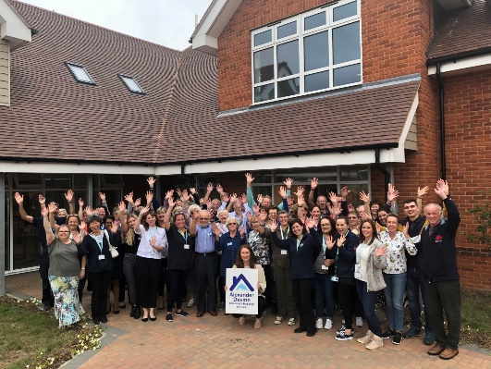
The amazing people that work here
Very simply, the team at Alexander Devine makes our charity such a unique place to work. To quote one of the young people that we support:
“If I had to summarise what makes Alexander Devine so special, I would say it’s the people that work there…they are like family to us”
Whichever part of the charity you are working or if you
are a volunteer, we are proud of our ‘one team’ spirit.

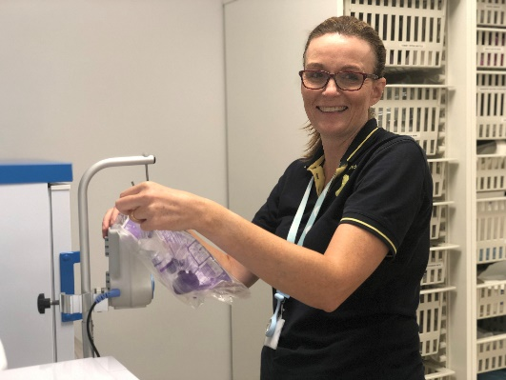
An employer that listens and cares
We pride ourselves on ensuring our staff receive regular supervision and support from their line manager, with opportunities for further training and development.
We also have an employee assistance programme, offering our employees a free confidential advisory and counselling service to help with any personal, work or family issues they may face.

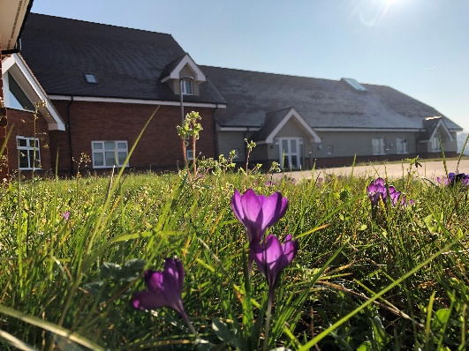
A beautiful setting in a convenient location
Our stunning purpose-built hospice is surrounded by beautiful countryside, but also just a stones throw from the M4 and A404, on the outskirts of Maidenhead.
There is free on-site parking for all staff.

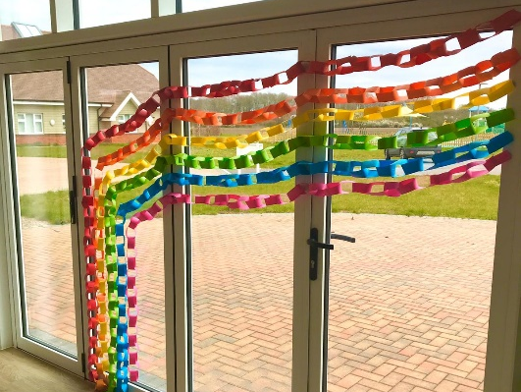
A strong focus on work / life balance, taking care of your health and planning for retirement
Making sure our employees have a good work/life balance is vital. In addition to a wellbeing programme, we offer generous annual leave entitlement with a day off for your birthday and an extra two additional days holiday, known as Alexander days each year.
There are also staff discounts on a range of products and services including travel and high street savings.
Further information

Equal opportunities
It is the policy of Alexander Devine Children’s Hospice Service to provide equal opportunities to any employee or job applicant and will not discriminate either directly or indirectly because of race, sex, sexual orientation, transgender status, religion, or belief, marital or civil partnership status, age, disability, or pregnancy and maternity.

We are committed to building a workforce that reflects the diverse communities we serve. At present, we recognise that our staff group is not as diverse as we would like it to be. We warmly welcome applications from individuals from underrepresented and minority groups, whose perspectives and experiences will help strengthen our team and the care we provide. We are dedicated to creating an inclusive environment where everyone feels valued, respected, and able to thrive

Safeguarding statement
At Alexander Devine Children’s Hospice, the safety and wellbeing of the children and families we support is our highest priority. We are committed to safer recruitment practices to ensure that everyone who works or volunteers with us is suitable to do so.

All appointments are made following robust recruitment processes which include appropriate references, identity checks, verification of qualifications and employment history if necessary, and relevant safeguarding checks, including an enhanced Disclosure and Barring Service (DBS) check where required. It is a criminal offence for people who are barred from working in regulated activity (under the Safeguarding and Vulnerable Groups Act 2006) to apply for roles that require them to work unsupervised with that particular group
Our recruitment and selection processes are designed to promote the welfare of children and young people and to deter, identify and reject anyone who may pose a risk to them.

How to apply
For an informal discussion about the role, please call Jenni, Lead for Trusts and Supporter Engagement on 01628 822777 or email questions to jennig@alexanderdevine.org
For an application form, please email fayd@alexanderdvine.org
Completed applications must be returned to fayd@alexanderdevine.org, by midday on 7th September 2026
We aim to hold interviews week commencing 14th September 2026

