



Application Pack
Events Fundraiser
Closing date for applications: 3rd November 2026
Alexander Devine Children’s Hospice Service

Alexander Devine Children’s Hospice Service (Alexander Devine) is a local charity that provides specialist care and vital support to babies, children and young people with life-limiting and life-threatening conditions, and their families, across Berkshire and into surrounding counties.

We individualise our approach to meet the unique clinical, emotional and practical needs of each child and their family, ensuring they receive the best possible care and support. Our comprehensive range of care services include Respite care, Specialist play, Symptom management, Family support, End of life care and Bereavement support. We provide care from our children’s hospice in Maidenhead as well as in the family home and across the community, including hospitals and schools.

Our hospice facilities offer opportunities for children and their siblings to experience fun, joy and adventures, and help families make precious memories for as long as they have. These include a hydrotherapy pool, sensory room, music room, games room, outdoor playground and sensory garden, six children’s bedrooms and two self-contained family flats. We also have a dedicated bereavement suite with its own garden.

Our children’s hospice service is free of charge for families, but it costs over £2.8 million a year just to maintain our current level of care. With very minimal government funding, our charity is almost entirely reliant on donations, fundraising and gifts in Wills to meet the costs of running our service. Which means every penny donated makes a huge difference to those we support.

We currently support over 165 children and their families, but we are committed to growing our service and reaching out to every child and family that needs us. In Berkshire alone, we know that there are an estimated 1,371 children with life-limiting conditions. And research shows that this number is likely to increase by at least a further 11% by 2030.

The charity was founded by John and Fiona Devine in memory of their son Alexander who sadly passed away from a rare brain tumour in 2006 at the age of eight. Their personal experience led them to realise a desperate need for a local children’s hospice service with a hospice facility in Berkshire.

www.alexanderdevine.org
Reg. Charity No. 1118947
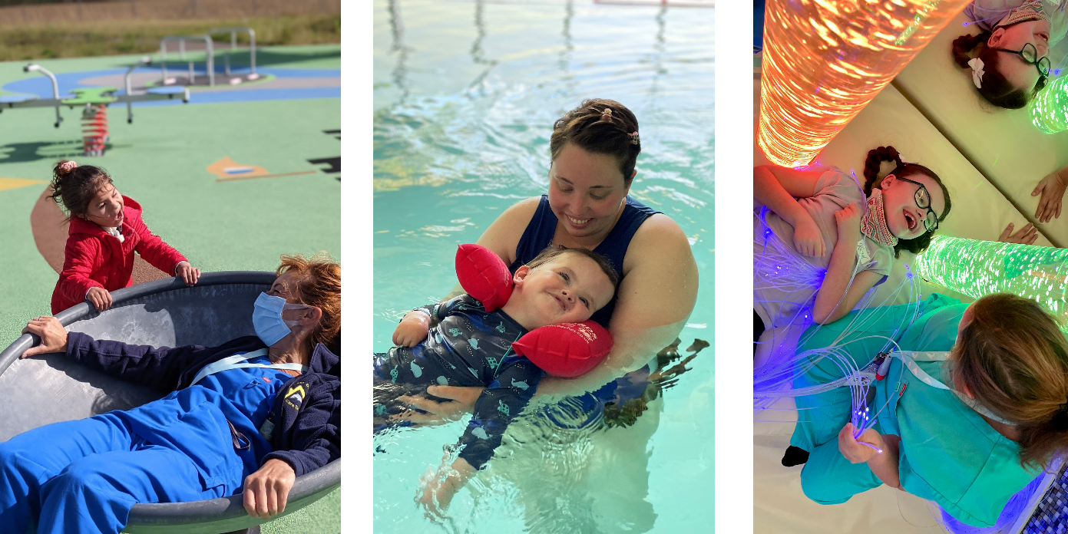

Our values, vision and mission

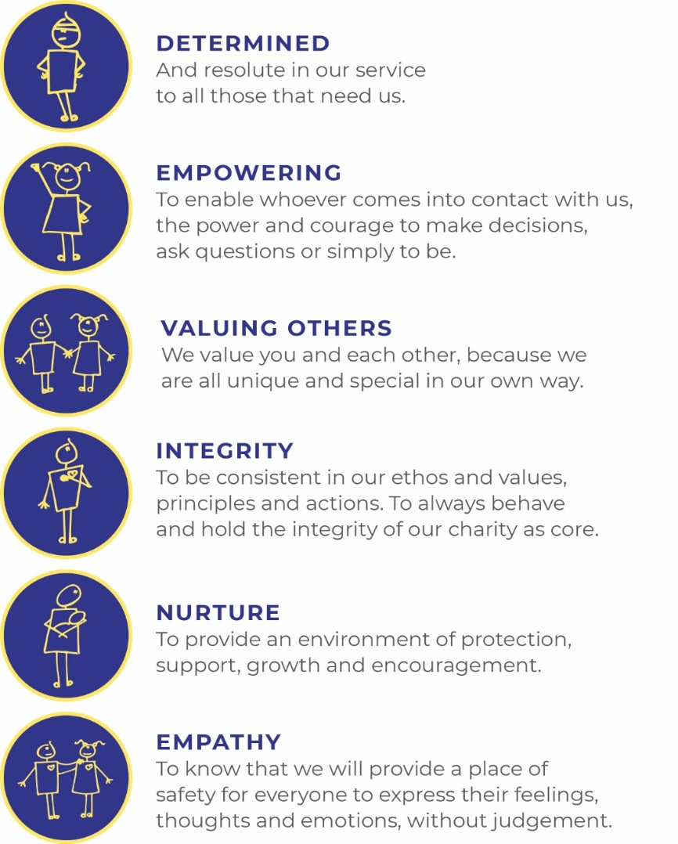
Our values
Our work is powered by our core values. They are key to everything that we do and the way in which we do it. Our expectation is that our values are upheld in all that we do and in our engagements, both internally and externally.

Our vision
We deliver palliative care to children and families through an holistic approach that meets the individual needs of each child and their family.
Our vision is to provide a service within Berkshire and surrounding counties that will give children and families a choice of care and support from a skilled and dedicated team. We work closely with the NHS, local authorities and other services in delivering our care.
Our mission
Reaching out to every child and family who needs us, offering support and care from people who understand.

The role
Trusts Fundraiser
Hours Full Time – 37.5 hours per week
Salary Band 5: £31,254 to £38,272 per annum
Location Based at Alexander Devine Children’s hospice in Maidenhead, Berkshire.
Benefits Competitive salary
Generous annual leave (plus your birthday as an additional day off)
Pension
Employee assistance programme
Death in Service Cover
Private Medical Insurance
Free on-site parking

Job purpose
The Events Fundraiser plays a key role in delivering a diverse programme of fundraising events and activities that inspire our local community to support the charity.
Responsible for planning, coordinating, and managing events from concept through to delivery, the postholder will build strong relationships internally and externally to maximise participation, income, and long-term engagement. You will use your strong event management skills to manage all logistics, provide exceptional supporter stewardship, ensure events are safe, compliant, and financially successful, and identify opportunities to grow fundraising income.
This is a wonderful opportunity for a proactive, organised, and relationship-focused individual who is passionate about creating memorable events that make a meaningful difference to the lives of children and families supported by the charity.
Grade | Band 5
Managerial reporting responsibility | Lead for Philanthropy
Professional reporting responsibility | Lead for Philanthropy

Job Description
Areas of responsibility

- Plan, coordinate, and deliver a portfolio of fundraising events, ensuring they meet all objectives.

- Manage all aspects of event logistics. Develop event project plans to ensure activities are delivered on schedule and within budget.

- Meet agreed income, participation, and expenditure targets

- Develop and implement event fundraising strategies to maximise sponsorship, registrations, donations, and additional fundraising opportunities.

- Promote fundraising and encourage participants to reach and exceed their fundraising goals. Maintain regular communication with participants throughout their fundraising journey, offering encouragement, resources, and support.

- Monitor event performance, analyse results, and identify opportunities for future growth.

- Provide exceptional stewardship to event participants, supporters, and sponsors to build long-term relationships with the charity.

- Collaborate with the Volunteer Development Manager to motivate and manage volunteers to support the successful delivery of events.

- Collaborate with the Communications team to develop marketing plans and promotional materials.

- Ensure all fundraising activities comply with fundraising regulations, GDPR requirements, health and safety legislation, and charity policies.

- Monitor and reconcile event income and expenditure.

- Work collaboratively with colleagues across fundraising, to deliver integrated campaigns and events that deliver excellent supporter journeys.

- Contribute ideas for new fundraising events and initiatives

- To champion, maintain, improve and interrogate our data in our CRM database, Salesforce.

Duties in common with other members of staff
- Contribute positively to good teamwork.

- To report and record accidents and incidents.
- To be an ambassador for the charity.
- To maintain the best appearance of your immediate working area.
- To demonstrate a positive and supportive attitude to staff and volunteers.

- Respect confidentiality applying to all areas of the hospice.

- To adhere to the Infection Control Policies and Procedures set by the charity and the Care Quality Commission.

- A commitment to, attitude and behaviour that reflects our core values - Determined, Empowering, Valuing others. Integrity, Nurture, Empathy.

- Commitment to ensuring your own wellbeing and that of your colleagues.

This job description reflects the present requirements of the post. As duties and responsibilities change and develop, the job description will be reviewed and is subject to amendment in consultation with the post holder.

Person specification
 | Essential | Desirable
Education, training and qualifications | English Language and Mathematics GCSE or equivalent grade C (grade 4) or above  Demonstrable intermediate IT skills including Microsoft Office suite. | A qualification in event management  First Aid qualification
Experience | Experience of planning, coordinating, and delivering events from conception to completion.  Experience of working to and achieving income, participation, or sales targets.  Experience of managing multiple projects simultaneously and meeting competing deadlines.  Experience of building and maintaining positive relationships with supporters, customers, volunteers, sponsors, or stakeholders.  Experience of handling budgets, monitoring expenditure, and reporting on event performance.  Experience of working with external suppliers, venues, and contractors. | Experience of using databases or CRM systems to maintain accurate records and track activity, ideally Salesforce  Fundraising / Charity experience, ideally in event management.  Experience managing volunteers  Experience of organising mass participation events, challenge events and special events such as balls and dinners  Experience developing H&S plans and Risk Assessments
Skills | Excellent organisational and project management skills.  Strong interpersonal and relationship-building abilities.  Excellent verbal and written communication skills.  Ability to motivate and inspire supporters to achieve their fundraising goals.  Strong customer service and supporter stewardship skills.  Good attention to detail and ability to maintain accurate records.  Ability to prioritise workload effectively and work under pressure.  Ability to analyse event performance data and identify opportunities for improvement.  Problem-solving skills with the ability to think creatively and adapt quickly.  Proficiency in Canva or an equivalent software.
 | Essential | Desirable
Other | Car driver - vehicle available for working.  Ability to work alone and as a member of a team.  Ability to work flexible working hours to attend events.  Commitment to the mission and ethos of Alexander Devine Children’s Hospice Service  Able to work within and uphold our core values: determined, empowering, valuing others, integrity, nurture and empathy.  Able to assess risk to maintain personal safety in a variety of settings.  Willing to undertake an Enhanced DBS.  Passed fit to undertake the duties of the post by Occupational Health.

A rewarding and special place to work
Finding ways to recognise, reward and support every member of our team is important to us. Here’s four big reasons why you will want to join our charity…
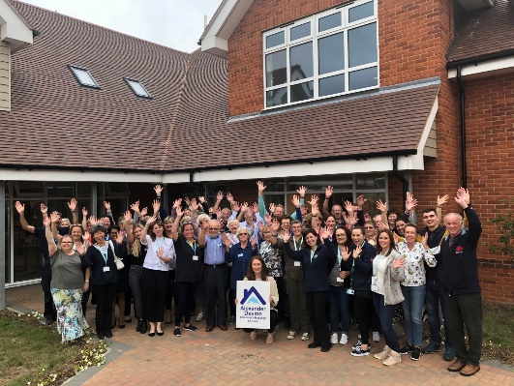
The amazing people that work here
Very simply, the team at Alexander Devine makes our charity such a unique place to work. To quote one of the young people that we support:
“If I had to summarise what makes Alexander Devine so special, I would say it’s the people that work there…they are like family to us”
Whichever part of the charity you are working or if you
are a volunteer, we are proud of our ‘one team’ spirit.

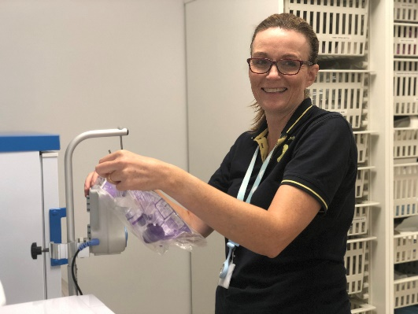
An employer that listens and cares
We pride ourselves on ensuring our staff receive regular supervision and support from their line manager, with opportunities for further training and development.
We also have an employee assistance programme, offering our employees a free confidential advisory and counselling service to help with any personal, work or family issues they may face.

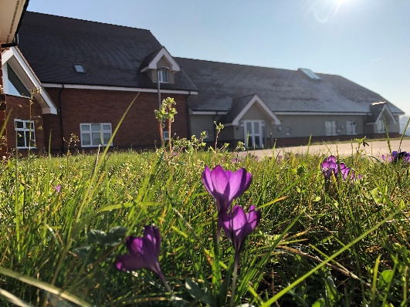
A beautiful setting in a convenient location
Our stunning purpose-built hospice is surrounded by beautiful countryside, but also just a stones throw from the M4 and A404, on the outskirts of Maidenhead.
There is free on-site parking for all staff.

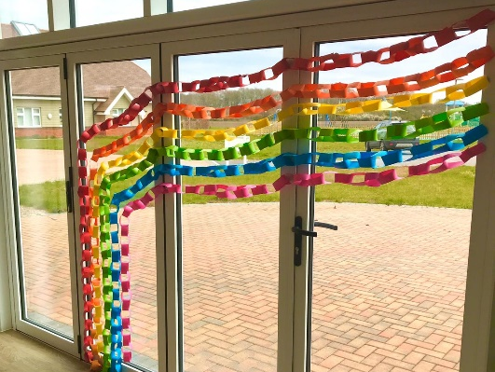
A strong focus on work / life balance, taking care of your health and planning for retirement
Making sure our employees have a good work/life balance is vital. In addition to a wellbeing programme, we offer generous annual leave entitlement with a day off for your birthday and an extra two additional days holiday, known as Alexander days each year.
There are also staff discounts on a range of products and services including travel and high street savings.

Further information

Equal opportunities
It is the policy of Alexander Devine Children’s Hospice Service to provide equal opportunities to any employee or job applicant and will not discriminate either directly or indirectly because of race, sex, sexual orientation, transgender status, religion, or belief, marital or civil partnership status, age, disability, or pregnancy and maternity.

We are committed to building a workforce that reflects the diverse communities we serve. At present, we recognise that our staff group is not as diverse as we would like it to be. We warmly welcome applications from individuals from underrepresented and minority groups, whose perspectives and experiences will help strengthen our team and the care we provide. We are dedicated to creating an inclusive environment where everyone feels valued, respected, and able to thrive

Safeguarding statement
At Alexander Devine Children’s Hospice, the safety and wellbeing of the children and families we support is our highest priority. We are committed to safer recruitment practices to ensure that everyone who works or volunteers with us is suitable to do so.
All appointments are made following robust recruitment processes which include appropriate references, identity checks, verification of qualifications and employment history if necessary, and relevant safeguarding checks, including an enhanced Disclosure and Barring Service (DBS) check where required. It is a criminal offence for people who are barred from working in regulated activity (under the Safeguarding and Vulnerable Groups Act 2006) to apply for roles that require them to work unsupervised with that particular group
Our recruitment and selection processes are designed to promote the welfare of children and young people and to deter, identify and reject anyone who may pose a risk to them.
How to apply
For an informal discussion about the role, please call Kate Wright, Lead for Philanthropy on 01628 822777 or email questions to katew@alexanderdevine.org
For an application form, please email fayd@alexanderdvine.org
Completed applications must be returned to fayd@alexanderdevine.org, by midday on 3rd November 2026

