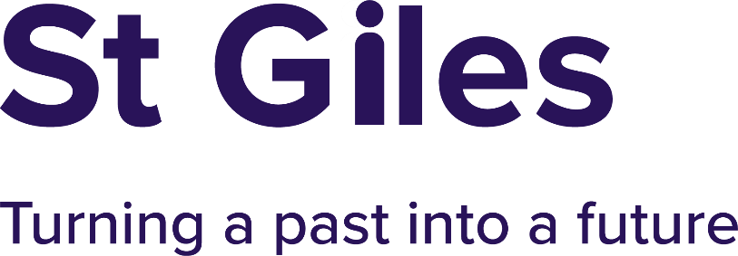


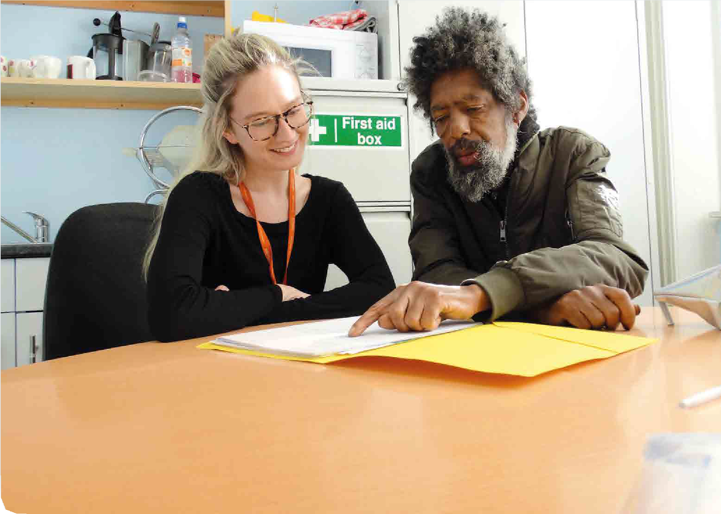
10


Risk and Governance Manager
Applicant Information Pack
January 2026

Introduction from our CEO

Thank you for your interest in joining St Giles Trust.

St Giles Trust is an exceptional charity with a proud 60-year history of helping people who have faced the toughest challenges in life; people who have been marginalised or held back by poverty, violence and exploitation, to build better futures for themselves and their families.

What makes St Giles truly unique is that the majority of our incredible team have lived experience of the issues our clients face. They have been there, they understand, and they use that insight every day to offer credible, compassionate, and life-changing support. This approach can be challenging, but we know it works, and we are deeply proud of the results. Independent research has shown that for every £1 invested in St Giles’ work, society benefits by £10. That’s impact that transforms lives, families, and whole communities.

Our new organisational structure reflects this commitment and focuses our work around three key pillars: Poverty, Violence & Exploitation, and the Justice System. Each pillar plays a vital role in helping us deliver long-term change: addressing the root causes of disadvantage, preventing harm, and creating pathways to independence and employment. Together, they ensure that we can respond holistically to people’s needs, supporting them at every stage of their journey towards stability and opportunity.
Whatever your role at St Giles Trust, whether you are working directly with clients, supporting our operations, or helping us advocate for systemic change, you will be part of a passionate, inclusive, and purpose-driven team. We work hard because we care deeply. The work can be demanding, but it is also profoundly rewarding, because every day we see people rewrite their own stories and realise their potential.

We are proud of our lived experience model, our diversity, and our commitment to inclusion. We actively seek people who share these values: people who bring empathy, integrity, and creativity to their work, and who believe that everyone deserves the chance of a better tomorrow.
If that sounds like you, we’d love to hear from you, especially if you can tackle challenges with a smile and keep the energy positive!

Tracey Burley, Chief Executive

About St Giles Trust
St Giles Trust is a national charity and a global leader in using lived experience to drive meaningful social change. For over 60 years, we have worked with people held back by poverty, exploitation, abuse, or the criminal justice system, supporting them to transform their lives and build a positive future. We are now a national organisation, working across England and Wales with offices in London, Norwich, Cardiff, Leeds, Coventry and Wolverhampton, and with a turnover of around £17 million. As we deliver our ambitious five-year strategy, we are determined to continue growing our reach, our impact, and our ability to change lives through empathy, trust and opportunity.
We deliver life-changing services through three key pillars of work:

- Poverty: Tackling the root causes of poverty, providing both emergency relief and long-term support to help people move towards independence and employment.
- Violence & Exploitation: Supporting those affected by violence, abuse, and exploitation, and preventing future harm through credible, empathetic intervention.
- Justice System: Helping people in prison and in the community to break the cycle of disadvantage, rebuild their lives, and access positive opportunities.

Lived Experience is in our DNA. We use it to empower people who are not getting the help they need, people who are hard to engage because they have been failed time and time again – held back by poverty, exploited, abused, dealing with addiction or poor mental health, caught up in crime or a combination of these issues and others. We see the person behind the problems and help them turn their lives around, then train and support them to do the same for others.

Who We’re Looking For

At St Giles Trust, we’re looking for people who share our belief in the power of change. You don’t necessarily need to have worked in the charity or criminal justice sector before; we welcome people from a range of backgrounds and with transferable skills. What matters most is your passion, empathy, and commitment to inclusion and equality. We want colleagues who are:

- Motivated by helping others realise their potential
- Inspired by working as part of a diverse and inclusive team
- Driven to use their skills to make a positive social impact

We especially welcome applications from people with Lived Experience, as this perspective strengthens our services and keeps our work authentic, informed, and impactful.



Advert

Join Us as Risk and Governance Manager
We are seeking strategic leader to join us as Risk and Governance Manager. This is a pivotal role in supporting effective decision-making, regulatory compliance, and maintaining assurance frameworks.

About the Role
St Giles is seeking a highly skilled and committed Risk and Governance Manager to lead our governance, risk, and compliance functions. You’ll join a passionate team within the People, Risk and Safeguarding Directorate, providing expert guidance to senior leaders and the Board, and ensuring we maintain the highest standards of regulatory compliance and strategic assurance.

To be successful in this role:
You will have significant experience in governance, risk management, or compliance leadership roles with a strong understanding of charity governance, regulatory reporting, and risk frameworks. Being adept at managing multiple priorities under pressure, with high levels of accuracy and discretion is essential, as is.
excellent communication and interpersonal skills are essential including being able to influence, inform, and partner with stakeholders at all levels.

Role Details
- Location: Camberwell or hybrid with travel up to 2 – 4 times per month
- Hours: Full-time, 35 hours per week
- Salary: £45k
- Holiday: 30 days + bank holidays
- DBS: Basic DBS check required

Recruitment Timeline
- Application Deadline: 9:00am on 2 February 2026
- Interview Date: 18 February 2026

Job Description

Role: | Risk and Governance Manager
Team: | Risk and Governance (part of the People, Risk and Safeguarding Directorate
Responsible to: | Executive Director of People
Responsible for: | 1 direct report
Hours: | Full time, 35 hours per week
Location: | Camberwell or hybrid with travel up to 2 – 4 times per month
Pay Band: | Band 6

Role Outline
Leading the organisation’s governance, risk, and corporate compliance functions, ensuring robust frameworks are in place to support effective decision-making, regulatory compliance, and strategic assurance. The postholder will provide expert guidance to senior leaders and the Board, oversee serious incident reporting to the Charity Commission, and maintaining oversight of ISO accreditation processes.

Key Accountabilities
Governance Leadership:
- Developing and implementing governance frameworks, policies, and procedures that support transparency, accountability, and compliance.
- Leading the coordination of Board and Committee meetings, including agenda planning, minute-taking, and action tracking.
- Advising senior leaders and trustees on governance best practice and statutory obligations.
- Ensuring timely and accurate reporting to the Board and external regulators.

Risk Management:
- Lead the organisation’s risk management strategy, embedding a proactive and systematic approach to risk identification, assessment, and mitigation.
- Maintain and oversee the corporate risk register, ensuring regular updates and reporting to senior leadership and the Board.
- Deliver risk training and support to teams across the organisation.
- Ensure risk management is integrated into strategic planning and operational delivery.

Serious Incident Reporting:
- Lead the process for identifying, assessing, and reporting serious incidents to the Charity Commission in line with regulatory guidance.
- Ensure robust internal procedures are in place for incident escalation, investigation, and resolution.
- Liaise with internal stakeholders and external bodies to ensure transparency and compliance in incident management.
- Maintain accurate records and ensure lessons learned are captured and acted upon.

ISO Accreditation Oversight:
- Oversee the organisation’s ISO accreditation processes (e.g. ISO 9001,), ensuring compliance with standards and readiness for audits.
- Coordinate internal reviews and external assessments, working with relevant teams to address findings and implement improvements.
- Maintain documentation and evidence required for accreditation and re-certification.
- Promote a culture of continuous improvement aligned with ISO principles.

Compliance and Assurance:
- Monitor compliance with internal policies, external regulations, and sector-specific standards.
- Lead internal audit planning and coordination, ensuring findings are addressed and improvements implemented.
- Develop and maintain assurance frameworks and reporting mechanisms.
- Act as a key point of contact for external auditors, regulators, and partners.

Leadership and Team Management:
- Lead and manage the Governance and Risk team, fostering a culture of high performance, collaboration, and professional development.
- Represent the organisation in external governance and risk networks and forums.
- Champion ethical leadership and organisational integrity.

Other
- Ensuring that confidentiality and security of information is maintained in accordance with our Confidentiality, Data Protection, IT and Security policies. Promoting sustainable working practices and reducing the environmental impact of St Giles work.
- Demonstrating an understanding of and commitment to St Giles values and to equality, diversity, and inclusion.
- Demonstrates a strong understanding of St Giles approach to employing and developing lived experience including how it is applied in line with our values.

Basic DBS Check is required for this role

PERSON SPECIFICATION

Experience, Knowledge & Qualifications
- Significant experience in governance, risk management, or compliance leadership roles.
- Strong understanding of charity governance, regulatory reporting, and risk frameworks.
- Experience in serious incident reporting and regulatory liaison.
- Familiarity with ISO accreditation processes and standards.
- Relevant professional qualification (e.g. ICSA, IRM, ISO Lead Auditor) is desirable

Skills & Abilities
- Ability to develop and implement governance and risk strategies aligned with organisational goals.
- Proven ability to lead, motivate, and develop teams, fostering a culture of accountability and continuous improvement.
- Excellent written and verbal communication skills, with the ability to present complex information clearly to diverse audiences including senior leaders, trustees, and regulators.
- Strong interpersonal skills with the ability to influence decision-making and build consensus across departments and senior stakeholders.
- Ability to interpret data, identify trends, and make evidence-based recommendations to improve governance and risk practices.
- Skilled in identifying issues, assessing risks, and implementing effective solutions under pressure.
- Ability to manage multiple priorities and projects simultaneously, delivering outcomes to deadlines and within scope.
- High level of accuracy in documentation, reporting, and compliance monitoring.
- Demonstrates discretion and sound judgement when handling sensitive information.
- Strong understanding of charity governance, serious incident reporting requirements, and ISO standards.
- Proficient in Microsoft Office and governance/risk management systems; comfortable with digital tools for reporting, collaboration, and document control.
- Ability to design and deliver governance and risk training to staff and stakeholders.
- Comfortable working in a dynamic environment and responding to emerging risks or regulatory changes.

Personal Qualities
It is important to us to have kind, flexible, adaptable, and empathic individuals within the team. Therefore, your contribution to the organisation should be one that supports creating an inclusive and safe environment. You will consciously aim to use your position within the organisation for the enablement of others by creating a collaborative, empowering, respectful, and inspiring environment where people look forward to coming to work.

In addition, the success candidate will:

- Have an interest in and commitment to the long-term success and development of St Giles
- Be flexible and adaptable
- Act as a role model for the organisation with integrity and a demonstrable commitment to upholding professional standards
- Demonstrate passion and approach all work in an enthusiastic way

Our Values
- Positively ó Empowering
- Persistently ó Supportive
- Flexibly ó Creative
- Proactively ó Empathic
- Activelyó Inclusive
- Clearly ó Communicating

Team Structure Chart

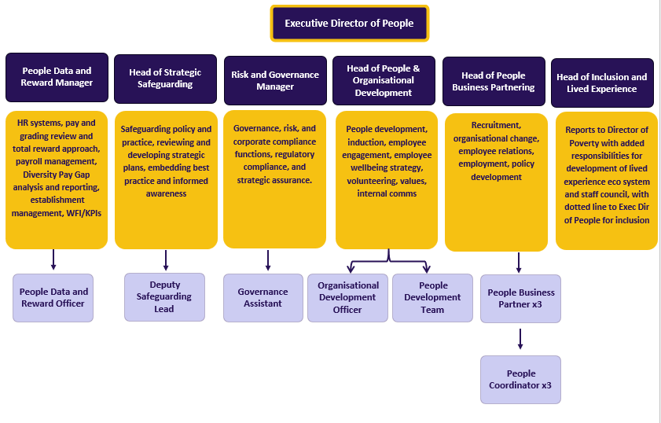

Employment Terms

Salary
The annual full-time salary for this role is £45,000. Please note that this includes London weighting, which may not be applicable depending on your location and homeworking arrangements.

St Giles Trust is committed to pay transparency and is an accredited Real Living Wage Employer. This means every employee earns at least the Real Living Wage, an independently calculated hourly rate based on the actual cost of living, rather than the government minimum. We believe that a fair day’s work deserves a fair day’s pay.

Days and Hours of Work
The contracted hours of work are 35 hours per week. This is exclusive of an unpaid lunch break each full working day.

We offer flexible and hybrid working arrangements wherever possible. You will have the opportunity to discuss your preferred working pattern at interview.

Probation
All appointments are subject to satisfactory pre-employment checks. The probation period for this post is six months.

Annual Leave
St Giles Trust offers a generous annual leave entitlement of 30 days per year, plus public holidays. Annual leave for part-time roles is calculated on a pro-rata basis.

Pension
St Giles Trust operates a pension scheme with Aegon, matching employee contributions up to a maximum of 6% of salary.

If you meet the eligibility criteria, you will automatically be enrolled into the scheme at a contribution rate of 4%, with the option to adjust this to suit your circumstances.

Employee Benefits
We are proud to offer a range of benefits designed to support your wellbeing, financial security and personal development. These include:

- Competitive salary
- Employee Assistance Programme (EAP) offering 24/7 confidential advice and support
- Life assurance cover at three times your annual salary
- Enhanced family leave and pay (maternity, paternity, adoption, shared parental)
- 30 days annual leave, plus public holidays calculated pro-rated for part time colleagues
- Flexible working from day one
- Cycle to Work Scheme – tax-efficient bike and equipment purchase through Cyclescheme Ltd
- Season Ticket Loan – interest-free loan to cover the cost of travel season tickets
- Blue Light Card – discounts at major retailers, leisure outlets and restaurants nationwide
- Perks at Work – access to thousands of online and in-store discounts
- Big Yellow Storage Partnership – discounted storage and packing essentials at any branch
- Clinical and line supervision for relevant roles
- Ongoing training and development opportunities to support your professional growth

Training and Learning
At St Giles Trust, learning is part of who we are. We are committed to helping every colleague reach their full potential through:

- Regular supervision, coaching and mentoring
- A wide range of internal and external training opportunities
- Access to digital learning resources and e-learning modules
- Access to the St Giles Professional Mentoring Programme – a structured initiative pairing colleague with experienced professionals from corporate partners. The programme offers 1:1 guidance to help you develop your skills, build confidence, expand your network, and progress your career at your own pace.

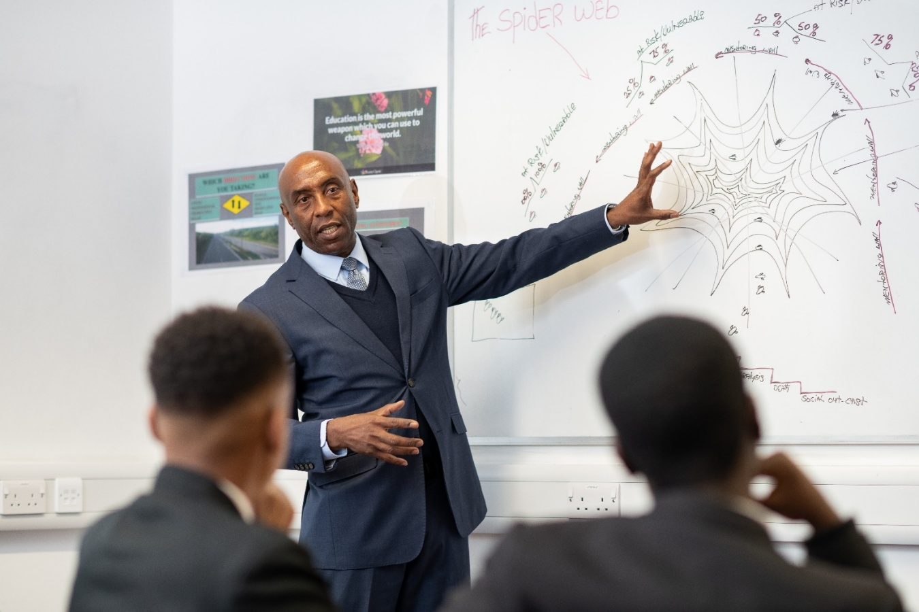

Equity, Diversity and Inclusion and Our Values

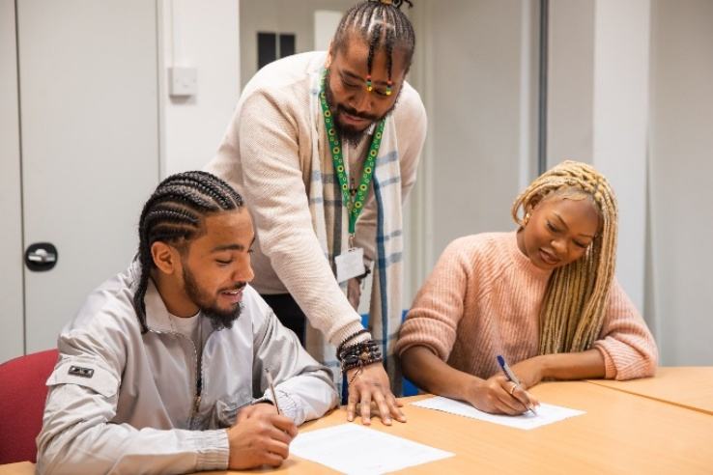
At St Giles Trust, we are committed to building a workforce that reflects the communities we serve. We welcome applications from candidates of all backgrounds and lived experiences, especially those who are currently underrepresented in our sector.

We are proud of our lived experience model and the diversity it brings to our organisation. We are dedicated to challenging discrimination, removing barriers, and building an inclusive culture where everyone can belong and succeed.

If you require flexibility in working arrangements, hours, or location, we will do our best to accommodate your needs.

Inclusive Working at St Giles Trust
At St Giles Trust, inclusion is not just something we talk about - it’s something we live every day. We are proud of our diverse workforce and are committed to creating a workplace where everyone feels welcome, respected and able to thrive.

Employee Resource Groups (ERGs) and Celebrations
Our colleague -led Employee Resource Groups play a vital role in shaping our inclusive culture and ensuring every voice is heard:

- LGBTQ+ ERG – Hosted a series of Lunch and Learn sessions over Pride month, alongside rainbow-themed cultural events, raising awareness and celebrating diversity across the organisation.
- BLAG ERG (Black, Latin, Asian and Global Majority) – Supported a range of initiatives for Black History Month, including engaging Lunch and Learns, a lively panel discussion, and fun quizzes to educate and connect colleagues.
- Neurodiversity ERG – Created a Neurodiversity Toolkit to help colleagues better understand how to support neurodiverse individuals, whether clients or coworkers. They have also developed a Neuroinclusive Practice training course, now delivered through our People Development Team.

Staff Council
Our new Staff Council gives colleagues across St Giles a direct voice in shaping our culture and decision-making. It provides a space to share ideas, raise concerns, and collaborate on initiatives that promote wellbeing, inclusion, and transparency. By involving colleagues at every level, we strengthen our sense of community and ensure that everyone feels heard and valued.

Connection, Wellbeing and Learning Together

We know that connection and wellbeing are central to inclusion. Our teams regularly come together for cultural events and initiatives that promote understanding, celebrate diversity, and build strong, supportive relationships.

- We host Pot Luck Food Events throughout the year, such as cultural pot lucks for Black History Month and rainbow-themed gatherings for Pride, bringing people together over food and shared experiences. Many offices also host quizzes and other creative activities.
- Our Cuppa, Cake and Chat initiative encourages teams to take time out, connect informally, and support one another, an important part of maintaining wellbeing and positive mental health.
- To mark the launch of our Menopause Policy, we were recently joined by an external expert for an online session, helping raise awareness and open conversations about how best to support colleagues experiencing menopause.

These are just a few examples of how inclusion, wellbeing and respect are embedded in everything we do. At St Giles Trust, everyone has a voice, and every voice matters.

Our Values
At St Giles, our values shape everything we do: how we support the people we work with, how we treat one another, and how we deliver lasting change. They underpin how we create the trust, understanding and innovation needed to help people overcome adversity and build better futures.

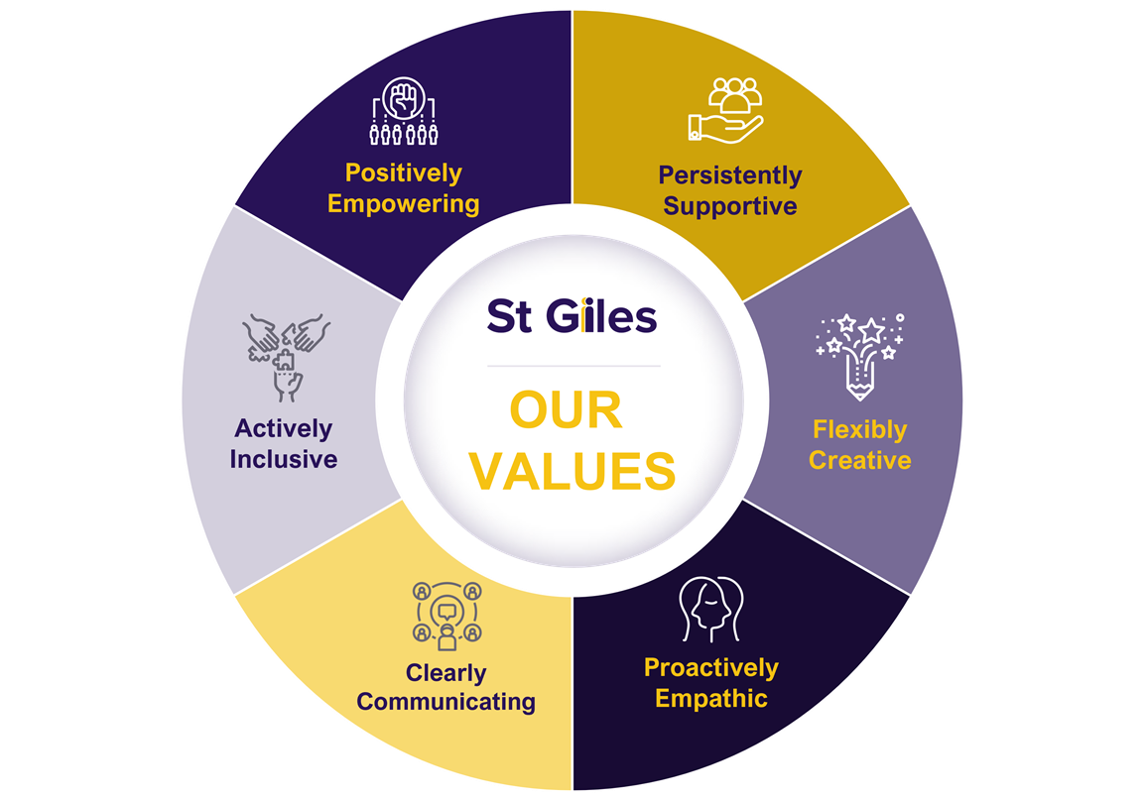

Safeguarding and Recruitment of People with Convictions

St Giles Trust is committed to safeguarding and promoting the welfare of the people we work with.
We recognise that having a criminal conviction does not necessarily prevent employment with us: in fact, lived experience of the criminal justice system can be a strength in many of our roles. Each case is considered on an individual basis, with transparency and fairness.

Data Protection

Your personal data will be processed and stored in line with current UK Data Protection legislation and St Giles Trust’s Data Protection Policy.
How to Apply

To apply, please access our online application form via our website:
https://www.stgilestrust.org.uk/current-vacancies/

Applications must be completed and submitted by 9:00am on 2 February 2026

If you have any questions or would like to discuss the post before applying, please contact us via email at humanresources@stgilestrust.org.uk

You can also find out more about St Giles Trust at www.stgilestrust.org.uk.

Interviews will take place via Microsoft Teams on 18 February 2026

Completing Your Application Form
What matters most to us when recruiting new members to our team is the inclusive attitude, relevant experience, and commitment to our values that you bring to the organisation and the role.
Please note that we do not accept CVs for this vacancy. All applications must be submitted via our online application form.

Supporting Statement
Your Supporting Statement is an essential part of your application and will be used to determine who is shortlisted for interview. Please ensure that your statement provides clear, specific examples of how your skills, experience, and values are relevant to the role and demonstrate your suitability for the position.

Your written statement should be no longer than 1,000 words and should address the criteria outlined in the Person Specification, covering the following three areas:

- Experience, Knowledge & Qualifications – Give examples of your professional and/or voluntary experience, highlighting how you meet the criteria.
- Skills & Abilities – Explain the skills you bring to this role and how you have applied them in practice.
- Personal Qualities & Values – Describe the personal attributes and values you would bring, including how you align with the values of St Giles.

We would like to thank you in advance for expressing an interest in working for St Giles Trust. We look forward to receiving your application.

