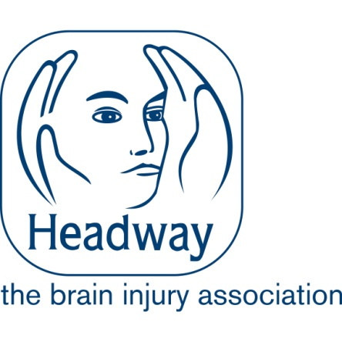
Role profile
Approved Provider Associate Manager

Team: | Services Directorate
Reporting to: | Approved Provider and Training Manager
Responsible for: | ID Card Project Lead
Salary: | £35,000 FTE (pro-rated to three days or 21 hours per week)
Location | Home based in the East or West Midlands or office based in Nottingham

The Role Purpose
The role will involve, conducting assessments and working with the current Approved Provider Associate Manager to manage Lead Assessors, who are based around the UK and the Service User Perspective Assessors, who are either brain injury survivors, or family members/ carers.
Headway UK developed the Approved Provider (AP) Scheme in 2011, with the primary aim to "promote and maximise the quality of specialist care delivery and appropriate training for those involved with brain injury survivors with complex, physical or behavioural impairment".
The AP scheme is a standards-based volitional accreditation scheme open to NHS and independent units providing residential care and/or rehabilitation to people affected by ABI at all stages of the care pathway.
Although the AP scheme awards units through the accreditation process, it is not just about recognition, it's about continuous improvement. We work collaboratively with residential units to provide support and recommendations, to enhance their services and care provision. With 66 units already on board across the UK, our reach and impact continue to grow.

Overview of the department/team
Headway UK’s Services directorate provides direct services to brain injury survivors and their families through the nurse-led helpline; Emergency Fund; training to both professionals and family members; peer support groups for brain injury survivors and the Justice Programme, which works with police and probation services and provides ID cards for brain injury survivors.

Additionally, the Services directorate includes the Network Support Team, which works with the UK-wide network of local Headway charities and volunteer-led branches, which provide a range of services including rehabilitation, reablement and peer support to brain injury survivors.

Key areas of accountability
- To conduct Approved Provider assessments, which includes travelling and at times may require overnight stay to brain injury units and assessing the services they provide, compiling reports and making recommendations, to improve practice against the framework.
- To maintain good channels of communication with new and existing AP units, ensuring clarity of the scheme and its expectations and requirements.
- To work with freelance Lead Assessors and Service User Perspectives (who are brain injury survivors or family members) who are based around the UK, to organise assessment visits and ensure the schemes standards are upheld.
- To prioritise and manage workload in line with service demands, deadlines and required standards, ensuring timelines are met and the service runs smoothly and consistently.

- To review Approved Provider reports written by other assessors and share them with the Director of Services for final approval.

- To work alongside the current Approved Provider Associate Manager to meet financial targets and grow the number of AP Units.
- To collaborate with the communications team Manager, Headway UK branches and Headway UK independent affiliated charities to actively market the AP scheme to onboard more units.

- To contribute to the development of Headway UK’s Approved Provider scheme, by continuing to drive forward standards.
- To comply with Headway’s Equal Opportunities and Health and Safety policies and undertake appropriate training and personal development as appropriate.

- To undertake such other reasonable tasks as may, from time to time, be deemed necessary.

Corporate responsibilities
- Safeguarding – Safeguarding is at the heart of what we do, and every member of staff has a duty ensure that they understand and follow safeguarding procedures to promote the welfare of our staff and service users.
- Health and Safety – We are an employer who is committed to health and safety, and you will have a role to play ensuring that we continue to embed a health and safety culture.
- Data Protection – You will help ensure that we remain fully compliant of our obligations in respect of data.
- Equal Opportunities is a key value of Headway UK. Every member of staff has a personal responsibility to ensure that they behave in an inclusive way and contribute to our diversity goals.
- You are an ambassador for Headway UK – We want all our staff, regardless of their roles, to be our ambassadors, representing the charity and promoting the work we do.

Person specification
Approved Provider Assessor
Qualifications | Essential/Desirable
Relevant professional qualification (e.g. occupational therapy, speech and language therapy, clinical psychology, physiotherapy, nursing, social work). | E
Experience and knowledge.

Prior experience of working in the field of acquired brain injury | E
An understanding of the effects of brain injury, as well as an awareness of other neurodivergent conditions. | E
To be highly organised and a self-starter with the ability to prioritise tasks, work under pressure to meet deadlines and to work effectively independently and within a team. | E
Ability to write and moderate written reports of high quality and clarity, to provide accurate and accessible feedback. | E
Ability to manage and support a team of freelance staff. | E
Ability to gain the trust, confidence, and respect at all levels within external organisations and staff groups. | E
Good IT and administration skills and the ability to use Microsoft Office and Salesforce (our CRM system). | E
Knowledge of current issues in neurological care provision at all stages of the care pathway. | D
Awareness of the framework and mandatory regulations governing practice in residential care/nursing/hospital settings. | D
A sound understanding of risk management safeguarding issues. | E
Knowledge and understanding of the data protection regulations. | E
Other

Demonstrate a clear understanding of safeguarding (adults at risk) | E
Demonstrate a clear understanding of equality of opportunity and diversity issues | E
Demonstrate a clear understanding of GDPR and the impact that it has on the role day to day. | E
Demonstrate a clear understanding of health and safety. | E
Ability to travel, with occasional overnight stays. | E
Full UK driving licence and access to the use of a vehicle. | D

Please note this role is subject to an Enhanced criminal records check.

