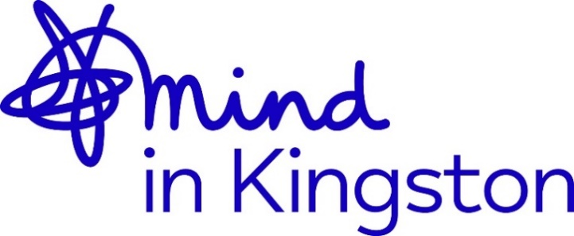

ALFRISTON HOT MEAL DELIVERY AND SUPPORT VOLUNTEER
Role Profile

Role Title: Alfriston Hot Meal Delivery and Support Volunteer
Hours: 3 hours approx. (11:45am – 3:00pm)
Expenses: Expenses are compensated where applicable such as travel
Commitment: At least 6 months
Responsible to: Alfriston Outreach Service Manager (& Deputy Manager in their absence)

Project overview:
Alfriston Outreach Service is dedicated to helping older and vulnerable people in Kingston. We provide services such as Hot Lunch delivery, Shopping, and Laundry delivered into people’s homes, with our aim to support older people to remain independent in their own homes. Our Hot Lunch service is one of the clearest examples of the impact that our work can have — this is often the only hot, nutritious meal that a person who we support might have that day. If you volunteer here, you will be working with some of the most vulnerable, older members of the community, but you will also be welcomed into their homes and see first-hand the effect that you can have on someone who is really struggling, just with a meal and a quick conversation.

About us:
Mind in Kingston supports people with mental health issues and raises awareness within Kingston and surrounding areas. We provide training, supervision, and opportunities for career development.

Volunteers are extremely valued within our team and a vital part of our service delivery. We welcome applications from people from all walks of life, including those who may have personal or professional experience of mental health. While lived experience can bring valuable perspective, it is not a requirement for volunteering with us. Our focus is on providing volunteers with the training, guidance and supervision they need to feel confident in their roles and to develop their skills. Volunteers are supported to succeed and offered opportunities to connect with trustees, staff and other volunteers both professionally and socially. Above all, we value the contribution volunteers make to our community and are committed to recognising their achievements.

Main purpose of the role:
- Support and assist the Lunch Delivery.
- Deliver the Hot Lunches into people’s homes.
- Report any observations or concerns about service users’ wellbeing to the supervisor.

Tasks will include:
- Supporting the Driver on the Lunch Delivery.
- Carrying Hot Meals into Service Users Homes.
- Using Key Safes to open doors where necessary.
- Delivering Laundry and Shopping to some Service Users.
- Provide a point of contact for Service Users.
- Reporting on changes in Service Users well-being.
- Reporting back any safeguarding concerns immediately to the supervisor.
- Maintain regular contact with the supervisor.
- Attend meetings and supervision sessions.

What you will receive in return:
- Training in Safeguarding.
- Training in Food Handling.
- Training for any other skills as identified by yourself and your supervisor.
- Regular check-in with your supervisor, reflective supervision, and managerial support.
- An opportunity to learn new skills and develop existing ones while being a part of a supportive team at Mind in Kingston.
- Reimbursement of reasonable expenses.
- Professional references upon completion.
- *Alfriston volunteers only: access to a discounted lunch (£5 per lunch, subject to availability). A minimum of 24 hours’ notice must be given.

What we expect from you:
- Commitment for at least six months.
- Completion of required training.
- Adherence to Mind in Kingston’s policies (e.g., confidentiality, safeguarding).
- Proactive engagement with your supervisor for support.

Application Process:
- Two recent references are required.
- An enhanced DBS check is necessary.

We ask volunteers for two references, one of which must come from someone who has supervised you recently in your work or studies, such as a current or previous employer or a tutor. You will also need to undergo an enhanced DBS (Disclosure and Barring Service) check, as you will be working with vulnerable adults.

Please apply by completing an application form at https://tinyurl.com/MiKVolForm and we will be in touch as soon as we can. If you would like more information or the application form in an alternative format, please email volunteering@mindinkingston.org.uk or call 020 8255 3939. You can also contact Alfriston at Lisa@mindinkingston.org.uk or call 0208 399 4289 for more information on the Alfriston Outreach Service.

Please note that we will be reviewing applications on a rolling basis and therefore reserve the right to close this early if all positions have been filled.

