2025
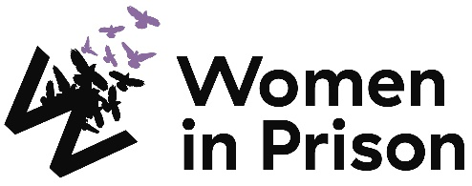

Advocate (Housing)

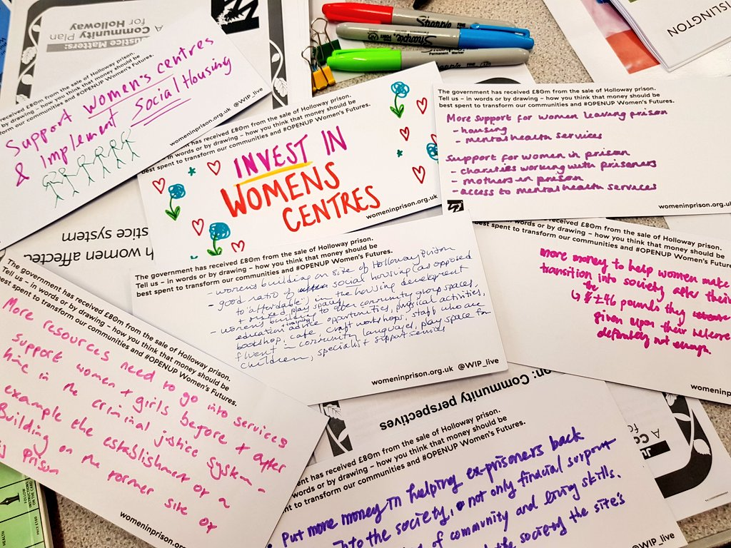

Charity no: 1118727. Company no: 5581944.



Welcome!
Dear Applicant,
Women in Prison is the only national charity focused on women in the criminal justice sector, we are women-led and know the importance of ensuring we have a clear gendered approach in all that we do. Our influencing potential and campaigning voice are substantial. We are currently in our 40th year of supporting women impacted by the criminal justice system. We work with women who are at risk of, or being, harmed by the systems that are meant to protect us.

At Women in Prison we are passionate, ambitious and grounded in the reality of women’s lives. We are proud of our roots as a feminist grassroots organisation, and we have grown from strength to strength since the 1980s, delivering services to women and campaigning for change. We exist to support women facing multiple marginalisation and exclusion, who have been let down, and their rights denied. We believe that prison doesn’t work and we want to see an end to the harmful imprisonment of women in England and Wales.
This is a very exciting time in Women in Prison. As a deeply value-led organisation, we know that our recently agreed set of values represents the unique nature of our organisation, and also need to hold us to account for how we work in an unpredictable future. Our new vision and purpose will guide us as we build a strategy during 2024 to be implemented from 2025.

We know we want to build more coproduction; deeper support to women who are disproportionately affected by the system through an intersectional lens; greater connection between the women we support and the influencing we do; an increased focus on alternatives to the system and a stronger focus on preventing women being caught up in the system.

If you are excited by our purpose, and the breadth of what this role could offer to you, we would love to hear from you.

I look forward to meeting you.
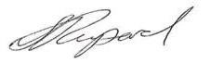

Sonya Ruparel, Chief Executive
Our Story

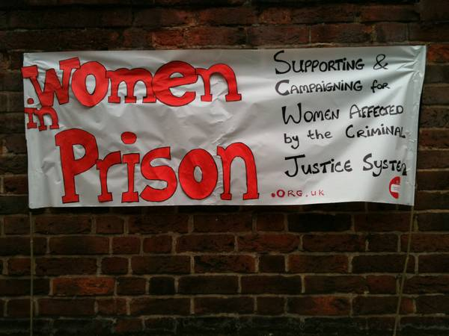

Our Vision is of a society which no longer accepts the structural inequalities that lead women and girls into contact with the criminal justice system.

Women in Prison was born out of the anger our founder – Chris Tchaikovsky – felt about what she experienced and saw when imprisoned in HMP Holloway in the 1980s.

During Chris' time in prison, a woman died after setting fire to her own cell. Chris saw that the specific needs of women in prison and the damaging effect prison sentences were having on women scarcely figured in public or political discourse. So, in 1983, alongside international criminologist Pat Carlen, Chris founded Women in Prison, pushed hard to expose this scandal and campaigned for change. Our founders wanted to increase awareness of the lives behind the women in our prisons, and the impact of poverty and abuse on women’s lives.

Chris believed the idea of sending a woman to prison as punishment was shameful and absurd.

In her words:

“Taking the most hurt people out of society and punishing them in order to teach them how to live within society is, at best, futile. Whatever else a prisoner knows, she knows everything there is to know about punishment because that is exactly what she has grown up with. Whether it is childhood sexual abuse, indifference, neglect; punishment is most familiar to her.”

In the early 1990s, the organisation was able to expand its remit beyond campaigning to deliver direct support to women affected by the criminal justice system. WIP's initial focus on prison in-reach services was then expanded to support women in the community following their release. Chris, sadly, passed away in 2002. Despite the loss of our visionary founder, Women in Prison works to carry on Chris' legacy.

Today, WIP is a national charity dedicated to making a difference to the lives of women affected by the criminal justice system. We campaign for a new system of justice - one that addresses the root causes of offending (including homelessness, substance use, mental ill health and experiences of poverty, trauma and abuse). Our women’s centres in Manchester and London and the services we provide in communities and prisons deliver holistic, women-centred support to enable those whom we work with to address the complex challenges they face.

We want to persuade decision-makers to radically reduce the women’s prison population, by demonstrating how a focus on human rights, social justice, health and investment in specialist community support services, including women’s centres, enables women to move forward with their lives. We do this by:

- Leading inspiring, passionate campaigns to replace the current system, and to radically reduce the number of women in prison, thereby freeing resources for investment in community support services, including women’s centres.
- Delivering high quality, trauma-informed, independent advocacy services for women, in communities and prisons, which focuses on early intervention, health and holistic provision as part of a ‘whole system’ multi-agency response.
- Offering a platform for women’s voices which builds women’s confidence and self-belief, strengthening an understanding of their rights and responsibilities, and provides opportunities to speak ‘truth to power’ to bring about real change

Click here for our most recent annual report

Advocate (Housing)
Reports to: Senior Advocate (Housing)

Direct reports: N/A

About Women in Prison

Women in Prison is a national, women-led, feminist organisation. We deliver front line support to women harmed by the criminal justice system, through our work in prisons, in the community and ‘through the prison gate’ as they resettle back into their communities. We also campaign for systems change that addresses the root causes of offending, reduces the harmful impact of prison, and creates workable, community-based alternatives to imprisonment.
Job Description:
Job Purpose:
To support the delivery of WIPs housing programme for unsentenced women, providing trauma-informed specialist support to women in HMP Bronzefield, and going through court processes, with a focus on improving housing outcomes for women affected by the criminal justice system.

Key Responsibility Areas

- To deliver an effective housing intervention for women impacted by the criminal justice system.
- To develop effective relationships with key stakeholders, such as housing departments, court-based and prison teams, to ensure a collaborative approach to women’s accommodation needs.
- To provide expert advice and support to colleagues, including upskilling through information and training sessions, and supporting system change activities.

Duties and key responsibilities:
- To deliver an effective accommodation intervention for women impacted by the criminal justice system:
- Deliver an intervention that assesses women’s housing needs, providing expert advice and support, and developing a support plan to address identified needs.
- Assist women with maintaining or accessing suitable accommodation, including negotiating with housing providers and landlords on women’s behalf.
- Provide trauma-responsive approach, undertaking risk and needs assessments that reflect each individual's situation and support needs.
- Deliver housing advice sessions to service users.
- Ensure that interventions are responsive to and meet the needs of women from diverse and minoritised communities.
- Accurately document all client interaction on relevant databases, always working in line with Women in Prison’s case management policy, and data protection legislation.

- To develop effective relationships with key stakeholders, such as housing departments, court-based and prison teams, to ensure a collaborative approach to women’s accommodation needs:
- Work in partnership with statutory housing departments, housing associations, community organisations, to advocate for women’s needs and solutions to accommodation issues.
- Take a collaborative multi-agency approach to supporting women, including representing and supporting women at multi-agency meetings.

- To provide expert advice and support to colleagues, including upskilling through information and training sessions, and supporting system change activities.
- Support the wider team to increase knowledge on housing legislation and pathways through providing support and advice, and training to internal colleagues.
- Contribute to development of new approaches and interventions that address underlying contributing factors to women’s offending and criminalisation.
- Support Women in Prison’s influencing work through actively contributing expertise into campaigns and ensuring that Women in Prison provides a platform for women’s voices.
- Maintain up-to-date knowledge and awareness of developments in relevant public policy and legislation by attending relevant training courses, meetings and conferences.

The job description does not form part of your contract of employment and can be amended from time to time as the needs of the organisation require.

Person Specification:
Skills and Experience
- Experience of providing support on accommodation issues or able to demonstrate equivalent skills and experience.
- Supporting women with a range of intersecting needs, including delivering trauma-informed, strengths based 1-1 and group interventions.
- Working in partnership as part of a collaborative and coordinated approach to supporting service user’s needs.
- Working a solution focused way to address challenging situations.
- Effective communication skills verbally and in writing with people of many different backgrounds and within a range of settings
- IT skills at a level that supports report writing, email, internet and use of a database.
- Knowledge of safeguarding practice, policy and procedures.
- Knowledge of the impact that contact with the criminal justice system may have on women.

Personal Attributes and other requirements
- Commitment to the core values and ethos of Women in Prison, including social justice and feminism.
- Commitment to anti-discriminatory practice and equal opportunities and an ability to apply awareness of diversity issues to all areas of work.

Terms and Conditions:
Start date: 2nd February 2026
Salary: £30,640 per annum (which includes London weighting)
Location: Primarily based in HMP Bronzefield with some travel to South London.
Working hours: 35 hours per week

Contract: Permanent

Annual leave: 30 days plus statutory bank holidays (if full time). All WIP staff also receive an additional 3 days leave between Christmas and New Year.

Pension scheme: WIP provides an auto enrolment pension scheme with 5% contributions from the employer and 3% from the employee.

To Apply:

Applications close: Monday 12th January 2026 at 9am. We reserve the right to close this advert early.
Interviews with Women in Prison: w/c 19th January 2026
To apply: Completed application form and submit to Application Portal

If you require reasonable adjustments to support you during the application process, please contact the HR team on hr@wipuk.org.
We are happy to invest in developing the right person, so you are welcome to apply even if your professional experience does not fully meet the job description or person specification.

We particularly encourage applications from Black, Asian and minoritised women, and women who have personal experience of the criminal justice system.

If you do have lived experience, please see policy below on the Recruitment of Women with Lived Experience of the Criminal Justice System.

In line with legal requirements and the nature of our work, this role:
- Is restricted to women only as a genuine occupational requirement
- Requires the right to work in the UK
- Is subject to an Enhanced and Adult Barred List DBS check.
- Is subject to HM Prison and Probation Service vetting (‘Enhanced Level 1’ or ‘Standard Plus’)
- Requires that the post holder is not automatically disqualified by (or can obtain a waiver from) the Charity Commission

Equality, Diversity and Inclusion Policy

Our Principle Commitments
WIP is committed to building and valuing diverse teams and taking positive action to promote equality and challenge unfair and unlawful discrimination. We recognise that women may experience multiple and intersecting forms of discrimination based on their sex and additional, real or perceived, characteristics including age, disability, gender reassignment, marriage or civil partnership, pregnancy or maternity, race, religion, sexual orientation, social-economic background, immigration status, caring responsibilities, spent convictions or trade union membership.

WIP works to tackle discrimination and the structural inequalities women experience. We are committed to embedding diversity and inclusion in all areas of our work, including recruitment, and aim to reflect the diversity and excellence of the women that we work with. We actively encourage applications from women from a variety of backgrounds, and with a range of skills and experiences. We are particularly interested to hear from Black, Asian and minoritised women and women who have lived experience of the criminal justice system.

Policy on the Recruitment of Women with Lived Experience of the Criminal Justice System

Women in Prison actively encourages and supports the employment of women with lived experience of the criminal justice system. We believe that women’s own experiences drive the Charity forward through understanding, solidarity and passion for change.

Job Advertisements and the Application Process
We do not ask for disclosure of criminal records during the application process, to ensure that women with lived experience of the criminal justice system are assessed on their merit, without risk of discrimination and are not asked to disclose sensitive personal information unnecessarily.

If a Disclosure and Barring Service (DBS) check is required for a role, this will be stated clearly in the job advert, including the level of DBS.

HM Prison and Probation Service (HMPPS) vetting
If HMPPS vetting is required for a role, this will be stated in the advert. Women in Prison has to adhere to this vetting requirement in order to deliver some of its services. We actively encourage and support women with lived experience to apply for our roles, but it should be noted that vetting must be passed to be appointed to roles with this requirement; there is no comprehensive list of reasons why vetting may be failed, though there is evidence to suggest that vetting may be failed for the following reasons: -

- Offenses against vulnerable people
- Offenses motivated by hate or discrimination
- Domestic abuse offenses
- Murder
- Firearms offenses
- Dishonesty-related offenses, such as fraud
- Multiple offenses
- Offenses involving violence, drugs, or dishonesty

Failure to disclose information
You might fail vetting if you don't disclose information about yourself or people close to you that raise concerns with the Police.

Incomplete or incorrect information
You might fail vetting if you provide incomplete or incorrect information on your application.
The level of checks you undergo will depend on the role you're applying for and the type of access you'll have. You'll need to provide supporting documentation to confirm your identity address, and right to work

Unlock can provide you with some guidance on applying for roles in the criminal justice sector.

Levels of DBS Checks
Basic DBS checks contain details of unspent convictions. Standard and Enhanced DBS checks contain details of unspent and spent (unless filtered) convictions and cautions (including reprimands and warnings). Enhanced DBS checks may also include other information held by police forces deemed relevant to the role or check for inclusion on the Children’s or Adults’ Barring List.
Job Offers and the Induction Process
We will only ask for a DBS check at the point of job offer.
Disclosures will be treated confidentially and only stored where necessary, in line with General Data Protection Regulation (GDPR) guidelines. Access will be restricted to limited Senior Management or HR representatives as needed to assess suitability for the role.
A criminal record will not arbitrarily bar women from employment with us. We discuss disclosures with applicants (in person, or via phone or video call), to allow them to explain the background in their own words. We consider the relevance to the role, including the type and seriousness of an offence, how much time has passed and whether the individual’s circumstances have changed. If they have restrictions on the work they are able to do, we consider whether we are able to make reasonable adjustments to facilitate their employment.
The Charity Commission does however have its own automatic disqualification rules on who can hold senior positions within a charity, which apply to our Trustee, CEO and Director of Finance and Resources positions. Although it is possible to apply for a waiver.
Women in Prison does not have a blanket ban on any criminal records and will always approach disclosures fairly and on an individual basis. We seek to balance supporting women with lived experience into employment, alongside safeguarding our current employees, service users and the organisation.

