

JOB TITLE Peer Support Coordinator (£26,000 to £28,000) pro rata
PART-TIME 22.5hrs a week
15 Month Fixed Term contract
Home-based – Scotland

This post is funded by the National Lottery Community Fund.
Are you somebody who would love to use your coordination skills to help us Beat Macular Disease?

Macular disease is the biggest cause of sight loss in the UK, with around 300 people diagnosed every day. The Macular Society is the only charity determined to beat the fear and isolation of macular disease with world class research, and the best advice and support.

To support people affected by macular disease now, the Macular Society provides a range of support, information and services. Our research programme is focused on finding new treatments and a cure to beat macular disease forever.

We are seeking someone who can support our Community Engagement team to ensure groups and group volunteers have the resources they need to thrive. The candidate needs to have an open and collaborative approach and the ability to multitask and prioritise multiple projects and work streams.
If you feel you have the above attributes, then we would love to hear from you.

In return, we provide a great working culture and offer flexible working options, 26 days annual leave, the ability to buy or sell annual leave, supportive family policies, and a 6% pension contribution.

We are an equal opportunities employer, and we welcome applications from all suitably qualified persons.

This role is predominantly home-based; however, travel may be required across d and occasionally to Andover in Hampshire.

Please view the full job specification at: http://www.macularsociety.org/vacancies

To hear what our teams say about working here please visit: https://www.macularsociety.org/careers/what-our-teams-say/

Please address any questions by email to:
Maria van de Vorst - Maria van de Vorst@macularsociety.org

To apply please email your CV with a covering letter to: recruitment@macularsociety.org

Closing date: 30 October 2025

Interviews: w/c 3 November 2025



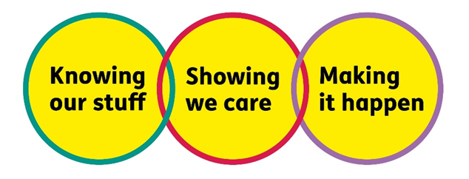

Logos read:
Happy to Talk flexible working
Show the salary
We will Beat Macular Disease by Making It Happen, Showing We Care, Knowing Our Stuff

