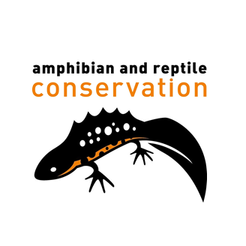

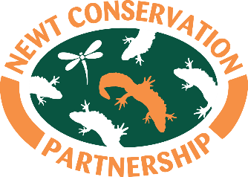

Application for the post: | Administrator Maternity Cover (FHT secondee)
Closing date | Thursday 7th May 2026 (midday)
Interviews | Tuesday 26th May 2026 (in Oxford)

Please complete and email this application form to:
info@newtpartnership.org.uk with subject reference: Administrator Application

- Personal Details
Surname
First name(s)
Address
Postcode
Mobile
Email
Do you have the right to work in the UK? Please tick the right box. | Yes | No
If yes, please specify the basis of your right to work (e.g. UK citizenship, settled status, visa type)

- Present or most recent employment
Employer’s name & address
Post held
Dates of joining and leaving
Period of notice required
Please give a brief description of the duties and responsibilities you carry/carried out:

- Previous Employment
Dates (from – to) | Employer name and address | Please give a brief description of the position, duties and responsibilities and your reason for leaving.

- Training, qualification and other learning
Please give details of your academic and professional qualifications, any other relevant qualifications you have gained, including specialist in-house training or short courses.

Formal Education | Dates
Professional Courses/Awarding Body | Dates

- Driving Licence
Do you have a full, current driving license? | Yes/No
Do you have a car you can use for work? | Yes/No

- Criminal Record
Please give details of any unspent criminal offence in accordance with the Rehabilitation of Offenders (Exceptions) Order 1975 and/or Northern Ireland 1979.

- References
Please give details of two people, not related to you, who we may ask for references. The first should be your current or most recent employer. The second should be someone able to comment on your work abilities.
Referee 1:
Name
Position
Address
Postcode
Mobile
Email
May we contact this person before your interview?
Referee 2:
Name
Position
Address
Postcode
Mobile
Email
May we contact this person before your interview?

- Additional Information
Before completing this section please read the Job Description and Person Specification carefully and demonstrate how you meet the requirements by giving relevant details of your experience, skills and knowledge gained in employment and elsewhere. We would also like to know what you can bring to the Newt Conservation Partnership and its partners.

- Signature
I confirm that to the best of my knowledge the information given on this form is correct.
Signature: | Date:

To help us monitor our recruitment advertising please tell us where you saw this post:

