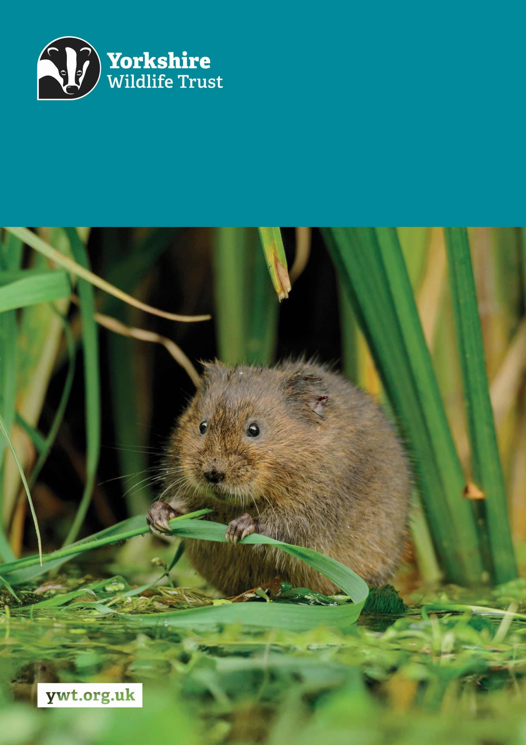
Z
Communications and Engagement Manager: Marine
Job Description
About us

Yorkshire Wildlife Trust is one of the region’s largest environmental charities; our mission is to drive nature’s recovery in Yorkshire across our land and at sea.
We are one of 46 regional Wildlife Trusts working for nature and collectively forming the Wildlife Trusts, one of the largest collective national movements for wildlife in Europe.
Our vision is for wildlife and people thrive together across Yorkshire’s communities, land, rivers and sea. We work holistically in nature, thinking globally, planning at regional and landscape scale, while delivering our work in partnership with local communities, caring for local wildlife together. Our dedicated team of staff (c.190) and volunteers (c.1000) work together, on behalf of all our members (c.41,000), in every corner of Yorkshire to make this vision a reality.

Since forming in 1946 with our first reserve at Askham Bog, we now steward 115 nature reserves, which cover more than 3000 hectares of land and include some of our most precious wildlife. We also work extensively with other land managers, communities and businesses, to inspire, advise and deliver restoration work, supporting others too play their part in nature’s recovery.

We are passionate advocates for Yorkshire’s incredible wildlife and wild places. Join us and help create a diverse and inclusive team, committed to driving change for Yorkshire’s wildlife, communities and a positive future.

Job Description
Communications and Engagement Manager: Marine

Responsible to: Marine Programme Manager

Location/based at: Spurn Point, Hull, with hybrid working subject to the requirements of the role

Date last updated: 5 August 2026

Main Purpose of the Role:

- Lead the development and delivery of the Marine Programme’s communications and engagement strategy, campaign plans and annual communications plan, aligned with Yorkshire Wildlife Trust priorities and the evolving portfolio of marine projects.
- Lead the Marine Programme’s social media, press and media activity, turning technical updates, stories, images and other source material provided by project teams into accurate, engaging and audience-appropriate communications.
- Work with marine programme managers to agree communications and engagement priorities on a project-by-project basis, determining the appropriate balance of social media, traditional media, campaigns and engagement events.
- Plan and coordinate agreed marine programme campaigns and priority events, working closely with project teams, partners, The Wildlife Trusts and YWT’s wider Communications and Engagement teams. Also work with the Communications, Marketing, Engagement and Fundraising teams to ensure marine programme activity supports wider organisational priorities.
- Provide specialist communications advice and editorial support across the Marine Programme, ensuring that communications are timely, accurate, consistent and aligned with Trust standards.
- The role requires occasional weekend and irregular-hours working to support agreed events, campaigns and media activity. Attendance at events will be undertaken with appropriate colleagues and in accordance with risk assessments and lone-working procedures.

Tasks and responsibilities:

Technical

- Develop, maintain and deliver the Marine Programme communications and engagement strategy, annual plan, campaign plans and content calendar, identifying priority audiences, messages, channels and measures of success.
- Lead the planning, production, scheduling and publication of Marine Programme social media content, using information, stories, photographs, video and technical updates supplied by project teams.
- Provide Marine Programme colleagues with proportionate communications advice in line with the agreed annual communications plan and programme priorities, including support with messaging, writing, editing, proofing, presentations and audience-appropriate content.
- Identify and develop press opportunities, write and issue press releases and coordinate responses to media enquiries, working with the Marine Programme Manager and central Communications and Public Affairs Team where appropriate.
- Write, edit, review and coordinate content for websites, press releases, social media, newsletters, interpretation, presentations, publications and other agreed communications materials.
- Plan Yorkshire Wildlife Trust’s contribution to national and partnership campaigns, such as National Marine Week, liaising with The Wildlife Trusts, the wider Trust communications team and Marine Programme colleagues.
- Agree project-level communications priorities with relevant managers and develop proportionate plans based on project objectives, target audiences, available resources and funder commitments.
- Plan and support a defined annual programme of priority Marine Programme events, working with project teams and colleagues who retain responsibility for operational delivery, staffing, health and safety and site management.
- Coordinate communications activity across partnerships, including preparing agendas, chairing or facilitating communications meetings, agreeing actions and maintaining oversight of shared communications plans and deadlines.
- Coordinate and manage external communications contractors, including filmmakers, animation studios, photographers and drone operators, from briefing and procurement through to delivery, ensuring outputs are on time, on budget and meet agreed communications objectives and Trust standards.
- Monitor and evaluate the performance of communications and engagement activity, using media coverage, digital analytics, audience feedback and project information to inform future planning and reporting.

Policy and procedure

- Ensure Marine Programme content complies with Yorkshire Wildlife Trust’s brand, editorial, accessibility and communications standards.
- Ensure appropriate processes are followed for copyright, data protection, image and filming consent, safeguarding and the use of personal stories and information.
- Identify potential reputational or sensitive communications issues and escalate these appropriately, working with the Marine Programme Manager and central Communications and Public Affairs Team on agreed responses.
- Follow the Trust’s financial, procurement and budgetary procedures when commissioning communications materials, contractors, venues or suppliers.
- Maintain accurate communications records, including media contacts, content plans, approvals, consent records, campaign outputs, event information and evaluation data.

Engaging local communities and working with partners

- Work with project managers to identify where community engagement events are an appropriate and effective part of project delivery and agree the level of wider team input and support required.
- Support the planning and promotion of agreed priority events, including audience identification, messaging, promotional materials, partner coordination and post-event communications.
- Attend agreed events alongside appropriate colleagues, ensuring staffing arrangements and risk assessments are in place and that the postholder is not expected to deliver or attend events alone.
- Build effective relationships with communications colleagues across project partnerships, The Wildlife Trusts and Yorkshire Wildlife Trust, supporting coordinated messaging, campaigns and media activity.
- Represent Yorkshire Wildlife Trust professionally at communications meetings, partnership forums, public events and media opportunities.

Other duties:

- Promote the Trust and partner organisations whenever possible.
- Demonstrate our Trust values every day.
- Support and promote the Trust’s commitment to equality, diversity and inclusion.
- The Trust is committed to safeguarding and promoting the welfare of children, young people, and adults at risk and expects all staff and volunteers to share this commitment.
- Abide by all Trust policies.
- Undertake any other duties as requested by your line manager and in line with the post.

Person Specification
Experience | Essential/Desirable
Experience of developing and delivering communications strategies, annual communications plans or campaign plans | Essential
Experience of managing proactive and reactive media activity, including writing press releases and responding to media enquiries | Essential
Experience of planning and delivering social media output, including maintaining content plans and adapting content for different audiences and channels | Essential
Experience of writing, editing and reviewing high-quality content for websites, social media, press, publications or other communications materials | Essential
Experience of translating technical or complex information into clear, accurate and engaging communications | Essential
Experience of planning and coordinating multiple communications activities, priorities and deadlines, including maintaining accurate records and approval processes | Essential
Experience of working across teams and with external partners to coordinate campaigns, communications activity or shared messages | Essential
Experience of planning and supporting events or public engagement activities | Essential
Experience of commissioning or coordinating designers, photographers, filmmakers, printers or other communications suppliers | Desirable
Experience of communications or engagement within the environmental, conservation, scientific or charitable sector | Desirable
Knowledge and Skills | Essential/Desirable
Excellent written and verbal communication skills, with strong editorial, proofreading and presentation abilities | Essential
Ability to identify compelling stories and turn information supplied by project teams into accurate, accessible and engaging content | Essential
Strong understanding of communications planning, campaign development, audience identification and selecting the most appropriate communications channels | Essential
Good knowledge of press and media relations, including sound judgement when handling sensitive, reactive or reputational issues | Essential
Strong organisational, administrative and project-planning skills, with the ability to manage competing priorities and deadlines | Essential
Strong attention to detail and the ability to maintain accurate, complete and consistent content, records, permissions and approvals | Essential
Ability to plan, schedule and evaluate social media activity, using relevant digital platforms and analytics to improve performance | Essential
Effective partnership-working, facilitation and interpersonal skills, with the ability to coordinate meetings and work with colleagues, communities, funders and external organisations | Essential
Ability to provide constructive communications advice and influence colleagues while working collaboratively across different teams and projects | Essential
Competent use of Microsoft Office and relevant digital communications systems | Essential
Knowledge of marine wildlife, conservation and the principles of marine restoration | Desirable
Experience of using website content-management systems, email marketing systems, design software or other specialist communications platforms | Desirable
Personal Qualities | Essential/Desirable
Well organised, dependable and committed to producing accurate, high-quality work on time | Essential
Proactive and able to identify communications opportunities, emerging issues and actions required | Essential
Self-motivated and able to manage their own workload across several agreed project and programme priorities | Essential
Able to work autonomously while remaining accountable to the Marine Programme Manager and working closely with the wider Trust communications team | Essential
Collaborative, diplomatic and confident when working with technical specialists, senior colleagues, partners and members of the public | Essential
Flexible and adaptable, with the ability to respond appropriately to changing priorities, media enquiries and time-sensitive opportunities | Essential
Able to balance creativity and enthusiasm with accuracy, sound judgement and sensitivity | Essential
Essential Qualifications/Requirements | Essential
A full driving licence valid for driving in the UK, with the willingness and ability to travel regularly to project sites, meetings and events | Essential
Willing and able to work occasional weekends and irregular hours to support agreed events, campaigns and media activity | Essential
Willing and able to attend events and field locations with appropriate colleagues and in accordance with agreed risk assessments and lone-working procedures | Essential

Terms and Conditions
Salary: | Within the range £33,038.72 - £36,357.36 per annum.
Hours: | 35 hours per week, Monday to Friday. The nature of the post’s duties may occasionally require evening and/or weekend work.  Paid overtime is not available, but time off in lieu will be given for essential additional hours worked.
Contract: | Fixed Term Maternity Cover. A probationary period of 4 months applies to new staff, during which you must complete all essential, mandatory training.
Flexibility: | Whilst ensuring the needs of the business and the role are met, the Trust endeavours to meet the flexible working needs of its employees. Depending on the nature of the role, the Trust offers hybrid working (a mix of office and at home).
Holidays: | 30 days per annum inclusive of 3 office/site closure days over the Christmas period, in addition to national public holidays, rising to 33 days after 5 years’ service. All leave is pro rata for part time employees.
Pensions: | You may be eligible to be auto enrolled into the Trust’s Pension Scheme. Terms of the scheme will be provided prior to joining.
Employee Assistance Programme: | The Trust provides an Employee Assistance Programme. This is a confidential service which aims to provide staff with support for a range of issues.
Health Questionnaire: | You will be asked to complete a health questionnaire in order to identify and support or adjustments you may require.
Equal Opportunities: | Yorkshire Wildlife Trust is committed to equal opportunities and appoints on merit. We welcome applicants from all sections of society regardless of gender, sexual orientation, race, disability, marital status, age and religion, perceived community background or political beliefs.
Place of Work: | The post will be based at Spurn Point, Hull,
Travel: | Public transport is encouraged although pool vehicles are available. In exceptional circumstances the use of the employee’s own vehicle may be necessary for business use, at a mileage rate of 55p per mile.
Training & Professional Memberships: | The Trust is fully committed to personal development and training and supports achieving and maintaining professional memberships and accreditations, with any essential-to-role professional memberships paid for by the Trust.

