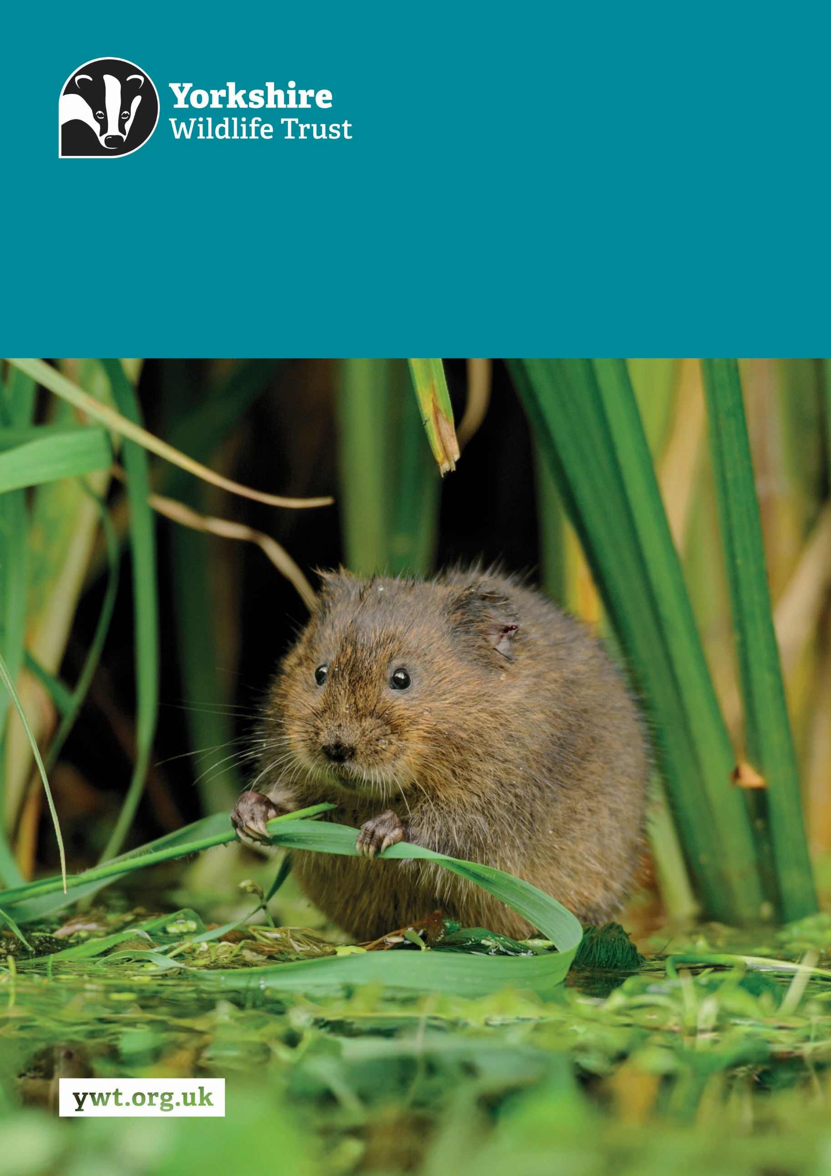
Z
Fundraising Research Officer
Job Description
About us

Yorkshire Wildlife Trust is one of the region’s largest environmental charities; our mission is to drive nature’s recovery in Yorkshire across our land and at sea.
We are one of 46 regional Wildlife Trusts working for nature and collectively forming the Wildlife Trusts, one of the largest collective national movements for wildlife in Europe.
Our vision is for wildlife and people thrive together across Yorkshire’s communities, land, rivers and sea. We work holistically in nature, thinking globally, planning at regional and landscape scale, while delivering our work in partnership with local communities, caring for local wildlife together. Our dedicated team of staff (c.190) and volunteers (c.1000) work together, on behalf of all our members (c.41,000), in every corner of Yorkshire to make this vision a reality.

Since forming in 1946 with our first reserve at Askham Bog, we now steward 115 nature reserves, which cover more than 3000 hectares of land and include some of our most precious wildlife. We also work extensively with other land managers, communities and businesses, to inspire, advise and deliver restoration work, supporting others too play their part in nature’s recovery.

We are passionate advocates for Yorkshire’s incredible wildlife and wild places. Join us and help create a diverse and inclusive team, committed to driving change for Yorkshire’s wildlife, communities and a positive future.

Job Description
Fundraising Research Officer
Responsible To: Individual Giving Manager
Responsible For: Volunteers
Location/based at: York, Stirley or Potteric
Date last updated: 24 August 2026

Main Purpose of the Role
- Lead, develop and implement processes and tools relating to prospect research, such as pipeline management and prospect propensity evaluations.
- Lead on the creation of accurate and insightful, high-quality research on current and prospective donors from a wide variety of trusted sources to derive and share insights which will inform the fundraising and supporter engagement strategy.
- Lead on working with colleagues across the Trust to support delivery of the Trust’s strategy through informing fundraising through strategic insight on sector trends.

Tasks and responsibilities
- Lead on the collaboration with the Head of Fundraising, Individual Giving Manager and senior stakeholders within the Trust to deliver the prospect research function, with a strong and sustainable prospect pipeline.
- Using a broad spectrum of sources, identify, research, organise and evaluate a prospect’s financial capacity, ability to give, willingness to give, charitable interests, and connection to the organisation and use this intelligence to inform the prioritisation of prospects and the development of our funding pipelines.
- Lead and coordinate meetings with internal stakeholders to discuss new prospects and the current High-Net-Worth-Individual portfolio and pipeline.

- Lead the prospecting strategy for the Trust through collaborating across the fundraising team and wider staff team to ensure a joined-up approach is taken.
- Ensure prospecting is carried out in line with GDPR requirements and consents are up to date.
- Keep up to date with research techniques and due diligence trends and best-practice processes within the sector, including identifying ways to improve risk research, due diligence and market insight, and implement new ways of working to continuously deliver a high quality and efficient prospect research methodology.
- Produce in-depth, well-written reports on prospects based on a combination of data from the donor database, open access records and other markers of high-quality donors.
- Carry out regular pipeline reviews to ensure that our prospect pipelines remain dynamic and fit for purpose.

Other
- Promote the Trust and partner organisations whenever possible.
- Demonstrate our Trust values every day behaving with courage, respect, and integrity whilst trusting others and taking responsibility for your actions at all times.
- Support and promote the Trust’s commitment to equality, diversity and inclusion.
- The Trust is committed to safeguarding and promoting the welfare of children, young people, and adults at risk and expects all staff and volunteers to share this commitment.
- Abide by all Trust policies.
- Undertake any other duties as requested by your line manager and in line with the post.

Person Specification – Fundraising Research Officer
Experience | Essential/Desirable
Experience of providing strategically aligned research to help identify and prioritise prospects capable of offering significant financial and/or other support. | Essential
Experience of profiling, network mapping, prospect qualification and other intelligence gathering activities. | Essential
Experience of working with colleagues in Individual Giving as well as with major donor and corporate fundraisers to optimise use of a CRM database to identify potential prospects. | Essential
Experience of carrying out due diligence assessments. | Essential
Strong understanding of GDPR and working within GDPR policies. | Essential
Experience in wealth screening, capacity assessment and affinity analysis to provide propensity scoring. | Essential
Experience of working with senior stakeholders (including the CEO and Board of Trustees) to identify key prospects within their networks and offer recommendations on next steps. | Desirable
Knowledge and Skills | Essential/Desirable
Ability to investigate, analyse, and synthesize large quantities of data into a user-friendly and concise format for the use by fundraisers and key volunteers (e.g. Trustees) | Essential
Ability to act proactively to identify new prospects. | Essential
Knowledge of due diligence platforms and how to carry out due diligence effectively. | Essential
Ability to juggle and prioritise multiple tasks and meet deadlines. | Essential
Demonstrable written and verbal communication skills. | Essential
Ability to take a tactful and ethical approach to fundraising tasks/projects. | Essential
Demonstrable understanding of GDPR and other regulatory compliance issues. | Essential

Strong understanding of the UK philanthropic environment across UHNWIs, Major Donors, Trusts and Foundations and Corporates. | Desirable
Personal Qualities | Essential/Desirable
Strong attention to detail | Essential
Good oral and written communication skills | Essential
Willingness to collaborate and work with colleagues to identify prospects | Essential
Strong natural communicator | Essential
Qualifications/ Requirements
UK driving licence, access to own transport and willing and able to drive across the region as required. | Essential
Masters level degree in a research discipline | Desirable

Terms and conditions
Salary: | Within the range £26,648.96 - £28,803.84 per annum (pro rata if part-time).
Hours: | 35 hours per week, Monday to Friday. The nature of the post’s duties may occasionally require evening and/or weekend work.  Paid overtime is not available, but time off in lieu will be given for essential additional hours worked.
Contract: | Fixed Term for 2 years. A probationary period of 4 months applies to new staff, during which you must complete all essential, mandatory training.
Flexibility: | Whilst ensuring the needs of the business and the role are met, the Trust endeavours to meet the flexible working needs of its employees. Depending on the nature of the role, the Trust offers hybrid working (a mix of office and at home).
Holidays: | 30 days per annum inclusive of 3 office/site closure days over the Christmas period, in addition to national public holidays, rising to 33 days after 5 years’ service. All leave is pro rata for part time employees.
Pensions: | You may be eligible to be auto enrolled into the Trust’s Pension Scheme. Terms of the scheme are available on request from Finance.
Employee Assistance Programme: | The Trust provides an Employee Assistance Programme. This is a confidential service which aims to provide staff with support for a range of issues.
Health Questionnaire: | You will be asked to complete a health questionnaire in order to identify and support or adjustments you may require.
Equal Opportunities: | Yorkshire Wildlife Trust is committed to equal opportunities and appoints on merit. We welcome applicants from all sections of society regardless of gender, sexual orientation, race, disability, marital status, age and religion, perceived community background or political beliefs.
Place of Work: | The post will be based at York, Stirley or Potteric
Travel: | Public transport is encouraged although pool vehicles are available. In exceptional circumstances the use of the employee’s own vehicle may be necessary for business use, at a mileage rate of 55p per mile.
Training & Professional Memberships: | The Trust is fully committed to personal development and training and supports achieving and maintaining professional memberships and accreditations, with any essential-to-role professional memberships paid for by the Trust.

