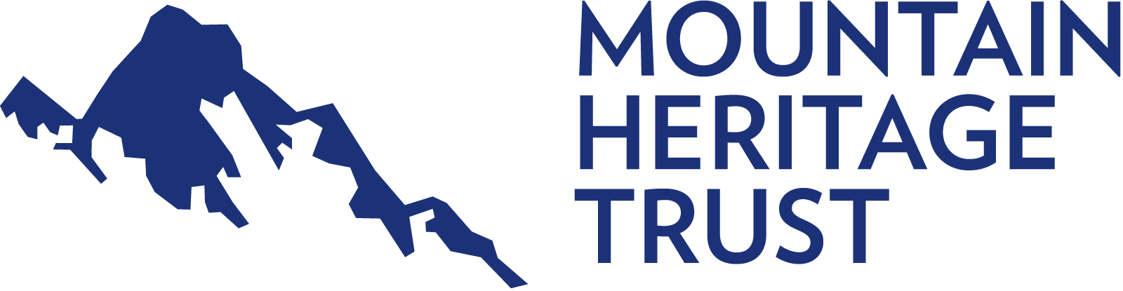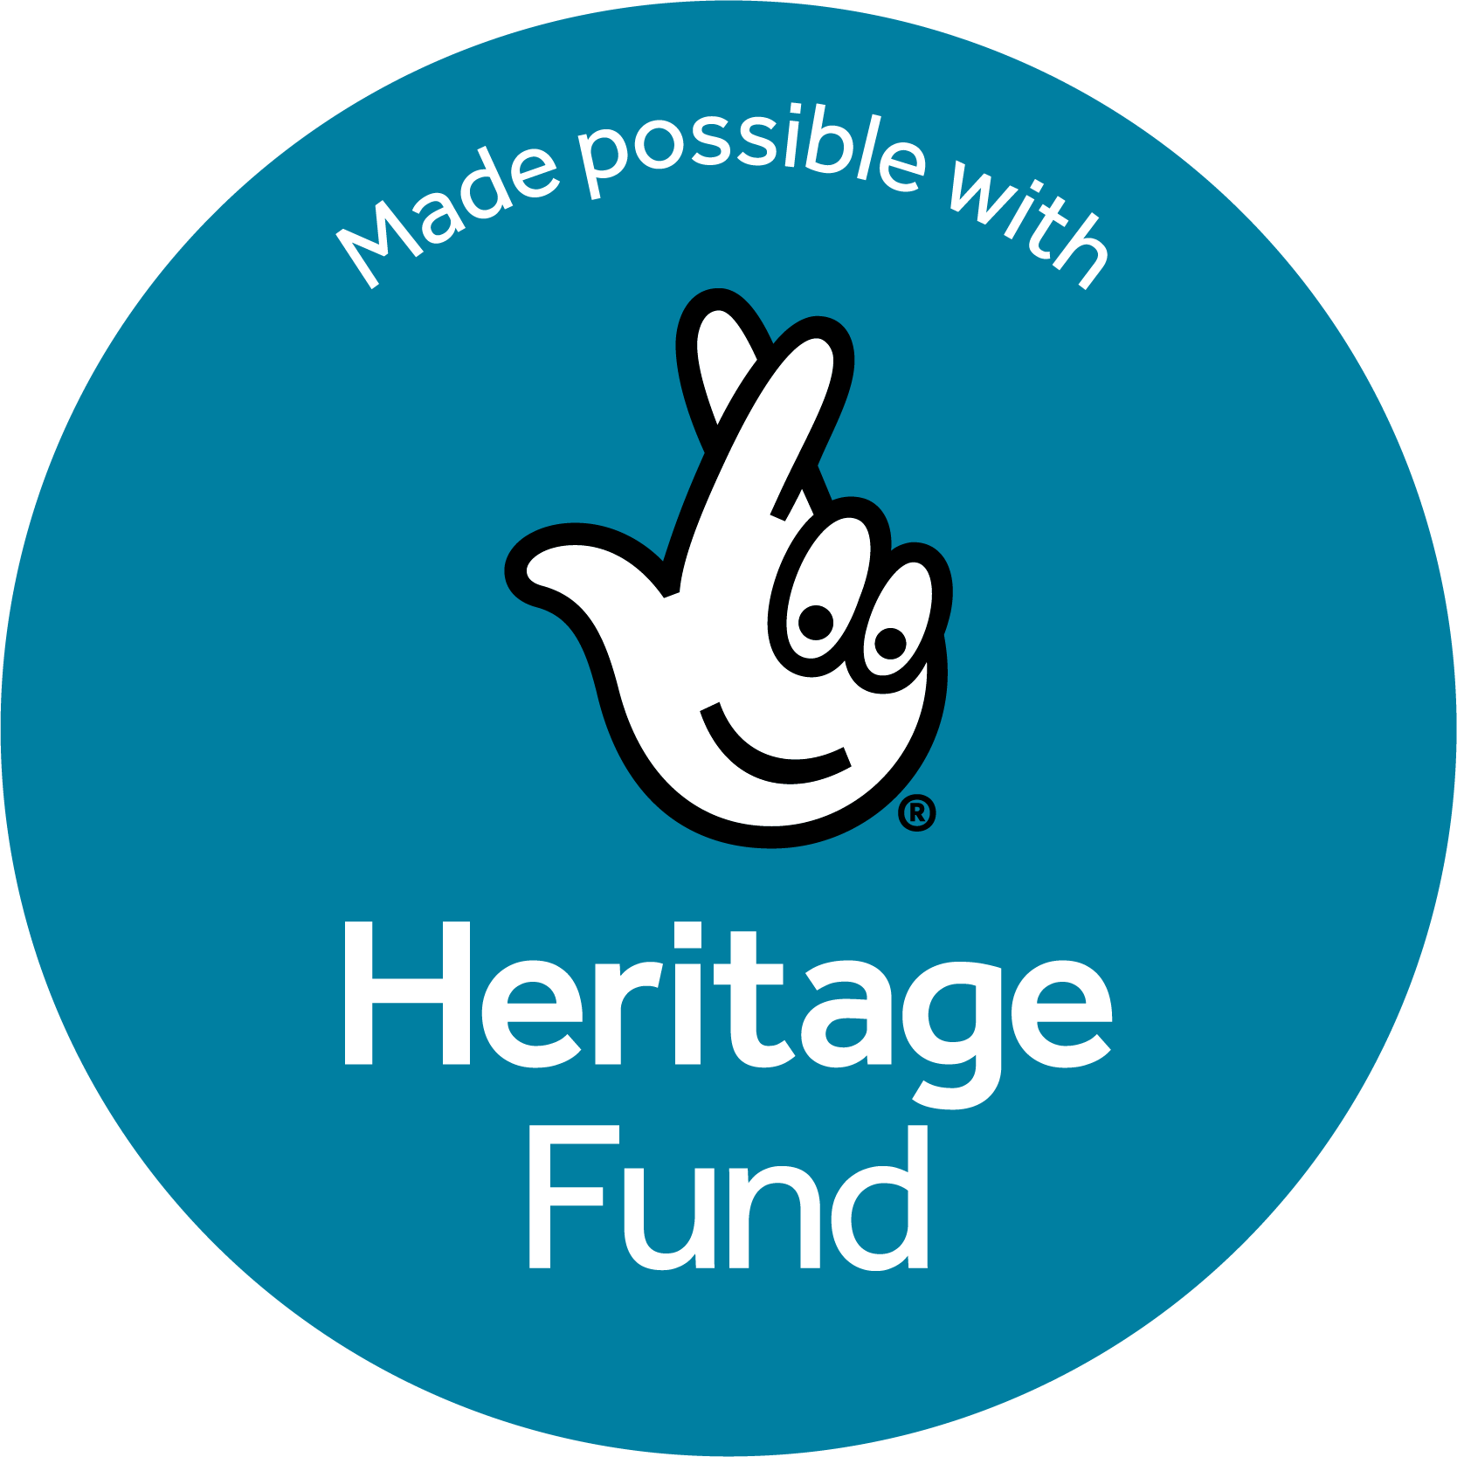
Communications & Business Development Manager
Salary: £42,000–£46,000 per annum
Contract: Full-time, fixed-term (Initial period of 2 years, but extendable as funding is secured)
Location: Blencathra Field Studies Centre, Threlkeld, Cumbria (flexible hours and hybrid working by agreement)
Help shape the future of Britain's mountain heritage
The Mountain Heritage Trust (MHT) is the national charity dedicated to preserving and sharing the rich history of mountaineering, climbing and exploration in the UK and beyond. Our collections, archives and stories document over two centuries of adventure, innovation and human endeavour in the mountains.
Thanks to support from The National Lottery Heritage Fund, we are embarking on an ambitious two-year programme to improve access to our collections, expand our audiences, strengthen partnerships and build a sustainable future for the Trust.
We are seeking an enthusiastic and entrepreneurial Communications & Business Development Manager to help lead this exciting next phase of development.
About the role
This is a unique opportunity to combine communications, fundraising, partnership development and project delivery within a respected national heritage organisation.
Working closely with trustees, volunteers, consultants and partner organisations, you will:
- Lead delivery of our communications and audience development activity
- Develop new fundraising, sponsorship and income generation opportunities
- Build and manage strategic partnerships across the heritage, outdoor and education sectors
- Co-ordinate and support our volunteer programme
- Help deliver exhibitions, events, outreach activity and digital projects
- Support delivery of our National Lottery Heritage Fund project and long-term organisational sustainability
This is a varied and outward-facing role with significant scope to shape the future direction of the Trust.
About you
We are looking for someone who can combine strategic thinking with practical delivery.
You may come from a heritage, charity, cultural, environmental, education or outdoor-sector background and will have experience in three or more of:
- Fundraising, business development, income generation and grant applications
- Communications, marketing or audience development
- Social media management
- Partnership management and stakeholder engagement
- Volunteer coordination and project delivery
- Heritage, museums or archives
- Interest in outdoor recreation, climbing or mountaineering
Most importantly, you will be a strong relationship builder, an effective communicator and someone who enjoys turning ideas into action.
In addition, applicants should:
- Have the right to work in the UK
- Be able to travel occasionally throughout the UK, so a driving licence is useful.
Why join us?
This is an opportunity to play a leading role in safeguarding and sharing Britain's mountain heritage while helping shape the long-term future of a nationally significant organisation.
Want to apply for this role?
Read the full job description and submit your application. You will be asked to upload your CV and supporting statement. You will need to be signed into a Google account to access the links.
For an informal discussion about the role please contact david.tait@mountain-heritage.org
Closing Date: 22 July 2026
Interviews: Week commencing 27 July 2026
Expected Start Date: September 2026

