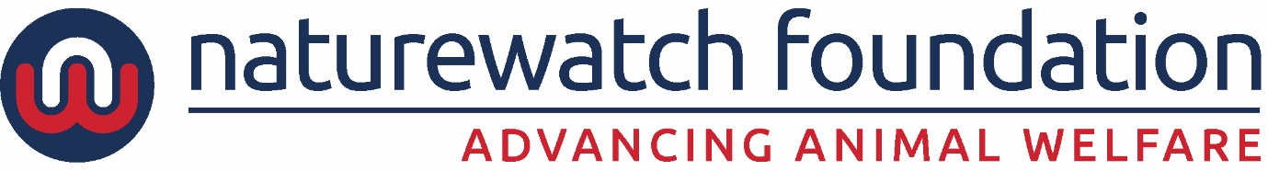

CAMPAIGNS ASSISTANT - Full-time permanent position (open to part-time applicants)

Join our dedicated, award-winning team at Naturewatch Foundation, where our mission is to prevent animal cruelty and make a meaningful positive impact on the lives of animals.

Role: Campaigns Assistant
Salary: Circa £23,000 full time dependent on experience. Full time is 35 hours per week, Monday to Friday, 9am to 5pm.
Location: Cheltenham, with some home working (full time with x3 days working in central Cheltenham charity office)

Job Description

Are you passionate about animals and looking for a job in campaigning, public policy change, public affairs and stakeholder relations? As Campaigns Assistant, you’ll support the delivery of impactful campaigns led by our Campaign Managers and support high-profile projects like World Animal Day and various events.

To be considered, we’ll be looking for motivated, resilient candidates with relevant experience or skills developed in an animal welfare (or related) degree or more general public policy and campaigning. The successful candidate would need to be organised, with a sharp eye for detail, able to deliver projects on time, whilst working as part of a team. You’ll need a strong ability to multi-task and prioritise, as no day is ever the same.
This is a full time or part time permanent role offering a salary around £23,000, depending on skills and experience.
If this sparks your interest, we would love to hear from you.
Essential Skills

- Excellent written and verbal communication skills
- Good time management skills with the ability to plan, prioritise workloads, work quickly and accurately under pressure and to deadlines
- Knowledge of campaigning, lobbying and public affairs and / or animal welfare policy issues
- Competent with Microsoft Office software such as Excel, Word, PowerPoint
- Able to organise events
- Able to work effectively as part of a small team, and interact with colleagues in a helpful and supportive manner
- Hard working, motivated and with a can-do positive attitude
- Able to handle sensitive, sometimes distressing information regarding animal welfare such as animal testing, animal cruelty and wildlife crime and the link with domestic abuse.

Desirable Skills

- Research experience
- Willing to network
- Volunteer management

Requirements
- Happy to work in our small Cheltenham office a minimum of three days a week if full time, and work remotely including from home on other days, plus willingness to attend meetings elsewhere as necessary
- Commitment to the objectives of the charity
- Agreeable to attend local, national and possibly international events occasionally and carry out any other reasonable tasks asked of you
- Start date January 2026

To apply:
Please send your CV and covering letter outlining your relevant experience and skills and including why you would like the position to sarah@naturewatch.org. Applications without a cover letter may not be considered for interview. Please include ‘Campaigns Assistant Job Application’ in your application.
Closing Date: Thursday 4th December 2025. We may contact applicants selected for interview prior to the closing date.
Find out more about Naturewatch Foundation:
www.naturewatch.org www.worldanimalday.org.uk and visit our social media
Naturewatch Foundation is a charity registered in England and Wales 1039679

